Chapter 4: Methodology

4.1 Research Environment and Respondents
This study is conducted in a fully computational research environment. It does not draw on a human population but instead studies typographic artifacts. The units of analysis are therefore not people but fonts and the rendered text-crop images derived from them. Because the study addresses typographic hallucination in generative AI images, no clean corpus of such crops exists at the scale a metric-learning model requires. The environment is consequently a synthetic-data one: the primary dataset is generated by the researchers from a curated, open-source font palette rather than downloaded ready-made. This follows the precedent of DeepFont, which likewise built a targeted synthetic dataset of rendered glyphs to train a deep visual font recognizer (Wang et al., 2015).

Digital Source and Trusted Environment
The font palette is sourced from Google Fonts (https://fonts.google.com; source repository https://github.com/google/fonts), the open-source typeface library maintained by Google LLC. Google Fonts is a trusted environment for three reasons. First, its faces are released under permissive open licenses (predominantly the SIL Open Font License), so every typeface can be freely rendered, degraded, and redistributed without the licensing constraints that encumber commercial font catalogues. Second, the collection is curated and version-controlled, giving each typeface a stable identity and provenance that a reproducible dataset requires. Third, its faces are among the most widely deployed on the web, so a model trained on them maps hallucinated text back onto a realistic, free reconstruction palette. From this library the study selects the top 50 to 100 Google Fonts, drawn from the platform’s own popularity ordering and chosen to span the four structural family classes (serif, sans-serif, display, and monospace) established in Section 3.2.1.
The decision to bound the palette this tightly is deliberate, and it follows from both the framework’s design and the evidence on large catalogues. Conceptually, the system is built for open-set recognition, in which the known set is intentionally finite and every out-of-palette input is routed to an “unknown” verdict; because the space of possible fonts is effectively unbounded and cannot be enumerated (Lu et al., 2025), a localized known set is the premise of the design rather than a limitation of it. Empirically, scaling the catalogue buys coverage, not robustness. The 3,474-font Storia-AI classifier is the field’s largest reference embedding, yet it still overfits pristine glyphs and degrades under generative deformation (Jiang et al., 2025), and Chen et al. (2026) show that pushing to 394 variants drops family-level accuracy to 40.2%, because the additional fonts are largely near-identical weight variants whose confusion dominates the error matrix. A curated palette that omits redundant near-duplicates avoids that failure mode directly. The trimmed set also excludes the typographic long tail of rare and display faces, which is both the hardest to recognize and the most severely hallucinated by diffusion models (Zhuang et al., 2025), and it keeps per-class image density high for the metric-learning objective, since a fixed rendering budget spread over fewer classes yields more examples per font. Finally, the study’s reconstruction goal only requires the faces designers actually reuse, which the popularity ordering already surfaces.
A second, external repository defines the study’s comparative baseline: Storia-AI’s Google Font Classifier (the font-classify/ sandbox), a pre-trained classifier over 3,474 Google Fonts. This classifier is not merely a convenience baseline; it is the field’s reference embedding for font identity, adopted as the fidelity backbone in recent typographic work (Jiang et al., 2025). Benchmarking against it lets the study demonstrate, on a recognized standard, how weights fitted to pristine glyphs degrade under generative-AI deformation.

Respondents: The Entities Being Studied
Because the data concern non-human objects, there are no human respondents in the primary sense. The entities being studied are of two linked kinds:
- Fonts (typefaces). The 50 to 100 selected Google Fonts are the population of typographic identities the system must recognize. Each font is one class label in the recognition problem and is characterized by the measurable structural traits defined in Chapter 3 (x-height, terminal form, stroke contrast, and counter shape).
- Rendered text-crop images. From each font the pipeline renders pristine word crops and then applies the algorithmic degradation operator of Section 3.2.3 to produce hallucinated variants. These grayscale image crops (standardized to a fixed input resolution, detailed in Section 4.3.1) are the individual “profiles” the model actually consumes; each degraded crop is an instance whose ground-truth label is the font it was rendered from.
The unit of analysis is the isolated text crop, not the full image. A real deployment receives a whole generative-AI image, which may contain several text regions in different fonts, so an upstream step must first locate and crop each region. That localization is handled by a standard off-the-shelf text detector and is treated as a delimitation rather than a contribution: this study does not train, tune, or evaluate the localizer, and it reports no detection metrics. Every crop the localizer emits is classified independently by the recognition engine, which is where the thesis’s contribution lies. Fixing the crop as the unit of analysis keeps the dataset, the metrics of Section 4.2, and the human-proxy baseline all defined at the same level.
A small human element enters only at the evaluation stage, and strictly as a benchmark rather than a training population: a three-person consensus panel establishes a human-proxy ground truth over a held-out set of 100 actual generative-AI image text boxes. This panel provides the accuracy floor against which the automated system is compared (elaborated in Section 4.10); its composition and screening criteria are specified there. Apart from this proxy panel, the study’s respondents are entirely typographic artifacts.

4.2 Research Instrument or Sources of Data
Because this study works on typographic artifacts rather than human respondents, its “instruments” are the software apparatus that manufactures, measures, and adjudicates the data rather than a questionnaire or survey. Four instruments are used: a researcher-made synthetic-data generation pipeline that produces the training and validation corpus, a set of standardized evaluation metrics that score the model’s output, a researcher-made human-proxy consensus rubric that fixes ground truth on real generative crops, and a web application that exercises the trained model in real time. The first three supply and assess data; the fourth is the interactive artifact through which the system is demonstrated and stress-tested.

4.2.1 Synthetic-Data Generation Pipeline (Researcher-Made)
The primary instrument is a researcher-built rendering-and-degradation pipeline. Its purpose is to generate a large, fully labeled corpus of text-crop images for which no in-the-wild equivalent exists at the scale metric learning requires, following the synthetic-corpus precedent of DeepFont (Wang et al., 2015) and the more recent DINOv2-based font pipeline of Chen et al. (2026). The instrument has two stages. The rendering stage draws pristine word crops from the selected Google Fonts palette; the degradation stage applies the operator $D$ defined in Section 3.2.3 — elastic warp, Gaussian blur and noise, and kerning jitter — to convert each pristine crop into a hallucinated variant.
The instrument’s construct validity rests on the correspondence between its degradation parameters and the deformation mechanisms the generative literature documents: cross-character attention smearing (Gillani et al., 2025), multi-instance entanglement (Du et al., 2025), and continuous latent-manifold mutation (Kondo et al., 2024). In other words, the pipeline is valid to the extent that its manufactured deformations reproduce those observed in real text-to-image output. Its reliability is guaranteed procedurally: rendering and degradation are deterministic given a fixed random seed, so any crop in the dataset can be regenerated bit-for-bit, and the per-parameter degradation levels are logged with each image. This distinguishes the instrument from a standardized dataset — it is researcher-made — but its determinism makes it reproducible by any third party who runs the same code with the same seed.

4.2.2 Standardized Evaluation Metrics
The model’s output is scored with published, standardized metrics rather than researcher-defined ones, which imports their established validity. Recognition accuracy uses the Top-1 and Top-3 (Top-K) protocol that DeepFont established as the field standard (Wang et al., 2015). Typographic proximity between a predicted font and the input crop is measured with structural-similarity metrics in a re-render-and-compare loop: the classical SSIM of Wang et al. (2004) and its deformation-robust successors DeepSSIM (Zhang et al., 2024) and SAMScore (Li, Chen, et al., 2025), whose reliability under geometric misalignment is exactly the property this study needs. Prediction-set confidence uses rank-calibrated conformal prediction (Shi et al., 2024; Ding et al., 2025), which carries a formal coverage guarantee. Finally, error severity is weighted by the embedding-centroid cosine severity index of Chen et al. (2026), which quantifies whether misclassifications stay within a typographic family. Because these instruments are drawn from peer-reviewed sources, their validity and reliability coefficients are inherited from the literature rather than re-established here.

4.2.3 Human-Proxy Consensus Rubric (Researcher-Made)
Ground truth for real generative crops — which carry no font metadata — is fixed by a researcher-made rating instrument administered to a three-person expert panel. For each of the [N = 100] real generative-AI text boxes, each rater independently assigns a font label from the palette or an “unknown / hallucinated” verdict, and a label is fixed only when at least two of three raters agree. The instrument’s content validity comes from panel expertise (raters screened for typographic training, criteria specified in Section 4.10); its reliability is quantified by inter-rater agreement, reported as a Fleiss’ $κ$ of [κ = X.XX] once the rating exercise is run. The 2-of-3 consensus rule is the instrument’s built-in reliability safeguard against any single rater’s idiosyncrasy.

4.2.4 Web Application (Interactive Testing Instrument)
The fourth instrument is a web application built on top of the trained model so that the system can be exercised in real time rather than only in batch evaluation. A user uploads a generative-AI image through the browser, the backend runs the inference engine, and the interface returns the Top-K Google Fonts shortlist or an “unknown” verdict. This instrument serves two methodological purposes: it is the demonstration artifact required by the build-method evaluation of Section 4.10, and it is a qualitative probe that surfaces failure cases on ad hoc, in-the-wild inputs that the fixed test set may not contain. Its design, framework choices, and development process are detailed in Sections 4.5 through 4.8.

4.3 Research Procedure
This section specifies how the data are gathered and treated. Section 4.3.1 defines the dataset schema, the variables, and the properties of the image and text data. Section 4.3.2 describes the preprocessing, augmentation, and adaptation applied before training, and closes with the validation strategy that guards against overfitting.

4.3.1 Gathering of Data
Data schema. The corpus is a table of image instances, one row per rendered crop, with the fields listed in Table 1. Each row pairs an image file with the metadata needed to train, stratify, and audit it.
Table 1
Schema of the Synthetic Text-Crop Dataset
Field | Type | Description
image_id | string | Unique identifier for the crop
image_path | string | Path to the rendered PNG
font_id | categorical | Google Fonts family and weight (the class label)
family_class | categorical | Serif, Sans-serif, Display, or Monospace
word_text | string | The rendered English word(s)
warp_level | float | Elastic-warp intensity $θ_{\text{warp}}$
blur_level | float | Gaussian blur/noise intensity $θ_{\text{blur}}$
kern_level | float | Kerning-jitter intensity $θ_{\text{kern}}$
split | categorical | train, validation, or test
seed | integer | Random seed for exact regeneration
Note. The three degradation-level fields record the parameters of the operator $D$ from Section 3.2.3, so each crop’s deformation is reproducible and can be analyzed after the fact.
Variables. The independent variables (inputs) are the pixels of the rendered text-crop image and, at a controlled level above them, the three degradation parameters ($θ_{\text{warp}}$, $θ_{\text{blur}}$, $θ_{\text{kern}}$) that the pipeline manipulates systematically, together with the categorical family_class factor used to analyze errors. The dependent variable (target) is the font class label, one of the 50 to 100 palette fonts, plus the open-set “unknown” outcome for crops belonging to no palette font. Secondary outcomes measured from the model are the Top-K rank of the true font, the structural-distance score between the input and the re-rendered prediction, and the open-set rejection score.
Image properties. Crops are rendered at 1024 px and downsampled to a fixed 224 × 224 input, which matches the DINOv2 ViT-B/14 backbone and the resolution used by Chen et al. (2026). To keep the model from learning a color shortcut, and to mirror the varied coloring of real generative text, foreground and background colors are randomized during rendering with a minimum luminance contrast of 80 (the Chen et al. precedent). Each crop is then reduced to single-channel luminance and replicated across three channels for ImageNet-normalized input, so the encoder reads grayscale structure while training on color-varied renders. Text alignment is jittered (left, center, or right) and lines wrap with roughly 20% probability, and about 575 images are rendered per font variant as the per-class volume baseline.
Text properties. The rendered strings are English (Latin script), drawn from a fixed word list of common words so that lexical content is decorrelated from font identity across the corpus. Each crop carries one to three words, so the visual field is dominated by letterform structure rather than long-line layout.
Extension beyond the precedent. Chen et al.’s (2026) augmentation is pristine-noise only (Gaussian $σ=25.5$). This study’s data contribution is to add the hallucination-specific degradation operator $D$, covering elastic warp, kerning jitter, and cross-character smear, that their closed-set pipeline lacks. As a result the corpus spans not merely clean renders under noise but the probabilistic glyph deformation that defines the target regime.

4.3.2 Treatment of Data
Before training, each crop passes through a preprocessing chain embedded in the model’s forward pass (square-pad, resize to 224 × 224, and ImageNet normalization) rather than applied as a separate offline step. Folding preprocessing into the forward method, following Chen et al. (2026), guarantees that the same transforms run at training and at inference, which eliminates train-serve skew when the model is later called from the web application. Degradation via the operator $D$ is applied online as a stochastic augmentation, so a given font is seen across a distribution of deformation amplitudes within and across epochs. Following the augmentation-as-coverage argument of Plastropoulos and Tegos (2024), this pushes the decision boundary into regions that stay stable under distortion.
Adaptation strategy. The default configuration keeps the DINOv2 backbone frozen and trains only a lightweight metric-embedding head (Section 2.5), because in-the-wild generative crops arrive without font labels and the open-set inference path must not depend on a closed-set classifier. Parameter-efficient fine-tuning (LoRA; $r=8$, $α=16$, about 0.2% of parameters) as used by Chen et al. (2026) is reserved for the supervised teacher that supplies reference distributions to the label-free prompt-distillation step. It is kept off the open-set inference path, whose closed-set assumptions it would otherwise reintroduce.
Validation strategy. The synthetic corpus is partitioned 70% / 15% / 15% into training, validation, and test sets, split by font_id and stratified so that every font class and every degradation level appears in each partition in proportion to its overall frequency. Stratification prevents a rare display or monospace face from landing entirely in one partition, which would otherwise inflate or deflate its apparent accuracy. Because per-class counts for the rarest faces are modest, stratified k-fold cross-validation ($k=5$) is used on the combined train-plus-validation data to stabilize the reported metrics, with the 15% test partition held out untouched until final evaluation. Separate from this synthetic split is the real-generative test set of [N = 100] in-the-wild crops labeled by the human-proxy panel (Section 4.2.3). It never enters training in any form, and it functions as the out-of-distribution generalization benchmark against which the synthetic-trained model is finally judged.

4.4 Concept

4.4.1 Core Concept and Vision
The system is a font-identification service for hallucinated type. Given a fragment of text lifted from a generative-AI image, it returns a ranked shortlist of the closest open-source Google Fonts, or an explicit “unknown” verdict when the glyph belongs to no font in its palette. Its purpose is practical reconstruction: letting a designer rebuild a generative image’s typography from a free, license-clear palette instead of paying a commercial identifier to name a font that may not be reusable. The framework is deliberately scoped. Rather than matching against the entire commercial typeface universe, it trades exhaustive coverage for a tractable, localized palette of the top 50 to 100 Google Fonts, which is what makes free reconstruction possible. A web application built on top of the model exposes this capability interactively, so the system can be tested in real time on uploaded images.

4.4.2 Conceptual Framework
The framework follows an input-process-output (IPO) structure, shown in Figure 8. The input is a graphic designer and the generative-AI image they supply. That image is a full scene, not a pre-cut crop: its text is probabilistically deformed, and it may hold several text regions, some set in fonts outside the palette. The process moves through four steps. A web-app frontend accepts the upload and displays results, a backend API routes the request, and an off-the-shelf text localizer isolates and crops each text region. Every crop is then passed independently to the ML inference engine, which performs the recognition that is the focus of this thesis. The localizer is a standard component and not a contribution of this work; the unit of analysis is the isolated crop, as stated in Section 4.1. Inside the engine, a crop is preprocessed, encoded by a frozen DINOv2 Vision Transformer, projected by the metric head $f_{θ}$ into a font-style embedding, and passed to the open-set decision that either rejects the crop as unknown or ranks the palette. Because the engine runs per crop, an image with several text regions produces one Top-K Google Fonts shortlist, or one unknown verdict, per region, and the results return to the designer for free template reuse. A separate offline subsystem, the researchers’ synthetic rendering, degradation, and triplet-training pipeline, produces the trained weights the engine loads, and appears as the lower band feeding the encoder and head.
Figure 8
Conceptual Framework of the Proposed Font-Identification System
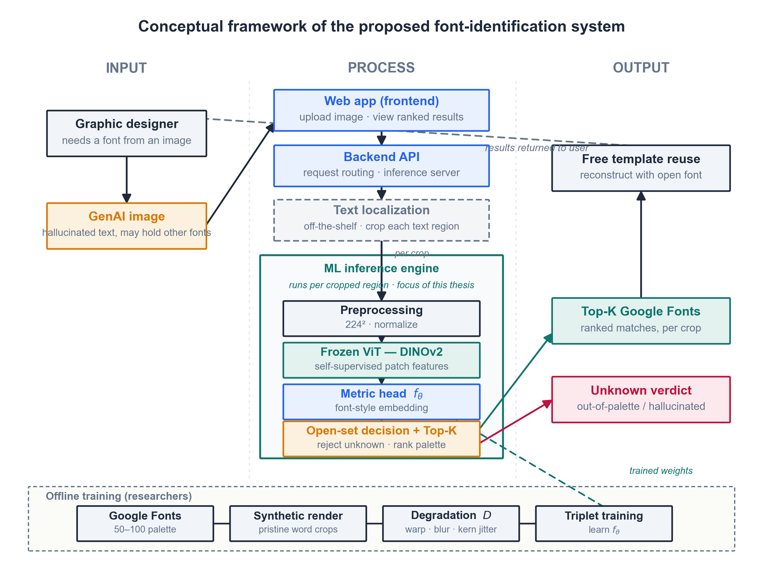
Input-process-output diagram showing a graphic designer and GenAI image feeding a web-app frontend, a backend API, an off-the-shelf text localizer that crops each text region, and the ML inference engine (preprocessing, frozen DINOv2 encoder, metric head, open-set decision) run per crop, producing a Top-K Google Fonts shortlist or unknown verdict per region, with an offline synthetic-training subsystem supplying the model weights
As shown in Figure 8, the runtime path (designer to frontend to backend to localizer to inference engine to shortlist) is cleanly separated from the offline training path (Google Fonts to synthetic render to degradation to triplet training). The two meet at a single point: the trained weights loaded by the frozen encoder and metric head. The localizer sits before the engine as a replaceable off-the-shelf stage, which keeps the thesis focused on the recognition that follows it. This separation is what lets the same model serve real-time web requests while remaining fully reproducible from the researcher-controlled data pipeline.

4.4.3 Value Proposition
The design suits its problem for three reasons. It is open-set: unlike a closed-set classifier that must name some font for every input, it can refuse, which matters when many generative crops correspond to no real typeface. It is trained on the hallucination distribution itself rather than on pristine glyphs, so it does not collapse on the warped, re-kerned input that defeats commercial identifiers and clean-glyph baselines. And because it targets a localized open-source palette, every match it returns is immediately reusable at no cost, turning recognition into a usable reconstruction rather than a paywalled lookup.

4.4.4 High-Level Operational Logic
From the user’s side the interaction is simple. A designer opens the web application, uploads a generative-AI image containing text, and waits a moment while the system localizes and crops the text regions and runs each crop through the inference engine. For every detected region the application displays a short, ranked list of candidate Google Fonts, each shown as a rendered preview, or an “unknown” message when the system judges the glyph to fall outside its palette. The designer picks the closest match and reuses it directly in their own document. The user needs no knowledge of embeddings, thresholds, or the training pipeline; the technical machinery of Sections 4.2 and 4.3 stays hidden behind a single upload-and-review interaction.

4.5 Analysis and Design
This section turns the concept of Section 4.4 into a specification. Section 4.5.1 states what the system must do and the qualities it must have, scoped to a local testing deployment rather than a public service. Section 4.5.2 describes the architecture that satisfies those requirements and how its parts communicate.

4.5.1 Requirements Analysis
Functional requirements. The system must:
- Accept an uploaded generative-AI image in common raster formats (PNG, JPEG) through the browser.
- Localize and crop each text region in the image using an off-the-shelf text detector.
- Preprocess each crop and embed it with the frozen DINOv2 encoder and the trained metric head.
- Apply the open-set decision to each crop, either rejecting it as “unknown” or ranking the localized palette.
- Return, for every detected region, a Top-K shortlist of candidate Google Fonts or an “unknown” verdict.
- Render a preview of each candidate font so the user can compare it against the source text.
- Expose the recognition pipeline through a REST endpoint (/predict) that the frontend calls.
- Load the trained model weights once at startup and reuse them across requests.
Non-functional requirements. The system should also:
- Be usable through a single upload-and-review interaction that hides the underlying model (usability).
- Return results at interactive latency on a single machine, targeting a response within a few seconds per image (responsiveness).
- Produce the same output for the same input, through deterministic preprocessing and pinned model weights and seeds (reproducibility).
- Run from a single Docker image on one host, with no external service dependencies at inference time beyond the bundled weights and font files (portability).
- Keep the localizer, encoder, metric head, and open-set decision as separable components, so any one can be replaced without rewriting the others (maintainability).
- Operate as a single-user local demo, with no authentication, accounts, or multi-user scaling in scope (a deliberate delimitation, consistent with Section 4.1).
- Report an honest “unknown” rather than a forced guess when the open-set score falls below threshold (transparency).

4.5.2 System Architecture
The architecture is a layered client-server design, shown in Figure 9. It separates a thin presentation layer from a Python inference backend, and separates both from the model and font resources they depend on.
Figure 9
System Architecture of the Font-Identification Web Application
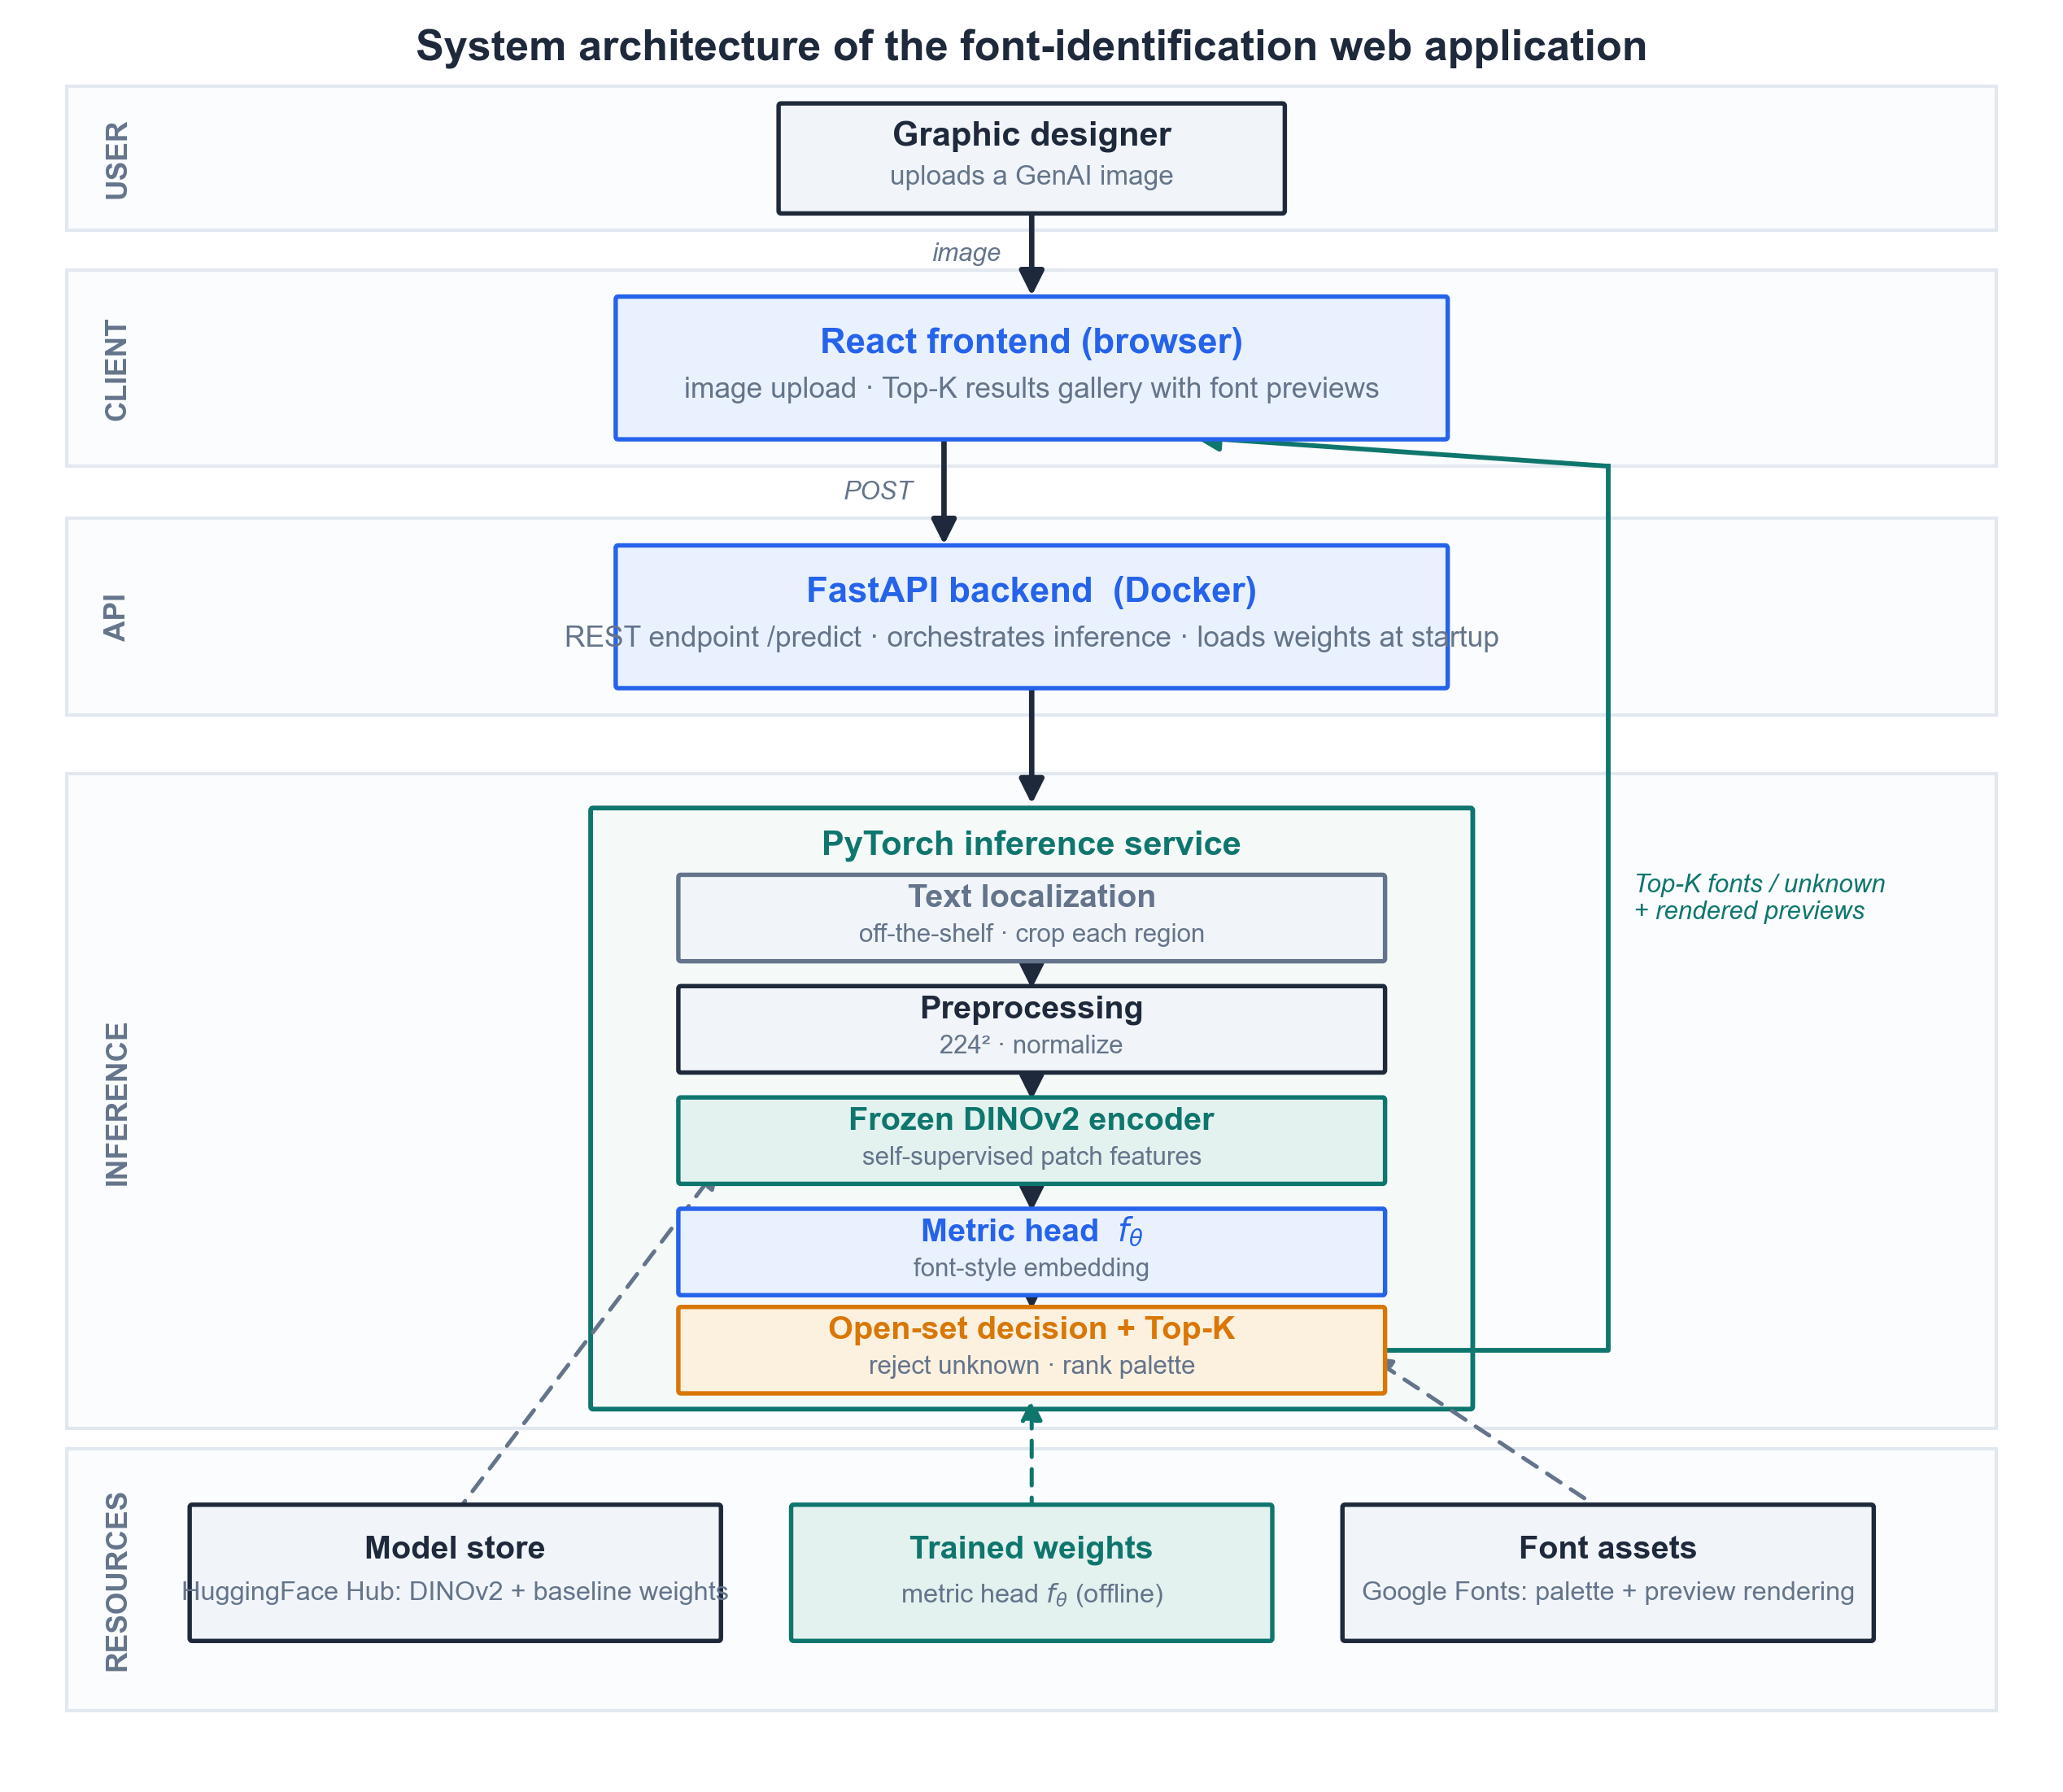
Layered architecture diagram with a user tier (graphic designer), a client tier (React frontend), an API tier (FastAPI backend in Docker), an inference tier (PyTorch service running text localization, preprocessing, the frozen DINOv2 encoder, the metric head, and the open-set decision), and a resources tier (HuggingFace model store, offline-trained metric-head weights, and Google Fonts assets), with a request path down and a results path back up to the client
As shown in Figure 9, a request flows top to bottom and the result returns to the client. The client tier is a React single-page application in the browser: it handles the image upload and renders the Top-K results gallery with font previews. It calls the API tier, a FastAPI backend packaged in a Docker image, which exposes the /predict endpoint, orchestrates the inference call, and loads the model weights when it starts. The API hands each request to the inference tier, a PyTorch service that runs the pipeline of Section 4.4: off-the-shelf text localization, preprocessing, the frozen DINOv2 encoder, the metric head $f_{θ}$, and the open-set decision that produces a Top-K shortlist or an “unknown” verdict per crop. The resources tier holds what the inference tier reads but does not compute at request time: the DINOv2 backbone and baseline weights pulled from the HuggingFace Hub, the metric-head weights trained offline, and the Google Fonts files used both as the recognition palette and to render the candidate previews.
Two design choices in this layout matter for the rest of the chapter. First, the inference tier is the only stateful-at-startup component and the only one specific to this thesis; the localizer above it and the font assets beside it are replaceable off-the-shelf parts. Second, the offline training that produces the metric-head weights is not part of the request path at all. It runs separately and deposits weights into the resource tier, which keeps the served system reproducible from the researcher-controlled pipeline and lets the model be retrained or swapped without touching the API or the frontend.

4.6 Development Model

4.6.1 Identification of the Model
This study follows an iterative-incremental development model. The system is built as a sequence of increments, each of which runs a full Analyze, Design, Build, and Evaluate cycle and delivers a working slice that integrates into the growing whole. The model is shown in Figure 10.

4.6.2 Justification
The iterative-incremental model fits this project better than a single-pass model such as Waterfall for two reasons. First, the work is part research: the behavior of the metric embedding and the open-set threshold cannot be fully specified in advance, and each increment’s evaluation, such as Top-K accuracy or the rejection rate on held-out crops, feeds back into the design of the next. A model that froze the design before any results existed would not survive contact with the data. Second, the components have a natural build order and dependencies: the recognizer cannot be trained without the synthetic dataset, the open-set decision cannot be tuned without a trained embedding, and the web application only has something to serve once the recognizer works. Delivering these as increments keeps a working, testable artifact in hand at every stage and isolates risk to one increment at a time, which suits a two-person team without a dedicated QA role.

4.6.3 Phases of the Model
The project is organized into four increments, each producing a deliverable that the next increment consumes.
- Increment 1: Synthetic data pipeline. Analyze the documented deformation modes, design the rendering and degradation operator $D$, build the pipeline, and evaluate the crops against the target hallucination distribution. Deliverable: a labeled corpus of pristine and degraded crops (Section 4.3.1).
- Increment 2: Metric embedding. Design and build the frozen DINOv2 encoder with the trained metric head, and evaluate embedding separability across fonts and families. Deliverable: the frozen encoder plus the trained head $f_{θ}$ (Section 4.3.2).
- Increment 3: Open-set decision and evaluation. Add the rejection score, the calibrated Top-K, and the structural-distance verification, then evaluate against the baselines and the human-proxy panel. Deliverable: the full recognizer with its Top-K, rejection, and metric outputs (Sections 4.2 and 4.10).
- Increment 4: Web application. Wrap the recognizer in the FastAPI backend and React frontend, then evaluate it interactively on real uploaded images. Deliverable: the running demo application (Section 4.5).

4.6.4 SDLC Diagram
Figure 10
Iterative-Incremental Development Model
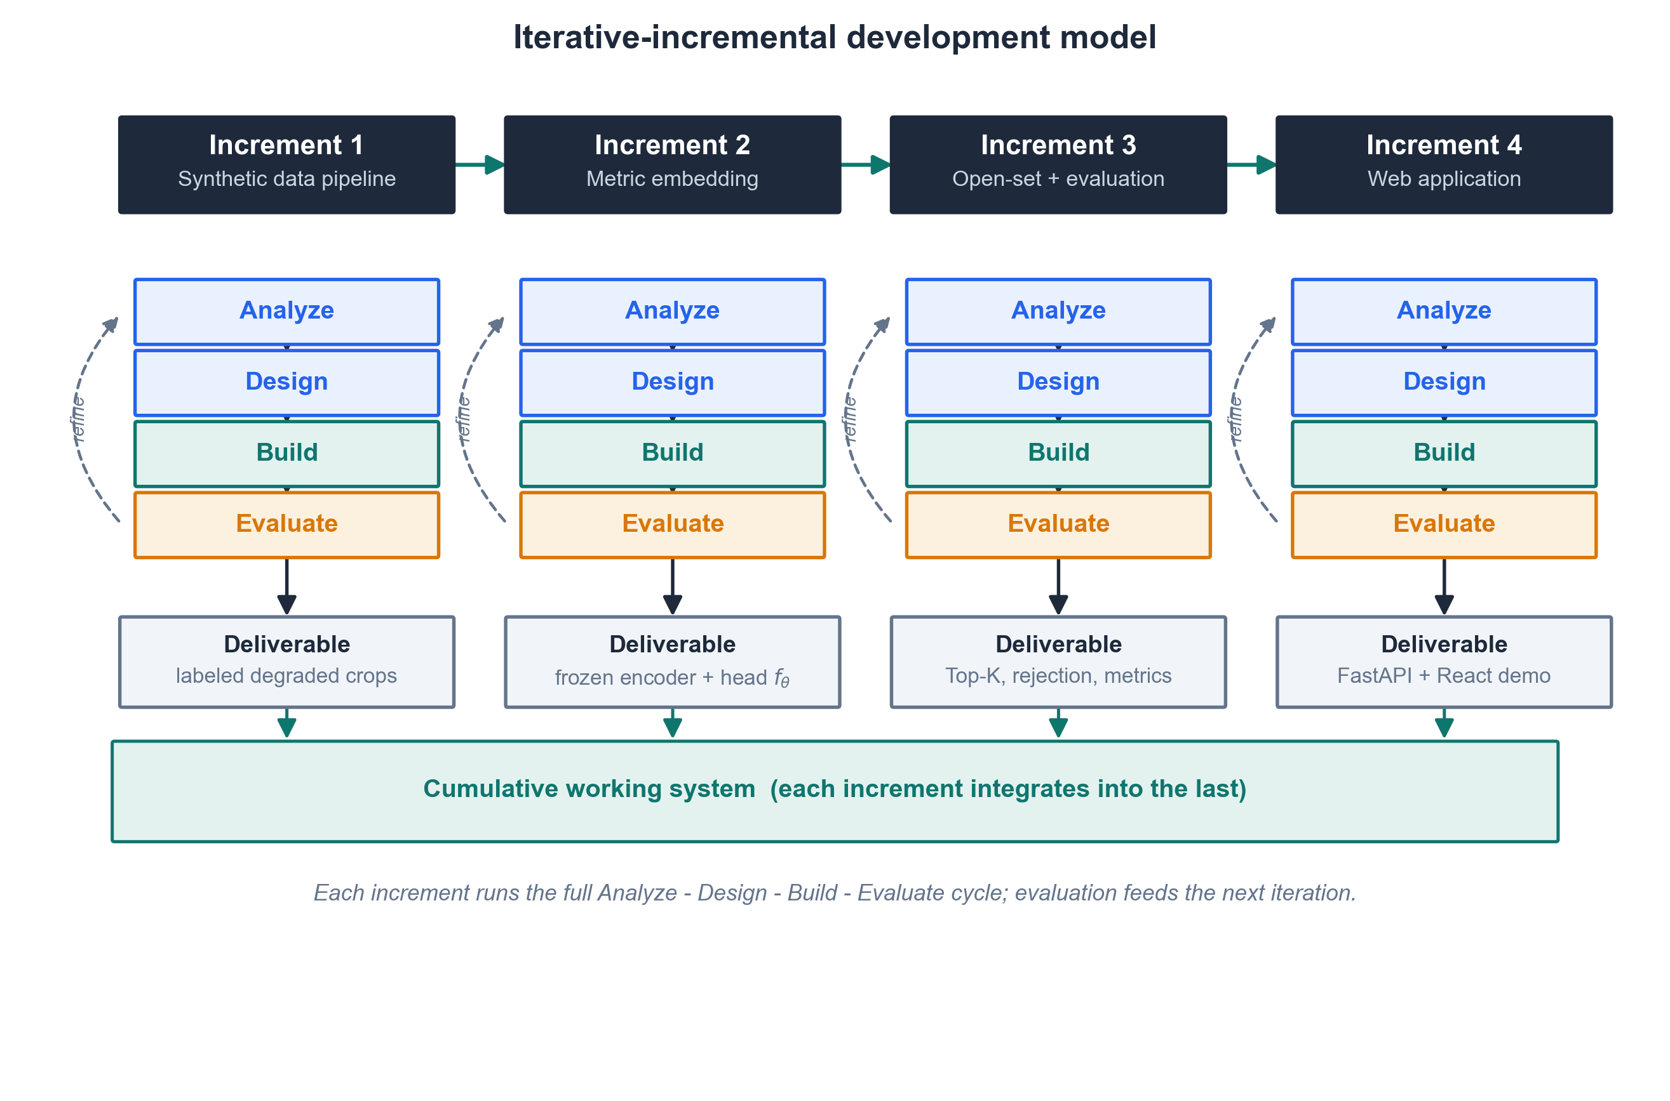
Diagram of four increments (synthetic data pipeline, metric embedding, open-set and evaluation, web application) arranged left to right, each running an Analyze, Design, Build, and Evaluate cycle with a refine loop and producing a deliverable, and each deliverable integrating into a cumulative working system band beneath them
As shown in Figure 10, the four increments proceed left to right, but the arrows within each increment show that development is not linear inside it: the Analyze, Design, Build, and Evaluate phases repeat, and each evaluation refines the same increment before the next one begins. The deliverables accumulate into a single working system rather than being integrated only at the end, so that a failure surfaced late, for example an open-set threshold that rejects too many valid crops, can be traced to the increment that introduced it.

4.7 Development Approach

4.7.1 Bottom-Up Construction
The system is built bottom-up. Construction starts at the data and model layers and works upward to the interface, in the increment order of Section 4.6: the synthetic data pipeline first, then the metric embedding, then the open-set decision and evaluation, and only last the web application that presents them. This direction follows the dependency structure of the problem, since each layer is useless to test until the one beneath it works, and it matches the runtime-versus-offline split of Figure 8, in which the offline pipeline produces trained weights that the served system later loads. A top-down approach, starting from the user interface and stubbing the model, would have deferred the project’s central research risk (whether a deformation-robust open-set recognizer is achievable at all) until after the surface was built, which is the opposite of what the schedule can afford.

4.7.2 Architectural Patterns
The build organizes around a few standard patterns. The application is a layered client-server system with a clear separation of concerns: presentation in the React client, request handling in the FastAPI service, and recognition in the PyTorch inference tier (Section 4.5.2). The client and server communicate over a REST interface, which keeps the frontend independent of the model internals and lets either side be developed against a fixed contract. The recognizer itself is a modular pipeline, in which text localization, preprocessing, encoding, the metric head, and the open-set decision are separate stages with defined inputs and outputs, so that a stage can be replaced, for instance swapping the off-the-shelf localizer, without disturbing the others. Inference is stateless across requests: the model weights load once at startup and each request is handled independently, which keeps the served component simple and reproducible.

4.7.3 Coding Philosophy
Three principles guide how the code is written. The first is reproducibility: random seeds, pinned dependency versions, and fixed model weights are recorded so that a run can be regenerated, and the preprocessing transforms are embedded in the model’s forward pass so that training and serving apply identical steps and no train-serve skew can creep in (Section 4.3.2). The second is reuse over reinvention: the backbone (DINOv2), the baseline classifiers, and the text localizer are taken off the shelf rather than rebuilt, so that effort concentrates on the thesis’s actual contribution, the deformation-robust open-set recognizer. The third is configuration over hard-coding: the palette size, degradation parameters, Top-K value, and rejection threshold are treated as configurable settings rather than constants buried in the code, which is what makes the iterative evaluation of Section 4.6 practical, since each increment can re-tune these without a rewrite.

4.8 Software Development and Tools
The stack is chosen against a few criteria: every tool is free and open-source, so the system can be replicated at no licensing cost, which is consistent with the free-reconstruction goal of the study; each is mature and widely supported, so documentation and community help are available; and each is the standard choice in its layer, which keeps the learning curve low for a two-person team. Because the served system is stateless and persists nothing between requests (Section 4.7.2), no database is used, so the database-connectivity criterion does not apply. Table 2 lists the tools by function, with the version used, an access link, and its role in the project.
Table 2
Software and Tools Used in the Development of the System
Function | Tool | Version | Access link | Use
Language and model | Python | 3.13 | https://www.python.org | Primary language for the data pipeline, model, and backend
Language and model | PyTorch | 2.6 | https://pytorch.org | Deep-learning framework for the encoder, metric head, and training
Language and model | Hugging Face Transformers | 4.49 | https://github.com/huggingface/transformers | Loads the DINOv2 backbone and the baseline classifiers
Language and model | Hugging Face Hub | 0.28 | https://huggingface.co | Pulls pre-trained weights and stores the trained metric head
Language and model | NumPy | 2.2 | https://numpy.org | Array and numerical operations
Language and model | scikit-learn | 1.6 | https://scikit-learn.org | Evaluation metrics, stratified k-fold split, confusion matrix
Data and rendering | Pillow (PIL) | 11.1 | https://python-pillow.org | Renders font specimens into word-crop images
Data and rendering | OpenCV | 4.11 | https://opencv.org | Elastic warp and other degradation operations
Data and rendering | EasyOCR | 1.7 | https://github.com/JaidedAI/EasyOCR | Off-the-shelf text localization and cropping
Backend | FastAPI | 0.115 | https://fastapi.tiangolo.com | REST inference API (/predict endpoint)
Backend | Uvicorn | 0.34 | https://www.uvicorn.org | ASGI server that runs the FastAPI app
Backend | Pydantic | 2.10 | https://docs.pydantic.dev | Request and response schema validation
Frontend | React | 19 | https://react.dev | Browser UI for image upload and the results gallery
Frontend | Vite | 6 | https://vite.dev | Frontend build tool and development server
Frontend | Node.js | 22 LTS | https://nodejs.org | JavaScript runtime for the frontend toolchain
Deployment | Docker | 27 | https://www.docker.com | Containerizes the backend for reproducible deployment
Version control | Git | 2.47 | https://git-scm.com | Source-code version control
Version control | GitHub | (web service) | https://github.com | Repository hosting and collaboration
Documentation | Matplotlib | 3.10 | https://matplotlib.org | Generates the thesis figures
Documentation | Pandoc | 3.10 | https://pandoc.org | Exports the Markdown chapters to DOCX
Documentation | Visual Studio Code | 1.98 | https://code.visualstudio.com | Primary code editor
Note. Versions are current as of July 2026 and are pinned in the project’s dependency lockfiles; a replicator should confirm the latest compatible releases at the time of setup. All tools are open-source and free to use; the hosted collaboration service (GitHub) offers a no-cost tier sufficient for this project.

4.9 Project Management

4.9.1 Schedule and Timeline
The project runs from June to December 2026. The schedule follows the increment order of Section 4.6, with the written chapters interleaved so that each empirical chapter is drafted as its results become available. Figure 11 shows the plan as a Gantt chart. As of the reporting date (July 10, 2026), Chapters 2 and 3 are complete and Chapter 4 is in progress; the four development increments, the results and conclusion chapters, and the final revisions follow through December.
Figure 11
Project Schedule and Timeline (June to December 2026)
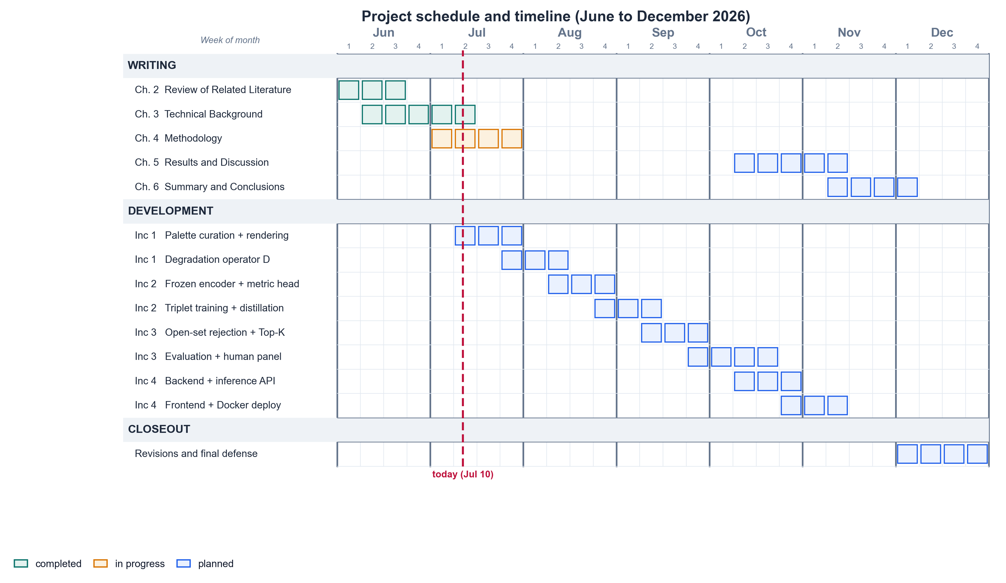
Weekly-cell Gantt grid spanning June to December 2026 with four week columns per month, tasks grouped into Writing, Development, and Closeout. Writing shows Chapter 2 and Chapter 3 completed, Chapter 4 in progress at the July 10 marker, and Chapters 5 and 6 planned. Development breaks the four increments into subtasks (palette and rendering, degradation operator, encoder and metric head, training and distillation, open-set and Top-K, evaluation and human panel, backend API, frontend and Docker). Closeout covers revisions and final defense in December
As shown in Figure 11, the early months cover the written groundwork (Chapters 2 and 3), the middle months carry the build increments from the synthetic data pipeline through the web application, and the final months are reserved for the results and conclusion chapters and for revision ahead of the defense. The development increments overlap the empirical chapters deliberately, because Chapter 5 reports the evaluation that increment 3 produces.

4.9.2 Responsibilities
The study is carried out by two researchers, both of whom act as researcher and developer. Table 3 divides the work. The split follows the two sides of the system: one member owns the Python model and data side, the other owns the service and interface side, and the writing is shared with cross-review.
Table 3
Division of Responsibilities
Member | Role | Responsibilities
Janritch Diputado | Researcher and developer | Python scripting: synthetic data pipeline, model training, and the inference engine. Lead author of Chapter 2 (Review of Related Literature) and Chapter 3 (Technical Background).
Matt Cabarrubias | Researcher and developer | Backend REST API (FastAPI) and the React frontend web application. Lead author of Chapter 4 (Methodology); contributor and reviewer for Chapters 2 and 3.
Both (shared) | Researchers and developers | System design, integration, evaluation and human-proxy panel coordination, and preparation for the final defense.
Note. Authorship is stated by lead contributor; both members reviewed and contributed to all chapters.

4.9.3 Budget and Cost Management
The budget below estimates what it would cost another researcher or organization to replicate this study, not only the out-of-pocket cost to the current team. It therefore includes labor, since replication effort is the largest real cost, alongside compute, utilities, documentation, and contingency. Because the entire software stack is open-source (Section 4.8), the study carries no mandatory license or subscription cost, which is a deliberate outcome of the free-reconstruction design. Table 4 lists the estimate.
Table 4
Estimated Replication Budget
Category | Item | Basis / assumption | Est. cost (PHP)
Labor | 2 researcher-developers | ~30 weeks × ~15 hr/week each ≈ 900 hours total, at an illustrative ₱250/hr | 225,000
Compute | Cloud GPU for training and experiments | ~100 to 150 GPU-hours; the backbone is frozen and only the metric head trains, so free Colab/Kaggle tiers can bring this near ₱0 | 5,000
Subscriptions | Software stack | Fully open-source; none required | 0
Data storage | Synthetic dataset | Generated locally (a few GB); no paid storage | 0
Utilities | Internet and electricity | ~₱1,500/month × 7 months, shared | 10,500
Documentation | Hard-bound thesis copies | ~₱1,500 × 3 copies | 4,500
Contingency | Overhead on non-labor items | ~10% | 2,000
Total (with labor) |  | Full replication cost | ~247,000
Total (materials only) |  | If replicated by unpaid students | ~22,000
Note. Figures are planning estimates, not incurred expenses. The labor line dominates and is the most adjustable: it scales with the hourly rate and with how much of the pipeline a replicator reuses from the released code. The materials-only total reflects the near-zero software cost that the open-source stack makes possible.

4.10 Verification, Validation and Testing
This section describes how the study checks its own work along three axes: verification asks whether the system is built correctly, validation asks whether the correct system was built (whether it meets the objectives of Section 1.2), and testing asks whether the software runs without errors. The study uses a combined build method and model method: the build method delivers the working artifacts (the recognizer and the web application) as evidence that the approach is realizable, while the model method evaluates an abstract model of the system through quantitative metrics on held-out data, which allows controlled measurement that the deployed application alone could not provide.

4.10.1 Verification: Building the System Right
Verification targets the internal correctness of each component. The pipeline stages of Section 4.4 (localization wrapper, preprocessing, encoder, metric head, and open-set decision) are checked with unit and integration tests that confirm each stage produces the expected shape and range of output and that the stages compose end to end. Reproducibility is verified directly: because random seeds, dependency versions, and model weights are pinned (Section 4.7.3), a fixed input must regenerate a bit-identical dataset and the same prediction on re-run, and the preprocessing-in-forward design is verified by confirming that the training-time and inference-time transforms produce identical tensors for the same crop, so no train-serve skew is present. Because the team has no separate QA role, the two members cross-review each other’s code, which serves as the verification pass on the parts each did not write.

4.10.2 Validation: Building the Right System
Validation asks whether the system meets the specific objectives of Section 1.2.3, and it is where the study’s quantitative and qualitative measures are applied. Each objective maps to a measure.
For the recognition objective, the system is scored under the Top-1 and Top-3 accuracy protocol that DeepFont established as the field standard (Wang et al., 2015), on both the held-out synthetic test partition and the separate real-generative test set. For the open-set objective, rejection quality is measured by the true-positive and false-positive rates at the operating threshold, reported as the false-positive rate at 95% recall so that the fraction of out-of-palette crops wrongly accepted is explicit. For the verification-of-prediction objective, each predicted font is re-rendered and scored against the input crop with a deformation-robust structural distance (Zhang et al., 2024), and the error distribution is analyzed by typographic family through a confusion matrix and weighted by the embedding-centroid severity index, so that within-family errors are distinguished from more damaging cross-family ones (Chen et al., 2026). The calibrated Top-K shortlist is validated by its empirical coverage against the conformal guarantee it claims (Ding et al., 2025; Shi et al., 2024).
Validation is also comparative and human-anchored. The system is benchmarked against two closed-set baselines, the Storia-AI Google Font Classifier (Jiang et al., 2025) and the DINOv2-LoRA model of Chen et al. (2026), both run on the same real-generative crops, to quantify how much the open-set, deformation-trained approach recovers where pristine-trained baselines collapse. The ground truth for those crops is set by a three-person expert human-proxy panel (Section 4.2.3): each rater independently assigns a palette font or an “unknown” verdict to each of the [N = 100] real generative text boxes, a label is fixed by agreement of at least two of three, and rater agreement is reported as a Fleiss’ $κ$ of [κ = X.XX]. The panel provides both the accuracy floor for the comparison and an independent, qualitative estimate of how often genuine typographic ambiguity occurs in uncorrected generative output.

4.10.3 Testing: Confirming the System Works
Testing confirms that the delivered software behaves correctly under normal and abnormal use. The web application is exercised end to end: an uploaded image must return a per-region Top-K shortlist or an “unknown” verdict with font previews, and the /predict endpoint is checked against its request and response contract. The responsiveness requirement of Section 4.5.1 is tested by measuring per-image latency against the interactive target. Error handling is tested with abnormal inputs, including unsupported file types, images with no detectable text, and crops the recognizer rejects as unknown, to confirm the system fails gracefully rather than crashing. Passing these tests, together with the verification and validation results above, is the evidence that the artifact both works and answers the research questions of Section 1.2.

