Chapter 3: Technical Background

3.1 Introduction to the Domain
This chapter gives the reader the theoretical and technical foundation that the methodology assumes, and it moves from the general to the specific. It first places the work within its parent computational fields and defines the core visual objects it manipulates: glyph anatomy, the typographic-hallucination model, the convolutional network, and the embedding space (Sections 3.1 and 3.2). It then develops the mathematics that turns those objects into decisions. Metric learning shapes an embedding space so that distance means typographic similarity, and open-set recognition lets the system refuse to answer (Section 3.3). Section 3.4 surveys the software tools and neural architectures the framework is built on, weighing each for what it does well and where it falls short. Section 3.5 draws these threads together onto the specific technical gap that motivates the thesis and hands off to the methodology.
This research belongs to a nested set of computational fields, and it sits at the innermost layer. The outermost field is artificial intelligence (AI), the broad study of systems that perform tasks normally requiring human intelligence. Inside AI is machine learning (ML), the subfield concerned with algorithms that improve at a task by learning statistical patterns from data rather than following hand-written rules (Sarker, 2021). Inside ML is deep learning (DL), a family of methods that stack many layers of simple non-linear transformations so that the system learns its own hierarchical representation of the input, from raw pixels up to abstract concepts, without human-engineered features (LeCun, Bengio, & Hinton, 2015). When deep learning is applied to images, it becomes computer vision (CV), the discipline of extracting meaning from visual signals such as photographs, documents, and rendered text.
More narrowly, this thesis addresses a specialized CV task: visual font-style recognition, the problem of identifying which typeface a piece of rendered text was set in, using only the image of the text. The classical version of this task, established by DeepFont (Wang et al., 2015), treats it as image classification over a fixed catalogue of fonts rendered as clean, geometrically exact glyphs. The regime this thesis targets is harder: text crops produced by generative AI image tools, in which the glyphs are probabilistically deformed rather than pristine. General-purpose vision-language models do not solve this problem. Li, Song, et al. (2025) show that state-of-the-art multimodal models “get lost” in font recognition, derailed by the semantic content of the word instead of reading its visual texture. The rest of this chapter builds the concepts needed to define and address this specific problem.

3.2 Core Concepts & Definitions

3.2.1 Typography and Font Anatomy
Typography is the craft of arranging letterforms for legibility and visual effect. Its atomic unit is the glyph, the concrete visual shape of a single character (the drawn form of the letter “a,” for example). A typeface is the underlying design of a coordinated set of glyphs, whereas a font is a specific digital file that implements that design at a particular weight and style; the two terms are often used interchangeably, but the distinction (design versus file) matters when cataloguing candidates. Typefaces are grouped into broad structural classes: serif faces carry small terminating strokes at the ends of letters; sans-serif faces omit them; display faces are ornamental designs intended for large sizes; and monospace faces give every glyph identical width.
These classes are distinguished by measurable structural traits. The x-height is the height of a lowercase “x,” which sets the visual size of the main body of the text; a terminal is the endpoint of a stroke (rounded, flat, or serifed); stroke contrast is the ratio between the thickest and thinnest parts of a stroke; and a counter is the enclosed or partially enclosed negative space inside letters such as “o” or “e.” Figure 1 illustrates these traits across the four family classes.
Figure 1
Font Anatomy Across Serif, Sans-Serif, Display, and Monospace Families
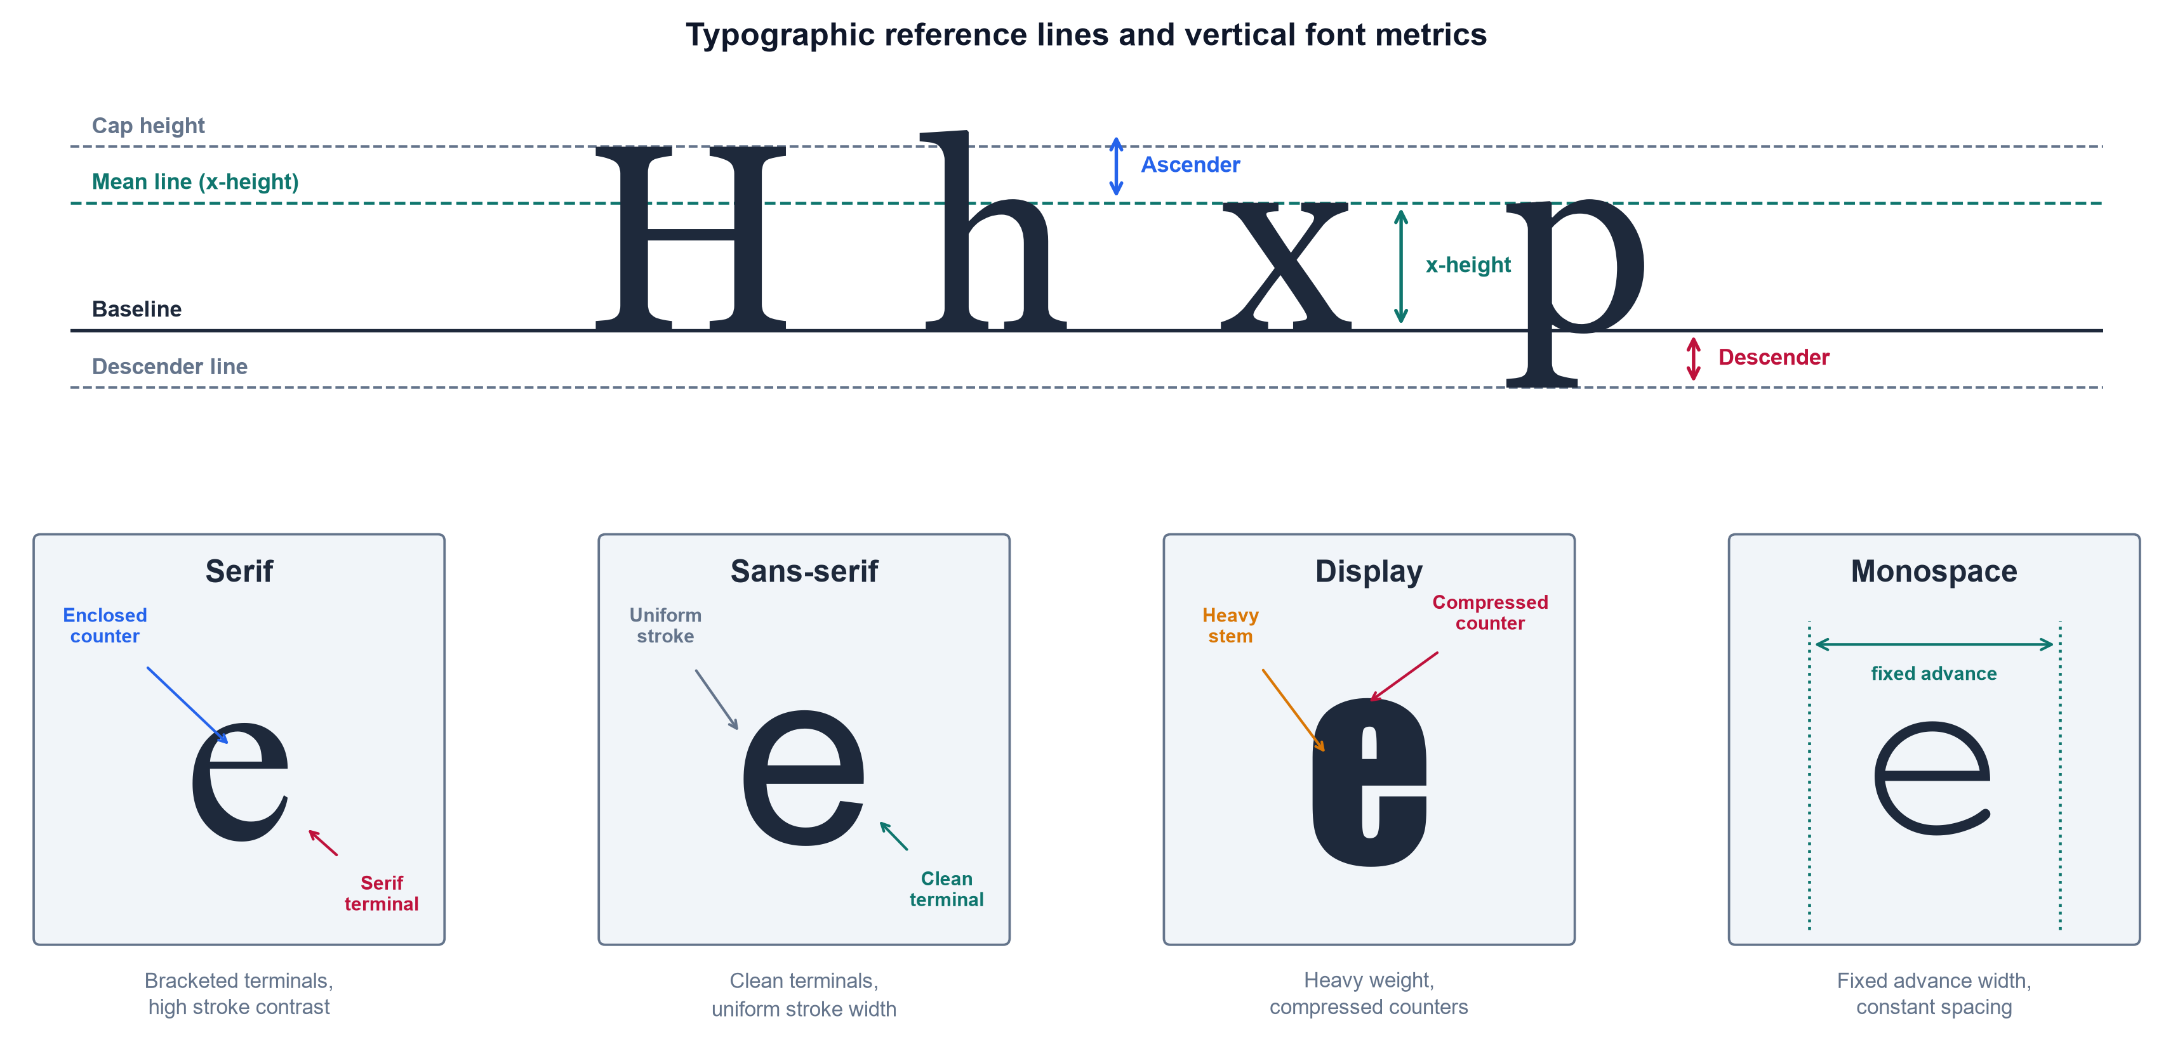
Font anatomy panel showing x-height, terminal, stroke contrast, and counter across serif, sans-serif, display, and monospace families
As shown in Figure 1, font identity is carried by fine-grained geometric traits rather than by the identity of the character itself, which is why this thesis reasons over visual texture instead of textual meaning.

3.2.2 Convolutional Neural Networks and Visual Feature Extraction
The dominant deep-learning tool for reading such visual traits is the convolutional neural network (CNN), an architecture that exploits the spatial structure of images through local, weight-sharing operations (LeCun, Bengio, & Hinton, 2015). Its central operation is convolution, in which a small kernel (also called a filter, a compact matrix of learnable weights) is slid across the image, computing a weighted sum at every position:
(I*K)(i,j)=m​n​I(i+m, j+n) K(m,n)
Here $I$ is the input image (a two-dimensional array of pixel intensities), $K$ is the kernel, $(i,j)$ is the output spatial location, and $m,n$ index positions within the kernel. The resulting array is a feature map, an image in which each value records how strongly the kernel’s pattern (an edge, a corner, a serif) is present at that location. The region of the input that influences a single feature-map value is that value’s receptive field; stacking convolutional layers enlarges the receptive field, so deeper layers respond to progressively larger and more abstract structures (Goodfellow, Bengio, & Courville, 2016). The spatial size $O$ of a feature map is determined by the input and kernel geometry:
$$O=\left\lfloor \frac{W−F+2P}{S}\right\rfloor +1$$
where $W$ is the input width (in pixels), $F$ is the kernel size, $P$ is the amount of zero-padding added to the border, $S$ is the stride (the step size between kernel positions), and $⌊⋅⌋$ denotes the floor function. Between convolutional layers, pooling downsamples each feature map, usually by taking the maximum value in each small window, which shrinks the representation and grants tolerance to small shifts in glyph position (Sarker, 2021). Figure 2 presents this convolution-pooling-classification pipeline.
Figure 2
Simplified Architecture of a Convolutional Neural Network
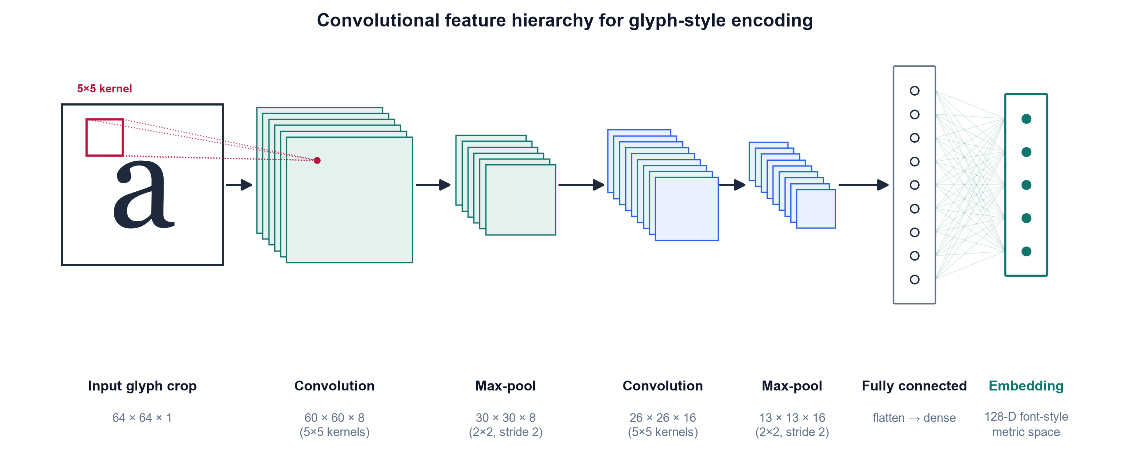
Block diagram of a CNN showing successive convolution and pooling layers feeding a fully connected classification block
Note. Adapted from LeCun, Bengio, and Hinton (2015) and Goodfellow, Bengio, and Courville (2016).
As shown in Figure 2, a CNN processes an image through successive convolution and pooling stages before a fully connected block. This staged processing produces the hierarchical feature learning on which later chapters depend.

3.2.3 Typographic Hallucination
The input distribution this thesis targets is not clean type but typographic hallucination: the probabilistic glyph deformation introduced when generative AI image models render text, including micro-warping, elastic distortion, and variable kerning (inconsistent spacing between characters). Kondo et al. (2024) demonstrate that diffusion models natively emit novel, unclassified glyph geometries when interpolating in latent space. This establishes that the deformations are an intrinsic output of the model class rather than an occasional artifact. To make this precise, hallucination is modeled here as a degradation operator $D$ applied to a pristine glyph crop:
$$\tilde{x}=D\left(x; θ_{\text{warp}}, θ_{\text{blur}}, θ_{\text{kern}}\right)$$
where $x$ is the clean rendered crop, $\tilde{x}$ is the resulting hallucinated crop, and $D$ composes three parameterized corruptions: an elastic warp (governed by $θ_{\text{warp}}$), Gaussian blur and noise ($θ_{\text{blur}}$), and kerning jitter ($θ_{\text{kern}}$). This operator, illustrated in Figure 3, is the formal object the synthetic-data pipeline of Chapter 4 will instantiate to train a deformation-robust recognizer. Modeling degradation as controlled, layered augmentation follows established practice: Plastropoulos and Tegos (2024) show that combining such transformations with deep feature extraction forces networks to learn resilient, continuous shape boundaries.
Figure 3
The Typographic-Hallucination Degradation Pipeline
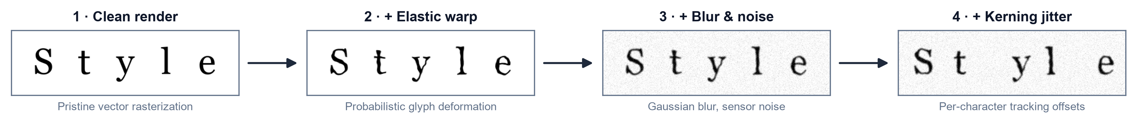
Degradation pipeline transforming a clean glyph through elastic warp, then Gaussian blur and noise, then kerning jitter
As shown in Figure 3, each stage of $D$ moves the glyph further from its pristine form and reproduces the exact deformations that cause commercial font identifiers to fail.

3.2.4 Embedding Spaces
Rather than emit a single hard label, the framework maps each crop into an embedding: a fixed-length vector of real numbers, produced by a deep network, that summarizes the visual content of the input. The set of all such vectors forms an embedding space, a continuous geometric space in which proximity encodes similarity, so that crops set in the same typeface should land close together and crops from different typefaces far apart (LeCun, Bengio, & Hinton, 2015). Representing fonts as points in a continuous space, rather than as entries in a fixed list, is what allows a hallucinated crop to be placed near its source typeface even when it matches none exactly. This is the property that the next section’s theoretical foundations formalize.

3.3 Theoretical Foundations
Having defined the visual objects and the network that reads them, this section develops the mathematics that turns embeddings into decisions. It moves from the general question of how a model can be trained at all to the two specific mechanisms this thesis assembles: metric learning, which shapes the embedding space so that distance means typographic similarity, and open-set recognition, which lets the system refuse to answer when a crop belongs to no known font.

3.3.1 Learning Paradigms
A deep network is trained by minimizing a loss function, a scalar-valued function that measures the gap between the model’s output and the desired output; optimization adjusts the network’s weights to make this quantity small. How the desired output is supplied defines the learning paradigm. In supervised learning, every training image carries a label (a human-assigned ground-truth answer, such as the font name), and the loss penalizes disagreement between prediction and label (Sarker, 2021). In unsupervised learning no labels exist, and the model must discover structure, such as clusters or densities, from the raw inputs alone. Self-supervised learning occupies the middle ground: it manufactures a supervisory signal from the data itself, for instance by asking the network to make two augmented views of one image agree, and so gains the benefits of supervision without manual annotation. This distinction matters here because in-the-wild generative-AI crops arrive without font labels, which pushes the thesis toward metric and self-supervised formulations rather than a purely supervised classifier.

3.3.2 Metric Learning and Embedding Distance
Metric learning is the family of methods that trains an embedding function $f_{θ}$ (a network, with parameters $θ$, that maps an input crop to a vector) so that geometric distance in the output space corresponds to semantic similarity (Schroff, Kalenichenko, & Philbin, 2015). Two distances are used to compare embeddings. The Euclidean distance between two crops $a$ and $b$ is
$$d(a,b)={\left\|f(a)−f(b)\right\|}_{2},$$
where $f(a)$ and $f(b)$ are their embedding vectors and ${\left\|⋅\right\|}_{2}$ is the $L^{2}$ (straight-line) norm; smaller $d$ means greater similarity. Cosine similarity instead measures the angle between the two vectors,
$$cos(a,b)=\frac{f(a)⋅f(b)}{\left\|f(a)\right\| \left\|f(b)\right\|},$$
where $f(a)⋅f(b)$ is the dot product; it ranges from $−1$ to $1$ and ignores vector magnitude, so it captures only direction.
To force these distances to encode font identity, the embedding is trained with a triplet loss. A triplet consists of an anchor crop $a$, a positive $p$ set in the same typeface as the anchor, and a negative $n$ set in a different typeface. The loss is
L=i​ f(ai)−f(pi)2−f(ai)−f(ni)2+α +,
where the sum runs over triplets, $α$ is the margin (a minimum required gap between the anchor-positive and anchor-negative distances), and $[ ⋅ ]_{+}=max(0,⋅)$ keeps only positive violations (Schroff et al., 2015). Minimizing $L$ pulls same-font crops together and pushes different-font crops apart by at least $α$. FaceNet established this on face identity, but it was validated only on clean, photographic faces, not on deformed glyphs. Two further results extend the rationale to the regime here. Huang and Zhou (2022) show that deep networks can decompose complex visual domains into structured feature vectors that support continuous proximity rankings rather than hard label buckets, and Umer et al. (2022) provide the optimization backing for tracking structural closeness on high-variance, distorted geometries. A cleaner space still helps: Wang et al. (2024) impose a non-negativity constraint on contrastive features, which yields sparse, axis-aligned embeddings, though their guarantees are also demonstrated on standard benchmarks rather than on typographic deformation.

3.3.3 Open-Set Recognition and Rejection Scores
A metric embedding still assumes every query belongs to some trained class. Open-set recognition removes that assumption: it partitions inputs into known classes (fonts seen in training) and the unknown class (anything else), and must reject the unknown instead of forcing it into a known bucket. The formal hazard is open-space risk $R_{O}(f)$, which is roughly the fraction of the large “open space” far from any training example that a recognizer nonetheless labels as a known font. Because a bounded amount of training data cannot fence off an unbounded space, minimizing $R_{O}(f)$ requires a rejection score (a scalar that summarizes how confidently an input belongs to any known class), compared against a threshold below which the input is declared unknown (Lu et al., 2025). Figure 4 depicts this geometry.
Figure 4
Embedding Space with Known-Font Clusters and an Open-Set Rejection Boundary
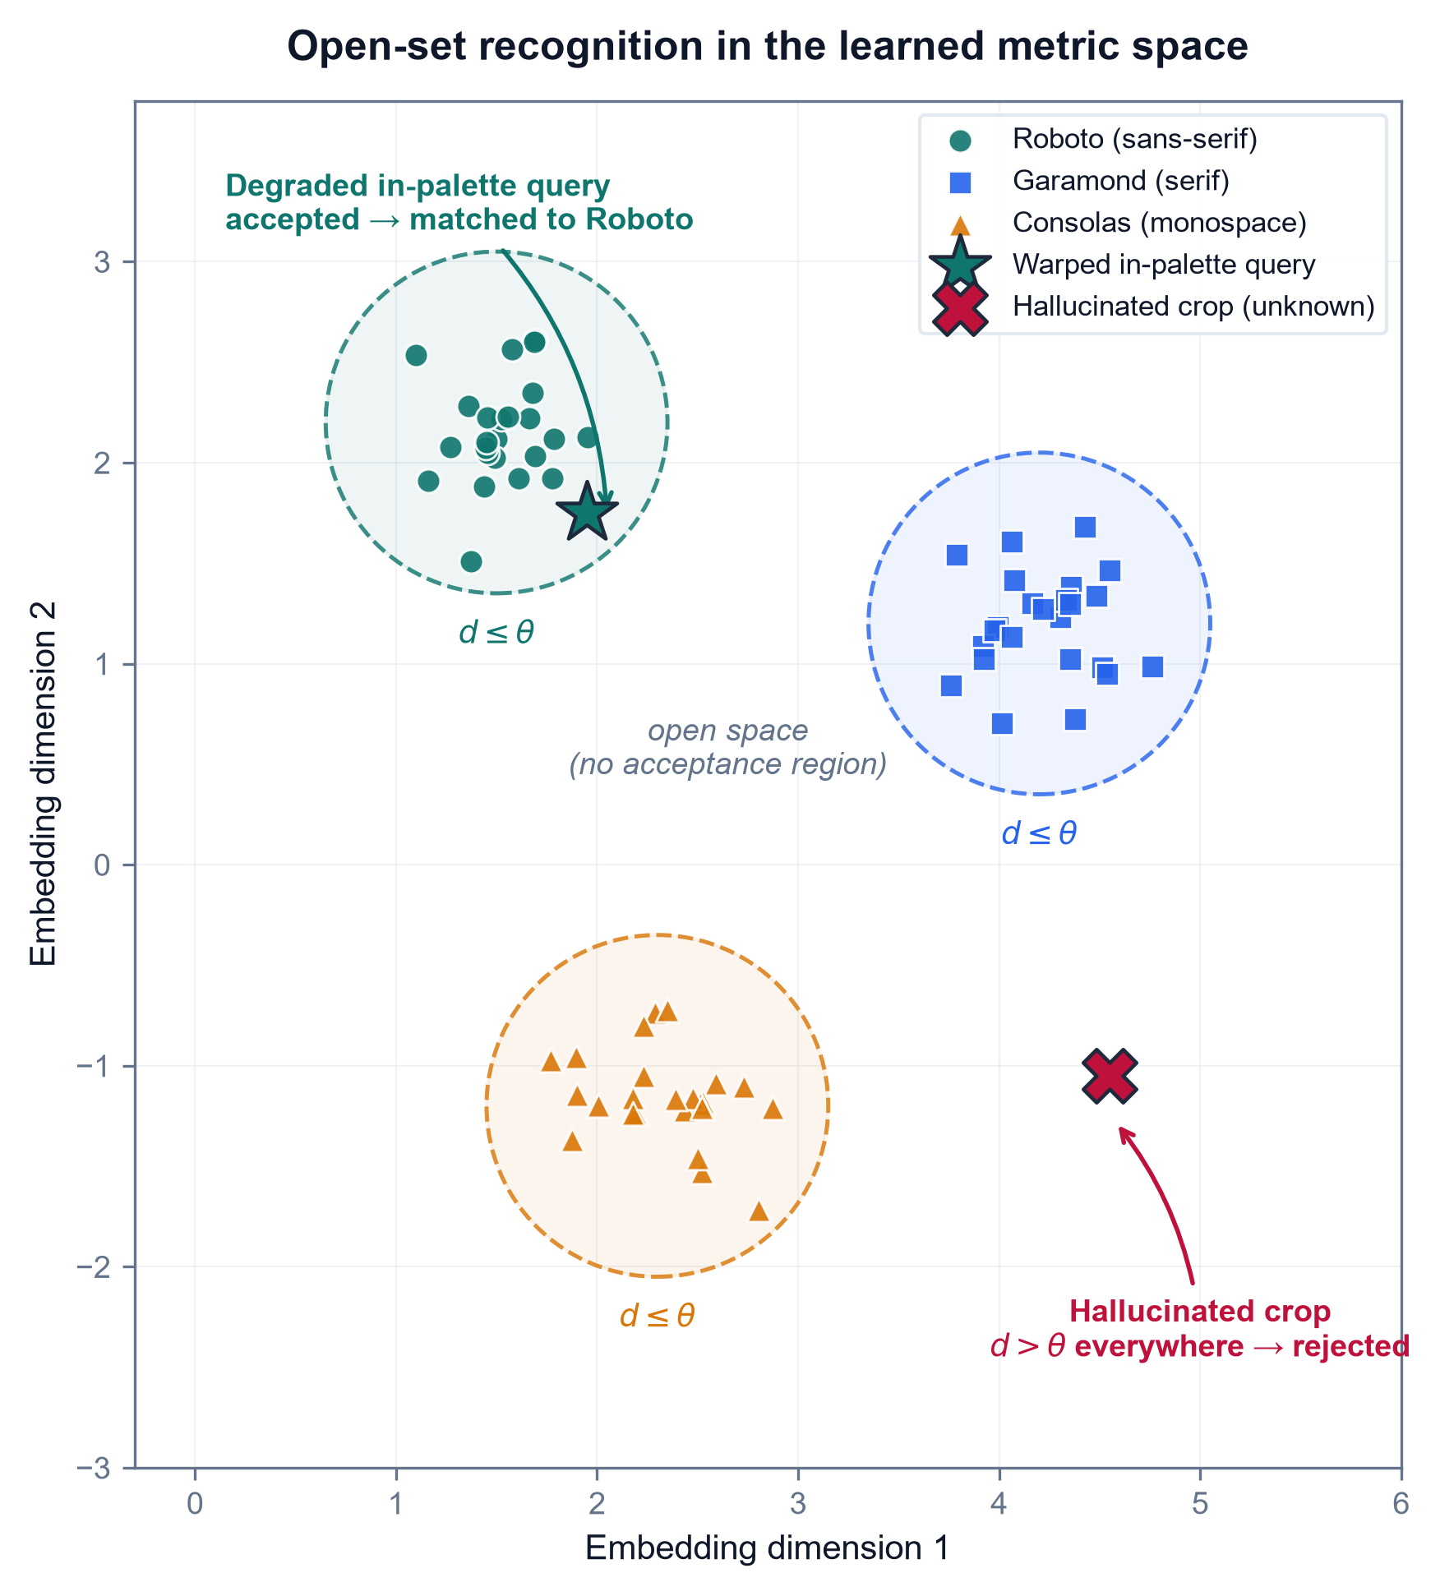
Two-dimensional embedding scatter showing compact known-font clusters enclosed by a rejection boundary, with a hallucinated out-of-palette crop falling outside all clusters
As shown in Figure 4, known typefaces form compact clusters while a hallucinated, out-of-palette crop lands in the open region beyond the rejection boundary, which is the case a threshold on the rejection score is meant to catch.
The rejection score can be read at several points in the network. Many scores start from the logits (the raw, pre-normalization outputs $f_{i}(x)$ of the classification layer for each class $i$), which the softmax function converts to a probability distribution,
σ(z)i=ezij​ezj,
where $z_{i}$ is the logit for class $i$ and the denominator sums over all classes so the outputs total one. Softmax confidence alone is a poor rejection score because networks are overconfident off-manifold; the recent literature therefore reads richer signals. Hofmann et al. (2024) compute an energy score,
E(x)=−T⋅logi​exp​fi(x)/T,
where $T$ is a temperature constant and the sum runs over class logits; low energy indicates an in-distribution input and high energy flags the unknown, and they sharpen the boundary by mining hard outliers near it. Djurisic et al. (2024) keep the decision in logit space but rescale the whole logit vector by a feature-derived scalar before thresholding, and this requires no retraining. Karunanayake et al. (2025) argue that the ranking of the runner-up classes is itself diagnostic, and far more deterministic for known inputs than for unknown ones. This idea maps directly onto a Top-K font shortlist, where the order of the second- and third-place fonts signals a hallucinated glyph. The limitation that ties all four together is that every one of these scores is validated on natural-image out-of-distribution benchmarks (CIFAR, ImageNet). None has been tested on typographic out-of-distribution input, the probabilistic warping and variable kerning this thesis targets. Whether these scores transfer to font hallucination over a localized palette is the question the methodology sets out to answer.

3.4 Existing Technologies & Frameworks
The theory of the previous section is realized through concrete software tools and neural architectures. This section surveys the ones the methodology builds on. Because every framework should be judged on both sides, each is paired with what it does well and where it falls short on this thesis’s deformed-glyph regime. The tools divide into a representation stack (a library, a backbone architecture, and a frozen encoder) and a measurement stack (structural-similarity metrics), followed by the generative process that produces the input distribution in the first place.

3.4.1 PyTorch and the Vision Transformer Backbone
A deep-learning framework is a software library that supplies the building blocks (tensor operations, automatic differentiation, and pre-built layers) for defining and training networks. PyTorch is the framework adopted here; its central strength is a dynamic computation graph, which means the network structure is defined on the fly as code executes, together with autograd, which automatically computes the gradients that optimization needs. This flexibility makes PyTorch well suited to research prototyping, but it is deliberately domain-agnostic: it provides no built-in typographic priors, so all font-specific structure must be supplied by the model and data the researcher constructs.
The backbone architecture is the Vision Transformer (ViT), which processes an image not through convolution but by splitting it into a grid of fixed-size patches, flattening each patch into a patch embedding (a vector), and letting the patches interact through self-attention. Self-attention, introduced by Vaswani et al. (2017), lets every element of a sequence weigh the relevance of every other element. Each patch embedding is projected into three vectors, a query $Q$, a key $K$, and a value $V$, and the operation is
$$\text{Attention}(Q,K,V)=\text{softmax}​\left(\frac{QK^{⊤}}{\sqrt{d_{k}}}\right)V,$$
where $QK^{⊤}$ scores how well each query matches each key, $d_{k}$ is the key dimension whose square root rescales the scores to keep them numerically stable, softmax turns the scores into weights summing to one, and $V$ carries the aggregated content. Figure 5 depicts this patch-embedding-and-attention flow.
Figure 5
Vision Transformer Patch Embedding and Self-Attention
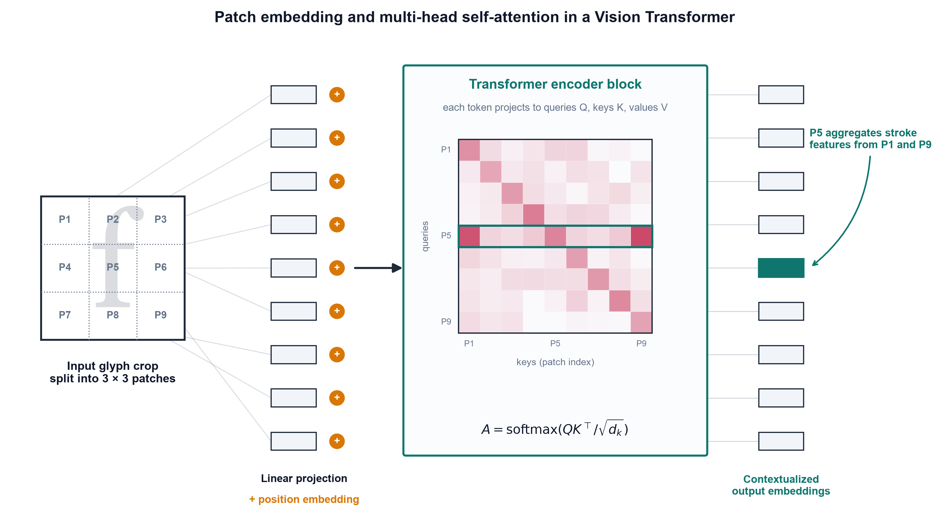
Schematic of an image split into patches, each linearly embedded and passed through multi-head self-attention that links distant patches
Note. Adapted from Vaswani et al. (2017) and Wang, Lv, et al. (2025).
As shown in Figure 5, self-attention links spatially distant patches directly, which is why Wang, Lv, et al. (2025) use a ViT to parse long-range document layout that fixed convolutional receptive fields cannot span. The limitation is twofold: self-attention is data-hungry and needs large training sets to generalize, and its all-pairs comparison has quadratic cost in the number of patches, which makes high-resolution inputs expensive.

3.4.2 Self-Supervised Frozen Encoders
Training a ViT from scratch is the data-hungry step this thesis wants to avoid. DINOv2 (Oquab et al., 2024) is a ViT trained by self-supervised distillation to produce all-purpose visual features that transfer to fine-grained classification and retrieval with no fine-tuning. Used as a frozen encoder, with its weights held fixed while only downstream components are trained, it lets the framework read patch-level embeddings from a glyph crop without building a font-specific network from scratch, and Sheikh et al. (2024) show the same frozen-DINO family extract layout structure with no labels at all. Its weakness is that these features are not clean: Darcet et al. (2024) identify high-norm artifact tokens that self-supervised ViTs repurpose for internal computation in low-information image regions, which corrupts the feature map. Their fix is register tokens (extra dedicated tokens that absorb this internal computation), which restore smooth attention and feature maps. That repair matters directly for glyph crops, whose informative signal is a few thin strokes on empty ground; yet, like the backbone itself, registers are validated only on natural images, never on re-rendered type.

3.4.3 Structural-Similarity Metrics
To score how well a predicted font matches a crop, the framework needs a structural-similarity metric, a measure of perceptual, structural agreement rather than pixel-by-pixel identity. The original one is the Structural Similarity Index (SSIM) of Wang et al. (2004), which models similarity as a product of luminance, contrast, and structure terms:
$$\text{SSIM}(x,y)=\frac{(2μ_{x}μ_{y}+C_{1})(2σ_{xy}+C_{2})}{(μ_{x}^{2}+μ_{y}^{2}+C_{1})(σ_{x}^{2}+σ_{y}^{2}+C_{2})},$$
where $μ_{x},μ_{y}$ are the mean intensities of the two image windows $x$ and $y$, $σ_{x}^{2},σ_{y}^{2}$ their variances, $σ_{xy}$ their covariance, and $C_{1},C_{2}$ small constants that prevent division by zero. SSIM is interpretable and computationally light, but classical pixel-SSIM collapses under geometric misalignment (when the two images are warped or shifted relative to each other), which is the normal case for a hallucinated glyph. Figure 6 illustrates the re-render-and-compare protocol this metric serves.
Figure 6
Structural-Similarity Re-Render-and-Compare Pipeline
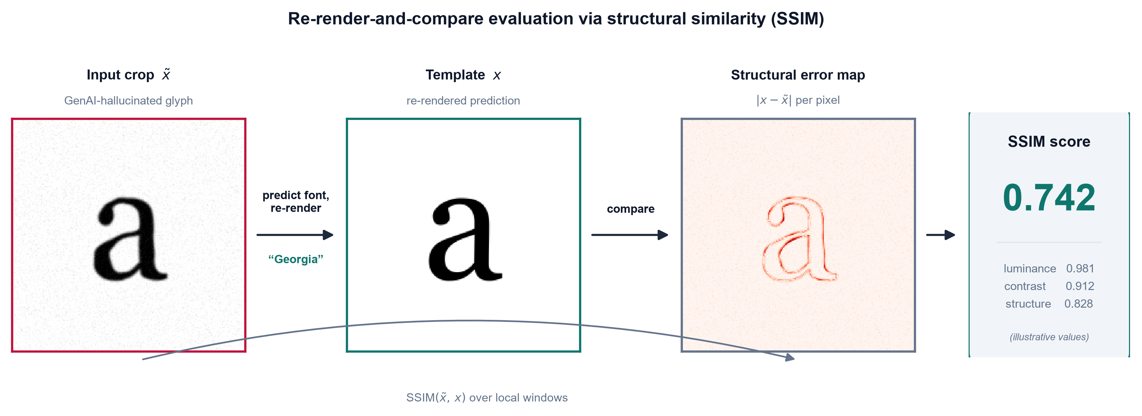
Pipeline rendering a predicted font to a clean glyph, then scoring its structural similarity against the deformed input crop
As shown in Figure 6, the predicted typeface is re-rendered and scored against the input crop, which is where classical SSIM’s alignment assumption breaks. Two deep successors address this: Zhang et al. (2024) compute DeepSSIM over deep feature maps with an attention-calibration step, which keeps the score valid under geometric misalignment, and Li et al. (2025) build SAMScore on segmentation-model embeddings to measure whether a transformed image preserves source content structure. Both are deformation-robust in principle, but both were validated on natural-image translation tasks, never on re-rendered glyphs. That untested transfer is what this thesis must confront.

3.4.4 Latent Diffusion as the Generative Source
Finally, the input distribution itself originates from latent diffusion, the class of generative models that synthesize images by iteratively denoising a compressed latent representation. Kondo et al. (2024) show that interpolating in this latent space natively emits novel, unclassified glyph geometries with fluid visual traits, which is peer-reviewed evidence that typographic deformation is intrinsic to the model class. Its strength as a generator is its weakness for this thesis: the process is uncontrolled with respect to font identity and produces glyphs that belong to no catalogued typeface. Diffusion is therefore the source of the problem this framework must handle, not a solution to it. That is why the thesis treats its deformed output as the input distribution, which the following chapter’s pipeline is built to handle.

3.5 Problem Context
Having assembled the concepts, theory, and tooling, this section states why no existing solution suffices on the input distribution this thesis targets: the in-the-wild GenAI crop, a fragment of text lifted from a generative-AI image whose glyphs are probabilistically deformed rather than pristine. Each mature tool works well on the distribution it was built for and fails on this one.
Classical OCR and closed-boundary layout analysis are the first casualty. Ponnuru et al. (2024) digitize smudged, handwritten prescriptions at a 98% accuracy baseline, which shows that traditional pipelines handle environmental noise on anatomically correct text with ease; but their adaptive-thresholding and bounding-box machinery presupposes rigid glyph geometry, which the topological warping of hallucinated type dissolves. The DeepFont-style font-classify baseline established in Section 3.2 fails for a different reason: trained on clean synthetic glyphs, it is pristine over-fit (tuned so tightly to geometrically exact vectors that deformed input falls off its learned manifold) and closed-set (it assumes every query belongs to a catalogued class and is therefore forced to return some known font even when the true typeface is absent). The measurement tools inherit the same brittleness: classical pixel-SSIM (Section 3.4) demands pixel registration, an exact per-pixel correspondence between the two images, which warped, re-kerned glyphs break outright. A general vision-language model is no escape either; Li, Song, et al. (2025) show that state-of-the-art VLMs get lost in font recognition, derailed by the word’s semantic content instead of reading its visual texture. Even the closest typographic precedent falls short: the L2@k and cos@k font-fidelity metrics of Jiang et al. (2025), computed over the very Storia-AI classifier this thesis adopts as its baseline, assume an undeformed input glyph and so cannot faithfully score a hallucinated crop. That the deformation is endemic rather than incidental is settled by Liu et al. (2024), who find that an uncorrected generative pipeline renders text correctly less than 20% of the time, which is the empirical size of the problem this thesis exploits.
These failures converge on a single consolidated gap. No existing framework couples an attention-isolated text crop → a deformation-robust, frozen-ViT metric embedding → open-set font-identity ranking with a calibrated Top-K over a localized open-set palette (the top 50 to 100 Google Fonts) on the GenAI-deformed input distribution. Figure 7 previews the end-to-end framework this thesis assembles to fill that gap.
Figure 7
End-to-End Architecture of the Proposed Font-Style Recognition Framework
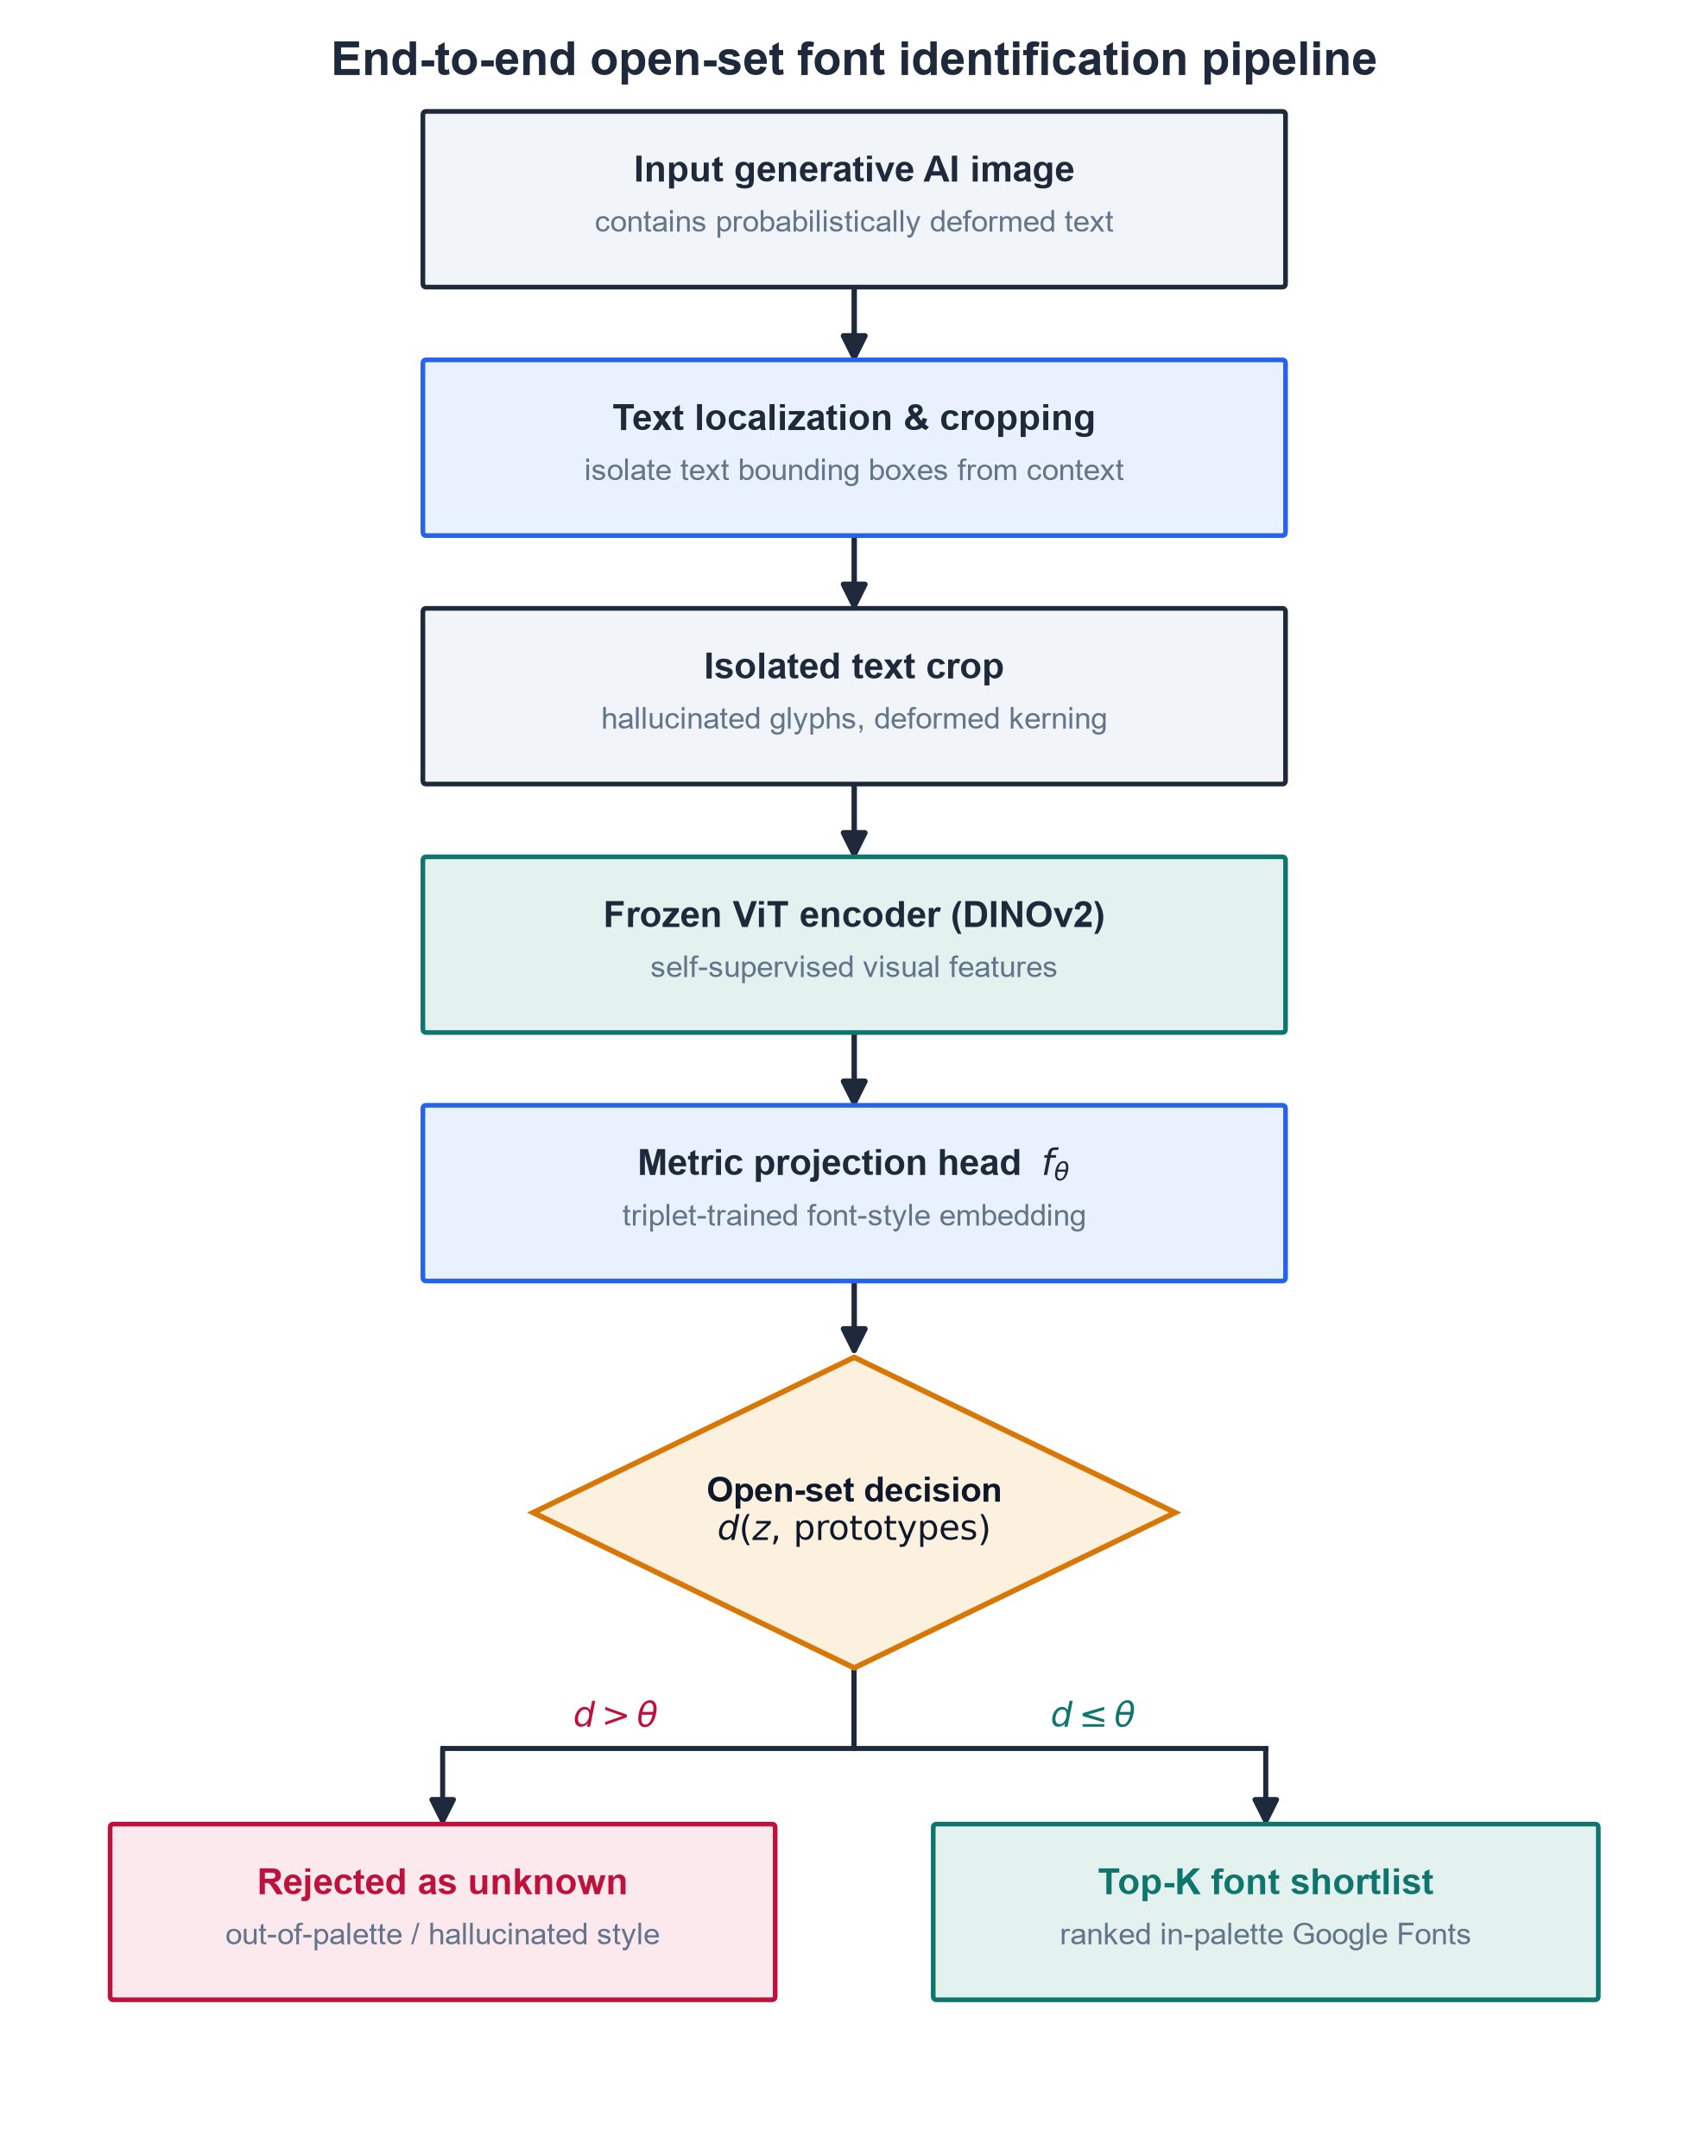
Flowchart of the proposed pipeline: a GenAI image feeds attention-based crop isolation, then a frozen Vision Transformer encoder, then a metric-embedding head, then open-set ranking with a calibrated Top-K shortlist over the localized Google-Fonts palette
As shown in Figure 7, an isolated crop flows through the frozen-ViT encoder into a metric embedding, where an open-set rejection score and a calibrated Top-K produce a ranked shortlist over the localized Google-Fonts palette. This is the coupling that the preceding tools, taken one at a time, leave unbuilt.
Having established the typographic, deep-learning, metric-learning, and open-set foundations, along with the specific technical gap they leave open, the next chapter details the synthetic-degradation pipeline that manufactures deformed training data, the model architecture that embeds and ranks each crop, and the evaluation protocol that measures the framework against a human-proxy baseline.

