Component Description:
The Review Management component allows users to create, view, edit, and delete property reviews. The component uses Angular reactive forms to collect review information, validate user input, and manage submitted reviews. The interface displays submitted reviews and provides options to modify or remove existing entries.
Review Management Component in Browser
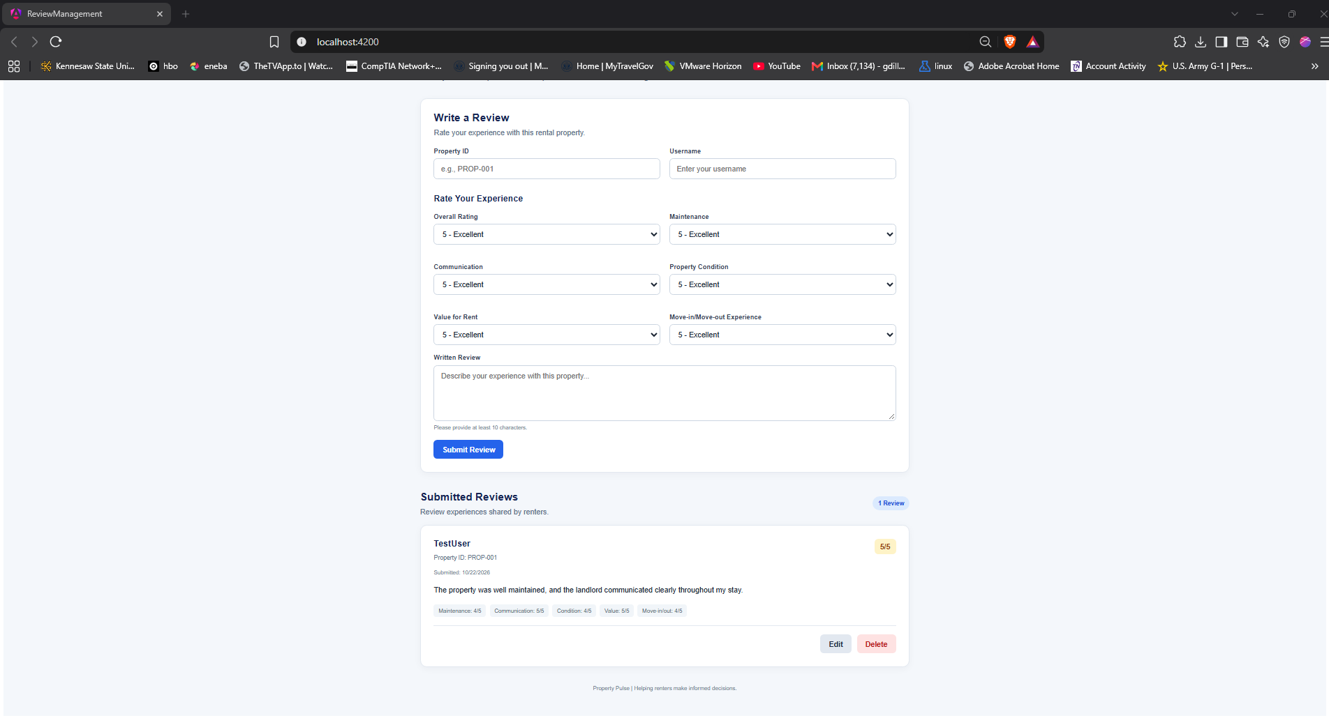
This screenshot demonstrates the Review Management component running in the browser. Users can enter property information, select ratings, and submit written reviews. Submitted reviews appear below the form, with options to edit or delete existing entries.
Reactive Form Setup
This code initializes the Review Management reactive form using Angular's FormBuilder. It defines controls for the property ID, username, six rating categories, and written review. Required-field validators ensure that essential information is provided, while the rating validators restrict ratings to values between 1 and 5. The written review must contain at least 10 characters.
this.reviewForm = this.fb.group({
propertyId: ['', Validators.required],
username: ['', Validators.required],
overallRating: [5, [Validators.required, Validators.min(1), Validators.max(5)]],
maintenanceRating: [5, [Validators.required, Validators.min(1), Validators.max(5)]],
communicationRating: [5, [Validators.required, Validators.min(1), Validators.max(5)]],
conditionRating: [5, [Validators.required, Validators.min(1), Validators.max(5)]],
valueRating: [5, [Validators.required, Validators.min(1), Validators.max(5)]],
moveRating: [5, [Validators.required, Validators.min(1), Validators.max(5)]],
reviewText: ['', [Validators.required, Validators.minLength(10)]]
});

Form binding: <form [formGroup]="reviewForm" (ngSubmit)="submitReview()">
Property ID Field: <div class="form-grid">
<div class="form-group">
<label for="propertyId">Property ID</label>
<input
id="propertyId"
type="text"
formControlName="propertyId"
placeholder="e.g., PROP-001"
/>

<small class="error"
*ngIf="reviewForm.get('propertyId')?.touched &&
reviewForm.get('propertyId')?.invalid">
Property ID is required.
</small>
</div>
Username field: <div class="form-group">
<label for="username">Username</label>
<input
id="username"
type="text"
formControlName="username"
placeholder="Enter your username"
/>

<small class="error"
*ngIf="reviewForm.get('username')?.touched &&
reviewForm.get('username')?.invalid">
Username is required.
</small>
</div>
Rating Fields: <div class="rating-grid">
<div class="form-group">
<label for="overallRating">Overall Rating</label>
<select id="overallRating" formControlName="overallRating">
<option [ngValue]="5">5 - Excellent</option>
<option [ngValue]="4">4 - Very Good</option>
<option [ngValue]="3">3 - Average</option>
<option [ngValue]="2">2 - Poor</option>
<option [ngValue]="1">1 - Very Poor</option>
</select>
</div>
Explanation of the HTML Form Template
This HTML template connects the Review Management interface to the reactive form defined in the TypeScript component. The formGroup binding associates the form with reviewForm, while the formControlName attributes connect individual inputs and rating selections to their corresponding form controls. The template also includes validation messages that inform users when required fields are invalid.
Github Repository Link
https://github.com/jdixo137/Property-Pulse/tree/main/Giovanni-Dillon/review-management/review-management-app

