Sudoers’ User Guide

Raysean Jones-Dent, Tonye Andre Martial, Matthew Mitchell,

Kristine Dudley, Woo Choi, Justin Kim

7 April, 2019

CMSC 495 7982

Dr. Janell Robinson

University of Maryland University College

Contents

Version History 3

User Guide 4

How to Login 4

How to Change Language 5

How to Deposit Funds 6

How to Withdraw Funds 7

How to Transfer Between Accounts 8

How to Check the Balance of an Account 8

How to Check an Account’s History 9

How to Logout 9

# Version History

|  |  |  |
| --- | --- | --- |
| **Date** | **Version** | **Description** |
| 4/2 – 4/3/2019 | Version 1 | Initial Draft |
| 4/7/2019 | Version 2 | Added version history, split user guide and test plan, and added peer suggestions |

# User Guide

* Note: Program will be started in Netbeans. Pictures approximate what the GUI will look like.

## How to Login

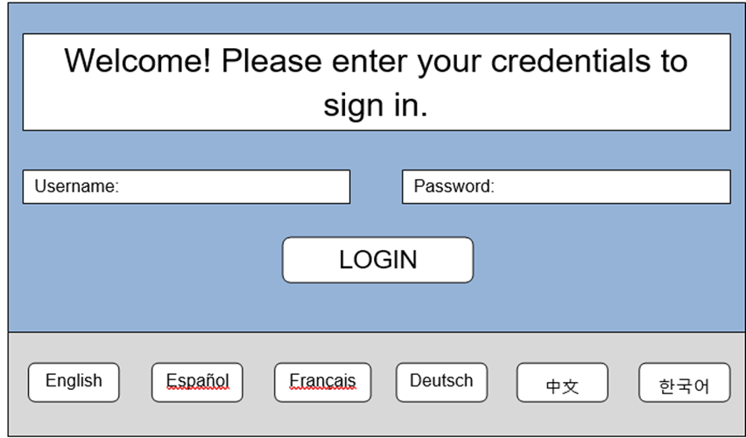

1. Enter username and password in appropriate slots.
2. Press “Login” button.
   * Caution: If you leave an input empty there will be a message box that will remind you to enter that missing information.

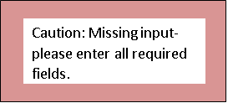

1. Press “Confirm” button.

## How to Change Language

1. On the Login Page, click on “Language” button.
2. A dialog box will open.
3. Choose the language you would like the ATM to be in.
4. Click “Confirm” button.
5. The ATM will now be in that language.

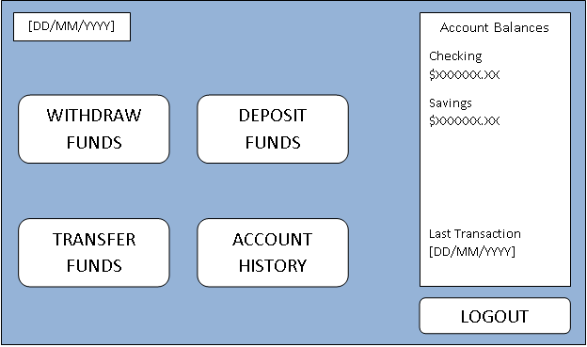

## How to Deposit Funds

1. Click on “Deposit” button.
2. A dialog box will open.

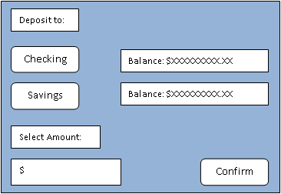

1. Choose the account you would like to deposit to and the amount.
2. Click the “Confirm” button
   * A message box will appear stating the amount and the account the deposit is going to. Press “Confirm” if correct. Press “Back” if not, this will take you back to the dialog box to reenter the correct information.
3. The new amount in that account will show on right side of screen.

## How to Withdraw Funds

1. Click on “Withdraw” button
2. A dialog box will open.

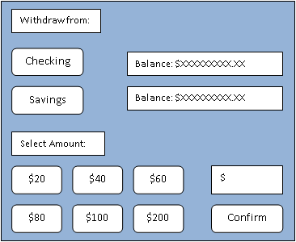

1. Choose the account you would like to withdraw from and the amount.
2. Click the “Confirm” button
   * Caution: If you do not have enough funds to cover the withdraw a message box will warn of insufficient funds

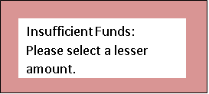

* A message box will appear stating the amount and the account the withdraw is coming from. Press “Confirm” if correct. Press “Back” if not, this will take you back to the dialog box to reenter the correct information.

1. The new amount in that account will show on right side of screen.

## How to Transfer Between Accounts

1. Click on “Transfer” button.
2. A dialog box will open.

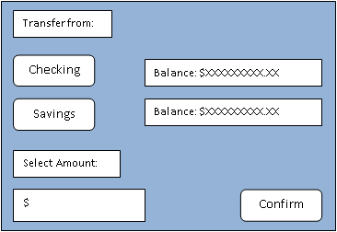

1. Choose the account you would like to transfer from and the account to transfer to.
2. Choose the amount you would like to transfer.
   * Caution: If there are not sufficient funds for transfer a message box will warn of insufficient funds
   * A message box will appear stating the amount and the account the transfer if coming from and the account the transfer is going to. Press “Confirm” if correct. Press “Back” if not, this will take you back to the dialog box to reenter the correct information.
3. The new amounts will show in the accounts on the right side of the screen.

## How to Check the Balance of an Account

1. Account balances are shown on the right side of the screen.

## How to Check an Account’s History

1. Click on “Account History” button.
2. A dialog box will open.
3. Choose the account you would like to view.
4. A scrollable message box will show the history of transactions for that account.

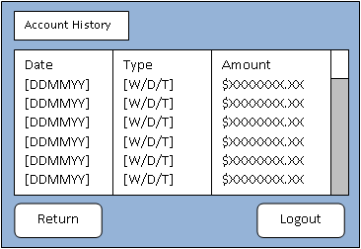

## How to Logout

1. Click on “Logout” button.
2. A dialog box will open.
3. Click either “Return” or “Exit”

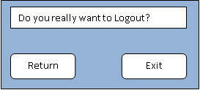

* + “Return” will bring you back to the main menu
  + “Exit” will logout of the main menu and return to the Login page.