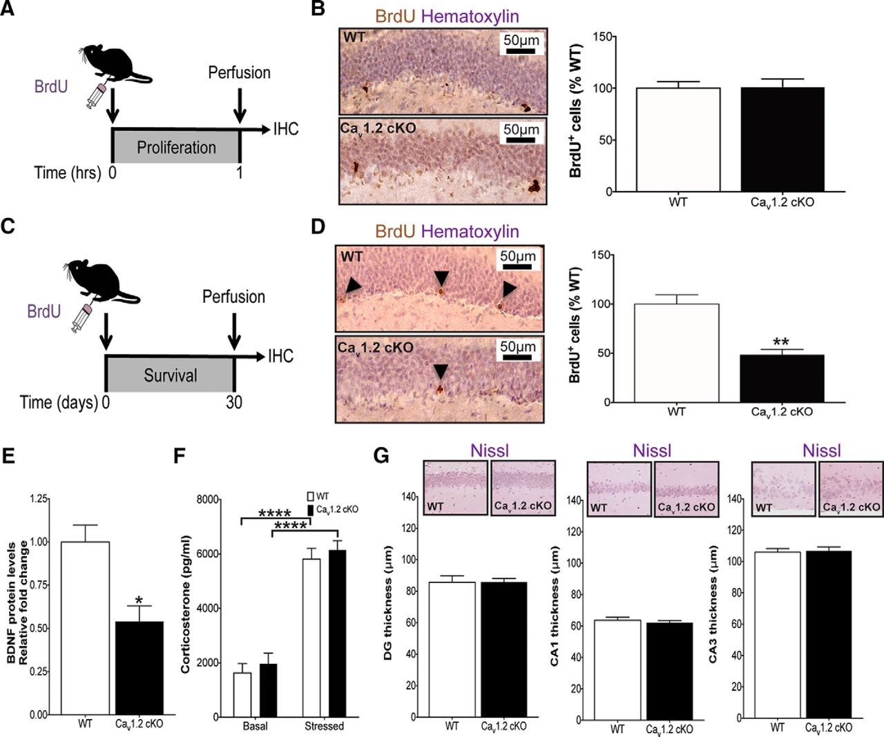Neuropsychiatric disease is the globally leading cause of non-fatal disease burden [1, 2], and approximately 46% of Americans will meet the American Psychiatric Association’s criteria for a mental disorder at some point in their lives [3]. The poorly understood pathophysiology of psychiatric disorders makes them difficult to diagnose and has broadly precluded development of mechanism-based treatments [5]. In recent genetic studies, the gene *CACNA1C* has consistently emerged as a risk factor for neuropsychiatric disease, including bipolar disorder [6-13], schizophrenia [7, 14-17], and major depressive disorder [18, 19]. Most notably, the largest genome-wide association study to date identified *CACNA1C* as one of only two collective risk genes among patients with bipolar disorder, schizophrenia, autism spectrum disorders, major depressive disorder, and attention-deficit/hyperactivity disorder [15, 20]. Nearly a decade after first being implicated in psychiatric disorders, the role of *CACNA1C* in psychopathology remains unclear.

*CACNA1C* encodes Cav1.2, which comprises 85% of voltage-gated L-type calcium channel (LTCC) alpha subunits in the mammalian brain and confers much of the whole channel’s functional properties, including drug sensitivity, selectivity, and composition of both the pore-forming unit and voltage-sensing domain [21-23]. Cav1.2 has a well-established role in coupling postsynaptic membrane depolarization with expression of genes involved in long term potentiation and concomitant memory formation [24-30]. Previously, our research group assessed the consequences of forebrain-specific elimination of *Cacna1c* on mouse postnatal hippocampal neurogenesis. Using this model, we identified a two-fold increase in young hippocampal neuron death, providing evidence for Cav1.2 as a key regulator of neuronal survival in postnatal hippocampal neurogenesis (Figure 1) [4].

Figure : Forebrain-specific knockout of Cav1.2 reduces the survival of newborn neurons.

Mice were given a single injection of bromodeoxyuridine (BrdU) and sacrificed 30 days later. Brains were serially sectioned and the number of BrdU-positive (BrdU+) neurons were quantified between genotypes. **p<0.01 [4]

Cell death is a prominent feature of many forms of neuropsychiatric illness [31] and can result from an array of mechanisms, including necrosis, autophagy, and apoptosis [32]. Importantly, loss of mitochondrial calcium homeostasis predisposes neurons to activation of cell death programs, placing mitochondria as pivotal regulators in neuronal life and death [33-39]. Energy-demanding tissues in the nervous system require tightly regulated mitochondrial calcium (Ca2+)for efficient production of adenosine triphosphate (ATP) [35, 40, 41].

Cav1.2 activity itself increases mitochondrial metabolism and reactive oxygen species (ROS) levels, likely due to allosteric activation of Ca2+-sensitive tri-carboxylic acid (TCA) cycle dehydrogenases and ATP synthase [42]. Persistently elevated Ca2+ levels push ROS production beyond tolerable signaling levels and lower the threshold for opening of the mitochondria permeability transition pore (PTP), priming mitochondria cytochrome C release and apoptosis [33-36]. In renal tubular cells, blockade of LTCCs reduces both mitochondrial Ca2+ accumulation and mitochondria-mediated apoptosis [43-46]. In addition, patients with bipolar disorder, schizophrenia, and major depression show deficits in neuronal oxidative phosphorylation [47, 48]. The links between Cav1.2 and mitochondria in calcium flux and cell death raise the possibility that altered Cav1.2 signaling in psychiatric disorders could disrupt intracellular calcium (Ca2+) handling in mitochondria and prime neurons for apoptosis.

* 1. 1. Murray, C.J.L., et al., *Disability-adjusted life years (DALYs) for 291 diseases and injuries in 21 regions, 1990–2010: a systematic analysis for the Global Burden of Disease Study 2010.* The Lancet, 2012. **380**(9859): p. 2197-2223.
  2. 2. Whiteford, H.A., et al., *Global burden of disease attributable to mental and substance use disorders: findings from the Global Burden of Disease Study 2010.* The Lancet, 2013. **382**(9904): p. 1575-1586.
  3. 3. Kessler, R.C., et al., *LIfetime prevalence and age-of-onset distributions of dsm-iv disorders in the national comorbidity survey replication.* Archives of General Psychiatry, 2005. **62**(6): p. 593-602.
  4. 4. Lee, A.S., et al., *The Neuropsychiatric Disease-Associated Gene cacna1c Mediates Survival of Young Hippocampal Neurons.* eneuro, 2016. **3**(2).
  5. 5. Bhat, S., et al., *CACNA1C (Cav1.2) in the pathophysiology of psychiatric disease.* Prog Neurobiol, 2012. **99**(1): p. 1-14.
  6. 6. Ferreira, M.A., et al., *Collaborative genome-wide association analysis supports a role for ANK3 and CACNA1C in bipolar disorder.* Nat Genet, 2008. **40**(9): p. 1056-8.
  7. 7. Moskvina, V., et al., *Gene-wide analyses of genome-wide association data sets: evidence for multiple common risk alleles for schizophrenia and bipolar disorder and for overlap in genetic risk.* Mol Psychiatry, 2009. **14**(3): p. 252-60.
  8. 8. Baum, A.E., et al., *A genome-wide association study implicates diacylglycerol kinase eta (DGKH) and several other genes in the etiology of bipolar disorder.* Mol Psychiatry, 2007. **13**(2): p. 197-207.
  9. 9. Sklar, P., et al., *Large-scale genome-wide association analysis of bipolar disorder identifies a new susceptibility locus near ODZ4.* Nature genetics, 2011. **43**(10): p. 977.
  10. 10. Sklar, P., et al., *Whole-genome association study of bipolar disorder.* Mol Psychiatry, 2008. **13**(6): p. 558-69.
  11. 11. Lee, M.T.M., et al., *Genome-wide association study of bipolar I disorder in the Han Chinese population.* Molecular psychiatry, 2011. **16**(5): p. 548-556.
  12. 12. Nurnberger, J.I., et al., *Identification of pathways for bipolar disorder: a meta-analysis.* JAMA psychiatry, 2014. **71**(6): p. 657-664.
  13. 13. Ament, S.A., et al., *Rare variants in neuronal excitability genes influence risk for bipolar disorder.* Proceedings of the National Academy of Sciences, 2015. **112**(11): p. 3576-3581.
  14. 14. Nyegaard, M., et al., *CACNA1C (rs1006737) is associated with schizophrenia.* Mol Psychiatry, 2010. **15**(2): p. 119-21.
  15. 15. Cross-Disorder Group of the Psychiatric Genomics Consortium, et al., *Genetic relationship between five psychiatric disorders estimated from genome-wide SNPs.* Nat Genet, 2013. **45**(9): p. 984-94.
  16. 16. Ripke, S., et al., *Genome-wide association analysis identifies 13 new risk loci for schizophrenia.* Nature genetics, 2013. **45**(10): p. 1150-1159.
  17. 17. Green, E.K., et al., *Replication of bipolar disorder susceptibility alleles and identification of two novel genome-wide significant associations in a new bipolar disorder case–control sample.* Molecular psychiatry, 2013. **18**(12): p. 1302-1307.
  18. 18. Green, E.K., et al., *The bipolar disorder risk allele at CACNA1C also confers risk of recurrent major depression and of schizophrenia.* Mol Psychiatry, 2010. **15**(10): p. 1016-22.
  19. 19. Casamassima, F., et al., *Phenotypic effects of a bipolar liability gene among individuals with major depressive disorder.* American Journal of Medical Genetics Part B: Neuropsychiatric Genetics, 2010. **153**(1): p. 303-309.
  20. 20. The Wellcome Trust Case Control Consortium, *Genome-wide association study of 14,000 cases of seven common diseases and 3,000 shared controls.* Nature, 2007. **447**(7145): p. 661-678.
  21. 21. Seisenberger, C., et al., *Functional Embryonic Cardiomyocytes after Disruption of the L-type α1C (Ca v 1.2) Calcium Channel Gene in the Mouse.* Journal of Biological Chemistry, 2000. **275**(50): p. 39193-39199.
  22. 22. Zamponi, G.W., *Targeting voltage-gated calcium channels in neurological and psychiatric diseases.* Nat Rev Drug Discov, 2016. **15**(1): p. 19-34.
  23. 23. Sinnegger-Brauns, M.J., et al., *Expression and 1,4-Dihydropyridine-Binding Properties of Brain L-Type Calcium Channel Isoforms.* Molecular Pharmacology, 2009. **75**(2): p. 407-414.
  24. 24. Gerald J. Obermair, Z.S., Emmanuel Bourinet, Bernhard E. Flucher, *Differential targeting of the L-type Ca2+ channel a1c (Cav1.2) to synaptic and extrasynaptic compartments in hippocampal neurons.* European Journal of Neuroscience, 2004. **19**: p. 2109-2122.
  25. 25. Moosmang, S., et al., *Role of hippocampal Cav1.2 Ca2+ channels in NMDA receptor-independent synaptic plasticity and spatial memory.* J Neurosci, 2005. **25**(43): p. 9883-92.
  26. 26. Bading, H., D. Ginty, and M. Greenberg, *Regulation of gene expression in hippocampal neurons by distinct calcium signaling pathways.* Science, 1993. **260**(5105): p. 181-186.
  27. 27. Anirvan Ghosh, J.C., Michael E. Greenberg, *Requirement for BDNF in Activity-Dependent Survival of Cortical Neurons.* Science, 1994. **263**: p. 1618-1623.
  28. 28. Deisseroth, K., et al., *Signaling from synapse to nucleus: the logic behind the mechanisms.* Current Opinion in Neurobiology, 2003. **13**(3): p. 354-365.
  29. 29. Zakharenko, S.S., et al., *Presynaptic BDNF Required for a Presynaptic but Not Postsynaptic Component of LTP at Hippocampal CA1-CA3 Synapses.* Neuron, 2003. **39**(6): p. 975-990.
  30. 30. Zhang, Q., et al., *The Effects of CACNA1C Gene Polymorphism on Spatial Working Memory in Both Healthy Controls and Patients with Schizophrenia or Bipolar Disorder.* Neuropsychopharmacology, 2012. **37**(3): p. 677-684.
  31. 31. Dodd, S., et al., *Putative neuroprotective agents in neuropsychiatric disorders.* Progress in Neuro-Psychopharmacology and Biological Psychiatry, 2013. **42**: p. 135-145.
  32. 32. Fink, S.L. and B.T. Cookson, *Apoptosis, pyroptosis, and necrosis: mechanistic description of dead and dying eukaryotic cells.* Infect Immun, 2005. **73**(4): p. 1907-16.
  33. 33. Das, A.M. and D.A. Harris, *Control of mitochondrial ATP synthase in heart cells: inactive to active transitions caused by beating or positive inotropic agents.* Cardiovascular Research, 1990. **24**(5): p. 411-417.
  34. 34. Hajnoczky, G., et al., *Mitochondrial calcium signalling and cell death: approaches for assessing the role of mitochondrial Ca2+ uptake in apoptosis.* Cell Calcium, 2006. **40**(5-6): p. 553-60.
  35. 35. Brookes, P.S., et al., *Calcium, ATP, and ROS: a mitochondrial love-hate triangle.* American Journal of Physiology - Cell Physiology, 2004. **287**(4): p. C817-C833.
  36. 36. Wang, W., G. Karamanlidis, and R. Tian, *Novel targets for mitochondrial medicine.* Science Translational Medicine, 2016. **8**(326): p. 326rv3-326rv3.
  37. 37. Liu, X., et al., *Induction of apoptotic program in cell-free extracts: Requirement for dATP and cytochrome c.* Cell, 1996. **86**(1): p. 147-157.
  38. 38. Yang, J., et al., *Prevention of apoptosis by Bcl-2: Release of cytochrome c from mitochondria blocked.* Science, 1997. **275**(5303): p. 1129-1132.
  39. 39. Nicholls, D.G., *Mitochondrial calcium function and dysfunction in the central nervous system.* Biochimica et biophysica acta, 2009. **1787**(11): p. 1416-1424.
  40. 40. Viola, H.M. and L.C. Hool, *Cross-talk between L-type Ca2+ channels and mitochondria.* Clinical and Experimental Pharmacology and Physiology, 2010. **37**(2): p. 229-235.
  41. 41. Fattal, O., et al., *Review of the Literature on Major Mental Disorders in Adult Patients With Mitochondrial Diseases.* Psychosomatics, 2006. **47**(1): p. 1-7.
  42. 42. Viola, H.M., P.G. Arthur, and L.C. Hool, *Evidence for regulation of mitochondrial function by the L-type Ca2+ channel in ventricular myocytes.* Journal of Molecular and Cellular Cardiology, 2009. **46**(6): p. 1016-1026.
  43. 43. Tanaka, T., et al., *Blockade of Calcium Influx through L-Type Calcium Channels Attenuates Mitochondrial Injury and Apoptosis in Hypoxic Renal Tubular Cells.* Journal of the American Society of Nephrology, 2004. **15**(9): p. 2320-2333.
  44. 44. Singh, A., et al., *Nimodipine, an L-type calcium channel blocker attenuates mitochondrial dysfunctions to protect against 1-methyl-4-phenyl-1,2,3,6-tetrahydropyridine-induced Parkinsonism in mice.* Neurochemistry International, 2016. **99**: p. 221-232.
  45. 45. Sun, M., et al., *CNTF-ACM promotes mitochondrial respiration and oxidative stress in cortical neurons through upregulating L-type calcium channel activity.* Molecular and Cellular Biochemistry, 2016. **420**(1): p. 195-206.
  46. 46. Saberzadeh, J., M. Omrani, and M.A. Takhshid, *Protective effects of nimodipine and lithium against aluminum-induced cell death and oxidative stress in PC12 cells.* Iran J Basic Med Sci, 2016. **19**(2008-3866 (Print)): p. 1251-1257.
  47. 47. Rezin, G.T., et al., *Mitochondrial Dysfunction and Psychiatric Disorders.* Neurochemical Research, 2008. **34**(6): p. 1021-1029.
  48. 48. Kato, T. and N. Kato, *Mitochondrial dysfunction in bipolar disorder.* Bipolar Disorders, 2000. **2**(3): p. 180-190.