**Here, I tried to convey the basic need for finding new methods of measuring inhibition in human subjects, other than TMS. If it feels somewhat congested, this is because I wanted to challenge myself and see if could fit a full idea of….**

1. **TMS as a tool for measuring Inhibition**
2. **Problems with this method**
3. **Possible new method**

**…. in the 500 words allowed. I hope that you will take this as somewhat of a “break” from the more rigorous, and frankly better, submissions we have read thus far.**

**My main concern is how well I was able to communicate the above ideas, in a way that comes off as summary, but is also understandable and not to scatter-shot. I suppose it could be read like an Introduction to a longer paper, so any suggestions on making it feel more like that, would be swell!!**

**I have included figures as a visual aid.**

**See you all soon!**

**Looking towards non-TMS methods of Cortical-Spinal Inhibition**

Transcranial Magnetic Stimulation (TMS) provides relatively focal and well tolerated stimulations of neuronal populations, while remaining non-invasive. When applied over primary motor cortex (M1), TMS produces a corresponding spike in muscular activity known as a Motor Evoked Potential (MEP, Figure 1.). If the cortical neurons responsible for the movement of that muscle are experiencing inhibition (GABAergic) at the time of the TMS pulse, their neurotransmitter release will be shunted, and the MEP will have decreased amplitude (Cortico-Spinal Inhibition, Figure 2.). TMS remains as one of the primary tools for the measurement of inhibition at the cortical level, with applications for pharmacology, physical therapy and cognitive studies.

However, TMS presents both experimental issues and unexplained phenomena that must be taken into account during research. TMS coil direction alone has been hypothesized to preferentially activate different populations of M1 interneurons, resulting in different effects on the MEP (Figure 3.). Alternate coils (H-Coils), have been devised to reduce any pulse-to-pulse variability in position due to experimenter error, but they are so far largely restricted to clinical settings. Additionally, stands used to hold the TMS coil to the head of the participant can also eliminate placement variability, but require immobility on the part of the participant, which can limit the flexibility of behavioral tasks. Ultimately, even when the TMS coil position is inert, MEP amplitudes are known to be vary pulse-to-pulse and can be suppressed by the TMS pulses themselves over the course of a longer experiment. TMS pulses also produce loud sounds and haptic sensations on the skull, which can become distracting and/or startling at higher intensities, and activate other, non-target, muscles. Finally, patients with epilepsy or traumatic brain injury are often excluded from TMS studies as a precaution, which eliminates the prospect of studying inhibition in such a unique population. Human studies looking at Cortico-Spinal inhibition with TMS must be designed such that they accommodate these physiological drawbacks. While TMS still remains a wonderful method for many task paradigms, it becomes particularly troublesome in tasks where small effect sizes may be susceptible to MEP variability, the patient population cannot use TMS, or where loud/jarring TMS pulses could alter the inhibitive responses.

The challenges of using TMS to measure inhibition have prompted the investigation into more universal methods. Some recent research has focused on correlating Electroencephalography (EEG) signatures (fronto-central P3), with decreased force output and/or reduced muscular activity. For example, in tasks where inhibition promoting (unexpected) stimuli are presented, participants can be instructed to hold a force meter at a constant level (Figure 4.). Previous findings have shown that both EEG signatures and force output of the hand show distinct modulations following unexpected stimuli, which are consistent with an inhibitory process (Figure 5.). Further investigations are currently underway to evaluate if the EEG/Force method of measuring Cortico-Spinal inhibition can viably substitute for TMS, during cognitive tasks. If so, many of the previously unavailable task paradigms and patient populations will be open for use in probing the questions regarding inhibition.

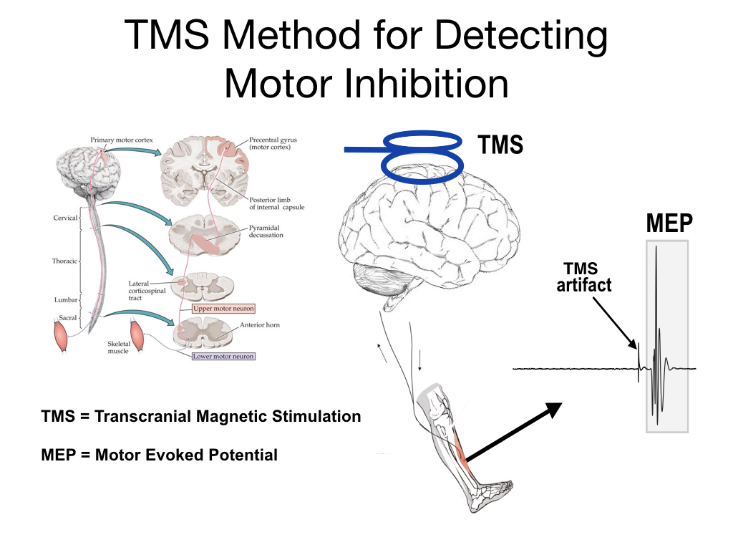

Figure 1. Example of TMS-evoked MEP in anterior tibialis muscle

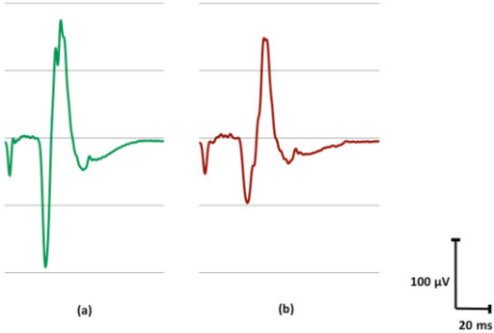

Figure 2. Averaged TMS-evoked MEP amplitudes for a single subject, at conditions of (a) lower inhibition and (b) higher inhibition.

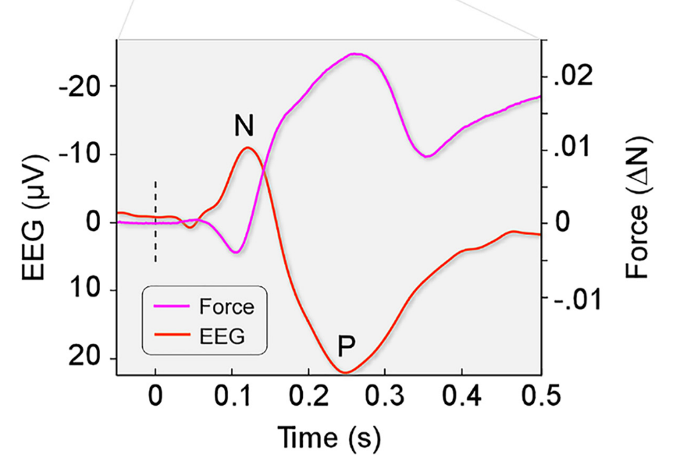

Figure 5. Example of EEG and Force modulations resulting from reactive inhibition due to unexpected stimuli.

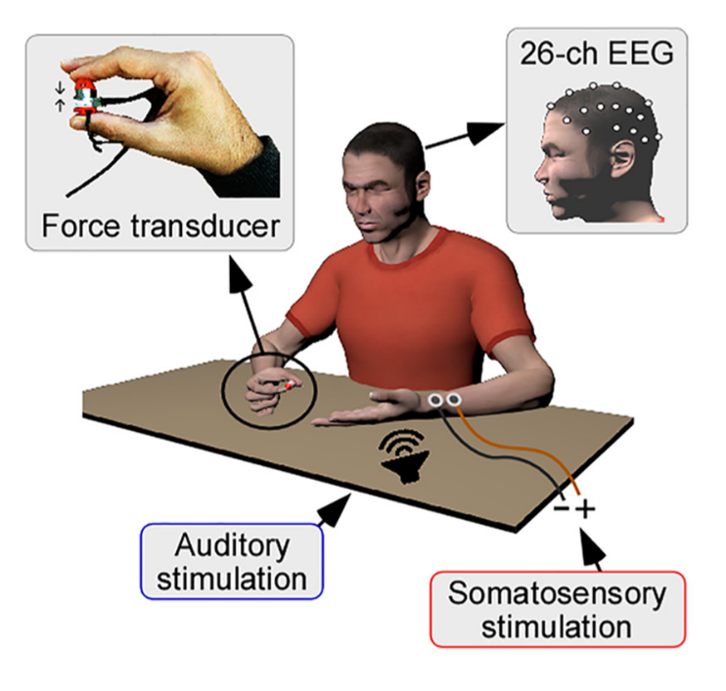

Figure 4. Example task paradigm, using EEG and pinch-grip force recordings to measure inhibition, resulting from unexpected auditory and somatosensory stimulus presentations.

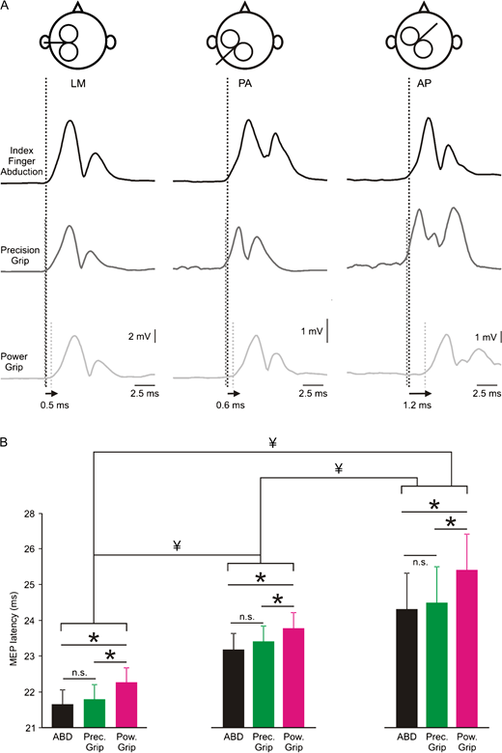

Figure 3. Example of TMS coil placement, and its effect on muscular output.