Face Mask Detecter

For

Project Report

17-Dec-2021

Prepared by: Miao Sun

Team Members: Miao Sun

Version History

|  |  |  |  |
| --- | --- | --- | --- |
| **Name** | **Date** | **Reason For Changes** | **Version** |
| First post | 12/15/ | Update most file | V1.0 |
|  |  |  |  |
|  |  |  |  |
|  |  |  |  |
|  |  |  |  |
|  |  |  |  |
|  |  |  |  |
|  |  |  |  |

Table of Contents

1. Deliverables 4

2. Executive Summary 5

3. Project Overview 6

3.1 Problem Statement 6

3.2 Scope 6

3.3 Project Team 6

4. Machine Learning Aspects 7

4.1 Dataset 7

4.2 Model Creation and Training 7

4.3 Inference 7

4.4 Evaluation of the Model 7

5. Software 8

5.1 System as a Software 8

5.2 System Architecture 8

5.3 User Interface Overview 8

6. Use Cases 9

7. References 10

8. Glossary 11

9. Appendices 12

# Deliverables

This document shall be submitted to Canvas course website Final Assignment by 11:59PM Dec 17th, 2021. Every student shall submit this document individually.

The following must be accessible by github account gheniabla and by gabla@palomar.edu.

All deliverables shall be available to access 11:59PM Dec 17th, 2021. Any content shall not be updated after the submission.

Code Repo (if any) (URL): https://github.com/jdkjjasd/CSCI-250-Fianl-Project

Presentation Slides(if any) (URL):

Presentation/Demo Video (if any) (URL):

# Executive Summary

Give a quick executive summary what you did and what is the general and most important capabilities of the system you investigated.

Please describe the most interesting/impressive aspect or experience you had in the is project.

If you didn’t get the results originally planned, include it here.

It is a one-member team, so I did everything by myself.

I changed the original topic which is game ai to face mask detecter. because the game ai requires an appropriate game to train. and it will take too much time to program a game.

so, combine with the present covid-19 epidemic and face mask requirement, I think a face mask detecter might be a good direction.

according to my research, they already have some similar projects on the internet, that is how I get the training dataset. but looks like they are using 1.x version of tensorflow, so I basically use the CNN training method based on sample code from the professor's post.

# Project Overview

## Problem Statement

Describe the purpose of your project, the problem it tries to discuss and solve.

This project could detective the face whether wear face mask or not. it could combine with a face detecter and monitoring system to find out who did not wear a mask into facility

## Project Team

Name of the project:

|  |  |  |  |
| --- | --- | --- | --- |
| Name of the Team member | Responsibility | Contribution % | Notes |
| Miao Sun | All | 100% |  |
|  |  |  |  |
|  |  |  |  |

**Please note:** The total contribution of all team members shall add up to 100%. For example, if you have 3 people in the group and each of them contributed equally, then each member’s contribution is 33.3%.

# Machine Learning Aspects

Describe AI/ML aspects in general.

## Dataset

* Describe the dataset if used.
* the dataset is download from internet which include two-part in the raw_image folder
  + have_mask folder include 605 pics
  + no_mask folder include 840 pics

## Model Creation and Training

* Describe the ML model training if related
  + This model using CNN (Convolutional Neural Networks) to

## Inference

* Describe the inference process if related.
  + 0 for have_mask
  + 1 for no_mask

## Evaluation of the Model

* Describe how you evaluated your model. Include accuracy and other relevant information of your model performance
  + 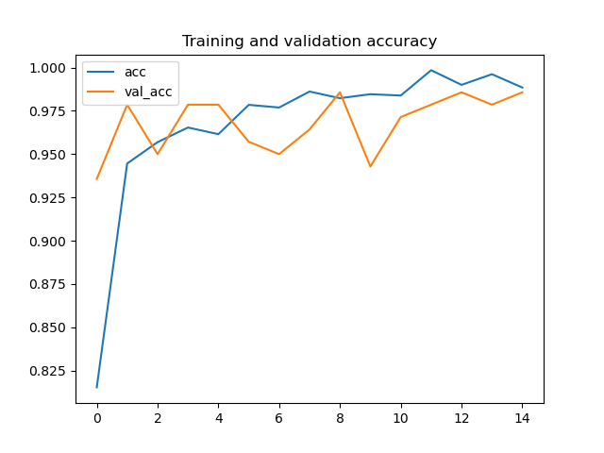Any tables, plot images for loss and accuracy

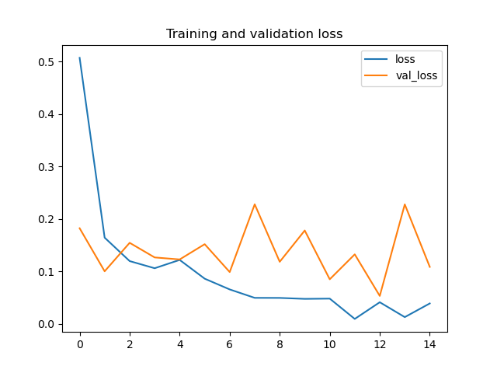

# Software

## System as a Software

* Identify the software system functionalities

## System Architecture

* Describe the software system

## User Interface Overview

* Describe the User interface of your system.

# Use Cases and tests

* Describe your use cases or tests you conducted.

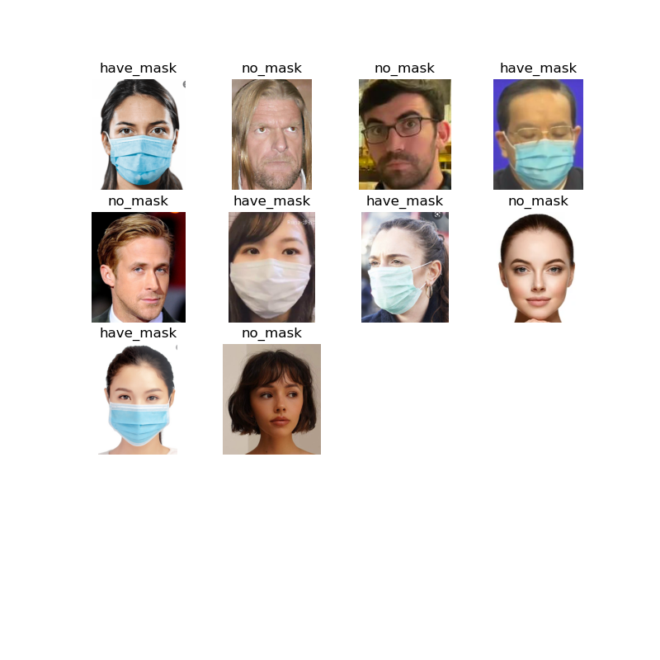

# References

* Provide a list of all documents and other sources of information referenced in your project. Include resource/document title, date, and author for each.

# Glossary

* Define all terms and acronyms required to understand your project and this report.

# Appendices

* Include any relevant appendices (if any).