**Problem Statement:**

Colloidal suspensions are a mixture of substances in which one phase is suspended in a dispersive medium. The colloid or the dispersion medium can be solid, liquid, or gas and the mixture of the two substances can occupy the same phase with the exception of gasses. Many examples of colloidal suspensions are found in the household, in industrial settings, and are studied across a number of academic disciplines. Products such as whipped cream, a foam created by air suspended in a liquid, and mayonnaise which is a stable emulsion of oil, egg yolk, and vinegar can be found in many households. Geological materials such as pumice and scoria are considered solid foams, gas suspended in a solid, and are used in industrial settings and as building materials for its insulative properties. In the environmental and medical fields aerosols and sols are of notable importance. Aerosols are often described as a solid phase within a gas, such as volcanic ash from an eruption or clouds containing ice particles, but also describe liquids such as fog. Sols describe a solid dispersed phase in a liquid dispersion media. Red blood cells, white blood cells, platelets, and other dissipated compounds are dispersed in bodily fluids and can be described as a sol. Sols of solid geological material (minerals) and biological matter (bacteria and waste matter) dispersed in liquid water are of particular interest to this study. For this study I define colloid transport and colloidal fluid in reference to sols, although portions of this work could be applied to other dispersed phases and dispersion media.

Much theoretical research has been completed in the field of colloid physiochemical transport. Knowledge of colloid transport and collection efficiency is critical to understanding the transport of emerging contaminants and environmental pathogens. Chemical interactions and the associated interaction energies resulting from interactions between colloid, fluid, and geological materials is central to colloid transport and immobilization. Increased understanding of the physical and chemical transport properties at a sub-micron scale can be used to improve field scale hydrologic models and hydrologic model planning scenarios. Modeling tools exist that can track particles, such as colloids through hydrological systems. Hydrus-1D [*Simunek et. al. 2008*] is an unsaturated zone modeling tool which assumes one dimensional flow and can apply the colloid advection-dispersion equation (CDE) with macroscopic parameters describing these processes. A distribution of particles is generated based upon the advection-dispersion parameters and is returned to the user. MODPATH [*Pollack 2016*] is a saturated zone particle tracking software to observe particle transport in a three dimensional hydrological systems. This tracking tool is limited to advective flow and saturated system. No retardation, diffusion, or dispersion is considered. A small number of pore scale models have been developed to track colloid transport in porous media [*Redman et. al. 2004, Gao et. al. 2010, Qui et. al. 2011*]. These models use Lagrangian mechanics which are computationally inefficient for large numbers of colloids, can only be applied to very small fluid domains, have long modeling run times, and operate as novel approaches to modeling micro scale colloid-surface interactions. The limitations of these systems leave the interdisciplinary researcher without a practical option to gain additional insight into controlling factors driving the physiochemical dynamics of colloid transport within their system.

Parameters such as diffusivity and dispersivity are not generally well known for most geological systems and can be time consuming and expensive to collect in the laboratory. A few studies have focused on the hydrologic unit scale description the description of these parameters [*Zenner and Grub 1973, Stevens and Beyeler 1985*], however these are rare due to limitations presented from cost and extended monitoring. Contaminant transport studies on the basin scale are generally applied to monitoring existing contaminated systems and the associated remediation process. These studies are generally have coarse discretization due to a limited number of observation wells, piezometers, and near surface monitoring equipment. Laboratory studies and numerical models are often used to understand the transport, distribution, and immobilization mechanisms in a hydrological system.

Physical forces describing colloid movement and settling in fluid and porous media are integral to colloid transport. Stokes settling can be applied to spherical particles with mass to describe sedimentation in an undisturbed fluid. Gravitational, buoyancy, and viscous drag forces can be used to determine a specific sedimentation velocity for particles of known density and mass. This relationship does not hold in porous media where fluid is rarely static. Drag forces can be extended to account for fluid and colloid velocity. Non dimensional colloid-surface correction factors presented in *Gao 2010* account for the structure of the porous media in calculating these forces. Fluid velocity vectors must also be accounted for in modeling colloid transport in porous media.

Physical forces alone do not describe colloid-colloid interactions or colloid-surface interactions. Development of colloid-surface interaction theory has been active since Helmholtz identified an interface between ionic solutions and a charged surface in 1853. Surface chemical potentials that define surface charge in colloid-colloid and colloid-surface interactions must be represented in colloid transport models. Significant refinement from Helmholtz initial model of surface interactions have provided a base for our modern model of colloid-surface interaction. Electric double layer interaction, Lewis acid-base, and Lifshitz van der Waals forces represent the major contributors to the classical Derjaguin and Landau, Verwey and Overbeek (DLVO) interactions. Representation of these micro-scale forces can provide insight into the dispersivity of colloids in a porous media. The inclusion of random motion defined by a random walk algorithm and Brownian motion described by a random Gaussian distribution has been used to describe Dispersivity, the random diffusion of particles by heat and solute gradient or collision.

A fundamental understanding of the basic chemical and physical processes of colloid-surface interaction is necessary to accurately develop prediction models of colloid transport where detailed historical data are not present. *Thomas et al. 1993* performed a basin scale study of radionuclide contamination (Ra, 40K, and U) in the Carson River groundwater basin, Nevada. Their results suggest that sediment transport and a dissolution of U coatings on Fe and Mn oxides is a principal mechanism for groundwater contamination in this watershed. The co-transport of viruses through the soil environment has also been documented due to colloid transport [*Syngouna et. al. 2013*]. Breakthough curve concentrations suggested that the presence of clay particles influenced the transport of PHI X174 virus. The MS2 virus in this study showed an affinity for attaching to clay particles. Bacterial transport can be modeled to a limited extent using colloid dynamics due to their physical size and chemical properties [*Redman 2004*]. However, bacterial transport modeling is limited using current methods, because of their ability to form communities as biofilms and their biological motility. Heavy metals and agricultural nutrients commonly sorb to colloids [*Bradford 2008*]. Heavy metals such as Arsenic, Silver, and Mercury pose an environmental and human health risk if released into surface or groundwater. Colloids provide a vector for cycling of both micro and macro nutrients important for agricultural productivity. Nutrients from Concentrated Agricultural Feeding Operations (CAFO) can be transported in such great concentrations that they pose human health risks [*Bradford 2008*]. Elevated nitrate concentrations is associated with the potentially fatal ailment blue baby syndrome (methemoglobinemia) in young children.

The purpose of this study is to examine the physical and chemical forces of colloid transport on the micro-scale and determine controlling factors of colloid transport. A significant effort will be made to provide a dynamic and reusable mechanism for rapid generation of macroscopic colloid transport parameters that future researchers can use to apply to column and field scale colloid transport prediction models. Previous modeling attempts [*Redman et. al. 2004, Gao et. al. 2010, and Qiu et. al. 2011*] have not been packaged and released as open source tools to scientific researchers. Use of these tools likely require advanced knowledge of computer science and involve steep learning curses. A need exists for a modular software suite that allows the researcher to leverage computational fluid dynamic models of geological materials and simulate colloid transport at the microscale. Customizable inputs that account for the major chemical and physical forces acting on a colloid in a porous medium should be provided along with multiple entry points of user interaction for both the regular researcher and the super user.

**Research Question:**

While many background studies exist that observe colloid transport as the sum of its parts, a basic research question can be explored. What are the controlling factors of colloid transport in porous media? Which physical and chemical forces dictate a colloid transport and immobilization within a porous media?

**Significance:**

A fundamental understanding of the chemical and physical forces that contribute to colloid-surface interactions at the micro-scale can aid researchers and consultants with developing more accurate field scale models of colloid transport. As noted previously laboratory and field methods can be time consuming. Although transport modeling is not a direct replacement for data collection, high quality physical models can inform experimental design, improve the efficiency of data collection by identifying data gaps, and help explain unexpected results.

Analysis of the magnitudes of each physical and chemical force, and its sensitivity to changing conditions will allow for the development of computationally efficient modeling of micro-scale interactions and the return of macroscale parameters. Rapid model return times allows researchers to simulate many more scenarios and gain a deeper understanding of their system. Releasing the proposed modeling software as a well-documented package that follows the Python PEP8 formatting and documentation rules will encourage collaboration and improvement in calculation and computational efficiency.

**Background:**

*Overview:*

Vadose zone hydrological processes are of the most critical importance for supporting terrestrial life in the earth system. The water retention curve which describes the relationship between matric potential and the relative saturation of the soil allows for predictions of soil moisture capacity, soil water storage, plant available surface water, and the energy required by plants to extract a certain portion of the soil water (integral energy) [*Minasny and McBratney 2006*]. A general understanding of the physical distribution of water in the unsaturated soil system under dynamic conditions is necessary for predictions about the transport of emerging contaminants, understanding environmental NAPL-water interactions, colloid transport and straining at interfaces, subsurface bacterial transport, and dissolution/precipitation processes. High quality three dimensional imagery taken of soil during drainage and imbibition can provide direct observations and insight into these processes. For these reasons many researchers rely on mathematical modeling of the soil system to gain insight into multiphase and multicomponent flow in the subsurface.

Multiple scales of mathematical simulation exist, introducing an important question that drives many decisions in the modeling process: What is the domain of the system defined by my research question? If the domain is field scale, models such as Hydrus [*Simunek 2008*] are able to make predictions about landscape scale changes over multiple decades. Hydrus is able to represent vadose zone flow based upon specific soil water characteristic models and the Richards equation. However, if the research goal is to represent fine scale fluid flow properties such as interface position during drainage and imbibition or colloid attachment and release processes, pore scale modeling systems are more representative of the physical processes in question. Many multiphase and multicomponent pore scale modeling systems have been reviewed by *Meakin and Tartakovsky 2008*.

Pore network models [*Joekar-Niasar et. al. 2007*], Level set method [*Adalsteinsson 1994, Prodanovic 2006*], and lattice Boltzmann models [*Sukop et. al. 2013*] have been shown to represent pore scale dynamics in complex systems. Sphere and tube pore network models are noted for their relative simplicity and their ability to represent large domains. Grid refinements to multiphase pore network models scale with O(N3), which is more computationally efficient than lattice Boltzmann or the level set methods [*Vogel et al. 2005*]. *Shan and Chen 1994* multiphase, multicomponent lattice Boltzmann’s strength is its ability to represent fluid-fluid and fluid-solid interactions in complex geological structures, defined by reconstructions of natural porous media. The SC approach is not limited to calculating interface and critical curvatures, it can also be used to derive microscopic and macroscopic fluid velocities in multiphase systems, observe fluid distributions and potential trapping of ganglia and films during drainage and imbibition in natural porous media [*Porter et. al. 2009*]. The level set method has been shown to robustly replicate experimental observation of fluid film critical curvatures in natural and artificial porous media [*Prodanović et. al. 2006*].

Limitations exist for each of these microscale modeling methods. Counter to its strengths, pore network models have suffered the issue of reproducibility between research groups [*Meakin and Tartakovsky 2008*]*.* Pore network models of specific interfacial area vs. saturation presented in *Joekar-Niasar et. al. 2008* over predict specific interfacial area when compared to SC lattice Boltzmann results from *Culligan et. al. 2006.* Drainage and imbibition curves for SC lattice Boltzmann models of natural porous media closely reflected laboratory results at the wet end for the porous media tested in *Porter 2009.* However, the LB method was limited by resolution due to computational demand, and was unable to adequately represent the dry end of the capillary pressure, saturation curve. Lattice Boltzmann and the level set method are both limited by specific resolution and bias introduced through the image collection, processing, and analysis step. The level set method is specifically limited to small domains and has the highest computational cost of these three methods.

Colloid transport in the soil environment may have significant environmental [*Gao et. al. 2009*] and agricultural impacts [*Bradford et.al 2008*]. The presence of dispersed colloids provides a vector for strongly sorbed chemicals, emerging contaminants, and agricultural amendments to be transported through the subsurface [*Qiu et. al. 2011*]. Structure, composition, and connectivity are generally considered primary mechanisms that control fluid flow in soils. In both saturated and unsaturated systems macropore flow from earthworm burrows, roots, cracks, and other heterogeneities can be described as preferential flow paths that bypass matrix flow within the subsurface [*Gerke 2006*]. Preferential flow has been identified as one of the most significant field-scale mechanisms to determine the pollution potential of chemicals [*Kung et. al. 2000*]. Field scale testing has been limited to the use of conservative and non-conservative tracers, which are not subject to the same suite of forces as colloids. Understanding the pore scale mechanics of colloidal transport is essential for elucidating the controlling factors of colloidal transport and for making more accurate predictions of colloidal deposition and transport on the field scale.

The attachment of colloids to geological materials and straining by constricting pores and immobile regions is heavily influenced by the physical and chemical characteristics of the hydrological system. Changes in physical characteristics (fluid velocity, reduced porosity due to compaction) and chemical characteristics (slight changes in fluid ionic strength from a rainfall event or mixing) can alter the distribution of colloids by altering the balance of chemical and hydrodynamic forces. Most laboratory studies focus on recovering macroscale parameters of colloid transport via laboratory analysis [*Saiers 1996, Kretzchmar et. al. 1997, Harter 2000, Sirivithayapakorn 2003, Kjaergaard et. al. 2004*] and field scale modeling. Micro-scale analysis of fluid flow domains can provide a means of identifying controlling factors for colloid-surface interactions and illustrate mechanisms of colloid retention that are not obvious in column or field scale studies. Processes such as colloid straining in pore throats or immobilization due to fluid stagnation zones are not visible at the field scale and play an important role in colloid retention [*Torkzaban et. al. 2008*].

Pore scale colloid transport modeling may be able to bridge a gap in the understanding and analysis of colloid transport studies. As stated previously, previous colloid modeling systems have not been released as open source tools, and as a result become limited as novel approaches. The development of an open source colloid tracking software allows for greater reproducibility of scientific studies and encourages collaboration among scientists to improve on the existing code base using shared knowledge. Collaboration between scientists becomes extremely important as academic funding becomes more limited.

*Lattice Boltzmann background:*

Lattice Boltzmann computational fluid dynamics is a refinement of lattice gas automata [*Frish et. al. 1986*]. The discretization processes and application of simple bounce back rules enables the representation of complex geological structures. Application of either body force of pressure boundary conditions [*Zou and He 1997*] drives flow within the system. Fluid flow is slightly compressible, and has been shown to return an approximation of the Navier-Stokes equation [*Benzi et. al. 1992*]. Lattice Boltzmann CFD models have been successfully used to represent fluid flow in saturated systems [*Blunt et. al 2013*], unsaturated systems [*Porter 2009*], heat transport [*He et. al 1998*], and macropore fluid flow [*Sukop et. al 2013*]. Colloid transport has been simulated using lattice Boltzmann as a computational base for simulating colloid distribution in porous media [*Redman 2004, Gao 2010, Qui 2011*]. Two dimensional, nine fluid node lattice Boltzmann fluid CFD was selected for this study. Validation of D2Q9 lattice Boltzmann with dispersed colloid transport is prioritized, and can later be extended to a three dimensional lattice Boltzmann implementation or unsaturated flow.

Fluid is represented as a particle distribution of a numerical density following traditional Boltzmann gas dynamics. Particles can interact and collide with one another, can collide with the solid phase and be reflected, and can stream according to a number of velocities associated with the specific direction and alignment of fluid nodes. D2Q9 lattice Boltzmann fluid velocities and eigenvectors are defined in Table 1. The eigenvector distribution preserves physical fluid vectors in a Newtonian system. An applied weight is given to each link type for streaming purposes and to preserve a mass balance in the system.

Non-dimensional particle density is calculated from the equilibrium distribution function and defines one of three base equations that form the equation of state. Non-dimensional fluid density is simply the summation of the particle distribution function with regard to each fluid node.

Momentum density and non-dimensional fluid velocity may also be calculated similarly by extending the previous equation to include the representative eigenvectors of the distribution function.

Non-dimensional fluid viscosity is calculated through the parametrization of a relaxation time . Adjustments to the relaxation time parameter effectively alter the shear viscosity and control the progression of the model to equilibrium [*Sukop 2006, Pan et. al. 2006*]

Non-dimensional time step and node separation are both commonly set to 1 and drop out of the equation <confirm this equation>.

Streaming and collision in the model domain is achieved using the BGK [*Qian 1992*] solution to the lattice Boltzmann equation. These functions are often separated in calculation, but represented as a single equation in the literature

A general form of the equilibrium distribution function closes the single relaxation time lattice Boltzmann CFD equation.

Node weights are applied as outlined in table 1.

Multiple relaxation time lattice Boltzmann implementations have been presented by *d’Humeries 2002, Hilpert 2011*. These methods account for instability in boundary conditions from relaxation times that diverge significantly from 1. Alternative boundary conditions have been developed and can extend the stable range of the relaxation time parameter for fluids [*Pan et. al 2006*].

Dimensionalization of lattice Boltzmann fluid domains has been covered in some detail by [*Hilpert 2011, Sukop 2013*]. The relationship between non-dimensional lattice Boltzmann and model dimensions can be derived through the non-dimensional Reynolds number:

where represents the mean pore radius of a geological media and is the porosity of the media. The non-dimensional Reynolds number is assumed to be constant between lattice units and physical units, therefore we can equate a lattice calculation and physical calculation of Reynolds number and solve for the unknown fluid velocity in physical units.

Lattice Boltzmann CFD methods that rely on defining their fluid flow domain from binarized porous media thin sections and X-ray computed tomography representations may be limited by image collection and processing methodology *Iassonov et. al 2009, 2010*. Collecting this imagery is expensive, proper contrast between phases can be difficult to achieve [*Wildenschild et. al. 2002*], and image segmentation is subject to operator bias and often a directional bias introduced by segmenting three dimensional structures as a series of two dimensional images [*Iasssonov et. al. 2009*]. Segmentation algorithm choice and optimization technique between researchers has been documented as a significant source of uncertainty in the representation of the skeletal system of porous media [*Baveye et. al. 2010*]. Results show porosity values ranging from 25% to 75% porosity for the same porous media segmented in different laboratories using accepted techniques. Currently over 100 segmentation techniques exist, each returning slightly different interpretations of greyscale imagery based its unique optimization function. The inclusion of organic material in soil samples presents its own limitations [*Wildenschild 2002*]. Dual energy X-ray CT scans and the addition of specific dopants are required to represent organic material in the image collection process [*Wildenschild 2002*]. Misrepresentation of organic materials can cause severe overestimations of porosity, connectivity, and permeability. The use of synthetically generated porous media for modeling method development is preferred to reduce uncertainty in physical properties of porous media from image collection and segmentation.

*Colloid Transport background:*

Colloid transport through the soil environment is of great interest and importance to soil development processes through the translocation of clays, contaminant transport [*Saiers 1996, Jaisi et. al. 2008*], filtration and transport of bio-colloids [*Harter 2000, Redman 2004, Foppen et. al 2005*], and soil nutrient dynamics [*Bradford 2008*]. Colloidal influence on transport of chemical contaminants and soil nutrients should not be understated. Saturated zone contaminant transport models have traditionally been modeled as immobile and mobile phase systems. Translocation and transport of inorganic and organic colloids complicate these models. It has been suggested by multiple researchers that the presence of colloids accelerates the breakthrough of strongly adsorbing contaminants. Results from column breakthrough studies of 137Cs radionuclide suggests that the first arrival of 137Cs is accelerated by 15 times the rate of first arrival without the inclusion of kaolinite colloids [*Saiers and Hornberger 1996*]. *Saiers 1996* suggests the accelerated arrival time is due to the presence of kinetic adsorption sites on kaolinite colloids. *Sirivithayapakorn and Keller 2003* performed micromodel studies with synthetic colloids on differently shaped pore and pore throat sizes; their results suggest that preferential flow over matrix flow in porous media drive the early arrival of colloids. The increase of clay content in a soil was correlated to the existence of very few, but highly connected, continuous larges pores that drive preferential flow and the acceleration of breakthrough of colloid sorbed contaminants [*Kjaergaard et. al. 2004*]. Further research into macropores formed as karst conduits shows that higher flow rates in macropores may actually slow the breakthrough of colloids due to increased collisions between colloids and geologic material leading to increased reversible attachment of colloids [*Goppert and Goldscheider 2008*]. Increased shear stresses at interface boundaries led to eventual release of attached colloids in karst conduits experiencing high flow rates [*Goppert 2008*] and do not affect long term retention rates.

Increased industrial use of new materials such as graphene and single-walled carbon nanotubes in technological production presents many research challenges. Carbon nanotubes and graphene have been shown to be insoluble and toxic to human and animal cells [*Ou 2016*]. Nanoparticles have also been shown to cross the placental barrier and display negative effects on embryo development [*Ou* 2016]. The presence of organic materials, such as humic and fulvic acids, increases the transport rate of carbon based nano-particles due to increased repulsion [*Jaisi et. al. 2008*]. *Jaisi* 2008 measured breakthrough profiles for single-walled carbon nanotubes over a variety of typical soil ionic strengths. Their results suggest a threshold of 3 mM ionic strength, which above this ionic strength physiochemical attachment processes dominate as the attachment mechanism over straining or exclusion in immobile regions. When straining processes dominate, depth dependent relationships are observed with greater deposition nearest to the inlet of column studies [*Bradford et. al. 2003, Torkziban et. al. 2007*].

Bio-colloid transport of *Escherichia coli, Total coliforms* [*Foppen et. al. 2005*], and protozoan oocysts [*Harter and Wagner 2000*] can contaminant water sources and cause serious health complications. Protozoan oocysts, such as *Cryptosporidium parvum*  and *Giardia lamblia* can lead to infection with the consumption of as few as ten oocysts [*Harter 2000*]. *Sinclair et. al. 1987* found evidence of oocysts in shallow, coarse grained, groundwater aquifers in Oklahoma. *Harter 2000* found that depth dependent filtration of *C. parvum* occurred in clean bed laboratory experiments. Changes in fluid ionic strength, such as a natural rain event, led to the secondary release of attached *C. parvum*. They conclude that contaminated soil material becomes a significant source of *C. parvum* due to secondary physiochemical release mechanisms. The transport of fecal coliforms and total coliforms are commonly used as indicators of human pathogen transport. In developing countries and impoverished regions of the United States onsite human waste disposal in pit toilets is common. *Lewis et. al. 1982* summarize the results of a number of field studies of total and fecal coliform transport. They conclude that bacteria can be transported moderate distances up to several hundreds of meters depending on groundwater flow rates and bacteria survivability in groundwater aquifers. *Foppen 2005* performed laboratory column studies of *E. Coli* bacteria transport. Even in sandy soils, they conclude that straining is a significant immobilization process.

Many field studies apply inverse modeling of the advection dispersion equation (ADE) updated for colloid transport (CDE). Application of mobile-immobile and mobile-immobile-mobile region refinement of CDE has also been applied. *Bradford et. al. 2003* present an inverse modeling solution implemented with HYDRUS-1D [*Simunek et. al. 2005*] that utilizes non-linear least squares optimization. Inverse modeling, however still requires laborious and often expensive laboratory or field methods to collect colloid transport data and recover CDE parameters. *Torkzaban 2005* indicate that their columns were excavated at 1cm intervals and concentrations of retained colloids were measured in centrifuge tubes. Physiochemical forward modeling of colloid transport has the potential to return similar colloid transport results, significantly reducing research time and cost when used in conjunction with laboratory or field studies.

Pore-scale modeling has the potential to elucidate mechanisms (attachment, straining, and exchange with immobile regions) and provide not only breakthrough concentrations of colloids, but also colloid immobilization distribution. A small number of pore scale models have been developed to model colloid transport at the pore scale. *Gao et. al. 2010* presents a colloid modeling approach which was updated by *Qiu et. al. 2011* to include more precise solutions of van der Waals and Lewis acid base forces based on lattice Boltzmann computational fluid dynamics. *Qui et. al. 2011* approach modeling colloids using a Lagrangian trajectory over a unit cell approach. This model examined effects of ionic strength on colloid attachment in a glass bead micro-model.

A colloid equation of motion is outlined by *Qui 2011* and can be updated to include gravitational and buoyancy forces not were not present in this approach:

where are the mass of colloid and change in colloid velocity with time.

Colloid drag forces can be calculated in normal and tangential directions as particles move through the system

*Gao 2010* defines the hydrodynamic force correction factors as

The non-dimensional gap distance describes the distance between colloid and surface normalized by the colloid radius. Colloid velocity along with complete the drag force calculation where is the fluid viscosity and is the colloid radius.

Gravity and buoyancy forces are calculated as

where are colloid and water density respectively and is gravity.

Dispersive processes can be represented through Brownian motion. Brownian motion describes the random movement of an object due to collision and bombardment from fast moving atoms [*Qui 2011*].

where is the product of the Boltzmann constant and temperature in Kelvin. represents a random Gaussian distribution whose mean is zero and standard deviation is one.

Chemical forces are split into three terms representing the major components of DLVO theory, electric double layer repulsion (EDL), Lifshitz-van der Waals (VDW), and Lewis acid-base (LAB). The chemical force term for colloid-surface interaction is [*Qui 2011*]

Surface-colloid electrostatic double layer repulsion interaction energy is taken from *Hogg et. al. 1996*

where is the dielectric permittivity of a vacuum (8.85 * 10-12C2/(J m), is the dielectric permittivity of water, , are the surface potential of the porous media and the colloid which are calculated from their respective zeta potential as:

We assume that the thickness of the Stern layer meters [*van Oss 2008*]. The Debye length, which represents the thickness of the diffuse double layer, is then calculated as

The Boltzmann constant , Avogadro’s number , and electron charge are used to parameterize to Debye length calculation leaving the solvent temperature and two times the solution ionic strength to be supplied or calculated.

Ionic strength is calculated from the cation charge and molarity of each ionic constituent.

Lifshitz-van der Walls interaction energy accounts for London dispersion forces, dipole interactions (Keesom forces), and induction forces. Lewis acid base forces account for acid-base bonding interactions. *Qui et. al. 2011* calculate these as separate force terms based on *Van Oss 1994.* The disadvantage of this approach is that it relies on van der Waals surface tension measurement values based on wicking studies and electron acceptor parameters that may not be readily available to the researcher

A more flexible option is to combine the attractive interaction energy calculations and estimate the attractive contribution based on *Liang et. al. 2007.*

where is the Hamaker constant describing colloid-surface interaction. The Hamaker constant is calculated as (*Israelachvili 1992*)

Colloid-colloid chemical interaction energies are calculated using similar DLVO formulations. The electrostatic repulsion between two colloids is computed as [*Elimelech et. al. 1995, Qui 2011*]

*Hogg et. al. 1965* derive repulsive interaction energies between two identical spheres. Their formulation matches identically to that derived by *Derjaguin 1939* for spherical particles.

This approximation is limited to surface potentials less than 60 mV. Changes in net repulsive interaction due to fluid ionic strength are wrapped into the surface potential calculation and the calculation of the Debye length for this approach.

Attractive interaction energies, Lifshitz van der Waals and Lewis Acid Base, can be calculated as a bulk term outlined by *Liang 2007*

In a finite element grid the spherical nature of the colloid shell can be accounted for in each principal direction by the formulation

where is the colloid-colloid chemical interaction energy in a finite element grid space.

Development of a lattice Boltzmann based colloid modeling system that draws on the strengths of previous works, and includes simplifications in the DLVO interaction energy scheme is of worth. Many parameters outlined in *Qui et. al. 2011* are not practical to collect. With the emergence of new materials such as SWNT and graphene these parameters may be extremely difficult to find in the current bank of scientific literature. Compilation and release of an open source and extendable computational fluid dynamic approach to colloid transport has the potential to evolve based on advances in colloidal science and collaboration.

**Framework:**

*Lattice Boltzmann code development:*

Work on this project will begin by researching and developing a two-dimensional, nine fluid node (D2Q9) version of lattice Boltzmann computational fluid dynamics (CFD). Lattice Boltzmann CFD has been chosen as the project base due to its ability to represent complex geometries, which is common in natural porous media, and for its relative ease of programming. Bhatnagar-Gross-Krook single relaxation time lattice Boltzmann has been shown to return an approximation of the Naiver-Stokes equation. *Pan et. al. 2006* show that instability can occur near no flow boundary conditions for relaxation times that diverge from 1. For many problems a relaxation time of 1 is sufficient and alternative boundary condition rules can be added without significant changes to the underlying computational scheme, due to the object oriented approach of the modeling code. Nine months of work is set aside to develop a user oriented version of D2Q9 lattice Boltzmann. In this time research and development will consist of three objectives.

*Lattice Boltzmann objective 1:* Research into binarization schemes from greyscale imagery of CT scan data and the conversion of binary images into fluid domains will be conducted. A general understanding of the limitations and advantages of binarization schemes is necessary to understand the limitations of lattice Boltzmann CFD modeling with heterogeneous natural porous media. Limitations may exist for computed tomography data collected from porous media high in organic materials which may be of interest colloid transport modeling.

*Lattice Boltzmann objective 2:* Research into lattice Boltzmann CFD literature and development of a computationally efficient version of D2Q9 lattice Boltzmann is planned. Although there are existing implementations of D2Q9 lattice Boltzmann with source code available, development of a custom implementation of lattice Boltzmann is valuable to understand the numerical methods and applicable boundary conditions applied to the modeling code. Development of a custom version will allow the code to be structured in a highly extendable way. Structuring lattice Boltzmann code into a series of object oriented subroutines instead of a functional code structure will allow it to be extended in the future to include more complex boundary conditions.

Dimensionalization from the non-dimensional lattice Boltzmann CFD results will be studied and subroutines added to the source code for data post processing. Dimensionalization will be implemented through the non-dimensional Reynolds number calculation.

*Lattice Boltzmann objective 3:* Create a user focused interface to lattice Boltzmann computational fluid dynamic modeling code. Creation of user focused interface will require research in software packaging and design. Two proposed entry points into the modeling software will be provided to the user. A keyword value style formatted text file will provide the regular user with a method to parameterize and run the lattice Boltzmann modeling software. The object oriented lattice Boltzmann classes will be available, and well documented for the super user to parameterize and run lattice Boltzmann models. A main advantage of the super user entry point is that it will be relatively simple to run multiple models and perform sensitivity analysis to changing parameters such as relaxation time.

*Colloid particle tracking code development:*

Work on this project will begin with research into existing colloid-surface interaction models. A general understanding of the benefits and limitations of other approaches to this problem will aid in the design and implementation of a colloid transport model. Research into other particle tracking software will provide a base set of numerical methods for tracking colloids. A computationally efficient particle tracking method is planned. Two years of research and development is necessary to accomplish this goal. This goal is split into six objectives.

*Colloid code objective 1:* Research particle tracking software and colloid-surface interaction models to develop a base approach to colloid transport modeling. A general understanding of the advantages and limitations of Eulerian, Lagrangian, and Newtonian modeling schemes will be necessary to begin developing a colloid transport model. Hybrid modeling approaches will also be considered to balance computational efficiency with precision. Compatibility with lattice Boltzmann CFD may limit the number of modeling approaches that are suitable for this project. Development of object oriented computer code to handle discretization conditions imposed by the choice of modeling scheme will be created and tested.

*Colloid code objective 2:* Research into the physical forces affecting colloid transport at the microscale will occur. Compilation of physical relationships of colloids in porous media is planned. It is expected that drag forces in a flowing fluid, buoyancy, gravity, Brownian motion and fluid velocity will be the dominant physical components that are included in the colloid transport code. Object oriented code for each physical force will be created to allow for later changes and updates to be performed. An initial colloid transport model run will be attempted with these forces to test boundary condition update routines.

*Colloid code objective 3:* Research into chemical forces influencing colloid-surface interactions at the microscale is planned. DLVO theory will be researched thoroughly to begin developing mathematical relationships for colloid-surface interactions. *Israelachvili 1992* and *Derjaguin**1939* will provide an entry point to explore colloid-surface relationships and identify unknowns that will be provided by the user. Previous colloid transport modeling papers [*Gao et. al. 2010, Qui et. al 2011*] will be consulted and mathematical relationships from these models will be incorporated as necessary. An object oriented approach to developing colloid-surface interaction code will be developed. It is anticipated that chemistry handbooks of surface forces will need to be consulted during development to parameterize surface chemistry for testing purposes. A series of initial model runs will be performed to test that boundary conditions along porous media grains are enforced by colloid-surface interaction chemistry.

*Colloid code objective 4:* Colloid-colloid chemical interactions will be studied and integrated into the colloid modeling software. Colloid-colloid chemical interactions differ from colloid-surface interaction based upon the assumed geometries and changing positions of multiple surfaces. An additional tracking colloid tracking scheme will be necessary to account for surfaces changing position. Interactions between many colloids will need to be simplified as feedback mechanisms between colloid chemical interaction fields may be challenging to represent and may not be computationally efficient.

*Colloid code objective 5:* Create a user focused input structure to the colloid particle tracking code. Creation of a user focused interface that interacts with lattice Boltzmann will require research into scientific code packaging and design. Two entry points will be provided to users. A formatted text file that contains block style entry structure similar to other scientific software is proposed for regular user interactions. This block style entry structure will use keyword, value notation for the user to easily adjust boundary conditions, physical parameters, chemical parameters, and output controls. The object oriented nature of the proposed code will allow for the super user to run multiple models with relative ease.

*Colloid code objective 6:* Inline documentation of all code following the PEP8 style guide for python and creation of user documentation will be necessary for packaging. Code documentation will include doc-strings for all custom python objects and any included compiled code. These doc-strings will inform the user documentation for both the super user and regular user. A set of user documents will be included with the packaged product. A technical note or academic paper will be drafted detailing the development, assumptions, and perceived limitations of the initial version of the colloid particle tracking software. Any other collected data or insights gained during the development process will be considered for academic publication.

*Lattice Boltzmann Colloids model validation:*

Model validation will be performed using a limited number of laboratory collected breakthrough curves. Multiple synthetic media thin sections will be generated digitally that approximate the physical structure and properties of the laboratory porous media. Simulated results will be compared to laboratory breakthrough curves in non-dimensional time. Many potential challenges are foreseen during the validation period and some may be addressed using optimization schemes or model independent parameter estimation software. Chemical property information may be difficult to find for some colloid or mineral assemblages. Bulk surface properties will have to be relied upon for heterogeneous porous media if spatial distribution of mineralogy is not known. Nine months of work is projected to complete this goal. Validation consists of four of objectives.

*Model validation objective 1:* Obtain quality break through curve data from laboratory experiments for model validation purposes. Collaborative work will be planned with other researchers to obtain relevant physiochemical properties of the geological media that laboratory studies were performed on and the colloids.

*Model validation objective 2:* A statistically significant number of artificial porous media, which approximate the physical properties of the laboratory media, will be generated. These porous media will be modeled with lattice Boltzmann and fluid velocity of the lattice Boltzmann domain will be compared to the calculated mean fluid velocity of laboratory samples during breakthrough experiments. Synthetic porous media will be regenerated in an iterative process until lattice Boltzmann CFD results are within a pre-defined tolerance of laboratory measurements.

*Model validation objective 3:* Simulations of colloid transport will be performed using the calibrated lattice Boltzmann CFD domains. Results of initial colloid transport simulations will be recorded and reported. An iterative process of altering chemical parameters will be performed as sensitivity analysis and to aid in identifying any gaps or limitations in the modeling software.

*Model validation objective 4:* Colloid transport models will be optimized using either an iterative approach with evaluation or model independent parameter estimation software if appropriate. Optimization will provide a means to identify gaps in the modeling software and provide an assessment of rigor for the lattice Boltzmann colloid particle tracking system.

*Model validation objective 5:*  The colloid transport model validation process will be documented through the drafting of an academic article prepared for submission to a peer reviewed journal.

*Proposed timeline:*

**Other Information**

*Current state of research and initial results:*

Synthetic porous media have been generated for use in colloid tracking software development. Two initial porous media were generated with the dimension of 64x64 pixels and 256x256 pixels [Figure xxx]. Both porous media were discretized at 1 um/vx and named *Synthetic_64* and *Synthetic_256*. Lattice Boltzmann CFD software was developed and tested using *Synthetic_64* and *Synthetic_256*.Each model was simulated to a steady state condition. Macroscopic, non-dimensional velocity vectors and boundary condition information are saved to output files at the successful termination of simulation. *Synthetic_64* was selected for use in development of the *LB-Colloid* particle tracking system due to its small domain and simple geometries, however *Synthetic_256* was used in testing boundary conditions in a more complex porous media.

Model grid refinement has been implemented as an option in *LB-Colloid.* A bi-linear interpolation scheme option is available to refine model grid resolution from the lattice Boltzmann resolution. Grid refinement interpolates over both the model domain and simulated macroscopic fluid velocities. This method is available due to the physical nature of colloid transport which operates at the um to nm scale. Grid refinement was applied to *Synthetic_64* to refine the resolution to 0.1 um/px.

Development of *LB-Colloid* boundary condition framework was influenced by the discrete nature of the macroscopic fluid vectors that lattice Boltzmann CFD models provide. A grid is generated over the fluid model domain and discretized at the simulation resolution. Solid and fluid phases are identified through a Boolean array. The Boolean array is used to identify pore space and set distances to the nearest solid-pore interface within the pore space. Application of this method preserves sign relating to the principal eigenvectors that define the macroscopic lattice Boltzmann fluid velocities. These arrays provide a basis for the pre-computation of some colloid-surface forces and interaction energies throughout the simulation. Pre-computed colloid-surface interaction forces and interaction energies allow for greater computational efficiency, although precision can be lost near colloid-surface interaction planes when coarse discretization is used. Refining the discretization through bi-linear interpolation can increase precision in these cases.

Physical forces were implemented initially in *LB-Colloid* development. Following the guidance in *Gao et. al. 2010* force correction terms were calculated as described previously in the colloid transport background section. The force correction terms allow for the calculation of Brownian motion and drag forces within an *LB-Colloid* simulation. Gravity and buoyancy forces are pre-computed and included in the physical force EOS. Figure <xxxx> shows a summation of physical forces for a single time step within a development simulation. The noisy pattern indicates that Brownian motion is the dominant physical interaction, excluding velocity, a colloid is subjected to during simulation.

Initial colloid streaming tests were performed with limited success. Colloids are introduced in the model in a continuous domain, which in turn are affected by forces calculated in a discretized domain, similarly to the particle tracking methodology of MODPATH (USGS). Initial methodology included temporary bounce back boundary conditions for colloids along fluid-solid interfaces. With temporary bounce back boundary conditions colloids were still apt to become stranded within the solid phase. Although no successful modelling runs were performed, colloid streaming conditions and debug flags were developed for future development.

Chemical interaction energies were implemented following guidance outlined previously in the colloid transport background section. Colloid-colloid attractive interaction energies are simulated using relationships derived from *Israelachvili 1992* and *Liang 2007*. Repulsive interaction energies are simulated using the electric double layer interaction equation outlined by *Elimelech 1995.* Colloid surface interactions follow the relationships described colloid transport background section. Currently attractive energies are being simulated using the Lewis acid base and van der Waals interaction energy calculations from *Qui et. al. 2012.* These interaction energies will likely be replaced by the relationships derived from *Israelachvili 1992* and *Liang 2007* to simplify the parameterization of the model by reducing the number of unknown parameter values.

An initial set of successful model runs were performed on *Synthetic_64*. Two separate fluid ionic strengths were simulated and 500 colloids were released during the first time step at the top of each simulation domain. The ionic strengths selected were 0.0001 M NaCl and 1M NaCl. These ionic strengths were selected to test the influence of colloid-surface interaction with changes in ionic strength. It was expected that increasing the fluid ionic strength will cause a collapse in the repulsive effects of the electric double layer and therefore more colloids will be retained within the simulation domain. Surface grains were simulated as glass bead porous media (z = -60e-3 mV) and colloids are simulated as Kaolinite (z = -40.5e-2 mV). Each simulation was run for 50,000 time steps, which was equivalent to 0.5 seconds. Figures <xxx> and <xxx> display initial results from these simulations. As expected fewer colloids were retained in the model domain under 0.0001 M NaCl fluid condition that a 1 M NaCl fluid ionic strength. Approximately 68% of colloids were retained in the low ionic strength simulation, where 97% of colloids were retained in the porous media in the high ionic strength simulation.

Further development included the addition of a multiple ionic strength modeling method (MISM) was to the *LB-Colloids* code. The MISM method allows for changes in ionic strength after a pre-defined number of model iterations. There is no upper bound to the number of changes in fluid ionic strength a single model can experience. Five synthetic porous media were generated for testing the MISM method, however only two synthetic porous media are discussed here *Synthetic_2*  and *Synthetic_5*. Each synthetic domain was generated at 100x100 pixels and was discretized at 1 um/px for lattice Boltzmann fluid simulations. Synthetic media was simulated as a glass bead media and colloids were simulated as kaolinite. Five simulations were performed on each porous media with an initial fluid ionic strength ranging from 1e-4 M to 1.0 M NaCl solution. After 1 second of simulation time the fluid ionic strength was reduced to 1e-4 M solution to simulate flushing effects due to natural rainfall.

Simulation results show display a similar trend as *Synthetic_64* models before the simulated flush event. For both domains colloid breakthrough profiles show an increased number of colloids exiting the domain with each log reduction in ionic strength. Profiles suggest that as ionic strength is increased the electric double layer repulsive forces decrease allowing more colloids to attach to mineral surfaces. Simulation of a flushing event at 1 second by introducing 1e-4 M solution of NaCl created a secondary release and breakthrough profile of colloids. The expansion of double layer repulsive forces is the primary mechanism for this release. The Debye length equation outlined in colloid transport background section predicts this behavior. The cumulative profile of colloid release shows that a lesser number of colloids exits the domain when exposed to a higher ionic strength solution, followed by a flush event than would be transported if only exposed to fluid with the same ionic strength as the flush <Figure xxx>. It is likely that some colloids in these simulations have been transported to immobile regions of simulation domain. Upon expansion of the double layer, these colloids have not exchanged back into mobile regions of the fluid domain and have likely been strained. Over a long enough time period, Brownian motion has the potential to move these colloids back into a mobile transport region. Separation of DLVO profiles show that changes in ionic strength are strongest in the EDL profile. EDL forces for kaolinite colloid and glass bead interaction are 2(O) greater than Lifshitz van der Waals and 6(O) greater than Lewis acid base attractive forces <figures>. The combined profiles display the weakening of repulsive forces with increased ionic strength due to the collapse of the electric double layer. Colloid-colloid interaction energy displays similar behavior. As ionic strength increases from 1 M NaCl to 0.0001 M NaCl a significant expansion of the EDL repulsive energies can be observed <Fig xxxx>.

Additional development of input and output control methods were added to both lattice Boltzmann and *LB-Colloids* simulation code. Parameterization of both lattice Boltzmann models and *LB-Colloids* simulation can be accomplished using simple formatted text files containing model information blocks. A set of default values are supplied in the background for many optional parameters. Parameterization can also be accomplished using python code, and parameterizing simple input-output classes. This option is advantageous, as the user can parameterize many models with a limited number of lines of code. A series of output processing classes were added for the super user, which provide basic analysis of both lattice Boltzmann and *LB-Colloid* simulations. Installation routines were built to properly add the *LB-Colloids* package to the global python library on a user’s machine. Routines include code to dynamically compile FORTRAN subroutines during the installation of *LB-Colloids.*

A series of five synthetic porous media were used in the final testing stages of initial development <Figure>. Each synthetic domain is 100x100 pixels and is discretized at 1um/px. Model domains range in porosity from 0.36 to 0.54 [Table 1]. Development models are assumed to be packed glass bead porous media. Lattice Boltzmann computational fluid dynamics were performed on each of the five porous media. Models were run until equilibrium conditions were present. Mean fluid velocity in each porous media ranges from 1.73e-6 m/s to 2.28e-4 m/s after dimensionalization. The average pore diameter of each domain ranges from 8.3e-6 m to 1.94e-5 m.

Colloid simulation domains were simulated at 0.1 um discretization. Lattice Boltzmann fluid domains and model domains were adjusted to the same discretization through a bi-linear interpolation routine. Zeta potential of the glass bead media was set to -60.9e-3 mV [*Ducker 1992*]. Ten simulations were performed on each domain by altering the fluid ionic strength from 1mM to 10mM NaCl solution in a regular step. Two-hundred kaolinite colloids were simulated for up to 500,000 time steps in each simulation. Kaolinite zeta potential was set to -40.5e-2 mV [*Chorom 1995*].

*Synthetic_1* and *Synthetic_3* returned results that indicated that no colloids passed entirely through the simulation domain. *Synthetic_1* and *Synthetic­_3* display mean pore to colloid size ratios of 8.31 and 10.60 which are the lowest of all simulation domains. The ratio of pore size to colloid size has been used as a predictor for straining and immobilization within the fluid domain [*Torkzaban 2006*]. Colloid size to pore size ratios of less than 20 are highly susceptible to straining mechanisms. For the purposes of the following discussion these results will be excluded. More detailed examination is required to interpret the results of these two domains. *Synthetic_2, Synthetic_4,* and *Synthetic­­_*5 produced breakthrough curves in each of the 10 ionic strength simulations.

*Synthetic_2* produced unexpected results regarding the relative number of colloid which passed through the system. DLVO theory predicts that increases in ionic strength shrinks Debye length of the electric double layer; increased attachment and retention of colloids is expected from increased fluid ionic strength. However a random distribution of relative concentration of colloids exiting the simulation domain was returned. The maximum breakthrough concentrations were achieved for ionic strengths 0.105 M, 0.116 M, and 0.0232 M concentration. This result does not correspond with predictions from DLVO theory. Other factors, such as Brownian motion are likely causing straining in immobile regions of the fluid domain affecting the breakthrough of colloids. A more detailed analysis of forces and colloid path lines is necessary to explain the observed behavior.

*Synthtic_4* is characterized by high porosity and large fluid cavities. Returned colloid breakthrough concentrations show expected behavior for most simulations. With some exception, lower fluid ionic strength simulations allow more colloids to stream completely through the model domain. Higher concentration simulations display an increased amount of attachment and straining in immobile zones. This result is consistent with expectations based upon DLVO theory. *Synthetic_5* simulations produced results consistent with DLVO theory for most simulations.

For all simulations a preferential colloid flow paths are observed in pores with fluid velocity maximums. Straining is primarily observed in immobile regions that display very low rates of fluid flow. Changes in ionic strength, and the corresponding thickness of the electric double layer, appear to be the controlling component in colloid attachment processes. Transport of colloids through the domain is dominated by preferential flow paths that display high fluid velocities relative to the remainder of the domain. Large pore radius and connectivity through the fluid domain define the preferential colloid paths. Presence of these larger pores may be used as a rough predictor characterizing the likelihood of colloid transport or immobilization.

**References:**

Adalsteinsson, D., J.A. Sethian. 1994. A fast level set method for propagating interfaces. Journal of Computational Physics 118. 269-77

Bayeve, P.C., M. Laba, W. Otten, L. Bouckaert, P.D. Sterpaio, R.R. Goswami, D. Grinev, A. Houston, Y. Hu, J. Liu, S. Mooney, R. Pajor, S. Sleutel, A. Tarquis, W. Wang, Q. Wei, M. Sezgin. 2010. Observer-dependent variability of the thresholding step in the quantitative analysis of soil images and X-ray microtomography data. Geoderma 157:51-63

Benzi, R. S. Succi, M. Vergasoola. 1992. The lattice Boltzmann-equation – theory and applications. Phys. Reports. 222(3):145-197

Blunt, M.J., M.D. Jackson, M. Piri, P.H. Valvatne. 2002. Detailed physics, predictive capabilities and macroscopic consequences for pore-network models of multiphase flow. Adv. Water Res. 25(8-12) 1069-89

Bradford, S.A., J. Simunek, M. Bettahar, M. Th. Van Genuchten, S.R. Yates. 2003. Modeling colloid attachment, straining, and exclusion in saturated porous media. Environ. Sci. Technol. 37:2242-2250

Bradford, S.A., E. Segal, W. Zheng, Q. Wang, S. Hutchins. 2008. Reuse of concentrated animal feeding operation wastewater on agricultural lands. J. Environ. Qual. 37:S-97-S-115

Derjaguin, B. 1939. A theory of interaction of particles in presence of electric double layers and the stability of lyophobe colloid and disperse systems. Acta Physicochimica URSS. 10(3):333-346

D’Humieres, D., I. Ginzburg, M. Krafczyk, P. Lallemand, L-S. Luo. 2002. Multiple-relaxation-time lattice Boltzmann models in three dimensions. Phil. Trans. R. Soc. Lond. A. 360:437-451

Elimelech, M., J. Gregory, X. Jia, R. Williams. 1995. Particle deposition and aggregation: measurement, modeling and simulation. Butterworth-Heinemann, Boston.

Frish, U., B. Hasslacher, Y. Pomeau. 1986. Lattice-gas automata for the Navier-Stokes equations. Phys. Rev. Lett. 56:1505-8

Foppen, J.W.A., A. Mporokoso, J.F. Schijven. 2005. Determining straining of *Escherichia coli* from breakthrough curves. Journal of Contaminant Hydrology 76:191-210

Gao, H., C.Q. Qiu, D. Fan, Y. Jin, L-P Wang. 2010. Three-dimensional microscale flow simulation and colloid transport modeling in saturated soil porous media. Computers and Mathematics with Applications. 59. 2271-89

Gerke. H.H. 2006. Preferential flow descriptions for structured soils. J. Plant Nutr. Soil Sci. 169:382-400

Goppert, N., N. Goldscheider. 2008. Solute and colloid transport in karst conduits under low- and high-flow conditions. Ground Water. 46(1):61-68

Harter, T., S. Wanger, E.R. Atwill. 2000. Colloid transport and filtration of *Cryptosporidium parvum* in sandy soils and aquifer sediments. Environ. Sci. technol. 34:62-70

He, X., S. Chen, G.D. Doolen. 1998. A novel thermal model for the lattice Boltzmann method in incompressible limit. Journal of Computational Physics. 146(1):282-300

Hilpert, M. 2011. Determination of dimensional flow fields in hydrogeological settings via the MRT lattice-Boltzmann method. Water Res. Res. 47. W09508

Hogg, R., T.W. Healy, D.W. Fuerstenau. 1965. Mutual coagulation of colloidal dispersions. Transactions of the Faraday Society. 62: 1638-51

Iassonov, P., T. Gebrenegus, M. Tuller. 2009. Segmentation of X-ray computed tomography images of porous materials: A crucial step for characterization and quantitative analysis of pore structures. Water Res. Res. 45: W09415

Iassonov, P., M. Tuller. 2010. Application of segmentation for correction of intensity bias in X-ray computed tomography images. Vadose Zone Journal. 9:187-191

Israelachvili, J.N. 1992. Intermolecular and surface forces. Third Edition. 674p

Jaisi, D.P., N.B. Saleh, R.E. Blake, M. Elimelech. 2008. Transport of single-walled carbon nanotubes in porous media: filtration mechanisms and reversibility. Environ. Sci. Technol. 42:8317-8323

Joekar-Niasar, V., S.M. Hassanizadeh, A. Leijnse. Insights into the relationships among capillary pressure, saturation, interfacial area and relative permeability using pore-network modeling. Transp. Porous Med. 74:201-219

Kjaergaard, C., T.G. Poulsen, P. Moldrup, L.W. de Jonge. 2004. Colloid mobilization and transport in undisturbed soil columns. I. Pore structure characterization and tritium transport. Vadose Zone Journal. 3:413-423

Kretzschmar, R., K. Barmettler, D. Grolimund, Y. Yan, M. Borkovec, H. Sticher. 1997. Experimental determination of colloid deposition rates and collision efficiencies in natural porous media. Water Res. Res. 33(5) 1129-37

Lewis, W.J., S.S.D. Foster, B.S. Drasar. 1982. The risk of groundwater pollution by on-site sanitation in developing countries. IRCWD Report No. 01/82. International Reference Centre fr Waste Disposal (IRCWD), Duebendorf, Switzerland.

Liang, Y., N. Hilal, P. Langston, B. Starov. 2007. Interaction forces between colloidal particles in liquid: Theory and experiment. Advances in colloid and interface science 134-135:151-166

Meakin, P. A.M. Tartakovsky. 2009. Modeling and simulation of pore-scale multiphase fluid flow and reactive transport in fractured and porous media. Reviews of Geophysics 47, RG3002

Minasny, B., A.B. McBratney. 2003. Integral energy as a measure of soil-water availability. Plant and Soil 249. 253-262

Ou, L., B. Song, H. Liang, J. Liu, X. Feng, B. Deng, T. Sun, L. Shao. 2016. Toxicity of graphene-family nanoparticles: a general review of the origins and mechanisms. Particle and Fibre Toxicology. 13(57) doi:10.1186/s12989-016-0168-y

Redman, J.A., S.L. Walker, and M. Elimelech. 2004. Bacterial adhesion and transport in porous media: role of the secondary energy minimum. Environ. Sci. Technol. 2004. 38 1777-85

Pan, C., L-S Luo, C.T. Miller. 2006. An evaluation of lattice Boltzmann schemes for porous medium flow simulation. Computers & Fluid 35:898-909

Pollock, D.W., 2016, [User guide for MODPATH Version 7 -- A particle-tracking model for MODFLOW](http://dx.doi.org/10.3133/ofr20161086): U.S. Geological Survey Open-File Report 2016-1086, 35 p., <http://dx.doi.org/10.3133/ofr20161086>.

Porter, M.L., M.G. Schaap, D. Wildenschild. 2009. Lattice-Boltzmann simulations of the capillary pressure-saturation-interfacial area relationship for porous media. Adv. in Water Resources. 32:1632-40

Prodanovic, M., S.L. Bryant. 2006. A level set method for determining critical curvatures for drainage and imbibition. Journal of Colloid and Interface Science 304:442-458

Qiu, C.Q., J. Han, H. Gao, L-P Wang, Y. Jin. 2011. Pore-scale numerical and experimental investigation of colloid retention at the secondary energy minimum. doi: 10.2136/vzj2011.0071 Vadose Zone Journal.

Saiers, J.E., G.M. Hornberger. 1996. The role of colloidal kaolinite in the transport of cesium through laboratory sand columns. Water Res. Res. 32(1):33-41

Sirivithayapakorn, S., A. Keller. 2003. Transport of colloids in saturated porous media: a pore-scale observation of the size exclusion effect and colloid acceleration. Water Res. Res. 39(4) SBH 11-1 – 11-11

Simunek, J., M. Th. Van Genuchten and M. Sejna. 2008. Development and applications of the HYDRUS and STANMOD software and related codes. Vadose Zone Journal. 7(2), 587-600

Stevens, K., W. Beyeler. 1985. Determination of diffusivities the the rustler formation from exploratory-shaft construction at the waste isolation pilot plant in southeastern New Mexico. USGS Water-Resources Investigations Report 85-4020.

Thomas, J.M., A.H. Welch, M.S. Lico, J.L. Hughes, and R. Whitney. 1993. Radionuclides in ground water of the Carson River Basin, western Nevada and eastern California, U.S.A. Applied Geochemistry. 8. 447-71

Torkzaban, S., S.A. Bradford, M. Th. Van Genuchten, S.L. Walker. 2008. Colloid transport in unsaturated porous media: the role of water content and ionic strength on particle straining. 2008. 96:113-127.

Shan, X., Chen, H. 1993. Simulation of nonideal gases and liquid-gas phase transitions by the lattice Boltzmann equation. Physical Review E 49(4):2941-48

Sukop, M.C., D. Thorne. 2006. Lattice Boltzmann Modeling: An Introduction for Geoscientists and Engineers. Springer Berlin Heidelberg. 172p

Sukop, M.C., H. Huang, P.F. Alvarez, E.A. Variano, K.J. Cunningham. 2013. Evaluation of permeability and non-Darcy flow in vuggy macroporous limestone aquifer samples with lattice Boltzmann methods. Water. Res. Res. 49:216-230

Syngouna, V.I. and C.V. Chrysikopoulos. 2013. Cotransport of clay colloids and viruses in water saturated porous media. Colloids and Surfaces A-Physiochemical and Engineering Aspects. 416. 55-65

Van Oss, C.J. 2004. Interfacial forces in aqueous media. CRC Press.

Van Oss, C.J. 2008. The Apolar and Polar Properties of Liquid Water and Other Condensed-Phase Materials. The Properties of Water and their Role in Colloidal and Biological Systems. Interface Science and Technology. Volume 16. 13-30

Van Oss, C.J. 2008. The extended DLVO theory. The Properties of Water and their Role in Colloidal and Biological Systems. Interface Science and Technology. Volume 16. 31-48

Vogel, H.-J., J. Tolke, V.P. Schulz, M. Krafczyk, K. Roth. 2005. Comparison of a Lattice-Boltzmann model, a full-morphology model, and a pore-network model for determining capillary pressure-saturation relationships. Vadose Zone Journal 4:380-388

Wildenschild, D. J.W. Hopmans, C.M.P Vaz, M.L. Rivers, D. Rikard, B.S.B Christensen. 2002. Using X-ray computed tomography in hydrology: systems resolutions, and limitations. Journal of Hydrology. 267:285-297

Zenner, H.H and H.F. Grubb. 1973. Aquifer diffusivity of the Ohio River alluvial aquifer by the flood-wave response method. Journal of Research of the US. Geological Survey. 597-601.

Zou, Q., X. He. 1997. On pressure and velocity boundary conditions for the lattice Boltzmann BGK model. Phys. Fluids. 9(6):1591-98

**Figures**

Figure 1: *Synthetic_255* (left) and *Synthetic_64* (right) were the initial development media for *LB-Colloids. Synthetic_64* is a sub-region of *Synthetic 255.*

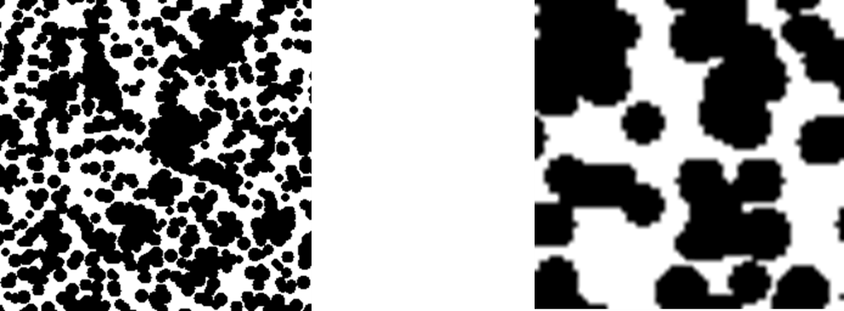

Figure 2: Summation field of physical forces, excluding fluid velocity, exerted on a colloid within a simulation domain in Newtons. The noisy pattern indicates that Brownian motion is the largest contributor to the colloid physical force domain.

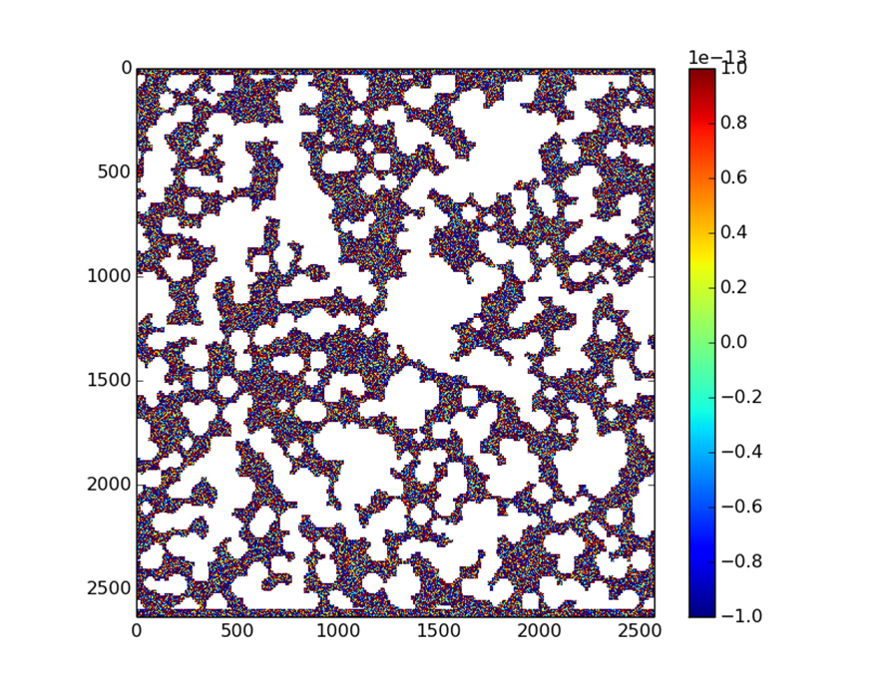

Figure 3: Colloid transport simulation of 500 colloid particles in 1e-4 M NaCl solution returned a breakthrough profile indicating that 68% of the released colloids were retained in the model domain.

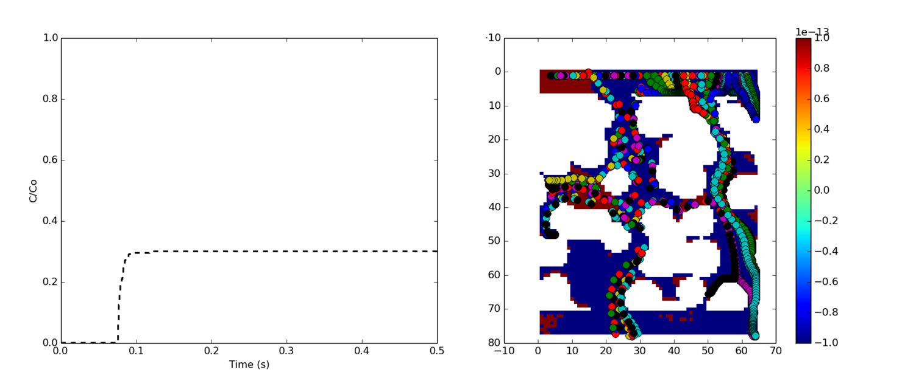

Figure 4: Colloid transport simulation of 500 colloid particles in 1.0 M NaCl solution returned a breakthrough profile indicating that 97% of the released colloids were retained in the model domain.

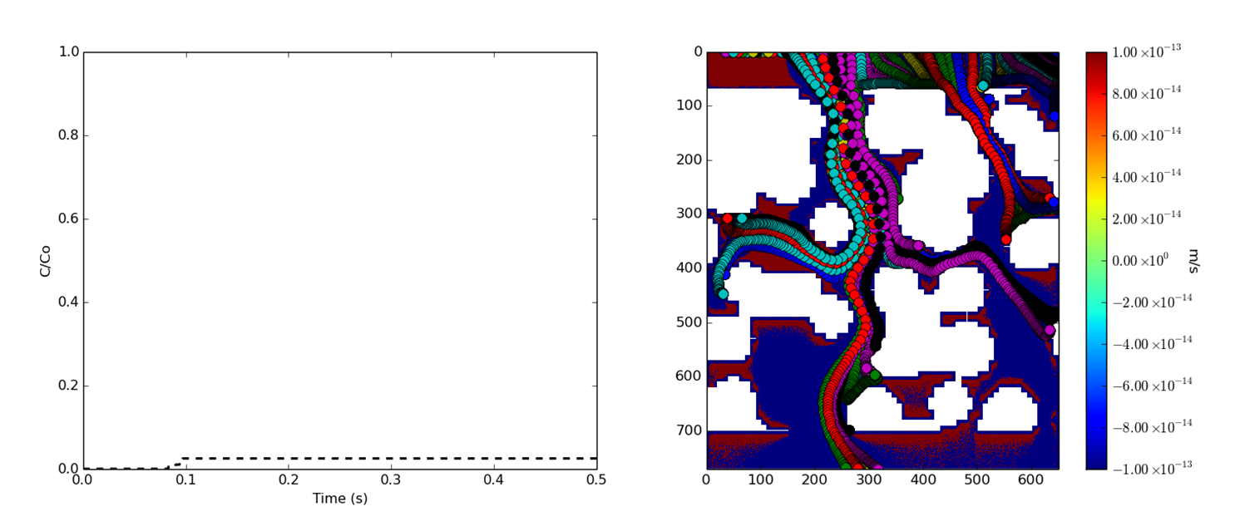

Figure 5: Colloid breakthrough profiles for *Synthetic_5* in a series MISM flush simulations. Application of a 1e-4 M NaCl solution occurred at 1 second.

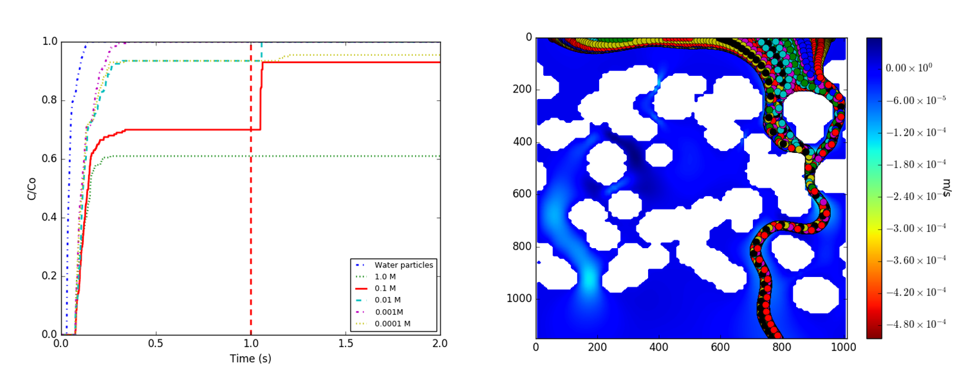

Figure 6: Colloid breakthrough profiles for *Synthetic_2* in a series MISM flush simulations. Application of a 1e-4 M NaCl solution occurred at 1 second.

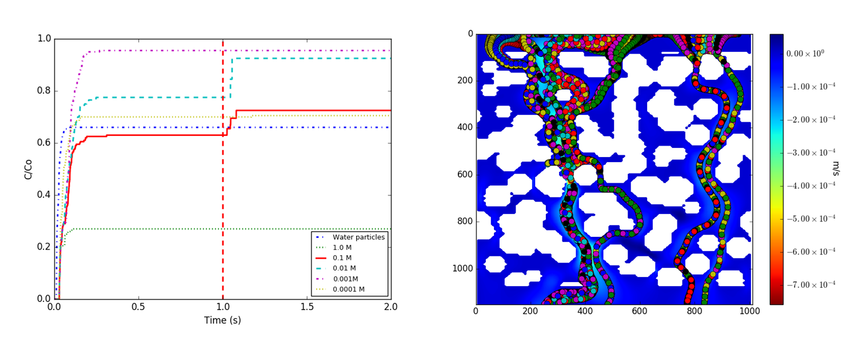

Figure 7: DLVO profiles show a reduction in the radius of the electric double layer repulsive field as ionic strength increases for simulations ranging from 6 M to 0.001 M NaCl solution. (Top Left) Electric double layer repulsion profiles. (Top Right) Lewis acid base interaction profiles. (Bottom Left) Lifshitz van der Waals interaction profiles. (Bottom Right) Combined DLVO force profiles.

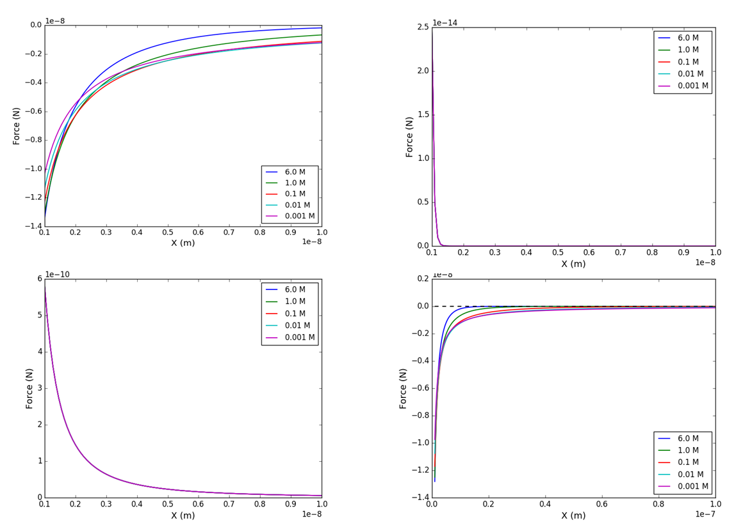

Figure 8: Colloid-colloid DLVO fields show an increase in the radius of net repulsion with decreasing ionic strength. (Top Left) 1 M NaCl, (Top Right) 0.01 M NaCl, (Bottom) 0.001 M NaCl.

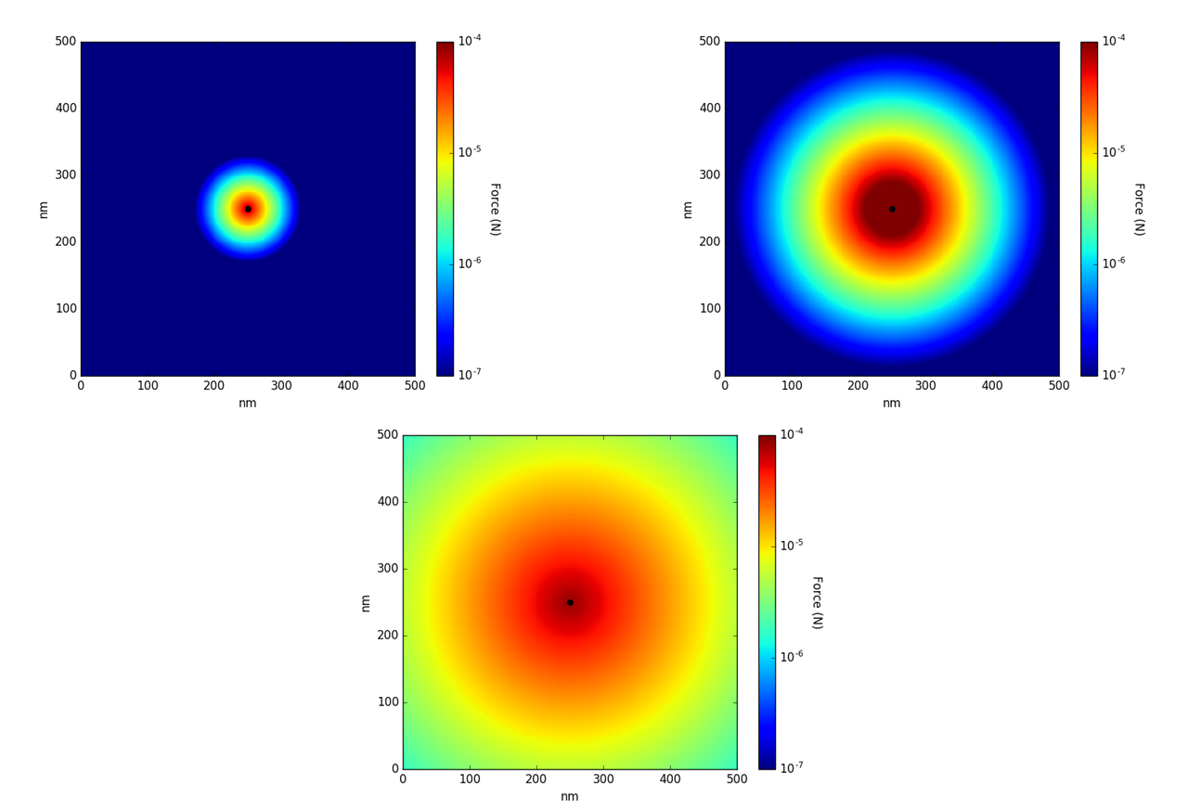

Figure 9: Synthetically generated glass bead model domains for *LB-Colloid* development and testing. From top left to bottom right: *Synthetic_1, Synthetic­_2, Synthetic_3, Synthetic_4, Synthetic_5.*

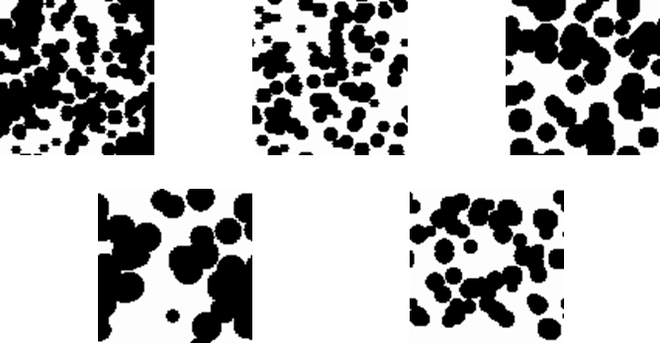

Figure 10: Cumulative breakthrough curves for *LB-Colloid* simulations on *Synthetic_2* ranging in ionic strength from 0.116 M to 0.0116 M NaCl solution did not return expected results. Breakthrough profiles suggest that Brownian motion is playing a significant role in transport processes due to the distribution of cumulative colloids vs. ionic strength.

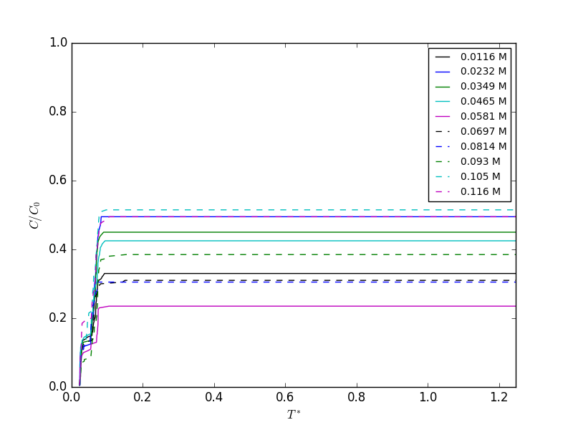

Figure 11: Cumulative breakthrough curves for *Synthetic_4* simulations with fluid ionic strength ranging from 0.116 M to 0.0116 M NaCl solution produces results consistent with DLVO theory indicating that DLVO forces, specifically EDL interactions dominate transport under these conditions within this model domain.

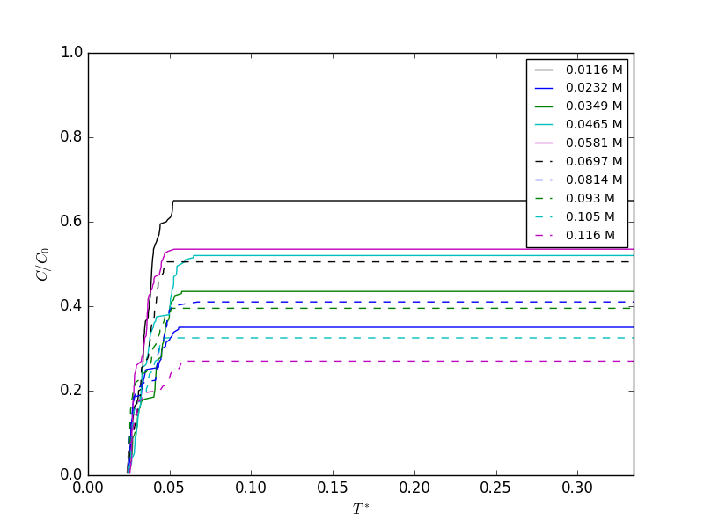

Figure 12: Cumulative breakthrough curves for *Synthetic_5* simulations with fluid ionic strength ranging from 0.116 M to 0.0116 M NaCl solution produces results mostly consistent with DLVO theory. Simulations such as 0.0465 M did not produce the expected profile with regard to DLVO theory, this suggests that Brownian forces may have moved colloids into immobile regions of the fluid domain.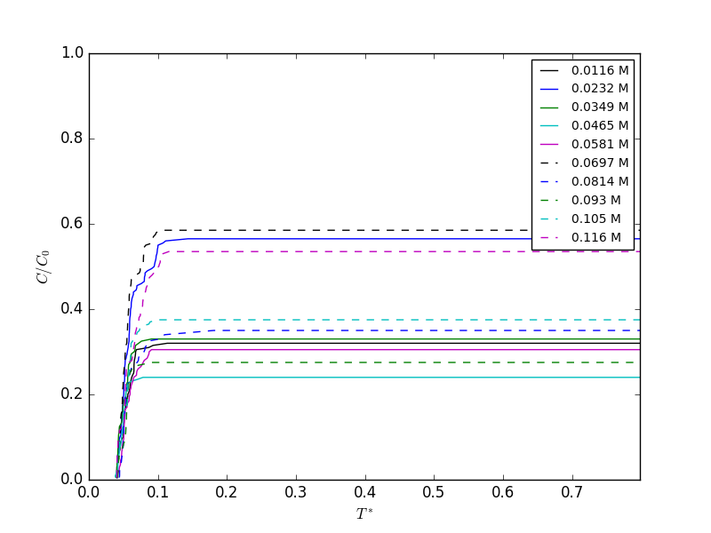

Table 1: Lattice Boltzmann simulation weights and eigenvectors for D2Q9 computational fluid dynamic simulations.

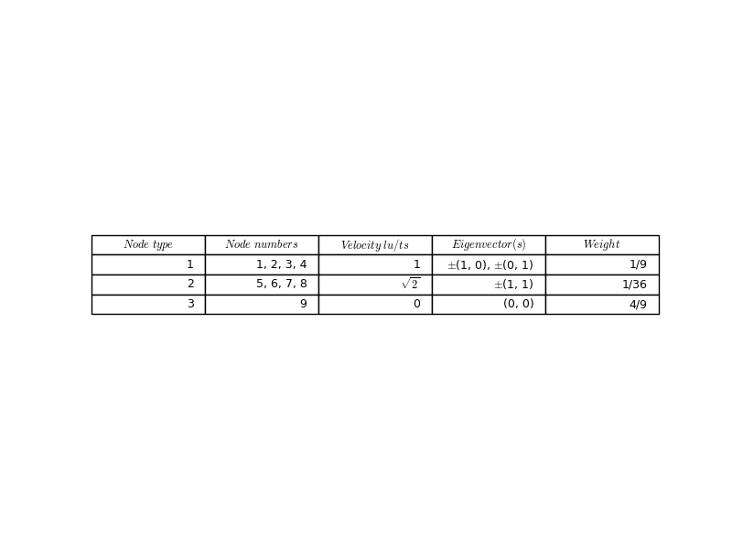

Table 2: Physical properties of *Synthetic_1 – Synthetic_5* including fluid velocities from lattice Boltzmann CFD simulations.

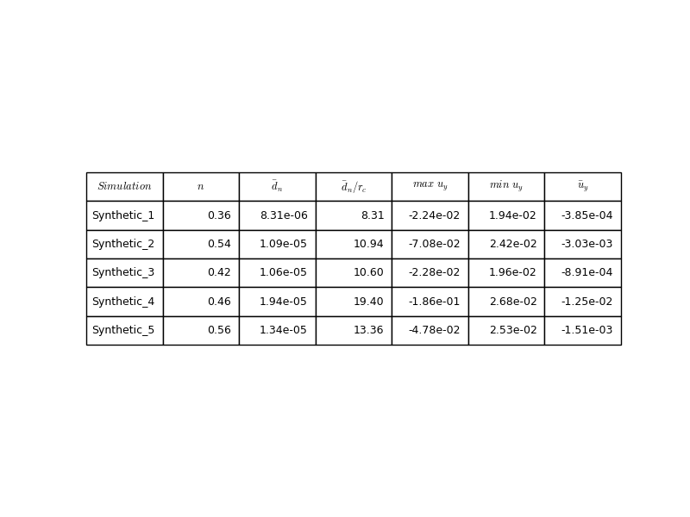

Table 3: Fraction of colloids that were transported through the simulation domain for each *LB-Colloid* simulation of fluid ionic strength ranging from 0.0116 to 0.116 M NaCl solution.

