***EE/CprE/SE 492 GROUP PROGRESS REPORT***

***Group number: sdmay22-30***

***Project title: 5G and beyond***

***Client: Hongwei***

***Advisor: Hongwei***

***Team Members: Josh Guyer, Joshua Naber, Johnathan Leisinger, Connor Kesterson, Raffael Neuser, Nick Garrelts, Ruofeng Gao***

* **Project Summary:** *(Short summary about the project. What are the design goals? Have the direction or scope of the project changed? This should be about a paragraph in length.)*

The goal of our project is to design and create a User Equipment enclosure that will be deployed locally around Iowa to be used by the ARA Wireless network. This enclosure will hold a couple radios including the B210 and skyLark mMIMO radio. All of these radios will be controlled by a main computer inside of the enclosure in which we will be using the Intel NUC. There will also be a secondary Intel NUC used within the enclosure to provide a research environment to outside researchers. Lastly, our direction of the project has changed slightly, we were looking into 3D printing an enclosure to hold these components but we found that a pre-assembled waterproof hinged enclosure may work better.

* **Accomplishments** *(Please describe/summarize as to what was done, by whom, when and, collectively as a group since the last report. This should be about a paragraph or two in length. Bulleted points are acceptable as well. Please keep only your technical details related to your project. Figures, schematics, flow diagrams, pseudocode, and project related results are acceptable, but please ensure that they are legible (clear enough to read) and to provide an explanation. If researching a topic, please add a few details about what was learned and how it is relevant to the project. If two or more people worked on a single task, be sure to distinguish how each member contributed to the task. Specific details relating to the assistance provided to other members may be included here.****)***

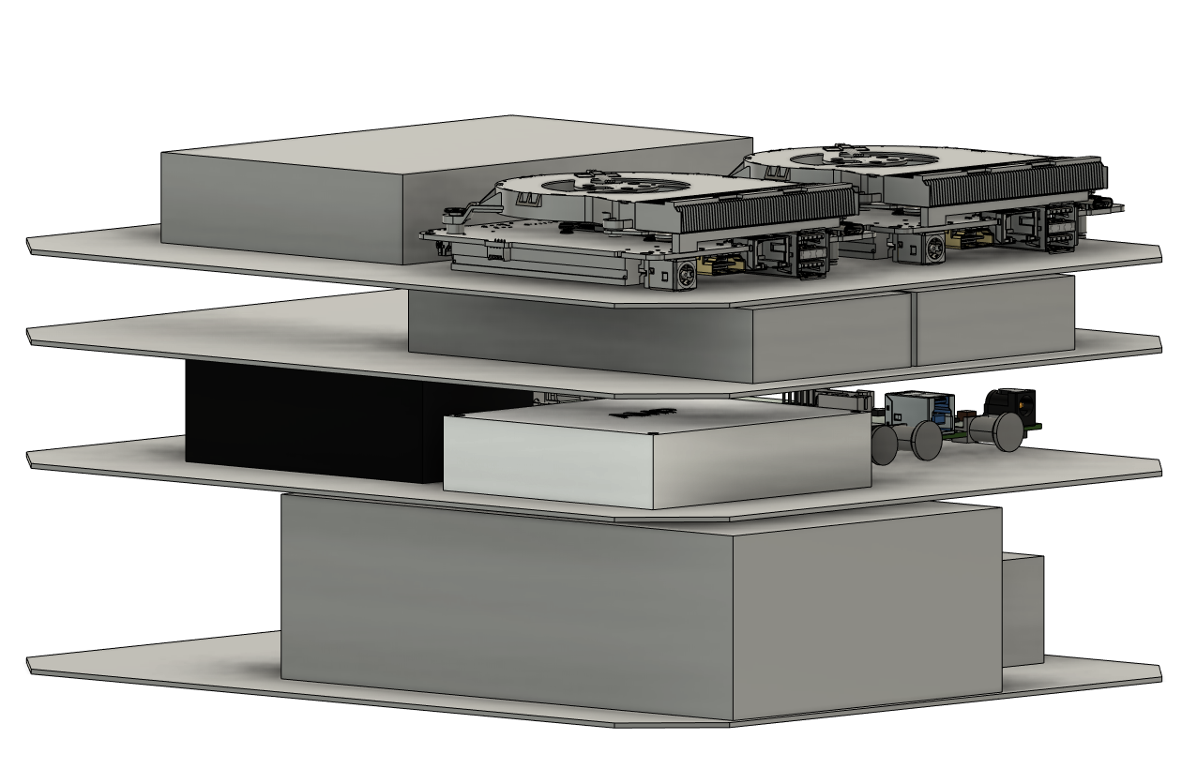

**Josh Guyer**

* Created a hardware diagram of how things in the enclosure are going to be laid out.
* Ordered the waterproof enclosure that we are going to be working with
* Laid out plans for how everything will be wired together such as power, USB, ethernet, ect.

**Joshua Naber**

* Helped Josh G arrange the hardware to fit within the waterproof enclosure

**Nick Garrelts**

* Researched AraRAN and AraHaul to see how they can compare to the current software focus of srsRAN and algorithms

**Team**

* Created weekly meeting times to improve communication between members of the team.
* **Pending issues** *(If applicable:* *Were there any unexpected complications? Please elaborate.)*

We have needed to change the design of our enclosure from 3D printing to a premade waterproof enclosure. There are a few more things that need to be put in the box such as a switch and another computer. The project has also run into budget issues as the professor and graduate students need to scale back the project.

Additionally, our software testbench site is currently being used in other research that has started in December 2021, so we will need to set up another testbench in another location which has been decided by our research assistant.

* **Advisor Input/Signature:**

Please select one of the options below and sign.

_______ I am pleased with the progress the team is making.

_______ The teams progress could use some minor improvements which I will discuss with them.

_______ The team’s progress has some major concerns that I will discuss directly with Dr. Bigelow

[bigelow@iastate.edu](mailto:bigelow@iastate.edu) , 515-294-4177

Signature: _______________________________________________________________________

* **Client Input/Signature:**

Please select one of the options below and sign.

_______ I am pleased with the progress the team is making.

_______ The teams progress could use some minor improvements which I will discuss with them.

_______ The team’s progress has some major concerns that I will discuss directly with Dr. Bigelow

[bigelow@iastate.edu](mailto:bigelow@iastate.edu) , 515-294-4177

Signature: _______________________________________________________________________