***EE/CprE/SE 492 GROUP PROGRESS REPORT***

***Group number: sdmay22-30***

***Project title: 5G and beyond***

***Client: Hongwei***

***Advisor: Hongwei***

***Team Members: Josh Guyer, Joshua Naber, Johnathan Leisinger, Connor Kesterson, Raffael Neuser, Nick Garrelts, Ruofeng Gao***

* **Project Summary:** *(Short summary about the project. What are the design goals? Have the direction or scope of the project changed? This should be about a paragraph in length.)*

The goal of our project is to design and create a User Equipment enclosure that will be deployed locally around Iowa to be used by the ARA Wireless network. This enclosure will hold a couple radios including the B210 and skyLark mMIMO radio. All of these radios will be controlled by a main computer inside of the enclosure in which we will be using the Intel NUC. There will also be a secondary Intel NUC used within the enclosure to provide a research environment to outside researchers. Lastly, our direction of the project has changed slightly, we were looking into 3D printing an enclosure to hold these components but we found that a pre-assembled waterproof hinged enclosure may work better.

* **Accomplishments** *(Please describe/summarize as to what was done, by whom, when and, collectively as a group since the last report. This should be about a paragraph or two in length. Bulleted points are acceptable as well. Please keep only your technical details related to your project. Figures, schematics, flow diagrams, pseudocode, and project related results are acceptable, but please ensure that they are legible (clear enough to read) and to provide an explanation. If researching a topic, please add a few details about what was learned and how it is relevant to the project. If two or more people worked on a single task, be sure to distinguish how each member contributed to the task. Specific details relating to the assistance provided to other members may be included here.****)***

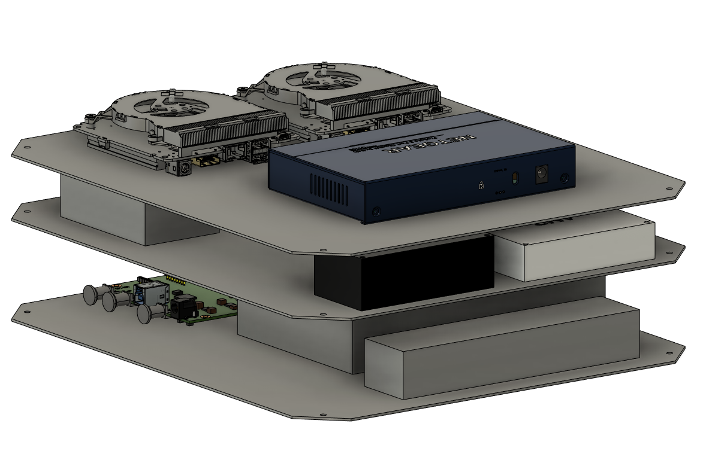

**Josh Guyer**

* Modified the design of how things in the enclosure are going to be laid out.
* Working on manufacturing the platforms for the inside of the box
* Have a platform cut out that fits in the box without holes for components
* Talked with the ABE lab in Sukup about manufacturing these platforms and how everything will fit

**Joshua Naber**

* Talked with lab in Sukup to get inserts machined out for our enclosure
* Helped arranged how hardware is going to fit into the enclosure

**Nick Garrelts**

* Researched srsENB source code, focusing now more on the MAC layer to implement modifications.
* Met with RA to discuss code deployment

**Connor Kesterson**

* Looked at srsENB code for a better understanding of how it works to see where modifications can be made to improve SNR.

**Johnathan Leisinger**

* Skimmed srsUE and srsENB code
* Met with RA to discuss feasibility of SDR deployment locations

**Ruofeng Gao**

* Understanding the logic of srsUE code part, and set up the base station.
* Met with RA

**Team**

* Worked on project milestone timelines to keep us on schedule.
* **Pending issues** *(If applicable:* *Were there any unexpected complications? Please elaborate.)*

Going with a larger enclosure than last week.

* **Advisor Input/Signature:**

Please select one of the options below and sign.

_______ I am pleased with the progress the team is making.

_______ The teams progress could use some minor improvements which I will discuss with them.

_______ The team’s progress has some major concerns that I will discuss directly with Dr. Bigelow

[bigelow@iastate.edu](mailto:bigelow@iastate.edu) , 515-294-4177

Signature: _______________________________________________________________________

* **Client Input/Signature:**

Please select one of the options below and sign.

_______ I am pleased with the progress the team is making.

_______ The teams progress could use some minor improvements which I will discuss with them.

_______ The team’s progress has some major concerns that I will discuss directly with Dr. Bigelow

[bigelow@iastate.edu](mailto:bigelow@iastate.edu) , 515-294-4177

Signature: _______________________________________________________________________