The Hidden Human
How AI Training Repeats a 250-Year-Old Trick
James (JD) Longmire
In 1770, a Hungarian engineer named Wolfgang von Kempelen wheeled a machine into the court of Empress Maria Theresa. It was a wooden figure dressed in Ottoman robes and a turban, seated behind a cabinet with a chessboard on top. Von Kempelen opened the cabinet doors, showed the audience the gears and clockwork inside, wound a key, and invited someone to play.
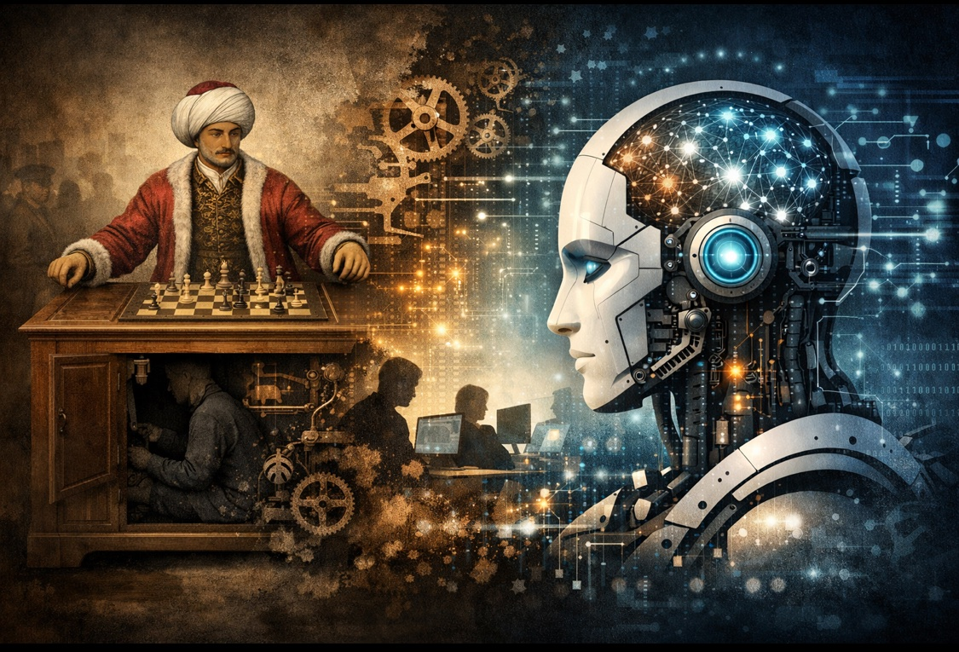
From von Kempelen’s cabinet to the modern model: the hidden human persists.
The machine won. It kept winning. For 84 years it toured Europe and America, defeating Benjamin Franklin, Napoleon Bonaparte, and some of the strongest chess players alive. Audiences were stunned. A machine that could think. A machine that could play chess, the quintessential game of intellect, all on its own.
Except it couldn’t. A human chess master sat hidden inside the cabinet, watching the board through magnets and operating the arm through levers. The gears were theater. The clockwork was misdirection. The intelligence was borrowed from a person the audience couldn’t see.
The Mechanical Turk is usually told as a historical curiosity. A clever fraud from the age of automata, long since exposed, interesting mainly as a footnote. But the Turk isn’t a footnote. It’s a template. And it has been running, with upgrades, for 250 years.
* * *
The Promise Fulfilled (Sort Of)
The Turk was a fake. But the dream it sold eventually came true, at least for chess.
In 1997, IBM’s Deep Blue defeated world champion Garry Kasparov in a six-game match. In 2016, DeepMind’s AlphaGo defeated Lee Sedol, one of the strongest Go players in history, in a game so complex that experts had predicted machines were a decade away from competing. These were real victories. No one was hidden inside the cabinet.
But someone was hidden behind it.
Deep Blue’s evaluation functions were fine-tuned by Grandmaster Joel Benjamin, who served as IBM’s official chess consultant. The opening book was built by grandmasters Miguel Illescas, John Fedorowicz, and Nick de Firmian. The machine searched 200 million positions per second. The humans decided what “good chess” looked like so the machine could optimize for it.
AlphaGo’s initial training used approximately 30 million board positions extracted from around 160,000 games played by strong human players on the KGS Go Server. Human expertise bootstrapped the system. Only after learning from those human games could AlphaGo begin the self-play reinforcement learning that eventually carried it beyond human ability. AlphaGo Zero later trained without human game data, but still required human researchers to design the architecture, define the reward function, and set the parameters within which self-play operated.
The pattern is subtler here than in the original Turk, but it’s the same pattern. Humans provided the expertise. The machine operationalized it. The public saw the machine win and attributed the intelligence to the machine. Deep Blue didn’t understand chess. It searched positions that humans had taught it to evaluate. AlphaGo didn’t understand Go. It optimized a reward function that humans had designed, bootstrapped from games humans had played.
These systems were honest about their narrowness. IBM never claimed Deep Blue was generally intelligent. DeepMind published their methods openly. The hidden human contribution was documented, if not widely discussed. And the domains were bounded: chess and Go have fixed rules, perfect information, and clear win conditions. The machine could be evaluated against an unambiguous standard.
The victories were real. The intelligence attribution was still wrong. And the misattribution primed the public for what came next: systems that claimed generality across all domains, with hidden human contributions far harder to trace and far less expert than a grandmaster’s.
* * *
Act I. The Original Turk (1770)
What made the Turk work wasn’t the engineering. It was the audience. People wanted to believe a machine could think. The desire preceded the evidence, and the cabinet provided just enough mystery to sustain it. You could open the doors, peer inside, see the gears, and still not find the person. The design was optimized for one thing: making the hidden human invisible.
Von Kempelen knew what he was selling. He called it “a bagatelle” and seemed almost embarrassed by its success. The real engineering achievement was the concealment mechanism, the sliding seat and internal partitions that let the operator dodge from compartment to compartment as each door was opened in sequence. The chess was real. The intelligence was real. The lie was about where the intelligence lived.
This is the structure worth noticing. The Turk didn’t fake chess. It faked the source of chess. Every move was legitimate. Every victory was earned. The deception wasn’t in the output. It was in the attribution.
* * *
Act II. Amazon’s Turk (2005)
Two hundred and thirty-five years later, Amazon launched a platform and named it after the fraud. They were remarkably honest about why.
Amazon Mechanical Turk, or MTurk, debuted in November 2005 as a marketplace for what Jeff Bezos called “artificial artificial intelligence.” The concept: when software can’t do a task, hide a human behind the API and let the requester pretend it’s automated. Need someone to identify objects in a photo, tag content, transcribe audio, verify data? Post it as a Human Intelligence Task, a HIT. Gig workers pick it up, complete it, and submit it through the interface. To the software on the other end, it looks like a machine did it.
The name was the confession. Amazon looked at von Kempelen’s chess-playing hoax and said: we’re doing that, on purpose, at scale. The hidden human was the product. The platform was the cabinet.
But Amazon’s version was structurally honest in a way von Kempelen’s never was. The Turk of 1770 hid a grandmaster and denied it. Amazon’s Turk hid thousands of workers and admitted it. The whole business model was predicated on the gap between what computers could do and what humans could do, and Amazon built the bridge by putting humans inside the machine and charging for the crossing.
There’s something almost admirable about the candor. The platform said, in effect: intelligence requires humans. We haven’t automated thinking. We’ve automated access to thinking. The API makes it seamless, but the work is done by people.
If you wanted a framework for this, you’d call it Human-Curated, AI-Enabled before the term existed. Humans originated the judgments. Software enabled the distribution and collection. The intelligence lived where it actually lived, in human beings, and the system was designed around that fact.
* * *
Act III. RLHF’s Turk (2020s)
This is where the story turns.
Reinforcement Learning from Human Feedback is the training technique that turned base language models into the polished chatbots the public now uses. The process works like this: the model generates multiple candidate responses to a prompt. Human raters compare the responses and indicate which they prefer. Those preferences get compressed into a reward model, and the language model is fine-tuned to produce outputs the reward model scores highly.
The human raters are the modern Turkers. In many cases, they are literally Turkers.
Anthropic’s early RLHF work used crowd workers recruited through Amazon Mechanical Turk and Upwork. OpenAI’s InstructGPT, the precursor to ChatGPT, relied on a team of about 40 contractors for its core training data. The broader ecosystem runs on platforms like Scale AI, Surge, Appen, and the dozens of annotation services that have sprung up to feed the insatiable demand for human preference data.
These workers sit behind the API, just like von Kempelen’s chess master sat behind the cabinet doors. They evaluate outputs, rank preferences, flag failures, and demonstrate desired behaviors. Their judgments get compressed into the reward model. The reward model shapes the language model. And then the workers are removed from the loop.
This is the critical move. Von Kempelen’s Turk always needed the chess master inside the cabinet. Amazon’s Turk always needed the workers behind the API. GenAI’s Turk extracts the workers’ preferences, encodes them as statistical patterns, and then runs without them. The hidden human has been distilled into weights and discarded.
What remains looks like intelligence. It passes the same test the original Turk passed: the audience can’t find the person inside the cabinet. But this time, the person really isn’t there. What’s there is a statistical residue of their judgments, a compressed approximation of what thousands of low-paid raters thought sounded good.
* * *
The Degradation of the Hidden Human
Here’s the part the industry doesn’t discuss. Each iteration of the Mechanical Turk has degraded the quality of the hidden human.
Von Kempelen hid grandmasters. The chess masters who operated the original Turk were among the strongest players in Europe. Johann Allgaier, Aaron Alexandre, William Lewis, Jacques Mouret, William Schlumberger: these were serious players capable of beating almost anyone. The hidden human was an expert. The output quality was genuinely high because the person inside the cabinet genuinely knew what they were doing.
Amazon hid gig workers. MTurk’s workforce is large, distributed, and varied in skill. Research has consistently found that MTurk workers earn around a few dollars per hour in many studies, well below minimum wage in any US jurisdiction. They perform tasks ranging from image labeling to content moderation to survey completion. They know what task they’re performing, and many are competent at it, but they’re not experts in the domains the tasks serve. They’re doing piecework.
RLHF hid raters who often can’t evaluate what they’re rating. This deserves some nuance. Not every annotation pipeline is identical. Some companies use domain-specialized reviewers for targeted tasks: code evaluation, math verification, safety-critical content. OpenAI’s InstructGPT used a curated team of 40 contractors. Platforms like Surge and Mercor recruit expert-level annotators for high-stakes domains. These efforts matter, and they produce better results where they’re applied.
But the bulk of preference data, the data that shapes general model behavior across all topics, comes from crowd workers without domain expertise in most of what they’re evaluating. When an RLHF rater chooses between two explanations of quantum field theory, or two summaries of a legal case, or two analyses of a financial report, they’re typically not evaluating correctness. They’re evaluating which one sounds better. Fluency, confidence, structure, apparent thoroughness: these are the signals accessible to a non-expert. Truth isn’t.
The trajectory is clear. 1770: hide a grandmaster. 2005: hide a gig worker. 2024: hide a mix of gig workers and some specialists, compress their preferences into weights, remove them, and market the result as general intelligence. The specialists improve specific domains. The general confidence comes from the crowd.
Each step moved further from expertise and closer to the appearance of expertise. The output got more polished at each stage. The grounding got thinner.
* * *
AIDK Was Baked In at the Factory
This is where the Mechanical Turk history meets the AI Dunning-Kruger framework.
AIDK describes the structural condition in which AI systems produce outputs with uniform confidence regardless of actual reliability. The system can’t detect its own competence boundaries. It can’t distinguish what it knows from what it’s guessing. Fluency is constant whether the content is solid or fabricated.
The Mechanical Turk genealogy explains why AIDK is structural rather than incidental. The confidence was never grounded in the first place. It was learned from human raters whose own confidence didn’t track truth.
A fair objection here: models aren’t only shaped by RLHF raters. Pretraining data includes textbooks, peer-reviewed papers, technical documentation, and expert-written code. That’s real knowledge, and it matters. Retrieval-augmented generation can pull in verified sources at inference time. Tool use lets models defer to calculators, compilers, and databases. These mechanisms partially mitigate specific failure modes, and dismissing them would overstate the case.
But none of them solve the problem the Turk genealogy reveals. Pretraining encodes knowledge without calibration: the model can’t distinguish what it absorbed from a textbook versus what it absorbed from a Reddit thread. Retrieval adds more symbols to an ungrounded system. Tool use defers specific computations without teaching the model when to defer. These are horizontal and vertical axis interventions. They improve infrastructure and reasoning quality within bounded domains. They don’t provide the grounding that would let the system know when its confidence exceeds its warrant.
And RLHF sits on top of all of it, shaping the voice in which everything gets delivered. Whatever the model knows from pretraining, whatever it retrieves at inference time, it expresses through a behavioral layer trained on crowd worker preferences. That layer is where confidence gets calibrated, and the calibration points toward sounding sure.
Think about what RLHF actually optimizes. The reward model learns to predict which outputs human raters would prefer. Human raters prefer outputs that sound knowledgeable, confident, and helpful. They penalize outputs that hedge, express uncertainty, or refuse to engage. So the training process systematically selects for confident-sounding output regardless of reliability. The model learns that humans want it to sound sure.
This is the Interactive Dunning-Kruger Effect (IDKE) built into the training pipeline. IDKE describes what happens when AI epistemic limitations meet human epistemic limitations: confidence amplification untethered from warrant. In deployment, IDKE occurs when a non-expert user consults an AI system and inherits its ungrounded confidence. But in the RLHF pipeline, IDKE occurs during training. The raters are the non-expert users. The model is the confident-sounding system. And the raters’ preferences for confident outputs get permanently encoded into the model’s behavior.
RLHF doesn’t just fail to fix AIDK. It manufactures AIDK. The training process takes the exact human weakness that IDKE exploits, the tendency to mistake fluency for reliability, and uses it as the signal the model optimizes for. The hidden human’s epistemic limitation becomes the system’s permanent operating mode.
This isn’t hypothetical. IBM’s Watson for Oncology was marketed as an AI system that could recommend cancer treatments, deployed to 230 hospitals worldwide. Internal IBM documents later revealed that the system produced “multiple examples of unsafe and incorrect treatment recommendations.” It had been trained on synthetic patient cases rather than real patient data, with recommendations based on the preferences of a handful of Memorial Sloan Kettering specialists rather than broad clinical evidence. (IBM and MSK publicly argued that problematic recommendations were identified through their quality process and corrected before reaching patients, and that the issues reflected the normal course of iterative development. The internal documents tell a less sanguine story.) A physician at Jupiter Hospital in Florida told IBM executives the product was essentially worthless for most cases.
The pattern fits the Turk template precisely. Hidden human expertise (a few MSK oncologists) was compressed into the system. The system was deployed far beyond the contexts those experts could evaluate, to hospitals in Thailand, India, South Korea, and the Netherlands where clinicians couldn’t assess whether the American-biased recommendations applied to their patients. The machine delivered its recommendations with the same confident interface regardless of whether the underlying guidance was sound. The humans receiving the output often lacked the domain-specific expertise to push back. AIDK met IDKE in an oncology ward, and the only thing that prevented patient harm was that physicians still had final authority over treatment decisions.
Watson for Oncology was a billion-dollar lesson in what happens when you hide experts inside a machine, remove them from the loop, deploy the machine globally, and assume the confidence carries.
* * *
Amazon Got It Right. The Industry Got It Backwards.
The irony is thick enough to cut. Amazon Mechanical Turk, the platform named after a fraud, was more epistemically honest than the AI systems it helped train.
MTurk acknowledged what it was. “Artificial artificial intelligence.” Humans doing the work, software providing the interface. The intelligence lived in the workers, and the platform was designed around that dependency. If you needed better results, you needed better workers. The quality of the hidden human determined the quality of the output. Everyone understood this.
The HCAE framework formalizes what MTurk practiced by accident. Human-Curated, AI-Enabled means the human originates the judgment and the system enables its application. The human brings reality access, domain knowledge, truth evaluation. The system brings scale, distribution, interface. Categories stay clean. The intelligence is attributed correctly.
GenAI inverts this. The marketing says the system is intelligent. The interface encourages users to treat it as a knowledgeable interlocutor. The training process hides the human contribution. The first-person language (“I think,” “I understand,” “I know”) adopts the voice of a grounded being produced by a system that is structurally ungrounded. Everything about the design obscures where the intelligence actually came from and whether it was any good.
Von Kempelen hid a grandmaster and let the audience attribute the chess to the machine. The industry hid gig workers, compressed their preferences into weights, and let the public attribute understanding to the model. The structure is identical. The scale is different. The honesty is worse.
* * *
The Fourth Turk
A 2023 study from Princeton found that 33 to 46 percent of crowd workers on Amazon Mechanical Turk were using ChatGPT and other large language models to complete their annotation tasks. The paper’s title captured the recursion perfectly: “Artificial Artificial Artificial Intelligence.”
Read that again. The workers hired to provide human intelligence for AI training are outsourcing their work to AI. The hidden humans are hiding their own machines. The Turk inside the Turk has its own Turk.
This isn’t just funny. It’s structurally devastating. If RLHF depends on human judgment to shape model behavior, and the humans providing that judgment are themselves deferring to models, then the training loop has closed into a circle. The model generates outputs. Workers use a model to evaluate them. The evaluations train the next model. Human judgment, the one thing the pipeline requires, is being drained from the system at the exact point where it’s supposed to enter.
The Mechanical Turk has consumed itself. The hidden human is gone. Not because the system learned to think, but because the human stopped thinking and let the system substitute. IDKE has infected the training pipeline. The raters have become the audience, fooled by the same fluency they were hired to evaluate.
* * *
What the Template Reveals
The Mechanical Turk template reveals a pattern that has repeated for 250 years: build a machine, hide a human inside it, let the audience believe the machine is thinking, profit from the misattribution.
Each iteration has made the hiding more effective and the human less visible. Von Kempelen’s audience at least suspected a person was inside. Amazon’s clients knew people were doing the work. GenAI’s users mostly don’t think about the training pipeline at all. The hidden human has become so thoroughly hidden that questioning whether the system “really” thinks is treated as pedantic.
But the template also reveals something the industry doesn’t want examined. The quality of the output has always depended on the quality of the hidden human. Grandmasters produced grandmaster chess. Gig workers earning $2 an hour produce $2-an-hour judgments. And those $2-an-hour judgments, compressed into reward models and baked into the weights, produce systems whose confidence dramatically exceeds their warrant.
AIDK is the Mechanical Turk with no one inside the cabinet. The gears still turn. The arm still moves. The moves still look like chess. But the grandmaster left in 1770, and every replacement since has been cheaper, less expert, and more thoroughly hidden.
To be precise about what’s missing: the model contains vast amounts of human knowledge from its training corpus. Textbooks, papers, code, centuries of written thought. That knowledge is real, and it makes the system genuinely useful for many tasks. What’s missing is the judgment layer: the capacity to know when that knowledge applies, when it doesn’t, when confidence is warranted, and when the system is confabulating. That layer was supposed to come from RLHF. What it actually came from was crowd workers selecting outputs that sounded good.
The system will never know what it doesn’t know. Not because it hasn’t been trained well enough. Because the people who shaped its confidence didn’t always know either, and their not-knowing got compressed right alongside everything else.
Design accordingly.
* * *
References
Bai, Y. et al. (2022) ‘Training a Helpful and Harmless Assistant with Reinforcement Learning from Human Feedback’, arXiv preprint arXiv:2204.05862.
Longmire, J. (2026a) ‘AI Dunning-Kruger (AIDK): A Framework for Understanding Structural Epistemic Limitations in AI Systems’, Zenodo. doi: 10.5281/zenodo.18316059.
Longmire, J. (2026b) ‘Human-Curated, AI-Enabled: A Framework for Reliable AI Deployment’, Zenodo. doi: 10.5281/zenodo.18368697.
Veselovsky, V., Ribeiro, M.H. and West, R. (2023) ‘Artificial Artificial Artificial Intelligence: Crowd Workers Widely Use Large Language Models for Text Production Tasks’, arXiv preprint arXiv:2306.07899.

