The Actualization Bridge: Transcendental Foundations of Logic Realism Theory
Part I: Ontological Groundwork

James D. Longmire
Northrop Grumman Fellow (unaffiliated research)
ORCID: 0009-0009-1383-7698

──────────────────────────────────────────────────

Abstract
This paper establishes the minimal ontological structure required for anything to exist. Beginning from the impossibility of derivation from absolute nothing, we argue that three primitives are jointly necessary and sufficient for the constitution of reality: prescriptive logical constraint (L₃), infinite informational possibility (I∞), and actualization (A). These primitives are not postulated but transcendentally derived as conditions for the possibility of determinate existence. Their interaction yields the core physics bridge of Logic Realism Theory: actuality coincides with the logically admissible informational configurations of the total possibility space. This result, expressed as A_Ω = L₃(I∞), provides the ontological ground from which physical structure can subsequently be reconstructed. The present paper develops no new physical formalisms; instead, it secures the ontological framework intended to underwrite subsequent formal reconstruction of quantum and spacetime structure.
Keywords: logic, information ontology, metaphysics of reality, transcendental grounding
──────────────────────────────────────────────────

1. Three Guiding Observations
The present argument begins from three observations about the structure of physical reality.
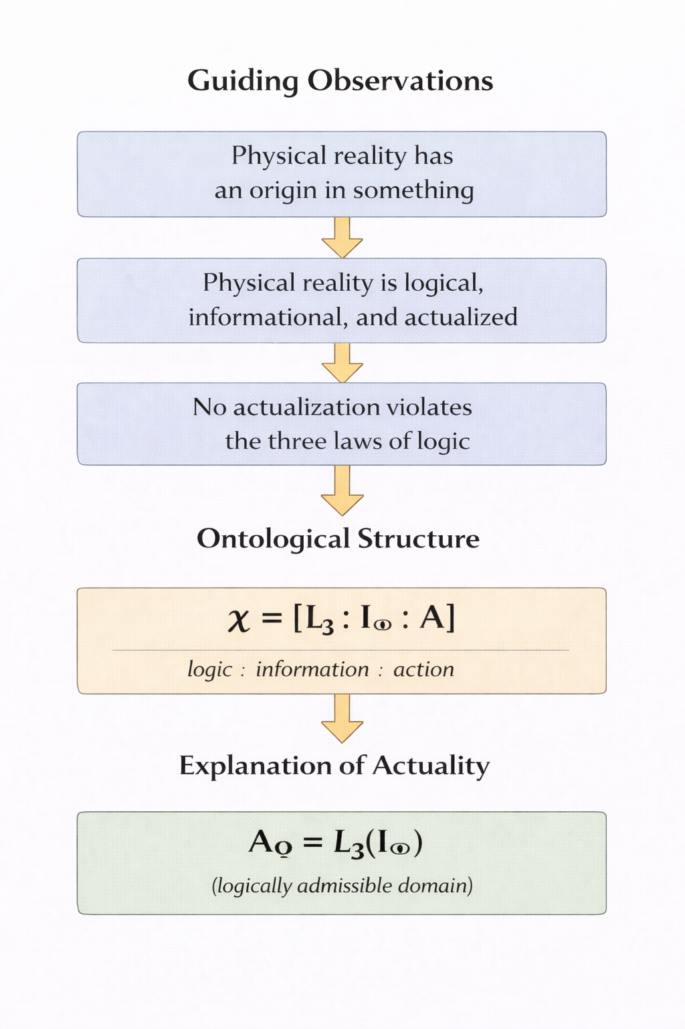
Figure 1: The complete grounding sequence. Guiding observations motivate the primitive ontology χ = [L₃ : I∞ : A], which grounds the actualized domain characterized by A_Ω = L₃(I∞).

1.1 Physical Reality Has an Origin
Physical reality has an origin in something. The origin need not be temporal; it may be ontological. But the idea that the totality of what exists is simply brute and underived is unstable. Even the denial that reality has an origin presupposes some background structure in virtue of which the denial is meaningful.
This observation deepens into an impossibility argument. Absolute nothing (the complete absence of being, structure, constraint, and possibility) cannot generate or ground existence. This is not merely an empirical observation but a logical necessity: nothing has no properties, including the property of being able to produce something.

1.2 Physical Reality Is Logical, Informational, and Dynamic
Our physical theories presuppose logical constraint: certain configurations are excluded as impossible. They describe systems through structured distinctions (states, fields, amplitudes) which are naturally interpreted as informational. And they encode change: systems evolve, transition, and actualize states.

1.3 No Actuality Violates the Fundamental Laws of Logic
Apparent anomalies in physics never license genuine contradiction. Superposition, contextuality, and nonlocal correlations challenge classical intuitions, but they do not instantiate violations of identity, non-contradiction, or excluded middle. The working assumption of physics is that whatever is physically actual must be logically admissible.

1.4 The Primitive Ontology and Two Core Results
The three observations motivate three primitives:
Observation | Primitive
Reality has an origin | Ontological unity χ
Logical/informational/dynamic structure | L₃, I∞, A
No actuality violates logic | Bridge constraint

The primitives form a co-constitutive unity:
χ ≡ [L₃ : I∞ : A]
The third observation yields the bridge equation: actuality coincides with the logically admissible configurations of the informational domain:
A_Ω = L₃(I∞)

1.5 Division of Labor: TAB and LRT-MASTER
This paper (TAB, Part I) develops the ontological groundwork only: the transcendental argument for χ ≡ [L₃ : I∞ : A] and the bridge identity A_Ω = L₃(I∞). No physical formalisms are derived here.
The physics reconstruction proceeds in the companion paper (LRT-MASTER, Part II), which imports the bridge identity as its starting point and derives the full structure of non-relativistic quantum mechanics: complex Hilbert space, projection-valued measures, the Born rule, continuous time, and the Schrödinger equation.

2. Necessity of Logical Constraint (L₃)

2.1 The Prescriptive Character of Logic
Logical constraint is not a description of how minds happen to think. It is a prescriptive structure governing what can and cannot obtain. The law of non-contradiction (a thing cannot both be and not be in the same respect at the same time) is not a psychological generalization but an ontological constraint.

2.2 From Inference to Ontology
A referee will rightly ask: why does the impossibility of asserting contradictions entail the impossibility of ontological contradiction? The bridge requires an additional step.
Determinate existence requires stable identity conditions. For something to be, it must be what it is and not something else. Contradictory states destroy identity conditions: if Px and not-Px hold simultaneously, x has no stable identity with respect to P. Such a state is not merely unthinkable; it is ontologically inadmissible. There is nothing for it to be.

2.3 L₃ as Prescriptive Constraint Structure
We designate the prescriptive logical constraint structure as L₃, signifying its triadic character: identity, non-contradiction, and excluded middle. These are not separate principles but aspects of a unified constraint on determinate being.
Identity: For any x, x = x. A thing is what it is.
Non-contradiction: For any x and property P, not (Px and not-Px) in the same respect at the same time.
Excluded middle: For any x and property P, either Px or not-Px.

2.4 From Epistemic to Transcendental Necessity
A careful distinction is required here between two types of necessity:
Epistemic necessity: We cannot coherently represent or reason about reality without presupposing L₃.
Transcendental necessity: L₃ is required for the possibility of any determinate being whatsoever.
The arguments above establish epistemic necessity directly. The skeptic cannot formulate their skepticism without invoking what they deny. But does this entail transcendental necessity? Could reality itself violate L₃ even if we cannot represent that possibility?
The answer is no, and the reason goes beyond mere representational limits. The argument from §2.2 establishes that determinate existence requires stable identity conditions. Contradictions do not merely evade our representation; they fail to constitute anything at all.

3. Necessity of Informational Domain (I∞)

3.1 The Requirement of Differentiation
Existence is determinate existence. For anything to be actual, it must be this rather than that. Determinacy requires differentiation, and differentiation requires a domain of possible distinctions.

3.2 Information as Structured Distinction
We understand information in the fundamental sense as structured distinction. Information is not primarily about messages or signals (though these are derivative). It is about the possibility of distinguishing configurations.

3.3 I∞ as Total Possibility Space
We designate the total informational possibility space as I∞. The subscript signifies completeness rather than cardinality. This distinction matters: the argument does not claim that the possibility space is numerically infinite, but that it is complete with respect to possible distinctions.

4. Necessity of Actualization (A)

4.1 The Gap Between Possibility and Actuality
L₃ and I∞ together provide logical constraint and a possibility space. But they do not yet account for actuality. Many configurations are logically consistent and informationally possible but do not obtain. Why these configurations rather than those?

4.2 A as Primitive Marking
We designate the actualization primitive as A. Its role is to mark configurations as obtaining. This marking is not explanatorily further reducible.
A critical distinction: actualization is ontologically primitive, not random. Randomness is a positive characteristic; it presupposes a probability distribution governing outcomes. A has no such characteristic. It is not that A "randomly chooses" configurations; rather, A is the primitive marking of obtaining, prior to any selection mechanism.

4.3 The Ontological Status of A
A is transcendentally necessary because without it, the gap between possibility and actuality cannot be bridged. L₃ constrains what can obtain. I∞ provides the domain of what might obtain. But neither makes anything actual. Actuality requires a primitive that is not reducible to constraint or possibility.

4.4 A's Grounding Role and the Bridge Identity
A potential objection arises from the bridge identity derived below: if A_Ω = L₃(I∞), has A disappeared from the resulting ontology? Is it explanatorily idle?
The answer requires distinguishing two questions:
1. What is the structure of the actualized domain? The bridge identity answers: L₃(I∞). The structural profile of actuality coincides with the L₃-admissible configurations of I∞.
2. Why is there an actualized domain at all? A answers: because actualization is a primitive fact. Without A, there would be a space of admissible configurations with no fact of the matter about which obtain.

5. Interaction of the Primitives

5.1 The Primitive Ontology
We now have three primitives, each transcendentally necessary:
L₃: Prescriptive logical constraint structure
I∞: Total informational possibility space
A: Actualization primitive
We designate their unity as χ:
χ ≡ [L₃ : I∞ : A]

5.2 Mutual Dependence
L₃ without I∞ would be constraint on nothing—a structure with no domain to constrain. I∞ without L₃ would be an undifferentiated plenum with no internal structure—configurations would blur into one another without the possibility of distinction. A without both would have nothing to actualize and no principle distinguishing coherent from incoherent configurations.

5.3 Non-Redundancy of the Primitive Set
The mutual dependence argument establishes that the primitives require one another. A stronger claim is available: no proper subset of {L₃, I∞, A} suffices for determinate actuality.

6. The Bridge Argument

6.1 The Grounding Sequence
We now present the core argument in three steps.
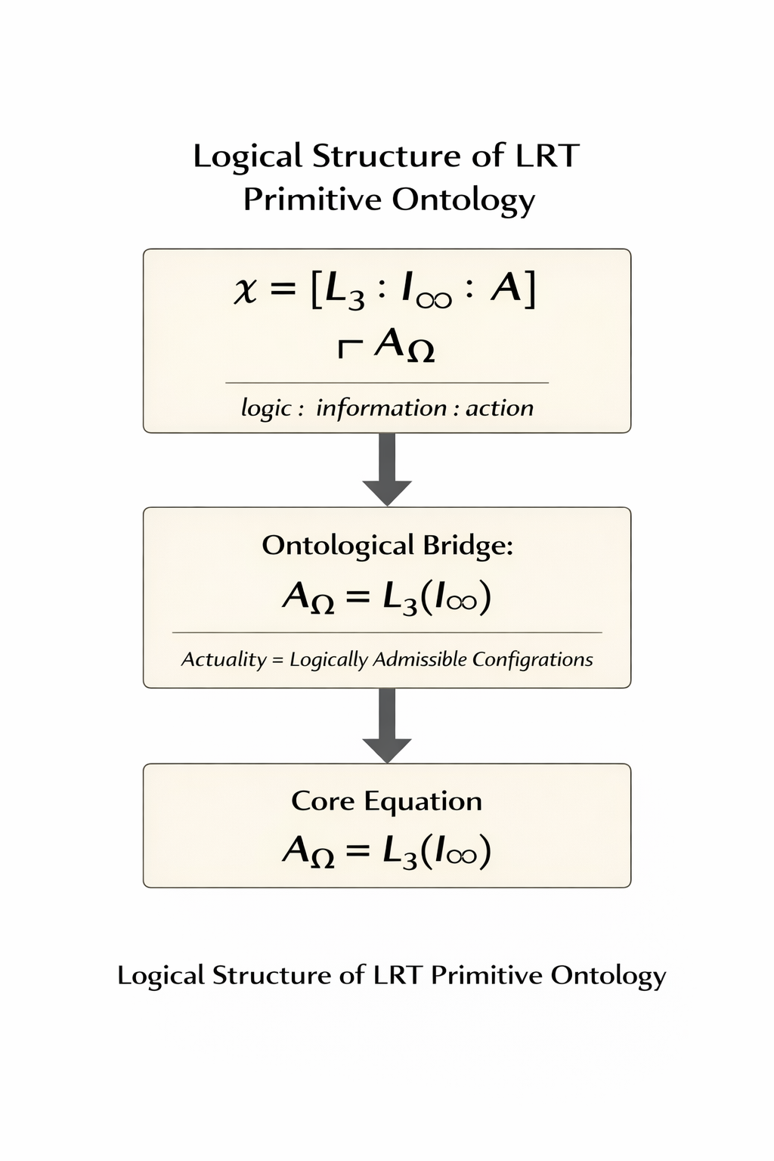
Figure 2: The equations-only view. Three observations motivate three primitives, yielding the primitive ontology and bridge identity.
Step 1: The Primitive Ontology
χ ≡ [L₃ : I∞ : A]
Step 2: The Grounding Relation
χ ⊢ A_Ω
Step 3: The Bridge Identity
A_Ω = L₃(I∞)

6.2 Status of the Bridge Equation
The bridge equation is an argued metaphysical identity. It is not:
• A definition: We are not stipulating that A_Ω means L₃(I∞). We are arguing that the structure of actuality, given the primitives, coincides with this characterization.
• A formal theorem: The argument is transcendental, not axiomatic. Formal verification can establish the internal consistency of the derivation chain, but the metaphysical warrant comes from the transcendental arguments of Sections 2–4.

6.3 The Bridge Lemma
The physics reconstruction in Part II requires a specific connection between the ontological primitives established here and the operational constraints that generate quantum structure. This connection is summarized as the Bridge Lemma:
Bridge Lemma. If A_Ω = L₃(I∞), then any proposition about a configuration c ∈ A_Ω satisfies L₃. Satisfying L₃ requires determinate content, which requires operational distinguishability. Therefore, every physical proposition is operationally distinguishable.

7. Discussion: Locating TAB in Information Ontology and Logic Realism
The transcendental derivation of the Bridge Identity establishes a prescriptive floor beneath contemporary information-based ontologies of physics. Much recent work proposes that physical reality is informational or mathematical in character. These frameworks often identify informational structure as fundamental but leave unresolved a central question: under what condition does informational possibility become concrete physical actuality?

7.1 From "It from Bit" to Logical Actualization
John Archibald Wheeler's "It from Bit" proposal suggested that physical reality arises from binary informational distinctions. Physical states correspond to answers to yes–no questions, and the structure of the universe reflects the accumulation of such informational choices.
Within TAB the distinction becomes explicit. Informational possibility is represented by the total informational domain I∞, the space of all structured distinctions. Physical actuality corresponds to the domain of configurations that obtain, A_Ω.

7.2 Static Plenums and the Role of Primitive Action
A different informational ontology appears in Max Tegmark's Mathematical Universe Hypothesis (MUH), which proposes that mathematical structure itself constitutes physical reality. Within this framework every consistent mathematical structure exists. Possibility and actuality collapse into a single category.
TAB preserves a distinction between these domains. Logical syntax and informational structure provide the formal vocabulary of possible configurations, but possibility does not entail actuality. A further primitive is required to mark which configurations obtain.

7.7 Contrast with Modal Realism
A natural question arises concerning the ontological status of non-actual configurations in I∞. If I∞ contains all L₃-admissible configurations, do the non-actualized ones "exist" in some robust sense?
TAB differs sharply from Lewisian modal realism, which treats non-actual possible worlds as concrete existents on par with our own. In TAB, non-actualized configurations in I∞ are structural possibilities, not concrete worlds. They are the configurations that L₃ permits and that A could mark as obtaining, but which lack the obtaining marker.

8. Consequences for Ontology

8.1 What the Equation Claims
The bridge equation establishes that the structure of actuality is not arbitrary. Reality has a form: it is the logically admissible informational configurations of the total possibility space. This form is not imposed from outside but constituted by the interaction of the primitives.

8.2 What the Equation Does Not Claim
The bridge equation does not claim:
• That we can derive specific physical laws from pure reason. Physics requires additional assumptions (empirical regularities, operational constraints) that are not contained in the primitive ontology.
• That the primitives are causally prior to the physical world. The grounding relation is not temporal.
• That the bridge equation is empirically testable in isolation. The equation is a framework, not a hypothesis.

9. Conclusion
We have argued that three primitives—prescriptive logical constraint (L₃), total informational possibility (I∞), and actualization (A)—are each transcendentally necessary and jointly constitute the minimal ontology of reality. Their interaction yields the core physics bridge of Logic Realism Theory.
──────────────────────────────
Bridge Result
χ ≡ [L₃ : I∞ : A]
χ ⊢ A_Ω
A_Ω = L₃(I∞)
──────────────────────────────
Actuality coincides with the logically admissible informational configurations of the total possibility space.

9.1 Outlook for Physics
The bridge identity constrains candidate physical theories in at least one concrete way: any physical structure must be realizable within A_Ω = L₃(I∞). This rules out physical theories that require ontological contradictions (states that are both P and not-P), configurations that cannot be distinguished from others (violations of identity), or structures that presuppose a possibility space narrower than L₃ permits without explanatory justification.

Appendix A: Primitive Definitions
Symbol | Name | Definition
L₃ | Prescriptive logical constraint structure | The triadic constraint of identity, non-contradiction, and excluded middle, understood as governing what can obtain, not merely what can be thought.
I∞ | Total informational possibility space | The complete domain of distinguishable configurations; exhausts the space of what might obtain.
A | Actualization primitive | The irreducible marking of configurations as obtaining; bridges possibility and actuality.
χ | Primitive ontology | The co-constitutive unity of L₃, I∞, and A: χ ≡ [L₃ : I∞ : A].
A_Ω | Actualized domain | The totality of what obtains; the result of A operating on I∞ under L₃.
L₃(I∞) | Logically admissible configurations | The subset of I∞ consisting of configurations that satisfy L₃.

Appendix B: Logical Notation
Symbol | Meaning
≡ | Definitional equivalence
⊢ | Ontological grounding (read: "grounds" or "constitutes")
χ | Chi; the primitive ontological unity
= | Identity
[A : B : C] | Co-constitutive unity of A, B, and C
∞ (subscript) | Completeness; exhausting the domain
Ω (subscript) | Actualized; obtaining

Appendix C: Formalization Status
The ontological framework presented in this paper has been partially formalized in Lean 4. The formalization project verifies the logical structure of the reconstruction chain that proceeds from the primitives established here. Current status (March 2026): 22 axioms, 0 unresolved proof obligations (sorries), representing a 50% reduction from the initial 44 axioms.

Axiom Classification
Category | Count | Description
PRIMITIVE | 3 | Ontological commitments (I, I_infinite, bridge_principle)
EXTERNAL | 19 | Established mathematics (Gleason, Stone, Hardy, etc.)
REMAINING | 0 | All derivable axioms converted to theorems

References
Chiribella, G., D'Ariano, G. M., & Perinotti, P. (2011). Informational derivation of quantum theory. Physical Review A, 84(1), 012311.
da Costa, N. C. A., & de Ronde, C. (2013). The paraconsistent logic of quantum superpositions. Foundations of Physics, 43(7), 845–858.
Floridi, L. (2011). The Philosophy of Information. Oxford University Press.
Hardy, L. (2001). Quantum theory from five reasonable axioms. arXiv preprint quant-ph/0101012.
Priest, G. (2006). In Contradiction: A Study of the Transconsistent (2nd ed.). Oxford University Press.
Tahko, T. E. (2014). The metaphysics of logic. In P. Rush (Ed.), The Metaphysics of Logic (pp. 1–17). Cambridge University Press.
Tegmark, M. (2014). Our Mathematical Universe: My Quest for the Ultimate Nature of Reality. Knopf.
Wheeler, J. A. (1990). Information, physics, quantum: The search for links. In W. H. Zurek (Ed.), Complexity, Entropy, and the Physics of Information (pp. 3–28). Addison-Wesley.

