**Towards Enhancing Usability and Modularity   
of the PRAGMA Cloud Scheduler**

Nannapas Banluesombatkul1, Prapansak Kaewlamul1, Shava Smallen2,

Nadya Williams2, Prapaporn Rattanatamrong1

1 Thammasat University, Thailand

2 University of California, San Diego

Demo requirements: time approximately10-15 mins, projector

The PRAGMA Cloud Scheduler provides researchers the capability for reserving shared computing resources which are distributed in many sites. The early version of this scheduler is implemented using an open-source web-based reservation software called Booked Scheduler, which provides a graphical user interface in a time table style and a powerful API to access its database with minimal development time. The PRAGMA Cloud Scheduler was previously reported to serve quite well the purpose of lightweight scheduling for a small group of users at the beginning stage of the PRAGMA Cloud.

During the PRAGMA31 Workshop, one of the issues being discussed is the limitation of the PRAGMA Cloud Scheduler in supporting broader group of users, including those who might not have intensive computing background like students or researchers from other fields. The PRAGMA31 Student Hackathon successfully set the first attempt in improving the user interface design of the PRAGMA Cloud Scheduler. We applied human-computer interaction principles to design a user interface in a dashboard style together with an interactive map that users can directly manipulate to view sites’ information. Follow-up discussion after the PRAGMA31 Workshop with the members of the Resource Working Group also highlighted the possibility of recent and ongoing PRAGMA/CENTRA projects bringing in new types of resources to share, such as sensors or data storages; this requires that the user interface design and backend implementation of PRAGMA Cloud Scheduler become flexible enough to accommodate the addition of these and other new resources without much trouble.

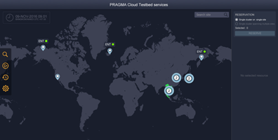To address the above requirements, we propose the new design and implementation of the PRAGMA Cloud Scheduler with enhanced usability and modularity. The web-based system is divided into 3 main layers. First, the presentation layer provides the user interface designed with the MVC Model (Model, View and Controller) and developed with the ReactJS framework, which is compatible with the component-based design to improve readability and maintainability of the code. Second, the business layer is responsible for determining the logic, changing, processing, and application data services. This layer is developed using an object-oriented programming paradigm in Python and based on the SOLID principle to ensure that each component includes only necessary source code, have their own clear single function and is open for further expansion in the future without excessive code modification. Third, the data layer provides data storage for the system. We decided to recreate and use the database in MySQL in order to keep the data layer as concise and efficient as possible instead of using the Booked API in accessing the resource site and reservation data.

This demo will provide an overview of the developed system and demonstrate how users can find sites’ locations on the map and view their descriptions, how users can search sites with different criteria, how users can create a reservation, and view status of their reservations.