**Task Analysis**

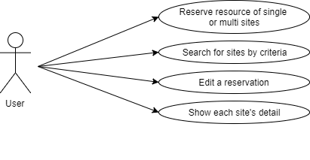

Use case diagram

I make 3 groups of users and pick a people who is an agent for each group. In addition I make a persona and write scenario for Task analysis. (link : <https://app.xtensio.com/folio/0l6ce4xg>)

1. First group is represent for users that rarely have computer skill. In addition they never used to use Cloud. The Persona image below is example people in this group.

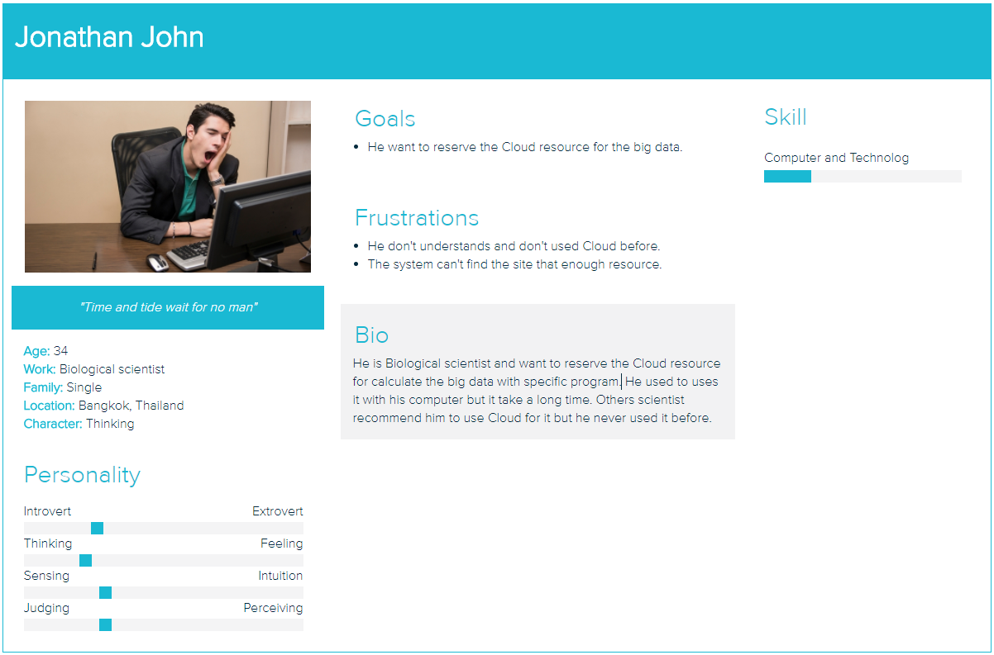

1. Second group is represent for users that fluent computer skill and used to use Cloud. The Persona image below is example people in this group.

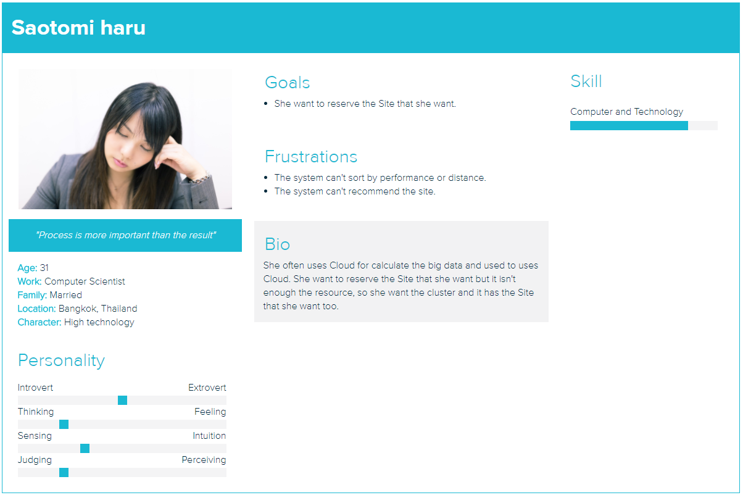

1. Last group is represent for users that fluent computer skill but never used to use Cloud. The Persona image below is example people in this group.

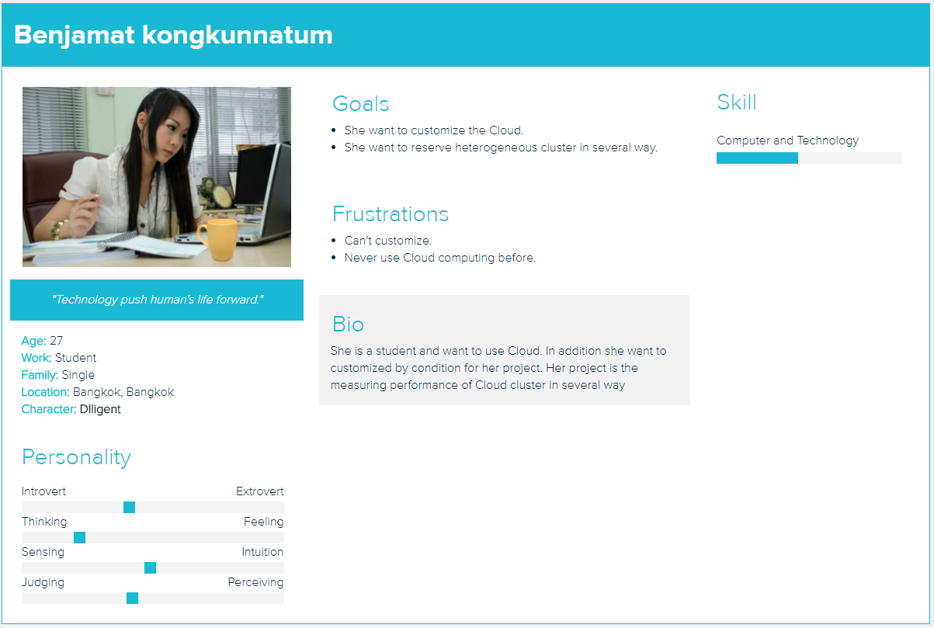

After I make 3 groups and 3 persona, I simulate the situation from each use case and analysis each step.

