**Frontend**

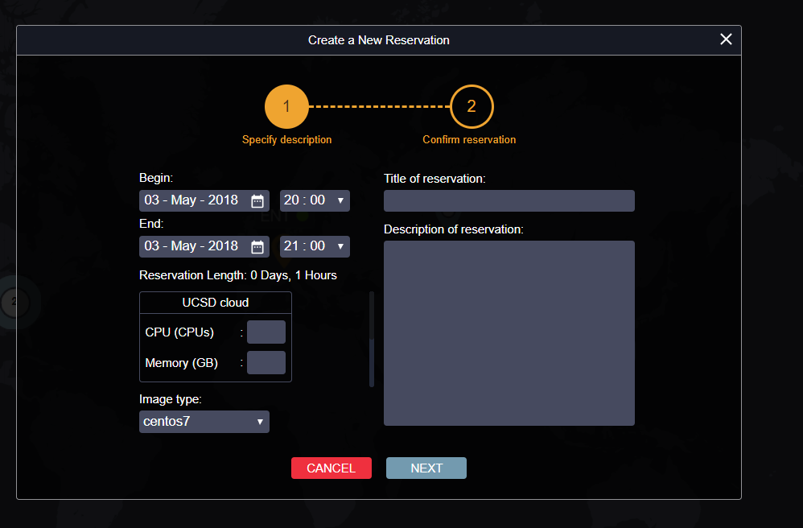

I changed the flow of reservation to 2 step.

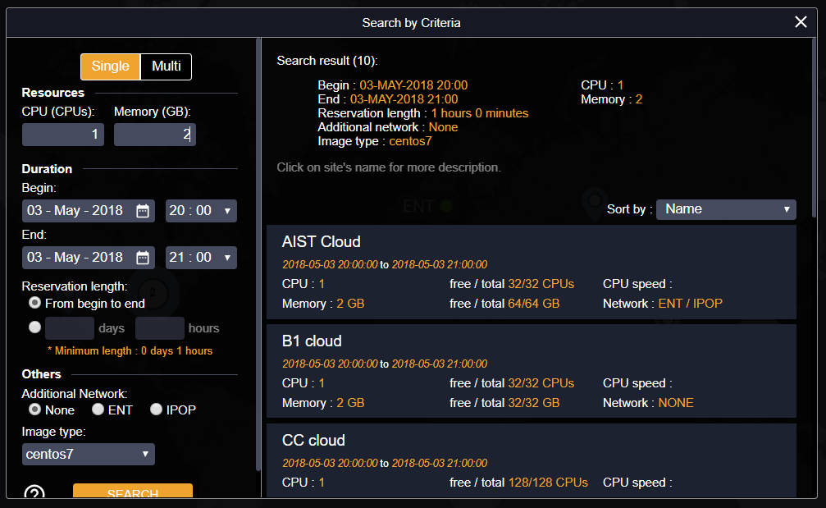

In addition, I added the selected button for sort the result and added the checking search input for the memory must be more than double of the CPU.

Backend

I added the search in the 80/20, but still the problem in the search for the "most resources left over", which I tried to solve in the section. It is  
In the case of the case, I have tried to add a 3site search pattern because I found that the search in 3site is less likely to be found compared to the 2site case with 4site. One may be because it is difficult to divide numbers.

You can view the case from the file sent up to github or link below.

<https://docs.google.com/spreadsheets/d/1VW34nL9z_ZhDmFf0kE3hvk3CbFNKcHtfpLDZO4K_tEs/edit?usp=sharing>