Consul on Foreign Relations Report
My family heritage has been destroyed since the 60’s it began with the Beatles in 1963 and there talk about ‘love’, love does mater but not at first it is about getting the child correct first love should be learned. I grew up happy it was aft my mother passed that I began to awake and be more aware I do have a stammer or stutter. I was diagnosed in 2002 with schizoaffective disorder and haven’t had a woman in 23 years. I’m English-German and Ashkenazi Jewish haplogroup's H3G1 and R-Z9. H3G1 has a lot of protective alleles. Rare in Eastern Europe and 1.6% Neanderthal. Below the National Average of 2.4%.
I'm an INTJ-T top 2 percent of the global population. I have worked for Adobe and been a Microsoft partner. I value education over money, but am wealthy. I'm a member of Mensa on Linked in. Rare in Eastern Europe and 1.6% Neanderthal And 2.6% Denisovan. And I do not consider myself an American but an artistic Englishman. I’m kind of angry ant Microsoft and Adobe for never calling or making my work feel significant I blame the banks for the money the IP does have value and is valued at a cost basis with COCOMO II. I received straight A's in computer science in college at Tenn Tech and a 3.0 at UVa.
I’m Moral, Loyal, Educated, and like Computer Science, Music, and Reading, I am a Moore #1 Irish/British pedigree. and Heritage activist. Microsoft Partner and now Adobe contract. Royal Society of the Arts Fellow. I don't believe in making a persons heritage extinct only forward and extant. And vote Libertarian or Green. I frequently read Burke's Peerage. Finally was awarded my title of nobility from the UK. And I also know society is zero sum and will only go to fairs.
I also helped win two Nobel Prizes one for the Higgs Boson and one for Gravitational Waves through BOINC. I make a sustainable intangible income through copyrights and through cost basis valuation with COCOMO II engineering models. I'm in the Virginia and National Associations for the gifted.
I think that a person in technology is never misdiagnosed due to the misunderstanding of or by physicians. That a person who is a college alumni or tests high on psychological tests or tests with a high IQ not go without procreation or startup funding if the university student has enough credits to be an alumni. That the alumni always has the equipment need for his/her career. That heritage is earned not given to people through science such as decision-making stem cell projects. That people on social media and social websites be given university credit in there given field for the content they write or share articles about. That people of royal decedent or surnames in nobility (burkes’s peerage) peerage be given more financial and relationship security with the same nobility In the United States Furthermore according to research I’ve conducted being smart does not help your chances to pass your genes on into the gene pool and this may be one reason why the human species is getting dumber. And lastly I believe there should be a class of nobility in the United States. I cannot knowingly stand by and allow the heritage of great families of the world be ruined by promiscuous sexual endeavors knowing that medically and genetically it is heritage that makes a person live the longest. In most cases. Also I’m requesting help with the checking account equity act of 1980. In the United States And am proposing bureaucratic and aristocratic segregation for health reasons. I believe America should have a monarchy because monarchy is the best form of government. I have conducted my research on Elizabeth the I and know she was one of the best monarchy’s of all time if not the best. Humanity is losing its way through irresponsible sexual endeavors Elizabeth the I had Elizabethan marriages and I know about her ties to Islam. I’m Muslim now. But really don’t consider myself that religious anymore since I’m been studying quantum physics. I believe I have been misdiagnosed but no one will help Southwest Virginia is corrupt I’m not. The local news station WCYB is a fake news station. And needs to be brought to justice. I don’t have much family left I would like to start a family. I believe in free speech not consulting. I would like to be considered for grants. All of my accomplishments I can prove.
One Last thing the is only about 50 years’ worth of oil left according to Forbes an BP.
https://www.forbes.com/sites/judeclemente/2015/06/25/how-much-oil-does-the-world-have-left/
I did test as an INTJ-T genius in Britain. My test is in this document.
Jonathan Moore
414-41-8621
Fellowship No. 8155507
Copyright 2020
Jdm7dv@virginia.edu
1+ 276-696-1163
http://github.com/jdm7dv
www.jonathanmoore.net

Grades for Jonathan Moore
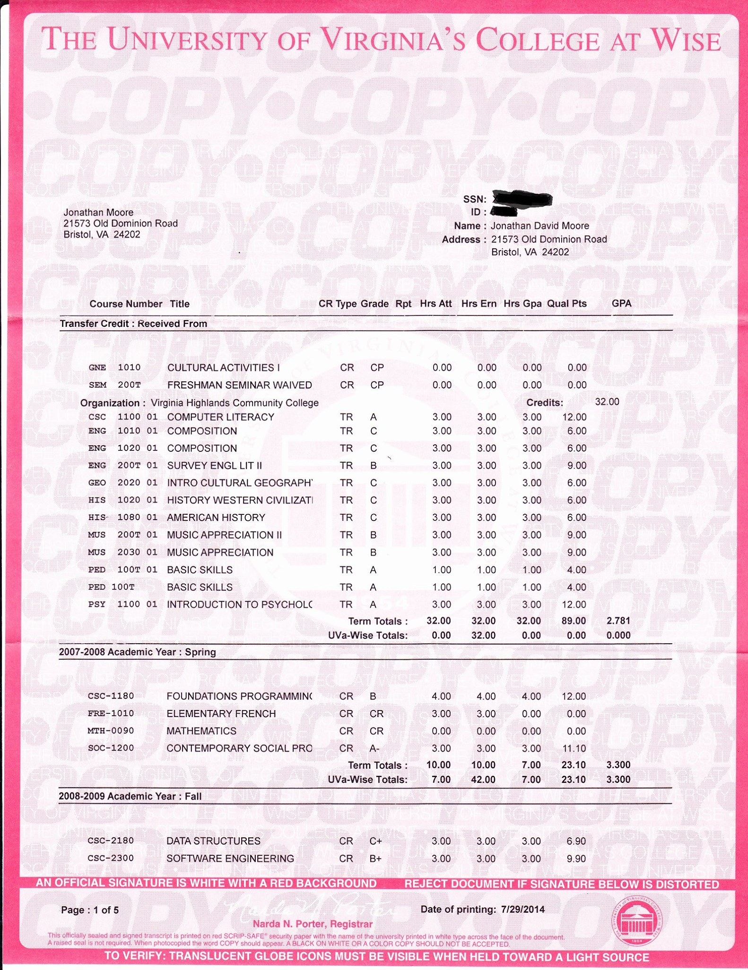
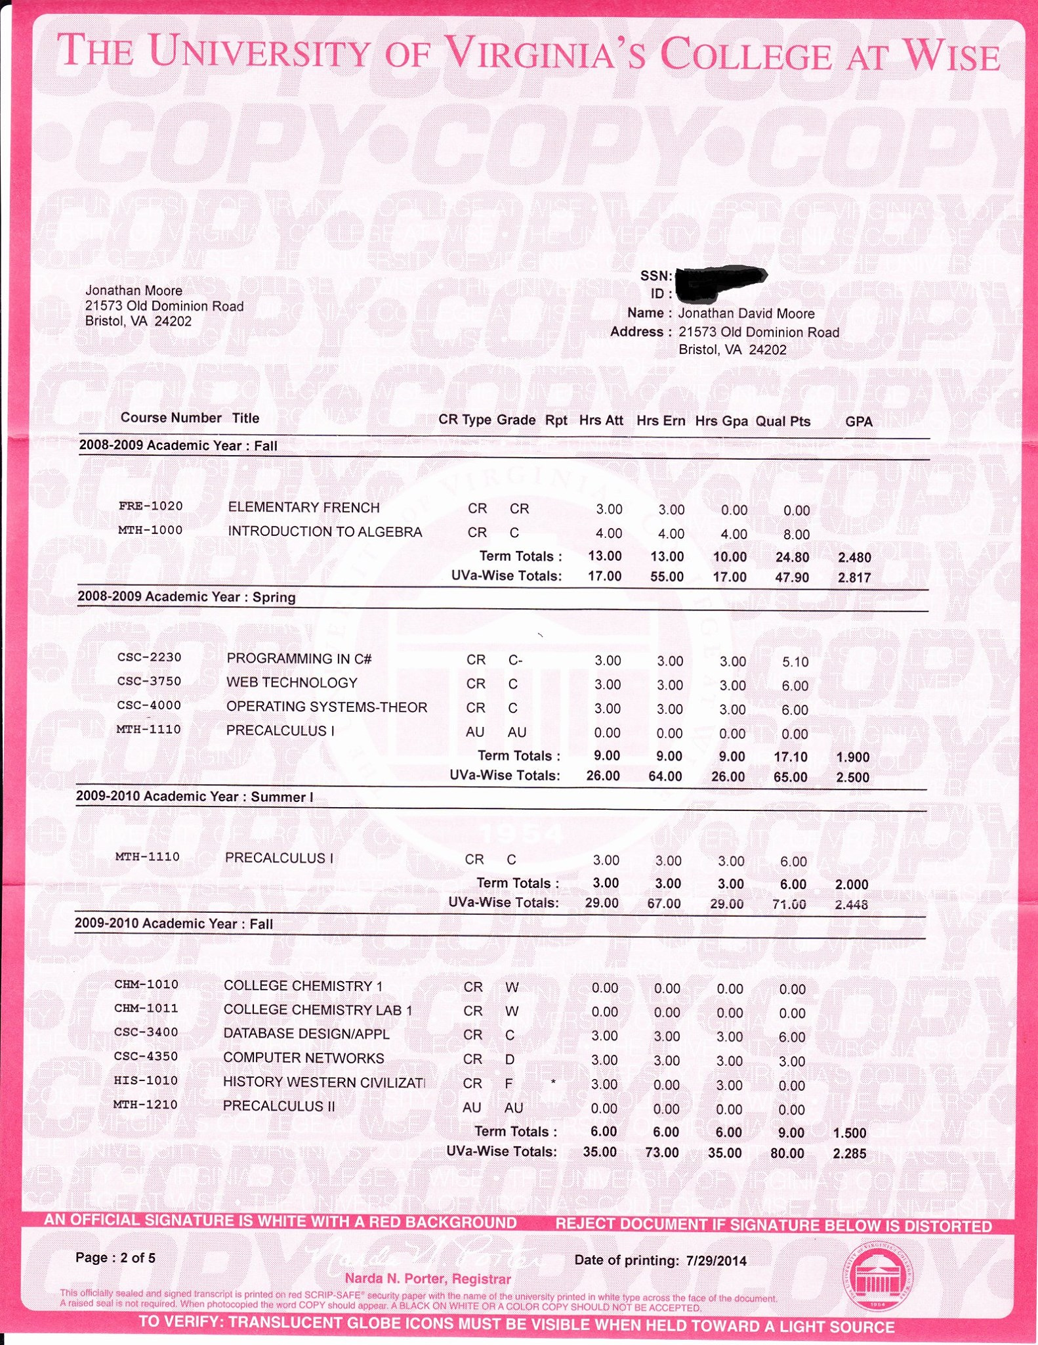


This valuation was done by David A Wheeler and his program that includes COCOMO II. And if was accepted by my bank just not in any account My accountant did say I could take a owners draw at cost basis but we were not sure if it would be a capital gain.

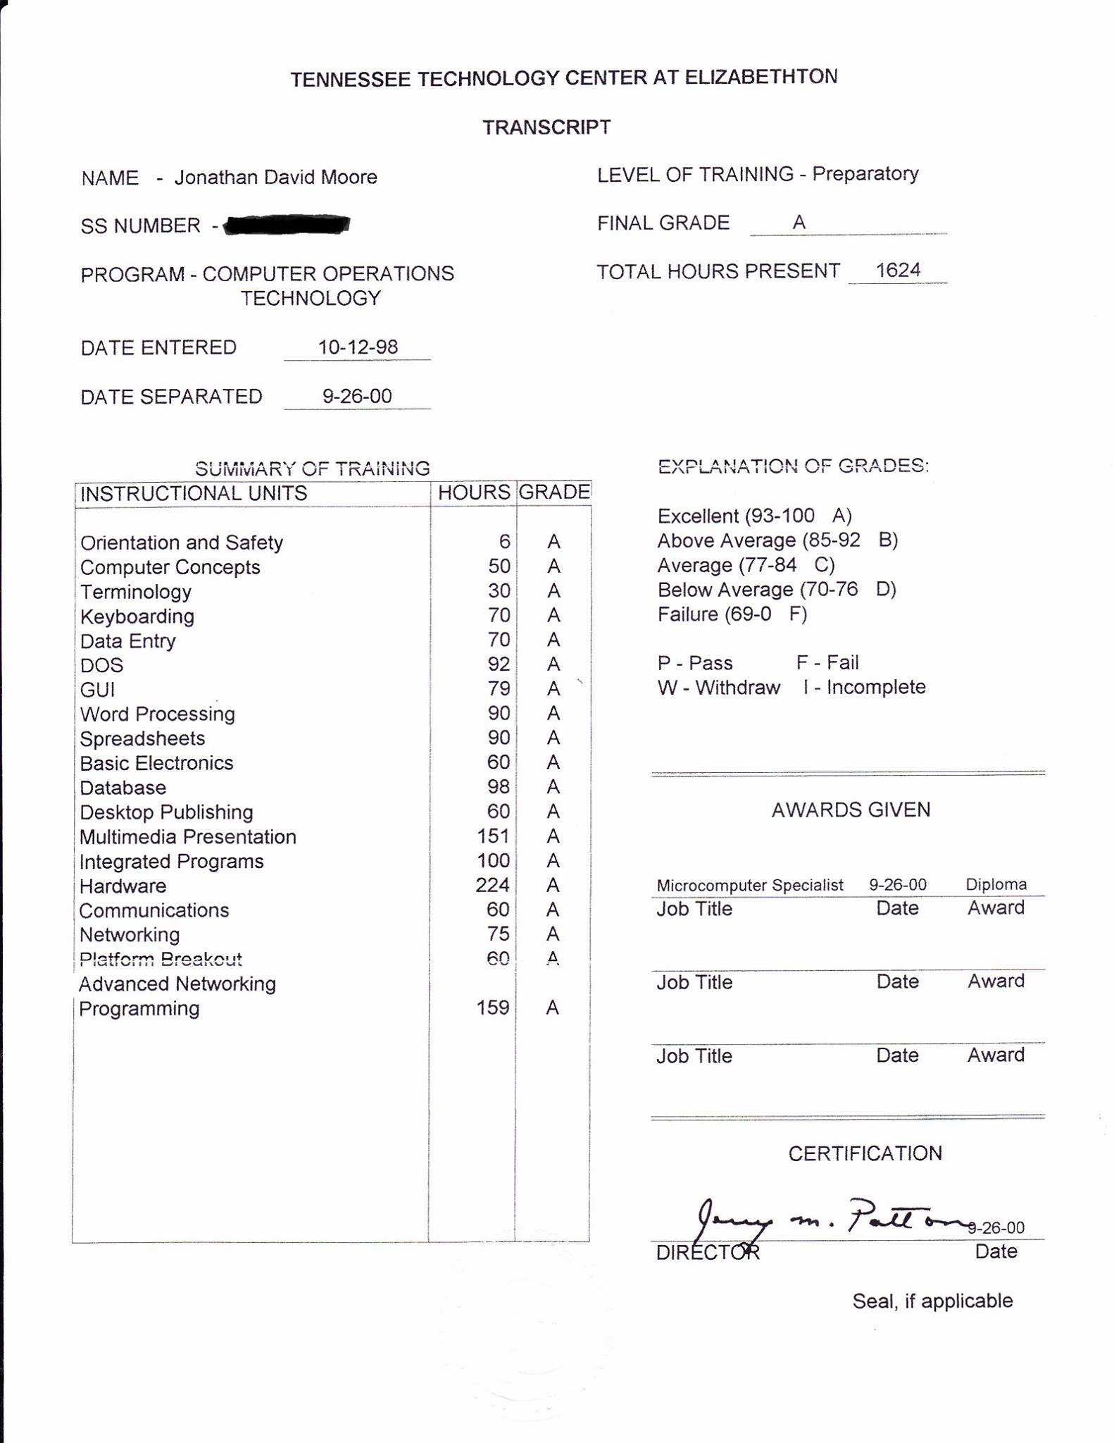
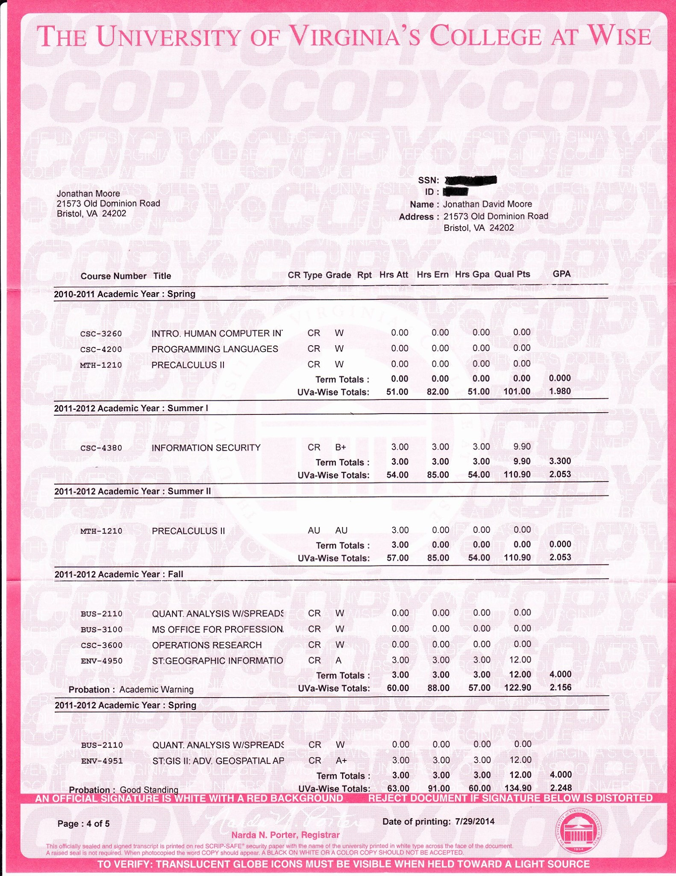

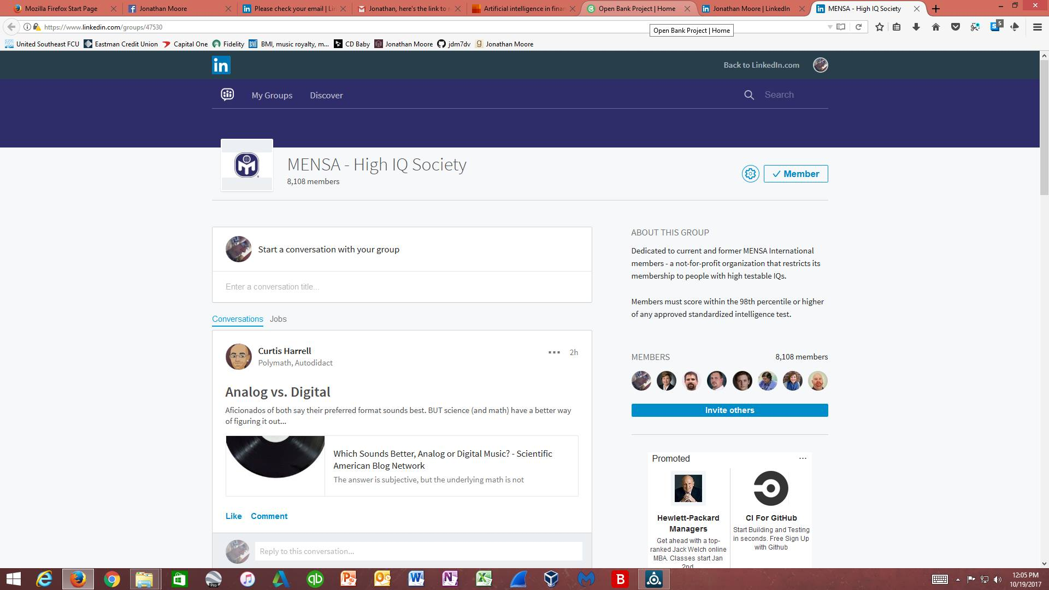

Politically correct labels and schizophrenia: a rose by any other name?
Heritage, health and well-being: assessing the impact of a heritage focused intervention on health and well-being
The Key to Genius
Report: Nonlethal Weapons Could Target Brain, Mimic Schizophrenia
Perfectionism and stuttering: Findings of an online survey
Creative minds 'mimic schizophrenia'
Evolutionary Economics
Stigma, schizophrenia and the media: exploring changes in the reporting of schizophrenia in major U.S. newspapers
America Hates Its Gifted Kids
Believe it or not, having a stammer can be a kind of a gift
Development of Auditory Sensitivity in Children Who Stutter and Fluent Children
Fake News TV Stations
Sexual Abuse and Lifetime Diagnosis of Psychiatric Disorders: Systematic Review and Meta-analysis

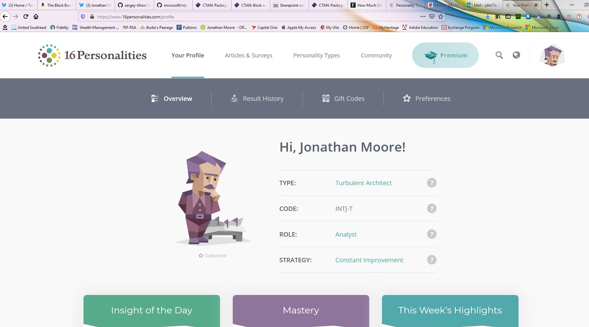

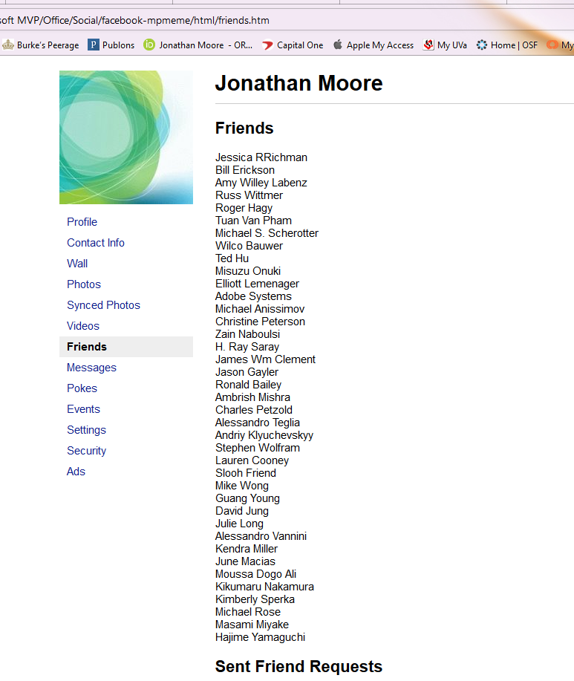
My Facebook friends before I was hacked.

https://www.ncbi.nlm.nih.gov/pubmed/11354587
https://www.tandfonline.com/doi/abs/10.1080/13527258.2011.651740
https://www.wired.com/2003/12/genius-2/
https://www.wired.com/2008/02/report-nonletha/
https://www.sciencedirect.com/science/article/pii/S0094730X1500008X
https://www.bbc.com/news/10154775
https://www.investopedia.com/terms/e/evolutionary-economics.asp
https://www.ncbi.nlm.nih.gov/pubmed/22108403
https://www.newsweek.com/america-hates-its-gifted-kids-226327
https://www.theguardian.com/commentisfree/2016/oct/22/stammer-awareness-gift-ed-balls-gareth-gates-stutter
https://www.ncbi.nlm.nih.gov/pmc/articles/PMC1999300/
https://www.prwatch.org/fakenews/tv-stations
https://www.ncbi.nlm.nih.gov/pmc/articles/PMC2894717/

