5:30 am Woke up this morning and gathered my social media archives, eating breakfast at

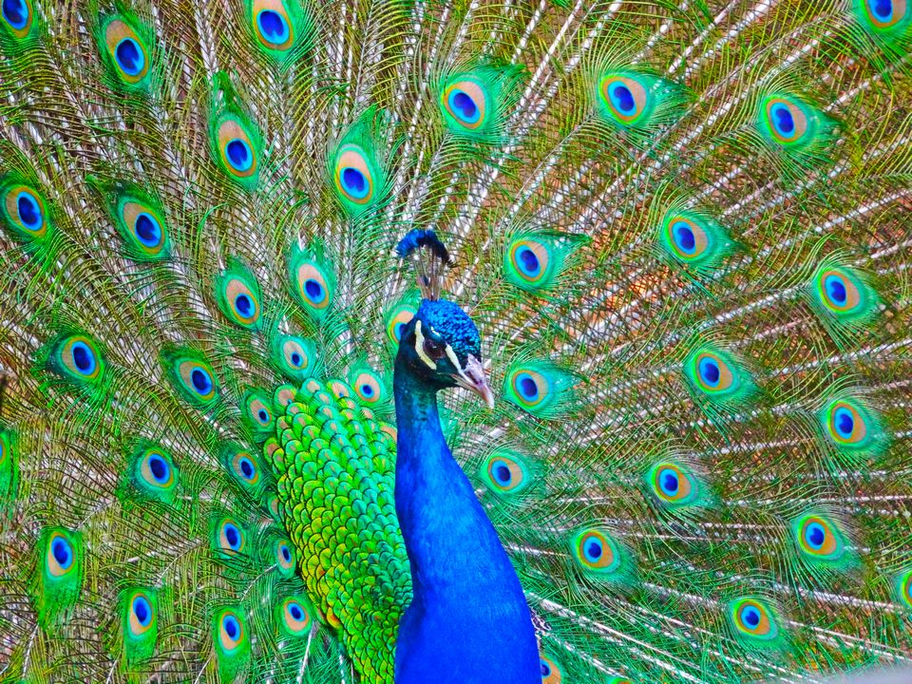
8:22 am After working a little on github I began to think about pride, what religion says and what work ethic says. My peacock feathers were ripped off of me by a social stigma diagnoses by a doctor who was jealous of my industry position a by one who wanted to keep the higher ups happy. Needless to say what effect that have on my love life. He must also been an abortion doctor. In 2013 open source won.

