Why would a person commit a crime and then discuss it openly in a public forum online? Publicly discussing one's crimes seems like a bid to be caught. Yet some users of online social media sites and discussion forums readily disclose information about the commission of crimes. This study explores some of the behavioral phenomena associated with disclosure of personally incriminating information on two sub-forums of the popular online discussion board Reddit (<https://www.reddit.com>).

Reddit, which bills itself as "the front page of the Internet," is a community-driven, corporate-owned discussion board comprising sub-forums—called "subreddits" or just "subs" on Reddit—on myriad topics and subjects. Individual thread topics often extend into the realm of the legally questionable; indeed, there are entire subreddits devoted to specific illegal behaviors.

In this study, qualitative content analysis of one week’s worth of forum posts on two drug forums and a statistical comparison of the resulting categorical data is employed in order to uncover differences between disclosure patterns on two subreddits dedicated to each illicit activity. We found seven major themes using inductive analysis: disclosure, instruction and advice, culture, community norms, moralizing, legality, and banter. Although the amounts of disclosure are similar in each subreddit, there are more instances of instruction and advice in discussions about opiates, and more examples of banter in comments about marijuana use. In fact, both subreddits had high incidences of banter. We argue that banter fosters disclosure in both subreddits, and that banter and disclosure are linked with information seeking behaviors in online forums.

Sample

1. [r/trees](http://reddit.com/r/trees), a forum frequented by marijuana users and advocates of marijuana legalization. Discussions regularly involve disclosure of activity explicitly deemed illegal by many jurisdictions (a fact acknowledged by forum participants), including but not limited to sale, distribution, use, and production of marijuana.
2. [r/opiates](http://reddit.com/r/opiates), a forum frequented by users of heroin and pharmaceutical-grade opiates and opioids. Discussions involve use of, sale of, abuse of, and addiction to opiates, as well as the adverse legal consequences of these activities.

Table 1.

*Codebook with categories, codes, and short descriptions.*

|  |  |  |
| --- | --- | --- |
| Category | Code | Description |
| Disclosure | DIS | Disclosing the act |
| Instruction/Advice | INS | Instructing or giving advice |
| Culture | CUL | Culture around the behavior (drug culture) |
| Community norms | COM | Referring to community rules/norms |
| Moralizing | MOR | Moralizing statements |
| Legality | LEG | Suggesting legal alternatives to activity |
| Banter | BNT | Banter, tangent, derail, unrelated topic |

Table 2.  
*Descriptive information about sample*

|  |  |  |  |
| --- | --- | --- | --- |
|  | Threads | Comments | Unique users |
| r/opiates | 62 | 1,266 | 355 |
| r/trees | 57 | 1,305 | 875 |
| Total | 121 | 2,571 | 1225* |

*\*There are 5 users who made comments in both or/opiates and r/trees.*

Comparing r/trees with r/opiates

According to a Pearson's Chi-squared test of independence, the differences between the two subreddits are statistically significant (, , ). To determine which categories made the largest contribution to these observed differences, we computed standardized residuals for each category as seen in Table 3.

Table 3.

*Chi-square observed, expected, and residual values*

|  |  |  |  |  |  |  |  |  |
| --- | --- | --- | --- | --- | --- | --- | --- | --- |
|  |  | DIS | INS | CUL | COM | MOR | LEG | BNT |
| r/opiates | Expected | 390.49 | 131.47 | 142.31 | 35.45 | 55.64 | 2.95 | 507.68 |
|  | Observed | 413.00 | 197.00 | 125.00 | 45.00 | 69.00 | 4.00 | 413.00 |
|  | Std. Res. | 1.92 | 8.47 | -2.16 | 2.28 | 2.57 | 0.85 | -7.62 |
| r/trees | Expected | 402.51 | 135.53 | 146.69 | 36.55 | 57.36 | 3.05 | 523.32 |
|  | Observed | 380.00 | 70.00 | 164.00 | 27.00 | 44.00 | 2.00 | 618.00 |
|  | Std. Res. | -1.92 | -8.47 | 2.16 | -2.28 | -2.57 | -0.85 | 7.62 |

Two categories contribute greatly to the significant difference between r/opiates and r/trees: instruction and banter. There is a more instruction than expected in r/opiates, and more banter than expected in r/trees. This can also be seen in the radial diagrams in Figures 3 and 4. Interestingly, although the users in r/trees have shorthand for disclosing their intoxication with marijuana while they are commenting, this does not have much an effect on the actual amount of disclosure in the subreddit.

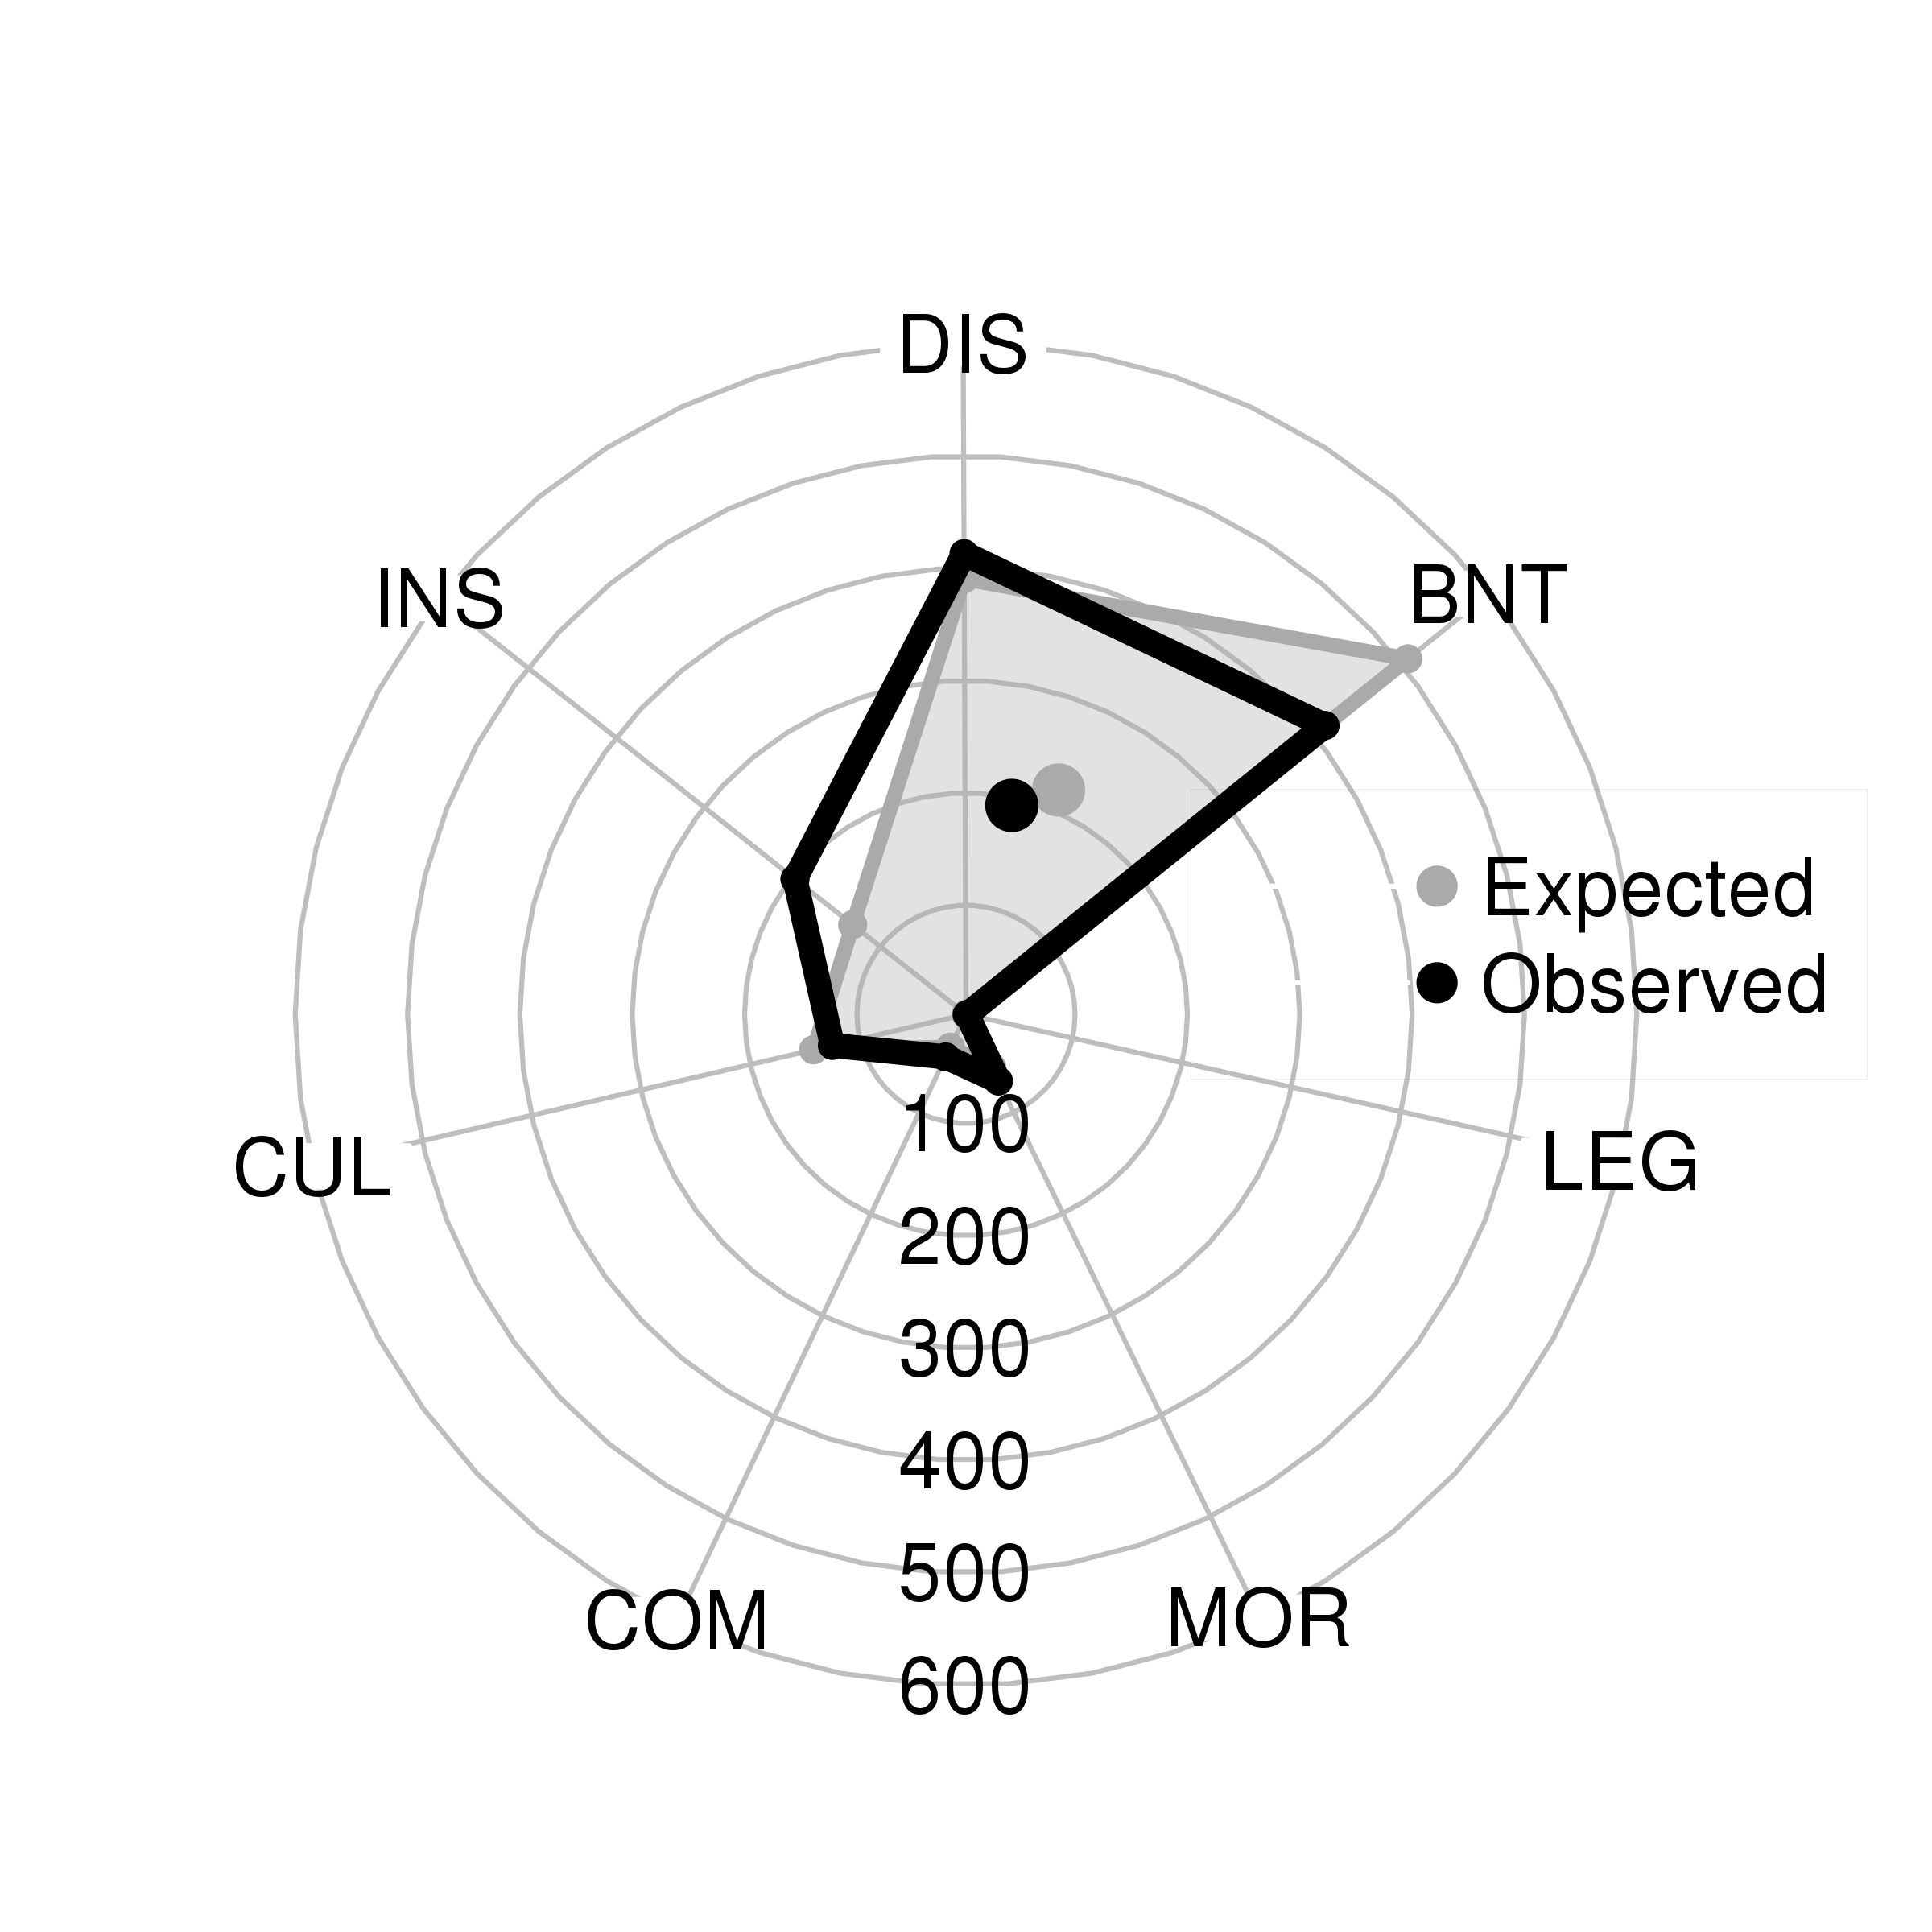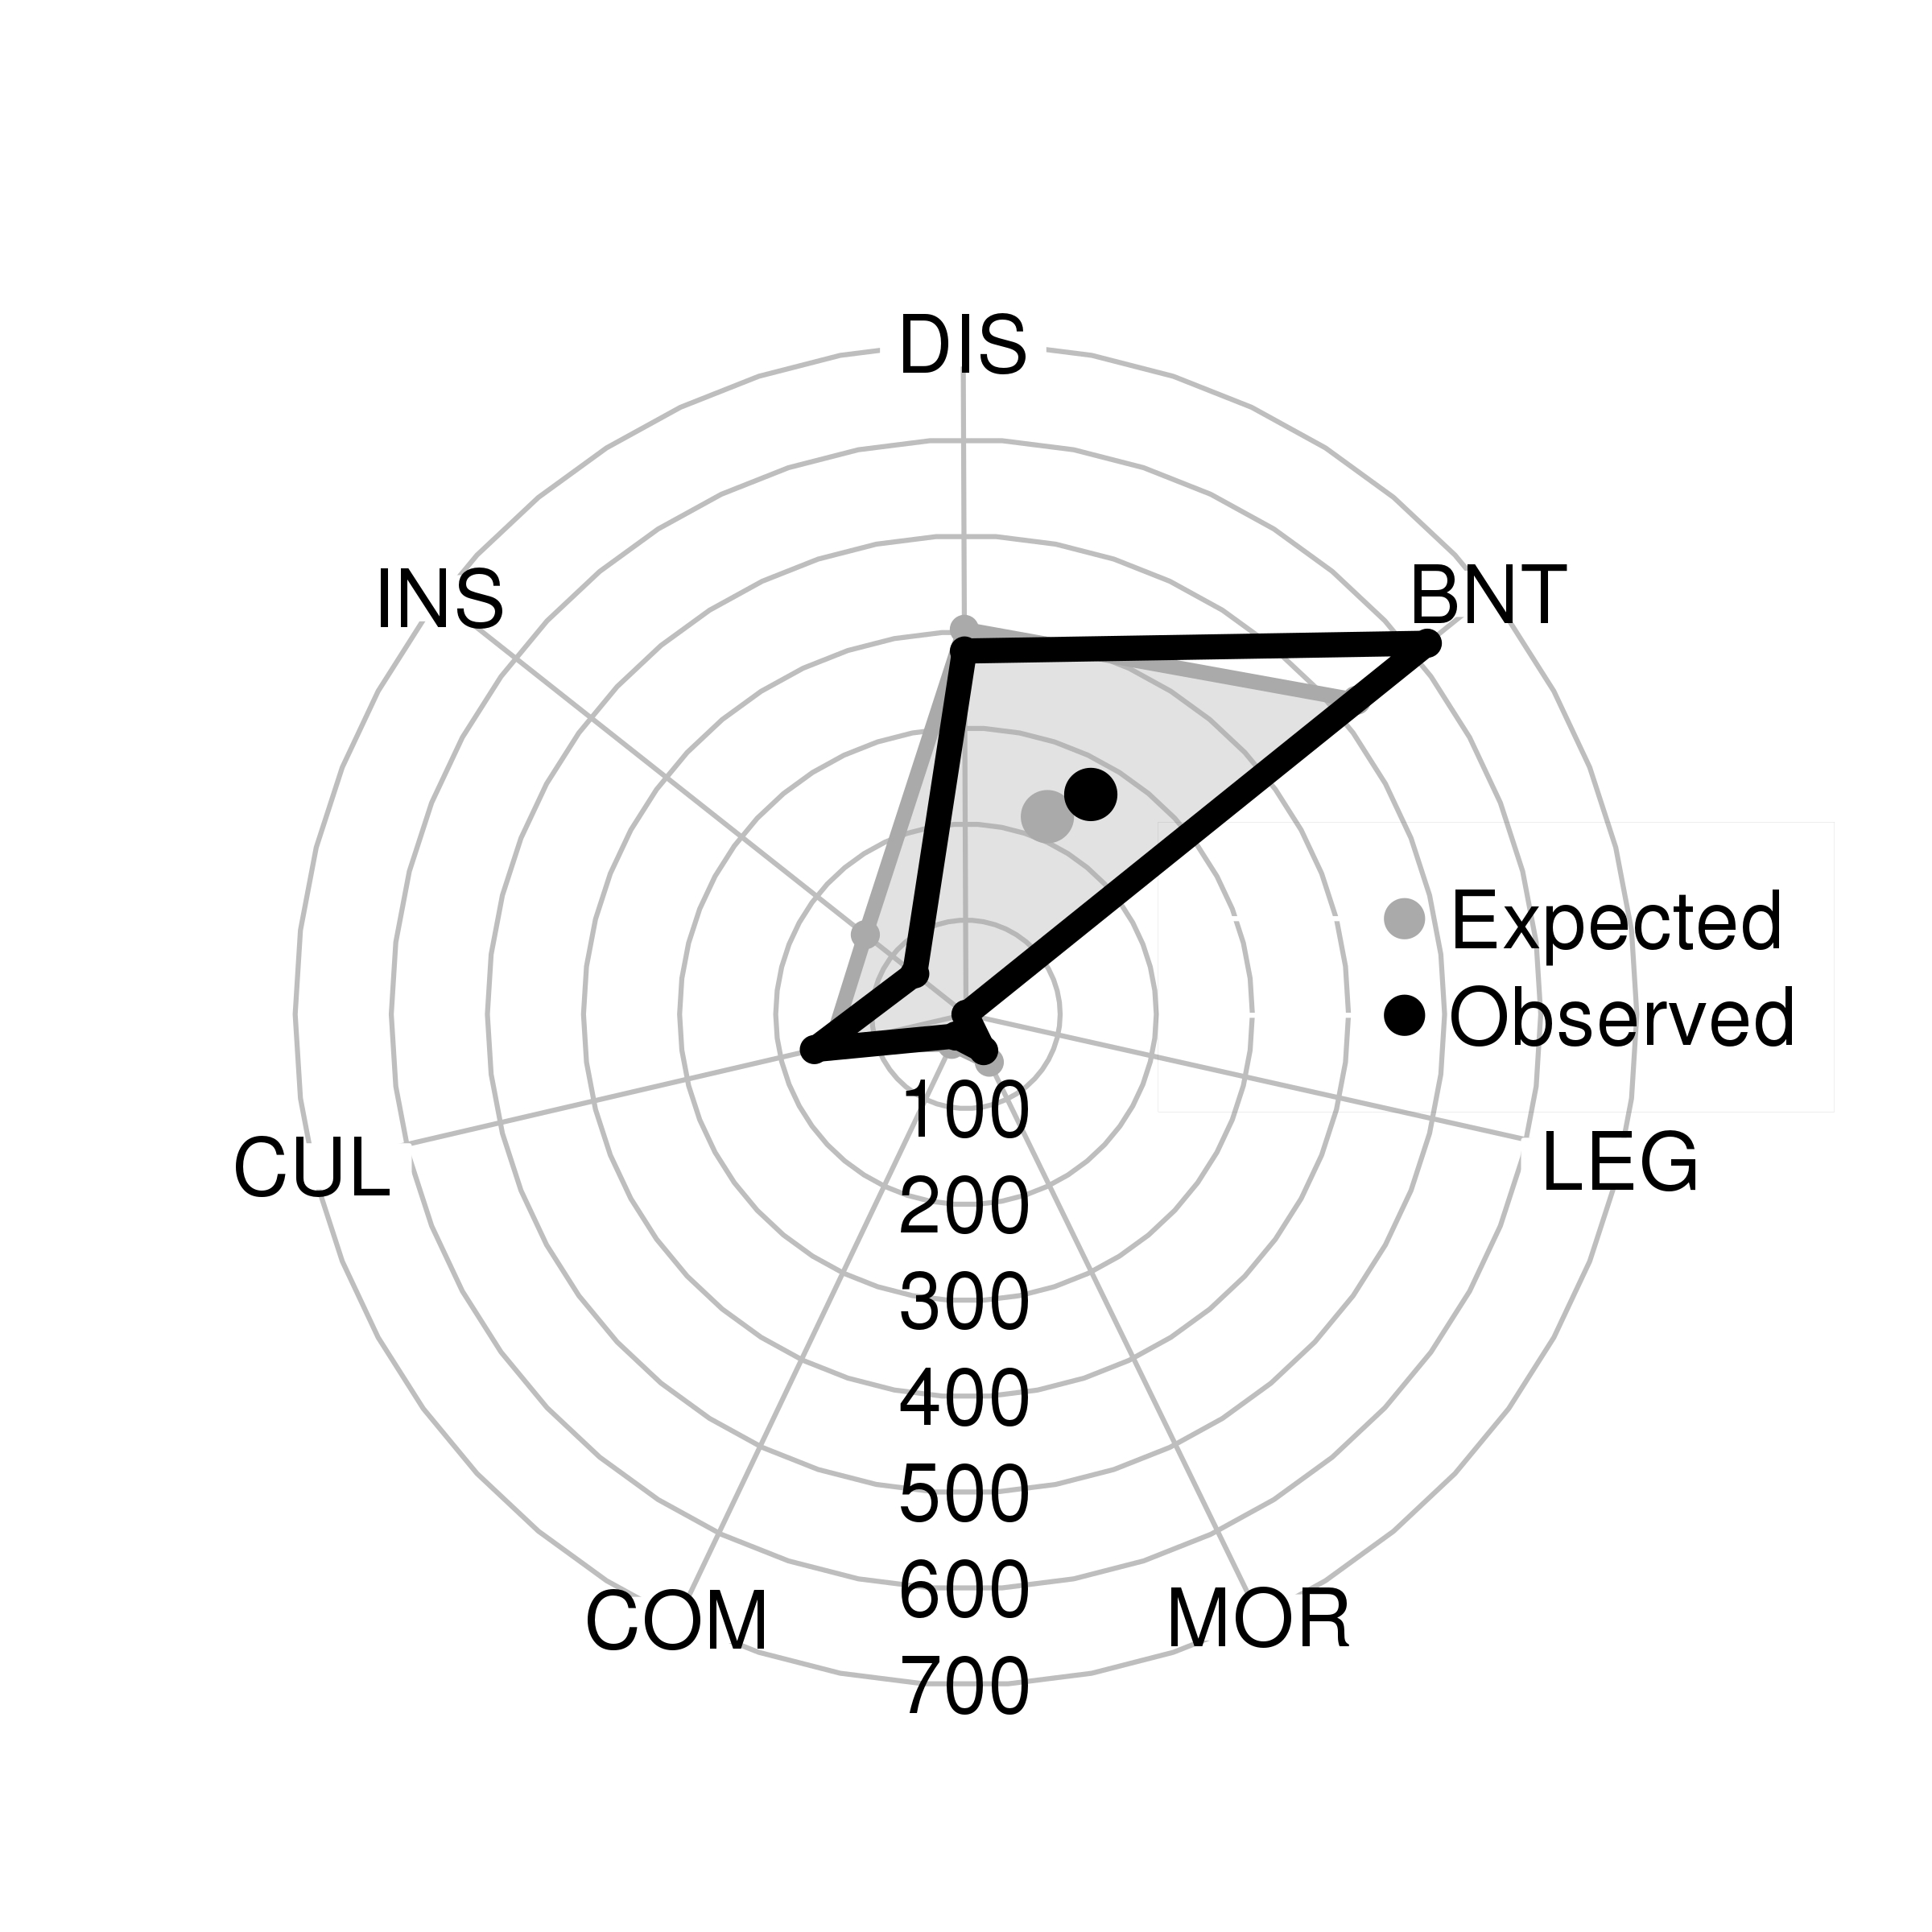

Figure 1. Expected v. observed: /r/opiates. Figure 2. Expected v. observed: /r/trees.