# ALGEE-HEWITT — Language

# <4 figures>

**Suspense: Language, Narrative, Affect**

Algee-Hewitt, M., Chelsea, D., Droge, A., Eccles, T., Eidem, L., Frank, M., Fredner, E., Porter, J. D., Shephard, A. and Walser, H.

As a textual phenomenon that seems to rely exclusively on the affective states of an audience, suspense would appear to be well outside of the quantifiable aspects of literature that are available to digital humanities study. Even while suspense can be understood as a genre of writing, this generic label is relegated to a relatively small group of texts, ignoring the way that many other genres—for example, horror, science fiction, mysteries, and thrillers—also make use of the same phenomenon. Compounding these difficulties, suspense is also a descriptive category that can be applied at the intertextual level (works can be ‘suspenseful’) as well as at the intratextual level (certain parts of works can be ‘suspenseful’). Finally, suspense can also manifest itself as an epiphenomenon of narrative: disentangling the ‘momentum’ of narrative propulsion from the existential suspense of genre fiction further complicates studies attempting to isolate the origins of suspense effects.

Recent work, however, has suggested that careful digital parsing of narrative might provide clues to the origins of this effect. Richard Doust’s study ‘Narrative Structures: The Case of Suspense’ (2010) argues that if narrative units can be digitally coded, then their pattern can reveal the mechanisms of suspense. While very promising, this work relies extensively on precoded (and thus predefined) narrative units, restricting its generalizability across time and genres. Yet the promise of this work is tantalizing. If it is possible to locate lexical or semantic features that are related to the experience of suspense, we would not only gain a much deeper understanding of what suspense is, but we would also be able to investigate narrative processes at the scale of corpora in a way that current digital humanities work cannot. Moreover, such an analysis would also offer a potential bridge between the often rigidly formalist approaches characteristic of quantitative textual analysis and the primarily subjective domain of the reader’s affective experience.

In this paper, ‘Suspense: Language, Narrative, Affect’, a collaborative project by members of the Stanford Literary Lab, we seek to unpack the transhistorical and transgeneric commonalities of suspense literature. Our goal is to isolate lexical and narrative features that, within the right context, create the potential for the experience of suspense. Drawing on previous narratological and psychological studies, our contention is that suspense, as a psychological affect, occurs in the negotiation between the reader and the text (for example, Brewer and Lichtenstein, 1982; Jose and Brewer, 1984; Carroll, 2001; Beecher, 2007; Smuts, 2008). That is, we argue that there are textual effects that create the potential for the experience of suspense, which are only realized by a reader encountering the text within a specific context.

As part of our goal in this paper is to trace these textual features both across time and across genres that are, to varying degrees, ‘suspenseful’, we have assembled a corpus of 216 texts from between 1780 and 2013 that were unanimously deemed suspenseful by the project group. These texts not only belong to the genre of ‘suspense literature’, but also to a variety of genres for which suspense is an important component, including Gothic fiction, detective fiction, sensation literature, science fiction, and horror. As a control, we also created a corpus of 107 ‘unsuspenseful’ texts sampled from the same time period. To explore both the textual and affective components of suspense we apply a set of innovative digital humanities methods to uncover textual features shared by suspenseful texts (or suspenseful episodes within texts) combined with collaborative social psychological work to explore how these textual features impact reader experience. Through this project we investigate the following questions: (1) Is, in fact, the experience of suspense common among a group of readers? (2) Are there lexical features that are shared by suspenseful narratives or narrative episodes? (3) Do these features form identifiable patterns within narratives that are common among our historically and generically diverse corpus? In this paper, we present the results of these first three phases of investigation.

**Expert Tagging**

Before we could begin investigating the specific textual features that were common among suspenseful narrative episodes, we first sought to confirm that a group of readers could reliably and independently come to a consensus in identifying suspense within a narrative. To this end, our first experiment was to use the project participants (eight PhD candidates in English literature) as a group of expert readers who could tag short stories for the effects of suspense and whose consensus we could reliably measure. Would a group of readers with similar educational backgrounds agree on the suspenseful and unsuspenseful parts of a narrative? Our corpus for this project was 13 short stories: each story was divided into discrete narrative units (roughly corresponding to a paragraph), and each unit was rated by each reader as to how suspenseful it was. Not only did this process demonstrate a remarkable consensus among the project participants, but it also revealed a number of narrative patterns of suspense whose commonalities suggest potential categories of suspenseful narratives (Figures 1 and 2). We are currently in the initial stages of a collaboration with members of the Stanford psychology department that will expand this tagging experiment to a diverse group of participants with different educational, disciplinary, and cultural backgrounds.

**Distinctive Lexical Elements**

With the results of the tagging experiment, we then turned to the question of whether the sections of the test corpus that were hand tagged by the group as highly suspenseful shared lexical features, as well as features that were distinctive of our suspenseful corpus compared to our nonsuspenseful corpus. For both, we identified the most distinctive words, the set of words that appeared significantly more often in either suspenseful passages or novels as compared to nonsuspenseful passages or novels. These words not only gave us a set of features through which we could identify potentially highly suspenseful passages in nontagged texts but also suggested some important lexical aspects of suspense. For example, words having to do with movement on a vertical axis (descend, ascend, lower, raise, etc.) were associated with suspenseful episodes and suspenseful texts. We also employed a part of speech tagger to identify the parts of speech that were most indicative of suspense and found a disparity between the number of adjectives that appear in nonsuspenseful texts versus suspenseful texts.

**Narrative Patterns**

In the final stage of this project we sought to use our intertextual results to study the narrative patterns of suspenseful texts. Is there a pattern of groups of words, or semantic fields, within a narrative that is indicative of that narrative’s potential to create the effect of suspense? To identify these semantic clusters of words, we ran a latent dirichlet analysis, or topic model, on our suspenseful corpora and combined these results with the distinctive words we identified in part 2 of our project. These gave us discrete meaningful fields whose presence and absence we could trace across the narratives of texts in our corpus. To help identify how the patterns formed by these clusters of words helped create the experience of suspense, we also tagged the highly suspenseful (and highly unsuspenseful) passages in small group of novels from our corpus. By plotting the scaled average of our semantic fields within a moving window across the text on the same graph as our tagged suspenseful passages, we can observe, for the first time, the interaction between textual features and the suspense effect. As we were interested in semantically meaningful clusters of words, as well as potentially parts of speech, we plotted both within these graphs (see Figures 3 and 4).

As a complementary measure of investigation, we explored how a text’s reading level varies throughout the course of its plot, and how this metric correlates with suspense. To do this, we applied Age-of-Acquisition (AOA) norms1 to our texts using a simple dictionary method. This AOA dataset contains 30,000 words, each with a score that corresponds to the mean age at which respondents have reported learning (or acquiring) the word. Once applied to our texts, we computed a moving average of this score to examine how AOA fluctuates in suspenseful plots, and we observed that the suspenseful moments correlate with a drop in AOA—that is, the more suspenseful an episode, the lower its reading level.

Through these three avenues of investigation, our paper explores how specific lexical features—including semantic clusters of words, parts of speech, and Age of Acquisition scores—operate within the narrative of texts to create the potential for the experience of suspense. As our study combines this digital humanities work with the methodologies of social psychology, it allows us, for the first time, to explore simultaneously the formal features of a text that are distinctive of suspenseful texts and how these features interact with readers to create the experience of suspense itself. Not only, therefore, do we offer a new way of understanding suspense as a critical narrative process that jointly operates between trackable textual features and the context in which they are encountered, but we also suggest a new avenue through which the formal and quantitative research of digital textual analysis can be combined with other fields of study to gain a holistic understanding of the aesthetic experience of reading.

**Figures**

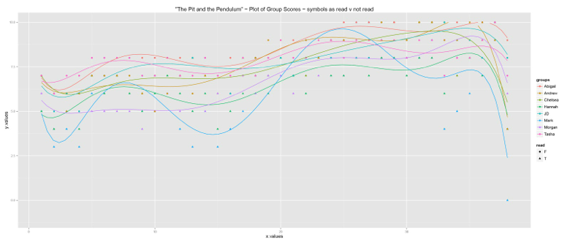

Figure 1. Expert reader tagging of passages for suspense in Poe’s ‘Pit and the Pendulum’.

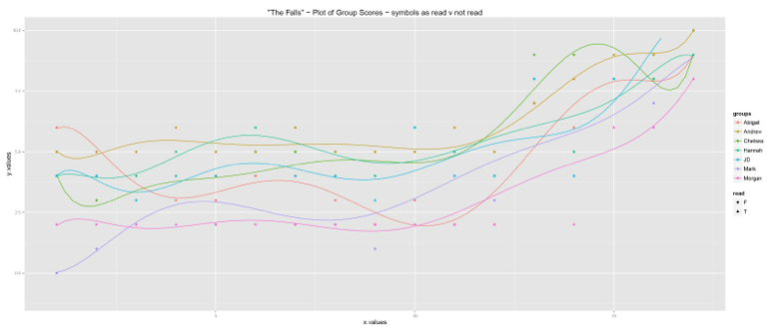

Figure 2. Expert reader tagging of passages for suspense in Saunders’ ‘The Falls’.

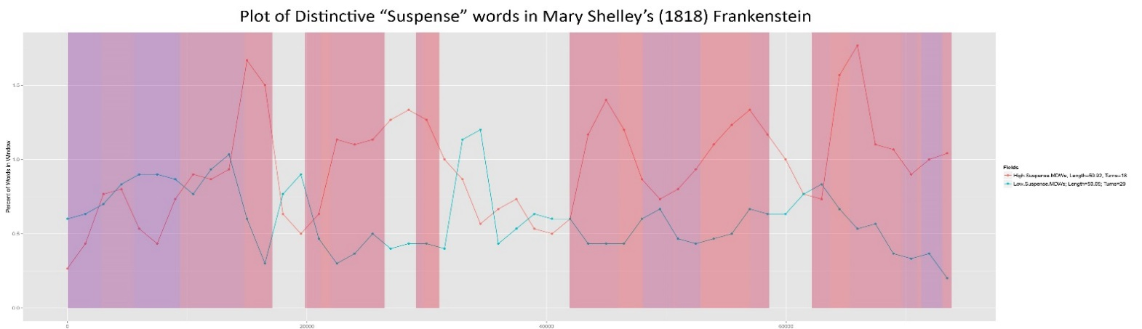

Figure 3. Moving average of most distinctive ‘suspense’ (red) and ‘nonsuspense’ (blue) words in Mary Shelley’s *Frankenstein* (1818); red and blue bands mark locations of passages tagged for high or low suspense, respectively.

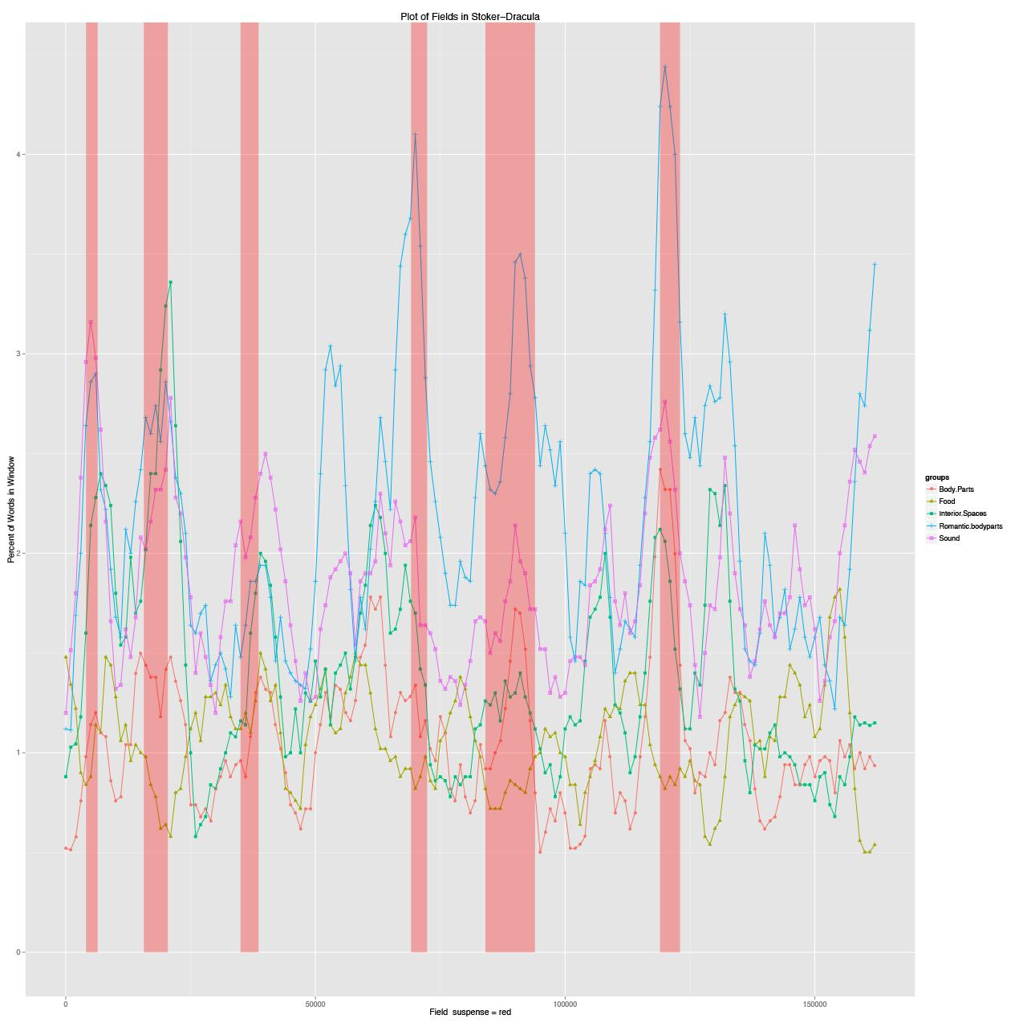

Figure 4. Semantic fields in Stoker’s *Dracula*: bands mark passages tagged as highly suspenseful.

**Note**

1. Dataset made available by Kuperman, Stadthagen-Gonzalez, and Brysbaert (2012).

**References**

**Barthes, R.** (1975). Introduction to the Structural Analysis of Narrative. *New Literary History*, **6**(2) (Winter): 237–72.

**Bernardo, A. B. I. and Gerrig. R. J.** (1994). Readers as Problem-Solvers in the Experience of Suspense. *Poetics*, **22**(6) (1994): 459–72.

**Beecher, D.** (2007). Suspense. *Philosophy and Literature*,**31**(2): 255–79.

**Brewer, W. and Liechtenstein, E.** (1982). Stories Are to Entertain: A Structural-Affect Theory of Stories. Center for the Study of Reading: Technical Report 265. University of Illinois at Urbana-Champaign.

**Carroll, N.** (2001). The Paradox of Suspense. In *Beyond Aesthetics*. Cambridge: Cambridge University Press.

**Doust, R.** (2010). Narrative Structures: The Case of Suspense. Probation Report for the Open University, 12 December2010, http://www.richarddoust.eu/suspense/sqdf.html#QQ2-2-1.

**Jose, P. and Brewer, W.** (1984). Development of Story Liking: Character Identification, Suspense, and Outcome Resolution. *Developmental Psychology,* **20**(5): 911–24.

**Kuperman, V., Stadthagen-Gonzales, H. and Brysbaert, M.** (2012). Age-of-Acquisition Ratings for 30 Thousand English Words. *Behavior Research Methods*, **44**, 978–90.

**Levine, C.** (2003).*The Serious Pleasures of Suspense: Victorian Realism and Narrative Doubt*. University of Virginia Press, Charlottesville.

**Rabkin, E. S.** (1973). *Narrative Suspense*. University of Michigan Press, Ann Arbor.

**Smuts, A.** (2008). The Desire-Frustration Theory of Suspense. *Journal of Aesthetics and Art Criticism,* **66**(3) (Summer): 281–90.

**Todorov, T.** (1977). The Typology of Detective Fiction. In Howard, R. (trans), *The Poetics of Prose*. Ithaca, NY: Cornell University Press, pp. 42–52.

**Truffaut, F. with Scott, H. G.** (1984). *Hitchcock*. Rev. ed. Simon & Schuster, New York.

**Vorderer, P., Wulff, H. J. and Friedrichsen, M.**, eds. (1996). *Suspense: Conceptualizations, Theoretical Analyses, and Empirical Explorations*. Lawrence Erlbaum, Mahwah, NJ.