**BURR — Environment**

<4 figures>

**An Environment for Putting Digital Humanities Pedagogy in Place**

Burr, E., Potapenko, E., Kovacs, P. and Concepción Durán, A

Although recent publications have focused on pedagogy in the digital humanities (see, for example, Brier [2012] and Hirsch [2012], the question remains: How to put digital humanities pedagogy in place? According to us, a certain type of working environment is needed that allows a ‘“learning-by-project” approach’ (Rehbein and Fritze, 2012, 48), to teach ‘methodological approaches’ (Mahony and Pierazzo, 2012, 215) at the same time and to ‘ensure that the acculturation and professionalization that takes place in the learning community is relevant to the students’ (Rockwell and Sinclair, 2012, 177). Such an environment seems to be missing. Elements that one would hope to be part of such an environment can certainly be found in quite a huge number of projects (see, for example, the projects treated in Warwick et al., 2012) but never together in one place.

# From Leipzig into the Romania

In our poster we present a digital working environment that has been built at Leipzig University in the framework of a project on the Neogrammarians and their influence on Romance linguistics.

## *The Project*

The Neogrammarians were a group of young linguists, mostly based at the University of Leipzig, who in the late 19th century proclaimed the creation of a new school. This so-called *Leipziger Schule* (Leipzig School) had a significant impact on linguistics in general. As their so-called Manifesto gave rise to the ‘Lautgesetzestreit’ (debate about the laws of sound change), which divided linguists all over Europe, the Manifesto together with texts written by its critics and defenders were chosen for digitalisation and annotation. At the same time, documents that would allow the positioning of the Neogrammarians were to be collected and integrated into the project. Scholarly works about the Neogrammarians and their importance for Romance linguistics were to be exploited with respect to questions like ‘Who are the members of the Leipzig School?’, ‘What is seen as their contribution to Romance linguistics?’, ‘Which Romance linguists were influenced by this school?’ etc. As the results of the project were to be presented to the public as soon as they became available, a website was to be set up.

## *(Digital) Pedagogy as Such Was Not Enough*

The project started in 2007. During the following semesters we had to recog­nise, however, that text encoding and data modelling as such would not allow our students to understand the rationale behind such an activity (see also Rehbein and Fritze, 2012, 48). Furthermore, it became clear that environments like Moodle would not allow our students to gain experiences of what work on one and the same project over years really means and how their individual contribution could form an organic whole with the contributions of others.

## *The Web-Portal—A Collaborative Environment*

The situation changed when we could actually start to think about building an environment that would allow us to integrate research, teaching, and learning as well as to present the results to the public. The most central aspect of this environment is TEI-Markup, because it integrates our sources with the information handling of the Portal.

In our poster we will not only explain the four levels where TEI-Markup plays an important role—texts, ontology, citations, and sources—but also demonstrate the administration of the sources (Figure 1):

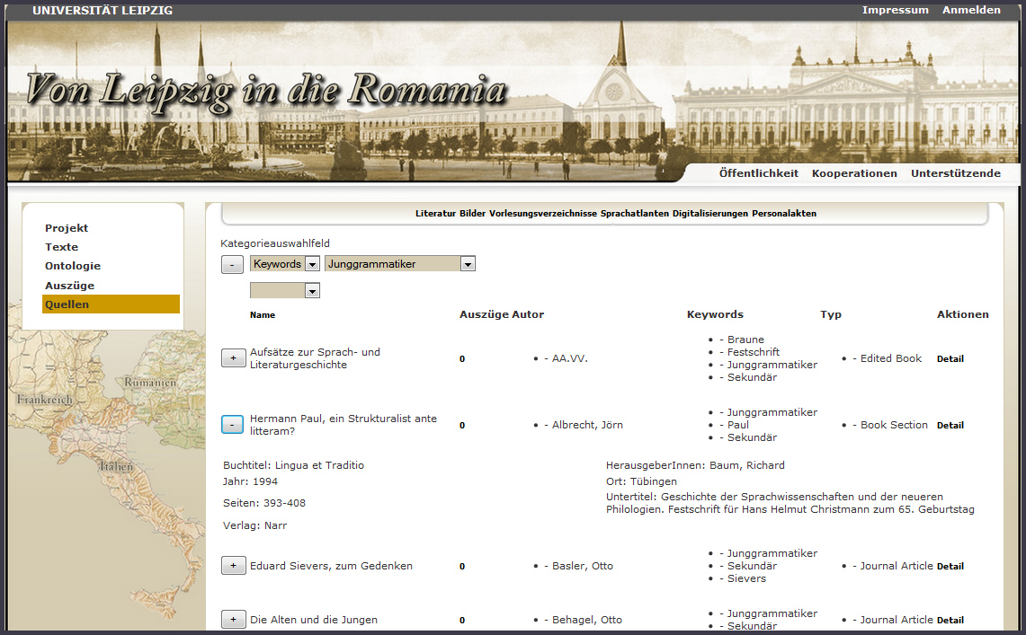

Figure 1. Administration of sources.

the filtering of sources for relevant information and its extraction (Figure 2):

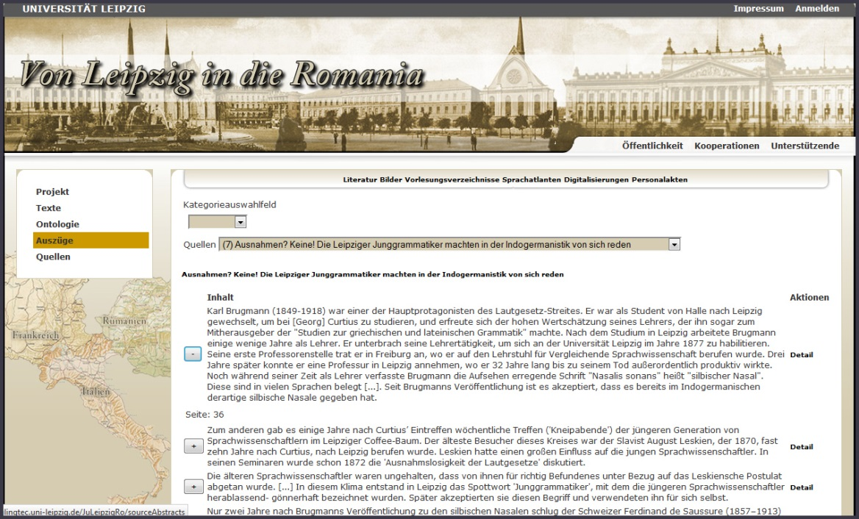

Figure 2. Administration of extracts from sources.

and the ordering of such extracted information into knowledge domains and the setting up of relations between them (Figure 3):

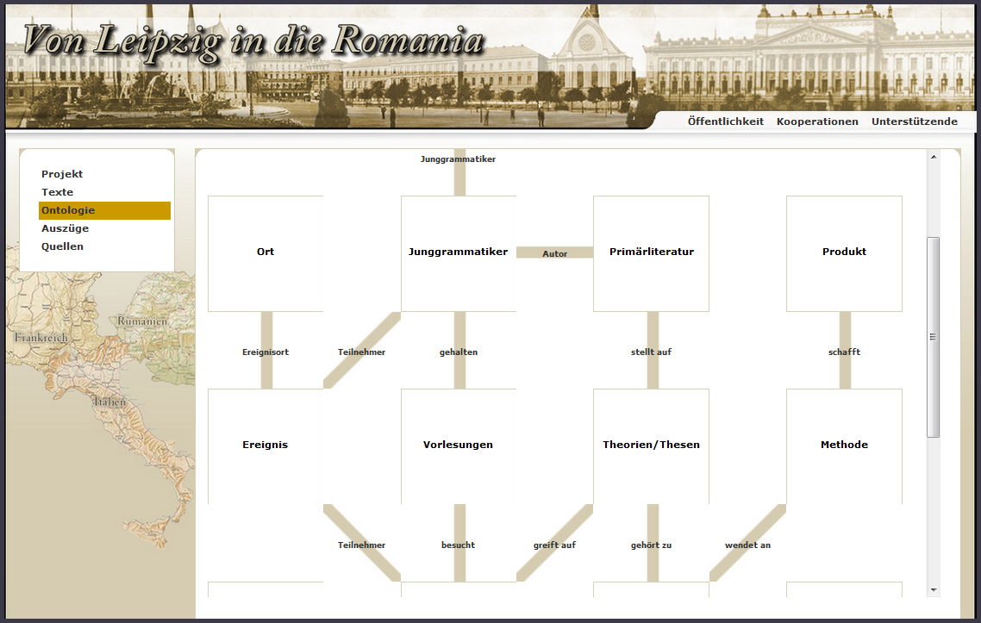

Figure 3. Visualisation of knowledge domains and their relations.

# Conclusion and Future Perspectives

As this environment not only provides our students with the possibility

• To mark up texts collaboratively according to the TEI guidelines,

• To use this markup to link these texts with the information handling of the Web-Portal,

• To order the information extracted from different types of sources into knowledge domains, and

• To model the knowledge which is thus being created with respect to the research question,

but also to exploit the markup and the information gathered for the writing of new TEI-compliant scholarly texts and to publish them in the Web-Portal (Figure 4):

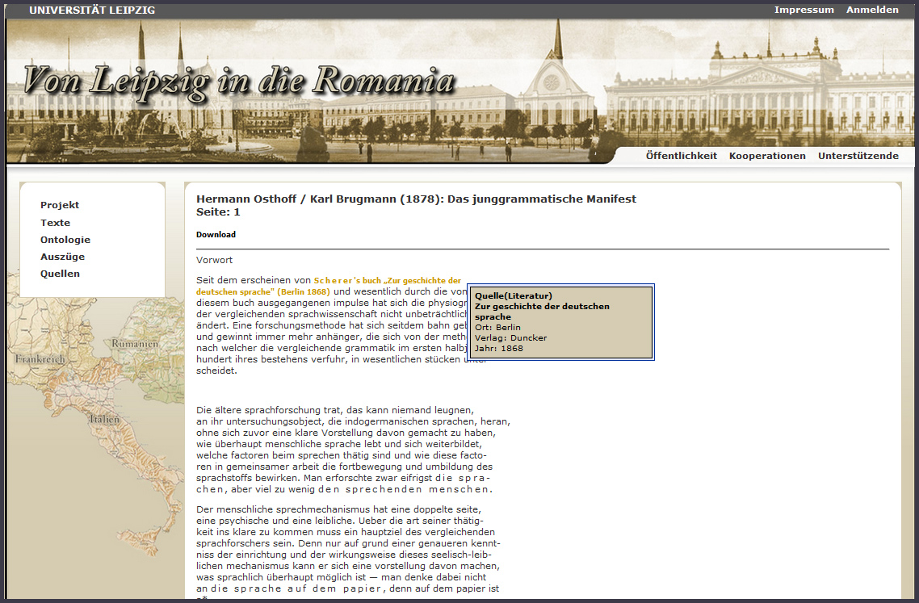

Figure 4. Scholarly texts written by the students.

we feel confident that this environment shows a possible way of how learning to do digital humanities and doing digital humanities research can be integrated, and thus the ‘antagonistic distinction between teaching and research’ that Hirsch talks about (2012, 5), can be overcome.

References

**Brier, S.** (2012). Where’s the Pedagogy? The Role of Teaching and Learning in the Digital Humanities. In Gold, M. K. (ed.), *Debates in the Digital Humanities*. Minneapolis: University of Minnesota Press, pp. 390–401.

**Hirsch, B. D.** (2012). </Parentheses>: Digital Humanities and the Place of Pedagogy. In Hirsch, B. D. (ed.), *Digital Humanities Pedagogy: Practices, Principles and Politics.* Cambridge: Open Book Publishers, pp. 3–30.

**Mahony, S. and Pierazzo, E.** (2012). Teaching Skills or Teaching Methodology? In Hirsch, B. D. (ed.), *Digital Humanities Pedagogy: Practices, Principles and Politics.* Cambridge: Open Book Publishers, pp. 215–25.

**Rehbein, M. and Fritze, Ch.** (2012). Hands-On Teaching Digital Humanities: A Didactic Analysis of a Summer School Course on Digital Editing. In Hirsch, B. D. (ed.), *Digital Humanities Pedagogy: Practices, Principles and Politics.* Cambridge: Open Book Publishers, pp. 47–78.

**Rockwell, G. and Sinclair, S.** (2012). Acculturation and the Digital Humanities Community. In Hirsch, B. D. (ed.), *Digital Humanities Pedagogy: Practices, Principles and Politics.* Cambridge: Open Book Publishers, pp. 177–205.

**Warwick, C., Terras, M. and Nyhan, J.** (eds). (2012). *Digital Humanities in Practice.* Facet Publishing, London.