**CAVINATO — 3D Model**

<1 image>

**A 3D Model of the Venetian *Galeazza***

Cavinato, A., Geissmann, B., Vandevelde, K. R., Dalang, O. and Rodighiero, D.

During its thousand-year life span, the Republic of Venice played a leading role in Mediterranean commercial activity, with a trading empire that spanned from the lagoons of the northern Adriatic Sea to the shores of Syria and Lebanon. The secret of the Venetian domain on the eastern Mediterranean was certainly the power of the Serenissima’s fleet, provided with ships that were efficient in commerce and battle. Among the most successful vessels of the Venetian fleet is the *Galeazza*, which represents the masterpiece of the shipping technology of the 16th and 17th centuries, and is the symbol of the Venetian domain on the Mediterranean Sea during this period.

In order to explain the secrets of the *Galeazza*’s success, we built a detailed CAD model of this ship, including interior and exterior design. The completion of the model allowed us to produce realistic renderings of the galleass, as well as to obtain quantitative results that might be appealing to naval experts and the digital humanities community. In this poster we show the steps that we have followed to develop the 3D model, as well as some renderings of different parts of the galleass. Moreover, we report the quantitative result estimated with CAD and naval simulation software. Finally, we offer an interactive live demonstration where users will have the chance to explore the 3D model and have a taste of life on such a ship.

**Materials and Methods**

In order to model the *Galeazza* in detail, we gathered information from history books specializing in the Venetian nautical field. In particular, we found eleven detailed drawings that served as the primary source of information for the construction of the main structure of the ship (Associazione Navimodellisti Bolognese, n.d.), as well as other books about the history and the evolution of the Venetian galleass during the different epochs of the Republic of Venice (Ercole, 2008; 2010).

With this documentation we started the modeling procedure, which has been carried out entirely in Rhino 3D. This software allowed us to model the main components of the ship by extruding the 2D profiles that were reported on the eleven drawings of the *Galeazza*[Scan with Rhino](http://veniceatlas.epfl.ch/wp-content/uploads/2014/03/Scan-with-Rhino.t).

Once all the main components were modeled, we started the assembly process by combining together all the 3D objects. We could deduce the exact position of each piece by looking at the plans of the galleass and at the original ancient drawings contained in Penzo (2000). Once the main shape of the ship was defined, we could start to embellish the model with more specific components and, at the same time, model the interior of the ship. The information that we needed for this step was gathered after an extensive inspection of the ancient drawings contained in Penzo (2000) and Ercole (2010).

In parallel with the modeling of the last parts, we started the rendering process. In order to produce a final result as realistic as possible, we selected each piece of the galleass and consulted the literature to identify the material it was made of. The proper texture was applied with Maxwell Render, allowing for a great level of detail, especially in the reflectance and light scattering of the different surfaces.

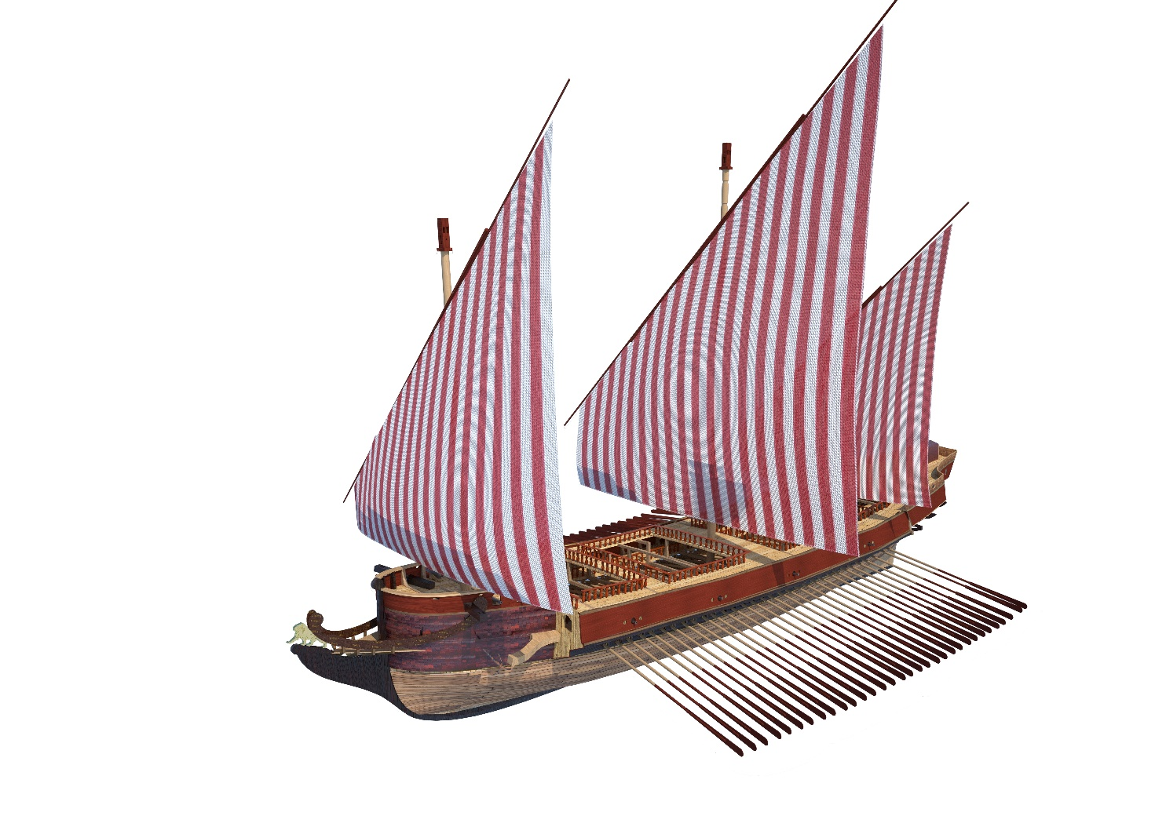

Figure 1. Complete CAD model of the *Galeazza*.

**Results**

Besides the realistic renderings, the detailed CAD model of the ship allowed us to come out with quantitative results that might be useful for further studies in maritime history. We performed computations of the center of gravity and waterline position by exploiting a naval simulation tool called Orca3D. Thus, by analyzing the distribution of weights, we could estimate the arrangement of the ballast, the placement of the ammunition magazine, the displacement and the total amount of potable water that was carried during a trip. Finally, we estimated the internal volumes that could be used as warehouse to store cannonballs, merchandise, food, and weapons. These results might be useful not only to comprehend the properties of the galleass itself but also to investigate the characteristics that led to the success of the Venetian fleet on the Mediterranean Sea.

**References**

**Associazione Navimodellisti Bolognesi.** (n.d.). *1351—GALEAZZA VENETA l.f.t. 71,50 m–1:50*, http://www.anb-online.it/navi-mercantili-e-navi-antiche/dagli-inizi-della-navigazione-al-1800-circa/1351-galeazza-veneta-l-f-t-7150-m-150/?lang=en.

**Ercole, G.** (2008). *Duri i banchi.* Gruppo Modellisticio Trentino.

**Ercole, G.** (2010). *Galeazze, un sogno veneziano.* Gruppo Modellistico Trentino.

<http://netwar.wordpress.com/2007/08/15/the-battle-of-lepanto/>.

[http://www.shipstamps.co.uk](http://www.shipstamps.co.uk/forum/viewtopic.php?f=2&t=13808&p=15397&hilit=galeazza#p15397).

**Penzo, G.** (2000). *Navi Veneziane.* Lint.