**BLAKESLEE — Digital Democracy**

<3 tables; 3 figures>

**Digital Democracy Project: Making Government More Transparent One Video at a Time**

Blakeslee, S., Dekhtyar, A., Khosmood, F., Kurfess, F., Kuboi, T., Poschman, H., Prinzivalli, G., Robertson, C. and Durst, S.

One would think in one of the most advanced industrialized countries in the world, in the state most renowned for technological innovation, an average citizen can easily find out what was said in a public session by his or her elected representative. Surprisingly this is not the case in California in 2014. In the California State Legislature, important legislative decisions on pending bills occur in committee hearings. The videos of these hearings are publicly available,1 but California is one of the many US states that do not transcribe or close-caption them. The committee hearings contain a treasure trove of information,2 but it takes extraordinary time and effort to find relevant information in the hours upon hours of raw, untranscribed, and unindexed footage. The ability to access and search transcripts of legislative committee hearings is a great resource for political insiders, media, government watchdog organizations, and interested citizens. It is one way to enable public accountability of elected officials (as well as government officials and lobbyists participating in the hearings) for the things they said at these hearings, and, more importantly, for the effects of the hearings on the state’s legislation.

We present our contribution to government transparency: the Digital Democracy (DD) platform. The goal of the project is to provide automated, inexpensive, timely, accurate, and informative knowledge extracted from legislative hearing sessions.

**The Digital Democracy System Design**

The Digital Democracy platform obtains data about the legislative committee hearings: the video archives, the information about the state legislature, and so on. Figure 1 shows the design of the DD system. The main source of information for the DD platform is the Cal Channel3 video archive of legislative sessions, a service provided courtesy of cable TV companies that operate in California. In addition, the DD platform obtains information on the nature of legislative sessions (bills, legislators, committees), political contributions, registered lobbyists, and financial disclosures from a variety of existing online databases provided by the state of California or by good government organizations. The information is stored in the Digital Democracy database (DDDB), from which it is delivered to the end users and used for analytical tasks.

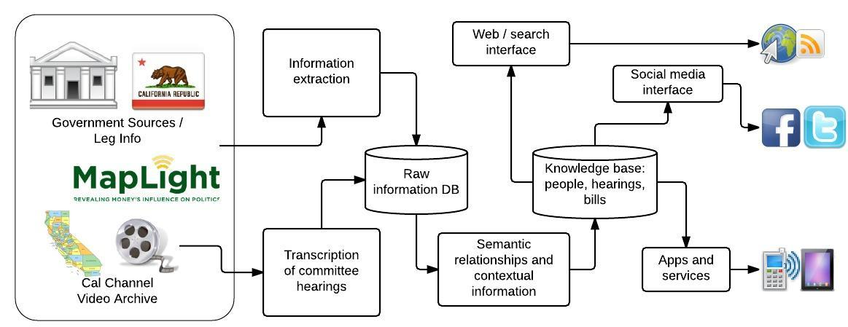

Figure 1. Digital Democracy system architecture.

Access to the information and the knowledge stored in the DD database is provided through a variety of means. The beta version of the DD platform uses a web portal4 as the means of accessing the data and interacting with the system. Mobile applications and social media plugins, complete with alerting mechanisms, are planned for the future.

**Users and Use Cases**

We consider three core categories of users of the platform: (a) individual citizens, interested in legislative affairs; (b) media and watchdog organizations observing and covering legislative sessions; and (c) legislators and their staff. For the first category of users, the key use case is the ability to find all committee hearings associated with a specific bill, watch the hearings and read transcripts, and search for the things a specific lawmaker (e.g., representing their district) said in those hearings. The second group of users is interested in searching the database for specific topics and being able to listen to and watch the portions of committee hearings related to the topics of their interest. Finally, the third category of users wants to use the DD platform to find specific moments during committee hearings where important decisions were made or important words were said.

## The Beta Site

In 2014 we piloted the beta site5 for the project. The site provided the basic navigation and search functionality for a collection of California legislative committee hearings from the 2013–2014 session. Users could search hearing transcripts, browse hearings and bills discussed at them, and look up information about the hearing participants. Screenshots of the beta site depicting results of the hearing transcript search and a hearing page are shown in Figure 2.

**Evaluation**

We conducted a beta test of the Digital Democracy site from March to July of 2014. The beta testers (public officials, their staffers, journalists, political activists) had access to about 30 committee hearings, primarily devoted to the discussion of California’s state budget. Tables 1, 2, and 3 and Figure 3 summarize the results of the beta test.

# **Conclusion**

The Digital Democracy platform is a research and reporting tool providing popular access to an aspect of the political discourse that was hitherto not available. We find that Digital Democracy is well received and useful, but has the potential to be much more. As we continue building the new features for our upcoming releases, we take into consideration the additional recommendations and feedback we receive from our beta testers.

|  |  |  |  |  |  |
| --- | --- | --- | --- | --- | --- |
|  | Do you feel that the ability to search legislative hearing videos using the Digital Democracy tool would be useful? | If you were able to search and clip a video to share on social media, would you find this feature useful? | If you were able to run analytics to identify trends in speaker statements, speaker interactions, voting records, and donor data, would you find this feature useful? | During the beta test, did you find the Digital Democracy site easy to navigate? | During the beta test, did you ever have problems with the video not playing correctly? |
| **YES** | 27 | 23 | 24 | 23 | 3 |
| **NO** | 1 | 6 | 3 | 5 | 23 |
| **NO RESPONSE** | 1 | 0 | 2 | 1 | 3 |

Table 1. Tester feedback on usefulness of Digital Democracy features and potential features.

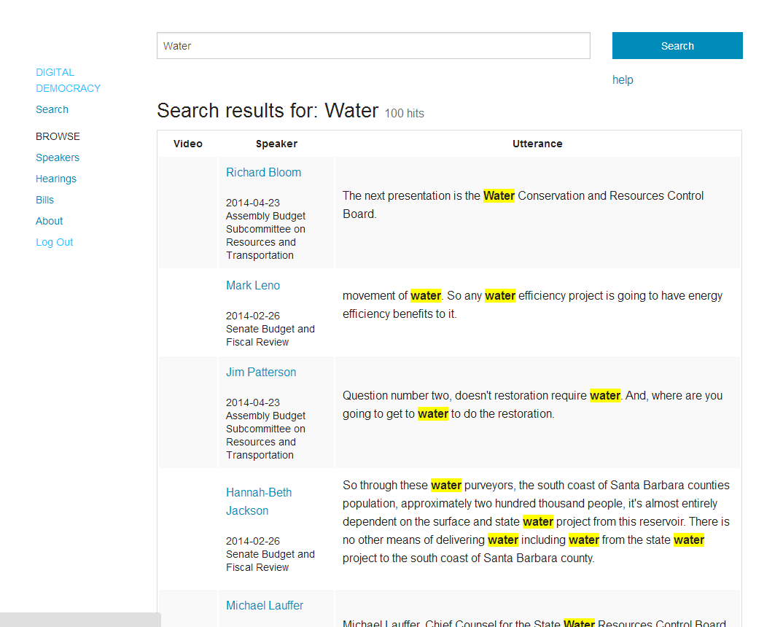

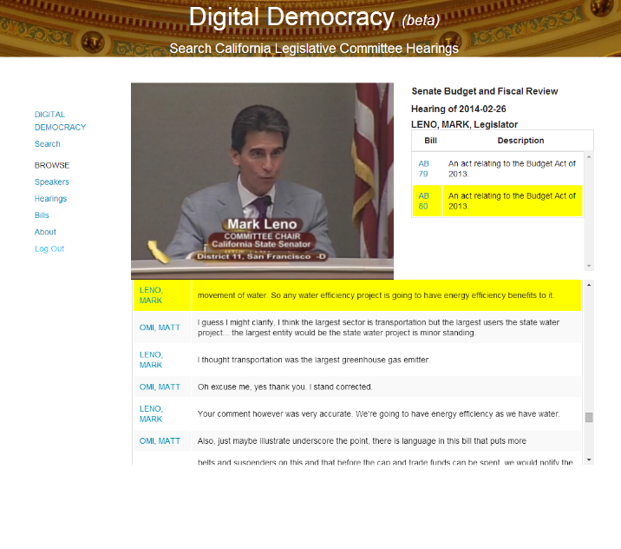

Figure 2. Screenshots of the Digital Democracy beta site.

|  |  |  |  |  |
| --- | --- | --- | --- | --- |
|  | Searching Keywords in Transcripts | Searching Speakers | Searching Issues/Topics | More Complex Analytical Searches |
| **EXTREMELY USEFUL** | 22 | 20 | 19 | 13 |
| **USEFUL** | 5 | 7 | 6 | 11 |
| **NOT USEFUL** | 2 | 2 | 2 | 3 |
| **NO RESPONSE** | 0 | 0 | 2 | 2 |

Table 2. Tester feedback on usefulness of search functionality.

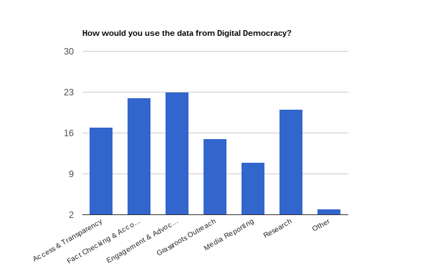

Figure 3. How users would use Digital Democracy data.

|  |  |  |
| --- | --- | --- |
| **In Free-Form Feedback** | number | example |
| Thought Very Useful | 8 | ‘This looks to be an extremely useful tool. I thought the site was easy to navigate and the links to video and text were seamless and really helpful’. |
| Suggested an Improvement | 7 | ‘Creating an alphabet list, at the top of the “browse speakers” feature in addition to the already present features, would allow for ease if searching by speaker’. |
| Wanted to See More | 7 | ‘I think this is a great start for a test. Look forward to seeing it grow with the inclusion of other subject areas (ie. energy, transportation, justice system, etc).’ |
| Had Difficulties | 2 | ‘Actually, the site never loaded at all. I could not give any real assessment as a result. But I would very much be interested in this kind of material being available and searchable’. |
| Wanted to Collaborate | 1 | ‘Would be interested in discussing how we integrate our services’. |

Table 3. Types of user feedback in free-form responses.

**Notes**

. http://www.calchannel.com/recentarchive/.

2. As evidenced by the firsthand experience of the first author, who served in both the California State Assembly and the California State Senate.

3. http://www.calchannel.com.

4. http://www.digitaldemocracy.org.

5. http://www.digitaldemocracy.org.