**WANG — Dunhuang**

<2 images>

**Digital Dunhuang: Enhancing Virtual Explorations of the Real Dunhuang**

Wu, J.

Zhou, P.

Wang, E.

Downie, J. S.

We are proposing a panel consisting of four panelists with complementary professional and scholarly expertise to create a forum to engage with the digital humanities community concerning the unique resources being created as part of the Digital Dunhuang project. The Mogao Caves at Dunhuang, a designated UNESCO World Heritage Site, are a splendid treasure house of art from ancient China (Fan, 2004; Fan and Yongzeng, 2007). Digital Dunhuang, an ongoing project funded by the Andrew W. Mellon Foundation under the auspices of the Dunhuang Academy, is creating a permanent digital archive and content delivery system for all caves and murals at the Dunhuang site. It incorporates existing and future digitization work into a powerful platform for digital asset management, digital preservation, and delivery of multi-terabytes of content. This panel session will encourage as much audience participation as possible to initiate an ongoing and vibrant dialogue with digital humanists in order to plan future developmental pathways for the Digital Dunhuang project. The ‘Real Dunhuang’ aspect of our panel title is intended to emphasize the fact that the Digital Dunhuang project incorporates much more than text as it strives to digitally capture, preserve, and then share the physical realities of the Dunhuang Caves and their cultural heritage treasures. The panelists, their affiliations, and their topics are listed below.

**Presentations**

**1. Introducing the ‘Real’ Dunhuang and the Digital Dunhuang Project**

Jian Wu, Dunhuang Academy

Dunhuang was a centre of commerce along the Silk Road in ancient times. During the 1,000 years after AD 366, with the spread of Buddhism, Buddhists including monastics, the rich and the powerful, as well as ordinary people, with the help of master painters, constructed the famous artworks of the Mogao Caves at Dunhuang. In 1987 the Mogao Caves became one of the UNESCO World Heritage Sites. The Mogao Caves contain large numbers of masterpieces of Buddhist art spanning a period of 1,000 years and covering a variety of genres. Currently there are 735 existing caves, 492 of which house about 45,000 square meters of murals. There are also more than 2,000 sculptures at the Mogao Caves. The unique artistic style of Dunhuang art is not only the amalgamation of Han Chinese artistic tradition and styles assimilated from ancient Indian and Gandharan customs but also an integration of the arts of the Turks, ancient Tibetans, and other Chinese ethnic minorities. As evidence of the evolution of Buddhist art in China, as well as historical records of artistic exchanges between China, Central Asia, and India, the Mogao Caves are of unmatched historical value and provide invaluable reference for studying the complex art history of ancient China and the world.

The relatively dry climate in and surrounding Dunhuang contributes a lot to the preservation of the Mogao Caves. However, damage has been caused to murals and sculptures due to the special nature of rock caves, the special materials used in painting murals, as well as other factors such as erosion, infiltration of rain, seasonal floods, and earthquakes. Some of the damage is even devastating. With the development of local tourism, more and more tourists are entering the caves, which makes protecting the caves even more challenging.

**2. Digital Dunhuang: Digitally Capturing, Preserving, and Enhancing Real Dunhuang**

Peter Zhou, University of California, Berkeley

Dunhuang Academy has been devoted to the protection of the Mogao Caves since its founding in 1944 (originally called the Dunhuang Art Research Institute). The protection measures since the 1990s include slowing down the degeneration of murals with a variety of protection techniques, as well as looking for digital tools to preserve the caves. With support from the Andrew W. Mellon Foundation, Dunhuang Academy is currently undertaking the Digital Dunhuang project with cooperation from home and abroad. We are working on digitizing the three-dimensional structures of murals, sculptures, and caves of all the 492 caves, and also working on constructing a digital database of the Mogao Caves resources. The Digital Dunhuang project not only enables permanent preservation of the significant cultural heritage but also provides a platform of sharing it with a larger audience, including scholars all over the world, which will definitely have a profound influence (Zhou, 2011).

Digital Dunhuang has called on the expertise of a number of institutions over the years, including the Dunhuang Academy, Zhejiang University, the Getty Conservation Institute, and Northwestern University, to name just a few (Lu, 2011; Xu et al., 2011). Compared with other digital humanities projects such as the International Dunhuang Project: The Silk Road Online (IDP; http://idp.bl.uk/), which is a consortium of linked digital collections of primarily Dunhuang manuscripts on the Internet, Digital Dunhuang is a multi-faceted platform for current and future content development, providing long-term preservation of large files of varying format, whether textual or representational (images), pertaining to either conservation or archaeological work carried out at the site and related records, and delivering high-resolution images and a virtual museum experience to the users around the world (Kenderdine, 2013).

*2.1 A Growing World-Class Digital Humanities Resource*

Over 400 caves are to be photographed (including individual and stitched images), and the Digital Dunhuang database is designed to incorporate a wide range of data types (Wu, 2011). These include complete archeological and conservation data and files, documentation for a large number of artifacts, Dunhuang manuscripts, and scholarly publications. The ultimate goal of Digital Dunhuang is to store the totality as well as minutia of the Dunhuang Caves’ digital content; preserve those digital surrogates, reconstructions, files, and digital assets perpetually; and provide a research platform for digital humanities scholarship (Tadic and Zhou, 2012). The size and scope of the project are quite significant. Some exemplary statistics include the following:

• 92 caves already photographed (with approximately 400 more to go).

• 14,000 square meters of murals captured.

• 600,000 raw images.

• 70 terabytes of data.

• 87 caves with complete QuickTime Virtual Reality.

• 42,000 negatives scanned.

• 20 years of climate monitoring data on 87 caves.

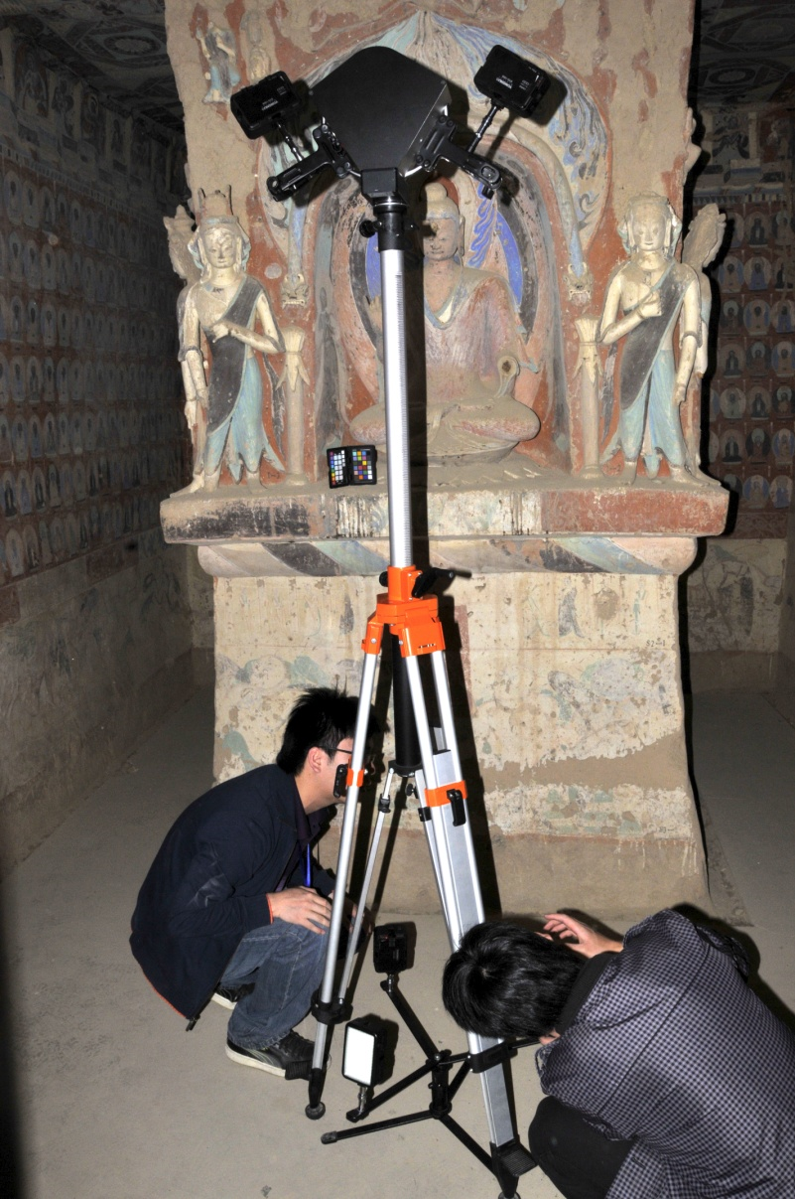

Figure 1. Dunhuang scientists preparing to digitally scan cave for 3D modelling.

**3. Explicating the Potentials of Digital Dunhuang on Scholarship and Teaching**

Eugene Wang, Harvard University

In-depth research of the Dunhuang Caves requires sustained and long-term immersion in caves. Humidity control in the caves and other conservation concerns make it unlikely for the caves to be infinitely available for unlimited access. Thus, the project makes a significant contribution to scholarship and education by making the caves available in a time-independent manner both for current and future scholars and students. Furthermore, unlike scroll paintings, the murals and sculptures in the Dunhuang Caves are deeply embedded in the visual program, encompassing all the walls and ceilings of the caves. Reproductions on printed pages never quite convey or deliver the complex spatial orientation and inter-relatedness of wall paintings. The Digital Dunhuang project is making it possible to create a truly immersive experience of the Dunhuang Caves. Mapping digital files of murals onto the spatial grid of a cave creates a reconstituted digital cave that allows the viewer to enter and contemplate the murals in their intended spatial orientation. Moreover, high-definition scans of murals enable students of the Dunhuang Caves to scrutinize details in physically inaccessible spots that even a real-time viewer in the cave cannot see clearly.

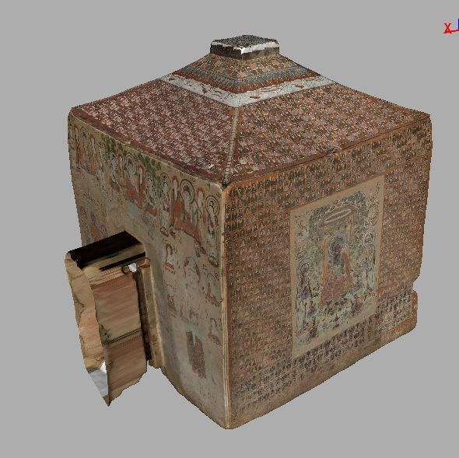

Figure 2. Example 3D rendering of cave interior paintings.

**4. Enhancing the Impact of Digital Dunhuang on Digital Humanities Scholarship**

J. Stephen Downie, University of Illinois

The Digital Dunhuang project has the potential to reinvigorate and reconceptualize Dunhuang and Silk Road scholarship. However, notwithstanding the growing domestic and international interest in Dunhuang remains, there is a noticeable lack of an integrated system to incorporate all content for perpetual curation and preservation for Dunhuang research, both in and outside of China. A range of scholarly projects in recent years have explored different aspects of the Dunhuang artifacts, and the Digital Dunhuang project is now exploring mechanisms by which to unite them with its ongoing digitization work. Both Open Annotation Collaboration (http://www.openannotation.org) (van Hooland and Verbough, 2014) and Linked Open Data (http://linkedata.org or http://lodlam.net) (Cole et al., 2013) as possible incorporation technologies. The project is also exploring a range of data curation practices and options to ensure that its data remain usable and accessible in perpetuity. Because many options are available to help integrate and curate data resources related to Dunhuang studies, the Digital Dunhuang project hopes to use the opportunity of this proposed panel to solicit the advice and expertise of the panel participants. In this way, the Digital Dunhuang project can better meet the needs of the digital humanities community.

**References**

**Cole, T. W., Gerber, A., Sanderson, R. and Smith, J.** (2013). Using Open Annotation. In *Digital Humanities 2013: Conference Abstracts*. Lincoln, NE: Center for Digital Research in the Humanities, University of Nebraska–Lincoln, pp. 11–13, http://dh2013.unl.edu/abstracts/workshops-003.html.

**Fan, J.** (ed.). (2004). *World Cultural Heritage: Dunhuang Grottoes*. China Travel and Tourism Press, Beijing.

**Fan, J. and Yongzeng, L.** (eds). (2007). *Appreciation of Dunhuang Grottoes*. Jiangsu Fine Arts Publishing House, Nanjing.

**Kenderdine, S.** (2013). ‘Pure Land’: Inhabiting the Mogao Caves at Dunhuang. *Curator: The Museum Journal,* **56**: 199–218, doi:10.1111/cura.12020.

**Lu, D.** (2011). The Research and Application of Conservation and Utilization in Mogao Grottoes Aided by Computer: Exploration and Practice. In *Proceedings of the International Conference on Cultural Heritages and Digitization*. Dunhuang: Dunhuang Academy, pp. 12–27.

**Tadic, L. and Zhou, P.** (2012). *Digital Dunhuang: A Repository System of Dunhuang Murals and Digital Resources: Functional Requirements.* Dunhuang: Dunhuang Academy.

**Van Hooland, S. and Verbough, R.** (2014). *Linked Data for Libraries, Archives and Museums: How to Clean, Link and Publish Your Metadata*. Facet Publishing, London.

**Wu, J.** (2011). Dunhuang Captured in Images: New Visual Dunhuang Created with Scientific and Artistic Technologies. In *Proceedings of the International Conference on Cultural Heritages and Digitization*. Dunhuang: Dunhuang Academy, pp. 28–34.

**Xu, L., et al.** (2011). Reconstruction of Spatial Information of Mogao Grottoes Mural Image Based on Laser Point Cloud. In *Proceedings of the International Conference on Cultural Heritages and Digitization*. Dunhuang: Dunhuang Academy, pp. 270–82.

**Zhou, P.** (2011). The Development of a Repository System of Dunhuang Murals and Digital Resources for Dunhuang Studies.In *Proceedings of the International Conference on Cultural Heritages and Digitization*. Dunhuang: Dunhuang Academy, pp. 317–23.