**HEUSER — Knowledge**

<5 figures>

**Knowledge Networks, Juxtaposed: Disciplinarity in the *Encyclopédie* and Wikipedia**

Heuser, R., Algee-Hewitt, M. and Bender, J.

The disciplines now maintained in universities have changed sharply since the 18th century, when they were still largely theological. However, the 18th century’s academies and encyclopedias set the stage for this transformation. How can the digital humanities help us understand and articulate such changes in the disciplinary structure within systems of knowledge?

Specifically, our project is designed to use methods of network analysis and visualization to explore commonalities and differences between the *Encyclopédie* (1751–1772), Diderot’s landmark encyclopedia of the 18th-century Enlightenment, and the Wikipedia of today. One of Diderot’s powerful innovations was a pervasive system of cross-references, networking the many thousands of articles into a navigable system. Wikipedia is built upon a similar system, both hyperlinking its articles together and recommending related articles under the heading of ‘See also’. Our project wagers that a juxtaposition of these cross-reference networks allows us to historicize the particular structures of knowledge interconnectedness as manifested in the *Encyclopédie* and in its modern Wikipedia descendant. Our results show that, perhaps unintuitively, cross-references more commonly ‘cut across’ demarcations of Enlightenment-born disciplines in Diderot’s *Encyclopédie* than in Wikipedia.

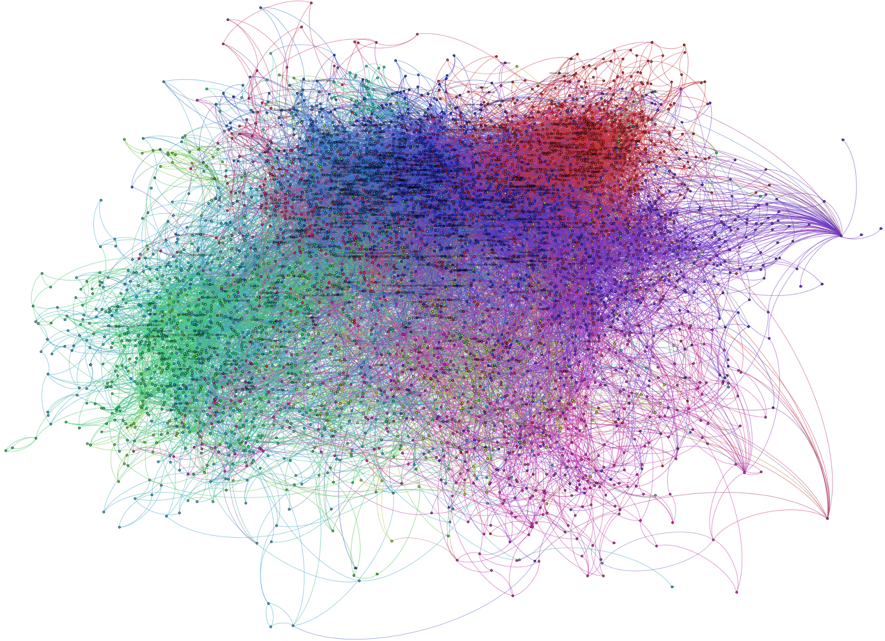

Figure 1. The article cross-reference network of the *Encyclopédie*. Each node is an article; each edge, or link, indicates a cross-reference between them. Articles without cross-references are not displayed here. The network was visualized in the software Gephi and colored by its network modularity algorithm with default settings.

Although 65 times larger than the *Encyclopédie*, Wikipedia, like Diderot’s encyclopedia, works within categories and operates by selection.1 One covert but powerful principle of selection within Wikipedia is that of modern disciplines. Although Wikipedia is not specifically organized by disciplines, they figure powerfully. Just one specific instance is that of the well-known article on the ‘philosopher’ in the *Encyclopédie*, assigning the broadest possible intellectual role to the kind of man of letters Diderot signified by the term. In Wikipedia, by contrast, ‘philosopher’ is specifically about practitioners of the modern formal discipline of philosophy.

Below, we compare these two encyclopedias by combining interpretive readings of cross-reference networks drawn from particular articles (Experiment 1) with a large-scale computational approach (Experiment 2). For the digitized text of the *Encyclopédie*, we turned to ARTFL, a comprehensive database of thousands of 18th-century French texts, including all 74,000 articles in Diderot’s *Encyclopédie* (‘ARTFL *Encyclopédie* Project’, n.d.). Mark Olsen and other researchers involved in the project have computationally identified and hyperlinked the *renvois*, or cross-references, embedded in its articles(‘Renvois Navigation’, n.d.)*.* Gilles Blanchard and Mark Olsen have published on the relationship between the *Encyclopédie*’s ‘tree of knowledge’ and its *renvois*, as two distinct models of knowledge organization, showing which parts of the tree are more strongly connected via cross-references than others. In this project, we juxtapose and compare the cross-reference networks of two encyclopedias created more than two centuries apart, in order to make visible and better understand the historicity of knowledge networks.

**Experiment 1: Case Studies of Key Article Networks**

First we drew up a list of articles on a wide range of topics that reflected a diversity of disciplines and that contained a large number of cross-references in both encyclopedias. These articles include, for instance, ‘philosopher’, ‘commerce’, ‘agriculture’, ‘nature’, and ‘existence’. For each selected article, we created a network linking it to all of the articles it cross-references; then we repeated this process only once for each of the cross-referenced articles. The resulting network is a directed cross-reference network with a depth of 2. For this experiment, we considered as cross-references all *renvois* of the *Encyclopédie* article, and all links under ‘See also’ in the corresponding English Wikipedia article.2

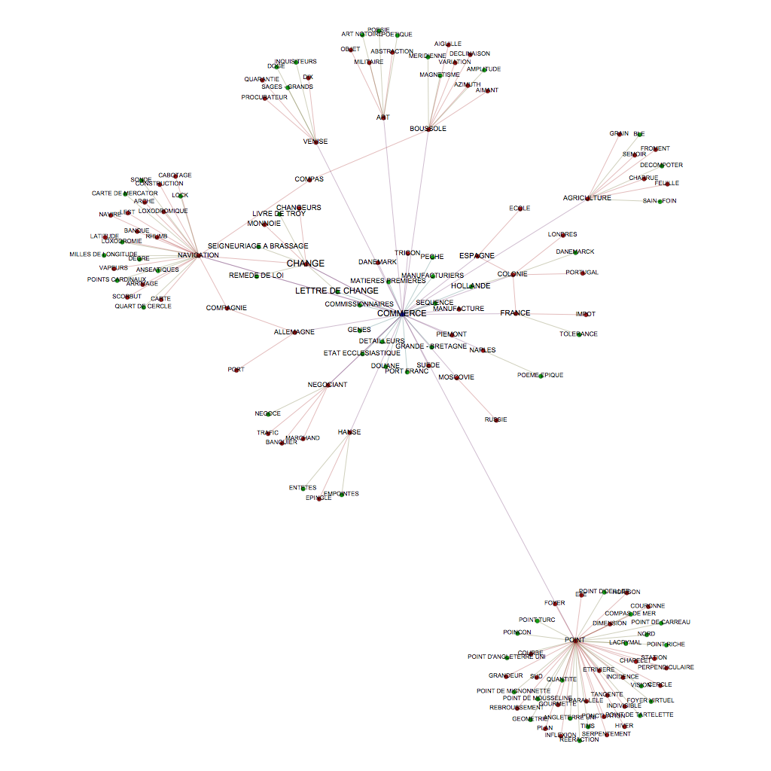

Figure 2. An article cross-reference network, centered on the article ‘commerce’ in the *Encyclopédie*, emanating two levels deep.

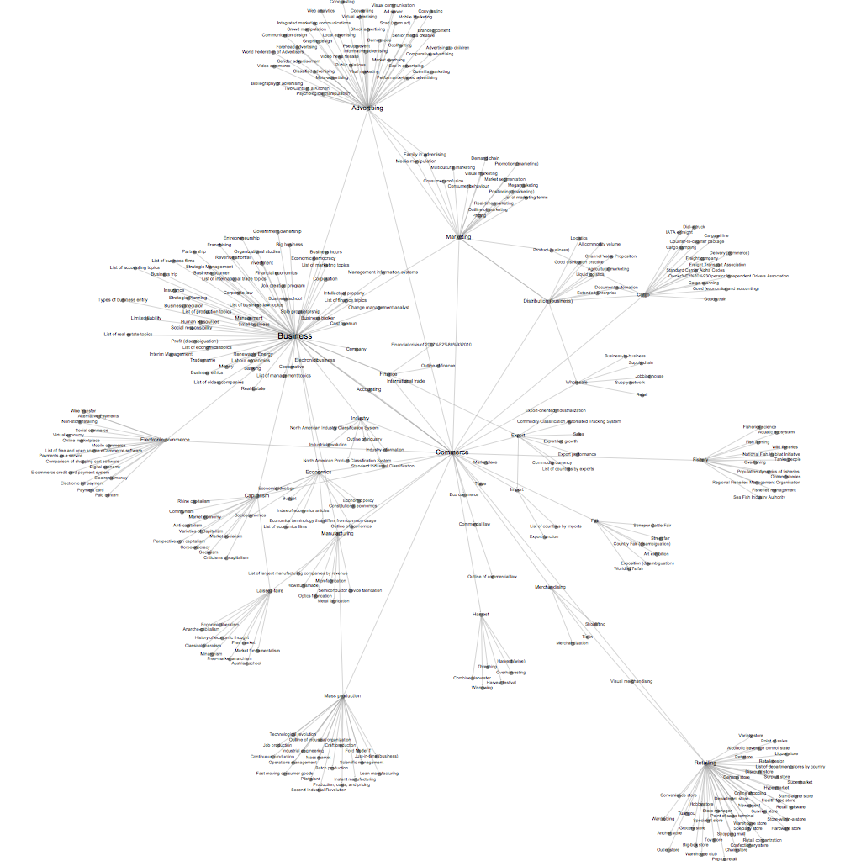

Figure 3: An article cross-reference network, centered on the article ‘commerce’ in the English Wikipedia, emanating two levels deep.

For example, one of the most striking comparisons we’ve found is the article on ‘commerce’. The *Encyclopédie* links ‘commerce’ to such diverse topics as art, navigation, and agriculture at the first level, and poetry, mathematics, and construction at the second (Figure 2). Wikipedia’s version of ‘commerce’, by contrast, is tightly disciplinary (Figure 3). At the first level of cross-references, nearly all of the headings are from business, trade, and manufacture. At the second level, at the furthest reach from the core of economics, we have ‘shoplifting’ and ‘classical liberalism’. Clearly, when it comes to ‘commerce’, the unannounced, implicitly defined discipline adhered to by Wikipedia is business management—no room for categories such as tolerance, winter, magnetism, the military, or poetic theory.

In these case studies, we see over and over again an increase in disciplinarity of the sort we see in ‘commerce’—but also a move to technical practices more generally, some of which are disciplinary, some of which are commercial, and some of which are institutional abstractions.

**Experiment 2: Large-Scale Network Comparison**

A potential objection to these English Wikipedia examples lies in our translation of 18th-century French concepts into 21st-century English. The translation of the words from French to English potentially introduces some inconsistencies. With this in mind, we move from particular article networks to a big-data approach, comparing the overall citational structure of the *Encyclopédie* to that of the French Wikipedia (hereafter *Wikipedie*). Although the French version is about a third smaller than the English, it is still 20 times larger than the *Encyclopédie*. In order to compare it to the *Encyclopédie*, therefore, we reduced both to the subset of headwords appearing in both encyclopedias. This left us with about 16,000 articles. Because the *Wikipedie* is smaller than its English equivalent, and less likely to have maintained ‘See also’ sections, we decided to consider as cross-references all of the hyperlinks in each article. This is a departure from our earlier practice (see note 2).

For every possible pair of the remaining articles, we calculated the shortest path between them, in the cross-reference networks of both the *Encyclopédie* and the *Wikipedie*. Then we looked at which links in each network were the most traversed among all of the shortest paths taken. By shortest path, we mean the smallest number of *renvois* necessary to reach a second article from a first. These most traversed links are, literally, structurally central to each system of knowledge: if one were navigating either encyclopedia by its cross-references, these would be the connections that you would be most likely to cross. In network theory, this type of centrality is known as *betweenness centrality*.

Our study of these central links showed a significant difference in the types of relationships so central for the two encyclopedias.3 By classifying them in terms of their analogical relationship, we discovered important differences in the way in which the two cross-reference networks are structured. In the *Encyclopédie*, these relationships are most often characterized by a ‘structuring’ or ‘governing’ analogy (Figure 4). For instance, ‘langue’ is governed by ‘gammaire’, ‘terre’ by its ‘axe’, ‘destin’ by ‘Dieu’, ‘religion’ by ‘foi’, and ‘justice’ by ‘droit’.4 In each case, the two concepts are distinct in kind, but they are brought together by a type of relationship in which the first concept depends on the second to give it order and form.

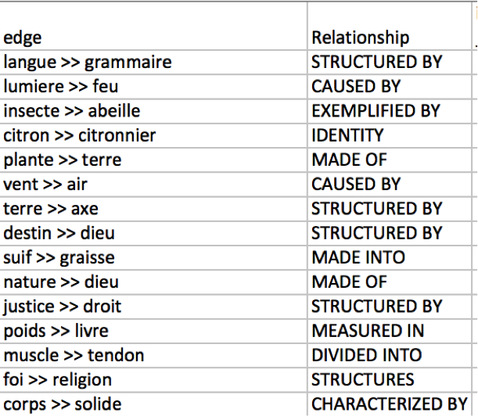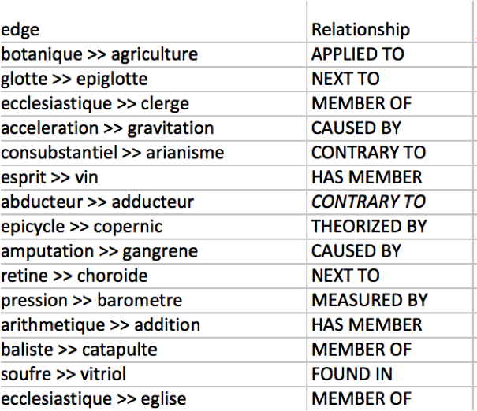

Figures 4 (left) and 5 (right): Links with greatest betweenness centrality, in the *Encyclopédie* (left) and *Wikipedie* (right) networks, respectively. Here, nodes consist only of articles present in both encyclopedias, and edges only the cross-references between them.

In the *Wikipedie*, none of the most important links are characterized by this type of analogy (Figure 5). Instead, the most frequent type of relationship is one of membership between two concepts of the same kind. For example, an ‘ecclesiastique’ is a member of the ‘clerge’; ‘vin’ is a type of ‘esprit’; ‘addition’ is a type of ‘arithmetique’.5Although the governing relationships in the *Encyclopédie* place the entries in large conceptual hierarchies, the taxonomic relationships in the *Wikipedie* point to disciplinary relationships, where knowledge is interrelated along an axis of specialization and depth. Compared with the *Encyclopédie*, the *Wikipedie* is less likely to make the metaphysical connection between arithmetic and, for example, logic; instead, it connects arithmetic to its constituent parts: addition, subtraction, multiplication, and division. We believe this juxtaposition of cross-reference practices and network structures reveals a notable shift toward disciplinarity in modernity, made visible by a combination of computational and hermeneutic methods.

**Conclusion**

From our research, then, it appears that the broad inclusivity of Wikipedia is, if anything, more deeply disciplinary than even the planned knowledge system of the *Encyclopédie*. It is worth wondering about how powerfully Wikipedia is driven by formal disciplines despite its largely informal surface structure. We are finding that where Wikipedia is not more clearly disciplinary, many articles still move toward a greater level of abstraction and institutional formation than in the *Encyclopédie*.

**Notes**

1. The English Wikipedia contains 4.6 million articles. See http://en.wikipedia.org/wiki/Wikipedia:Size_of_Wikipedia (accessed 2 November 2014).

2. In this experiment, we decided to leave aside the interlinear hyperlinks within most Wikipedia articles, because we believe they more poorly reflect the intentional editorial decisions of Diderot and his collaborators in making the *renvois* than do the cross-references contained under the ‘See also’ section. We decided to use the English Wikipedia in this experiment because, as the largest Wikipedia, it has received the most editorial attention and is most likely to contain the ‘See also’ section.

3. For this experiment, we annotated the type of analogy evident in the top-15 most central links from the shortest-path traversals of both encyclopedias’ cross-reference networks.

4. English translation: For instance, language is governed by grammar, Earth by its axis, destiny by God, faith by religion, and justice by right.

5. English translation: For instance, a clergyman is a member of the clergy; wine is a type of spirits; addition is a type of arithmetic.

**References**

**‘ARTFL Encyclopédie Project’.** (n.d.). Morissey, R. and Roe, G., eds. University of Chicago, https://encyclopedie.uchicago.edu/.

**Blanchard, G. and Olsen, M.** (2006). Le Système De Renvoi Dans L’Encyclopédie: Une Cartographie Des Structures De Connaissances Au XVIIIe Siècle. *Recherches Sur Diderot Et Sur L'Encyclopédie,* **31–32**: 45–70.

**‘Renvois Navigation’.** (n.d.). *ARTFL Encyclopédie Project*. Morissey, R. and Roe, G., eds. University of Chicago, https://encyclopedie.uchicago.edu/content/renvois-navigation.