**HOOVER — Cora**

<5 figures>

**Cora Crane’s Contribution to Stephen Crane’s Fiction**

Hoover, D. L.

Stephen Crane (1871–1900), best known for *The Red Badge of Courage,* is widely considered an innovative writer of great promise. He died at the age of twenty-eight, having completed five novels, a large number of short stories, some journalism and war correspondence, and two books of poetry. He left behind *The O’Ruddy*, an unfinished picaresque novel later completed by Robert Barr (see Hoover, 2010, for an analysis) and several unpublished stories and sketches (some of them unfinished). Considerable uncertainty surrounds the genesis of some of his posthumously published and unpublished fiction.

Crane’s adult life was unconventional and, for the times, rather scandalous. In 1896 he met Cora Taylor, ‘the madam of a pleasure resort, the Hotel de Dream’ (Wertheim, 1997). They traveled together as journalists and then moved to England, living as man and wife, though they never married. Crane contracted tuberculosis shortly after this and died in 1900. After his death, Cora, calling herself ‘Mrs. Stephen Crane’, tried to sell some her own fiction and some of his unpublished fiction, and she is known to have finished at least one of his stories, ‘The Squire’s Madness’ (Bowers, 1969). Opinions differ about how much she had to do with several other stories (Bowers, 1969; Wertheim, 1997; Gilkes, 1960). A contemporary source reported that ‘Mrs. Crane has taken upon herself the labor of completing seven or eight short stories that her husband left unfinished’ (‘The Lounger’, 1901, 199). One biographer puts the number at ‘half a dozen’ (Berryman, 1962, 259). She may also have had a hand in ‘The Ideal and the Real’ and ‘Brer Washington’s Consolation,’ two controversial stories with racist and pro-slavery themes that remained unpublished until 1978 (Linder, 1978, 2). Stephen also apparently had a hand in some of Cora’s work (under her pseudonym, Imogene Carter) as one of the first female journalists (Gilkes, 1960; Berryman, 1962). Finally, a late money-making project of Crane’s, *Great Battles of the World*, was researched and partly written by Kate Lyon (the mistress of the writer Harold Frederic), though the full extent of her contribution is unclear (Wertheim, 1997, 136).

Given this rather confused situation, it seems worthwhile to apply modern methods of authorship attribution to the questions surrounding the authorship of at least the following stories:

‘The Man from Duluth’

‘The Surrender of Forty Fort’

‘The Battle of Forty Fort’

‘A Self-Made Man’

‘A Man by the Name of Mud’

‘At the Pit Door’

‘An Illusion in Red and White’

‘Manacled’

‘A Desertion’

‘The Ideal and the Real’

‘Brer Washington’s Consolation’

The situation regarding the war correspondence and the war sketches partly by Kate Lyon seems too problematic for solution, as the amount of journalism by Cora or Cora and Stephen is quite small, and there seems to be insufficient additional writing by Kate Lyon for comparison. Crane’s reputation rests on his fiction, however, so that the stories seem the important focus, and there is at least a modest amount of Cora’s own writing to compare with Stephen’s.

Although she was not very successful in selling her own fiction after Stephen’s death, at least ‘What Hell Might Be’ (a short prose poem), ‘Cowardice’, and ‘The Red Chimneys’ were known to have been published (Gilkes, 1960; Wertheim, 1986). After some frustrating searching, I acquired e-texts of all of them. ‘The Lavender Trousers’, ‘Elbridge Carter’s Dream’, and ‘An Old-World Courtship’ were never published, but the manuscripts for these stories exist in the Stephen Crane Collection at Columbia University (they are discussed briefly by Gilkes [1960], who apparently read them in manuscript), and I have used OCR and manual transcription to produce e-texts of them (I am grateful to Columbia University Library for access to this material). Another story, ‘José and the Saints’, was reportedly unpublished and the manuscript lost (Gilkes, 1960, 277–78), but a contemporary source reports that she ‘found a ready market’ for it (‘The Lounger’, 1901, 199), and I have since discovered that it was published in 1902 and is available online. Together, these texts should be sufficient for an attempt to unravel the authorship of Stephen’s final stories. (I also collected two pieces of non-fiction by Cora for comparison—‘Arundel Castle’ and ‘The 17th Regiment of Light Dragoons’—but preliminary testing showed that Cora’s non-fiction is so distinct from her fiction that it is inappropriate for inclusion.)

Before attempting to measure Cora’s participation in Stephen’s late fiction, some aspects of this problem require further comment. Stephen’s fiction is quite varied in setting and theme, and contains several groups of more or less closely related stories. More than a dozen stories are set in the fictional Whilomville (loosely based on Port Jervis, New York, where Crane spent part of his childhood). Ten are loosely based on camping experiences of Crane and some friends northwest of Port Jervis. Six are set in Cuba, four concern an infantry regiment in the fictional country of Spitzbergen, and others have Mexican or western settings. Some are satiric, some comedic, some serious, and many treat war in some way. The one story we know Cora completed for Stephen, ‘The Squire’s Madness’, is a parody of a Gothic tale. Given this range of settings and subject matter, it seems important to select stories for testing against the questionable pieces so as not to privilege Stephen or Cora inappropriately. Cora’s seven independent stories are varied as well: besides the brief prose poem mentioned above, two take place at least partly in Mexico, two are set in England (one is a ghost story), one is set in Stephen’s Whilomville, and one is a maudlin story of an affair followed by a suicide. (This is an extreme form of problems identified in Hoover [2004] and, more thoroughly, in Eder and Rybicki [2013].) Fortunately there is an excellent resource in the *Stephen Crane Encyclopedia* (Wertheim, 1997) to aid in this effort.

My analysis is not yet complete, but Figure 1 shows some preliminary results, based on eight late Stephen Crane stories and the eight available Cora Crane stories, balanced as well as possible by kind and length. Here, I have divided the stories into sections of about 1,500 words to reduce the effect of size differences.

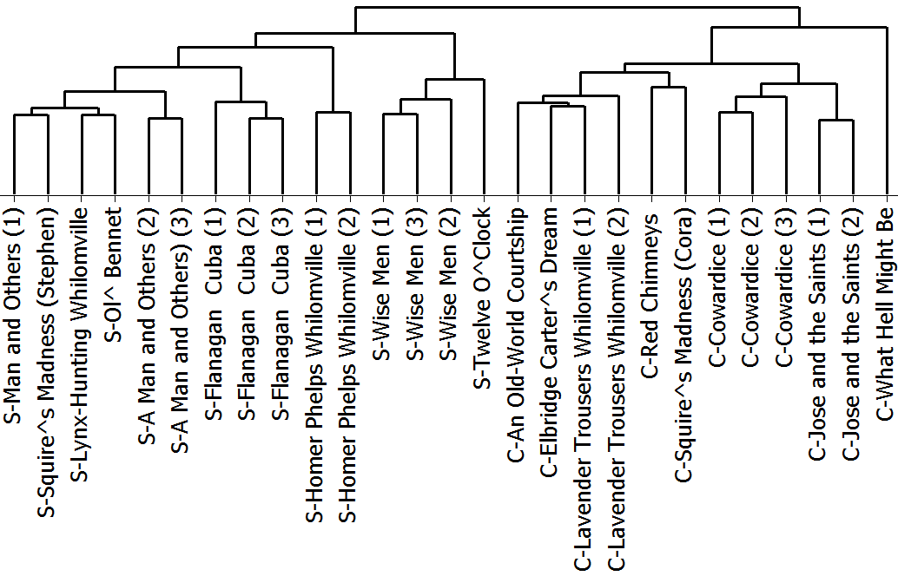

Figure 1. Cora Crane vs Stephen Crane: 800mfw, 1,500-word sections.

Cora’s stories all cluster separately from Stephen’s late stories (initial testing showed a fairly strong chronological development in Crane’s fiction, so I selected stories only from the last four years of his life). ‘What Hell Might Be’ is an outlier almost certainly because it is only 423 words long, as testing in 600-word sections confirms. An analysis based on the 900mfw separates all the sections correctly, and less accurate results, such as the one shown in Figure 2, based on the 800mfw, also suggest that they are distinct enough that it should be possible to detect even relatively small amounts of Cora’s writing in Stephen’s late fiction, if it exists. (One of the two texts by Cora that appears in the left cluster of Stephen’s texts is her half of ‘The Squire’s Madness’.)

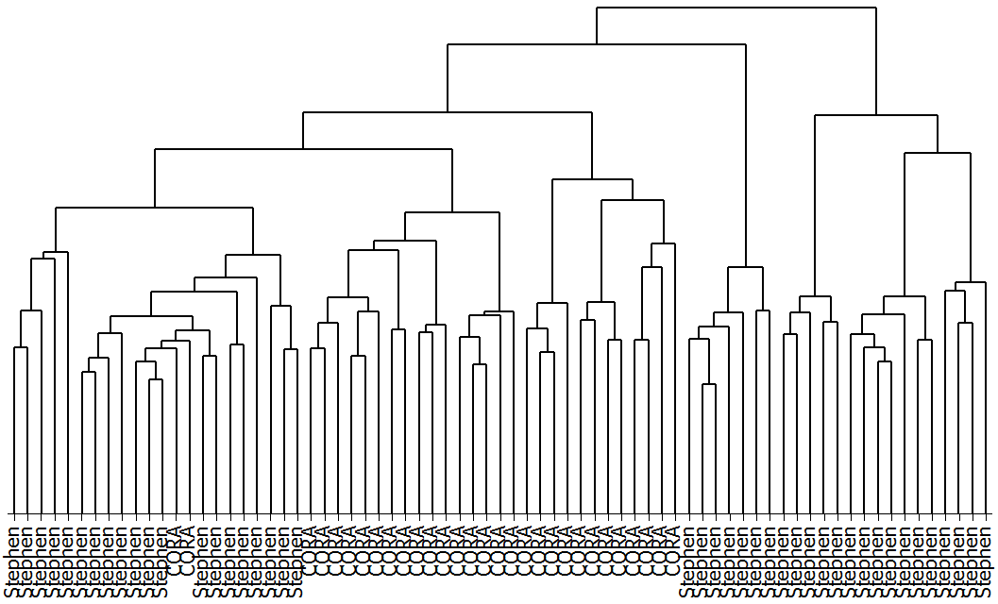

Figure 2. Cora Crane vs late Stephen Crane: 800mfw, 600-word sections.

As a first attempt at evaluating Cora’s contribution to Stephen’s late fiction, I tested the same eight stories against the eleven texts of questionable authorship mentioned above, with the results seen in Figure 3.

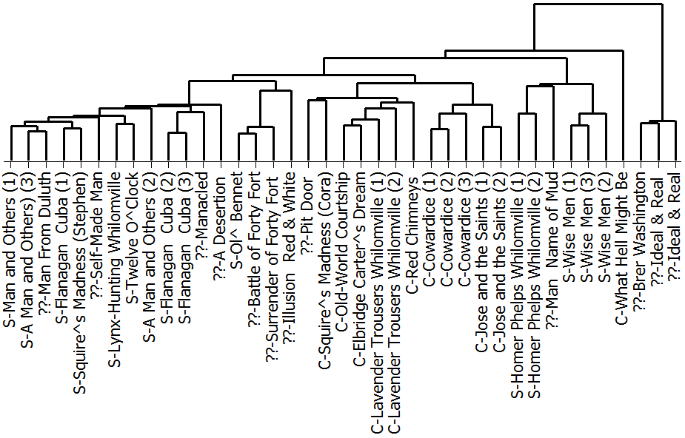

Figure 3. Cora vs Stephen and 11 questionable texts: 400mfw, 1,500-word sections.

The presence of all but one of Cora’s stories in the central cluster, the correct clustering of the two parts of ‘The Squire’s Madness’, and the presence of only one of Stephen’s stories, ‘At the Pit Door’, in Cora’s cluster do not support the idea that she had much to do with the posthumous stories. (‘At the Pit Door’ is a lighthearted sketch about a line outside a theatre; no typescript or manuscript exists.) Furthermore, the appearance of the two racist stories published in 1978 as an outlying cluster suggests that their very heavy dialect make them quite distinct. An analysis of the same texts divided into smaller sections of approximately 1,000 words is shown in Figure 4.

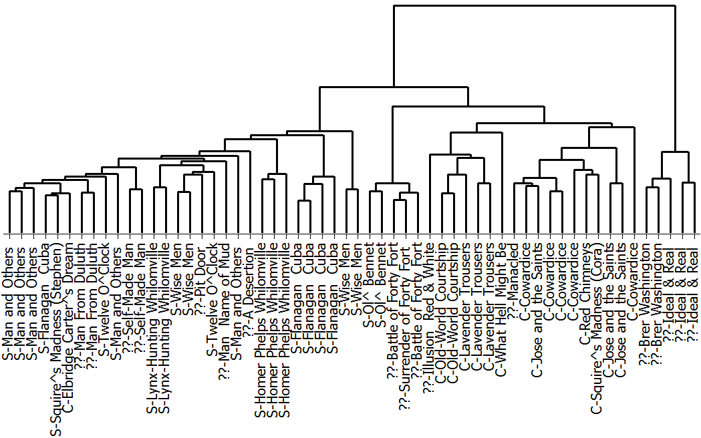

Figure 4. Cora vs Stephen and 11 questionable texts: 500mfw, 1,000-word sections.

This analysis generally supports the previous one. Here only Cora’s ‘Elbridge Carter’s Dream’ clusters with Stephen’s texts, and only Stephen’s ‘An Illusion in Red and White’ and ‘Manacled’ cluster with Cora’s texts. (Crane’s publisher already had both of these stories in January 1900, five months before Crane’s death [Bowers, 1969].) The two racist stories remain outliers. Dropping the two outliers and retesting in 600-word sections gives the results in Figure 5, which tell much the same tale. Here one section each of Cora’s ‘José and the Saints’ and ‘Elbridge Carter’s Dream’ cluster with Stephen, but none of Stephen’s and none of the questionable texts join the Cora cluster. The eleven questionable sections that form a cluster to the left of Cora’s cluster have often been suggested as having possible contributions from Cora, but they are all set in 18th-century Pennsylvania, and one, ‘Ol’ Bennet and the Indians’, was published before Crane’s death.

Dividing the same set of texts into sections of approximately 500 words and performing t-tests on all the words with a frequency of three or more yields only 101 significant words (p < .05). Repeating the analysis in Figure 5 using only these words correctly clusters all the sections except one (from ‘Elbridge Carter’s Dream’), and suggests only one section of ‘A Desertion’ and all the sections of the two racist stories as being by Cora. Preliminary Delta testing lends some equivocal support to these attributions and weakly suggests the possibility of Cora’s hand in ‘At the Pit Door’, ‘An Illusion in Red and White’, ‘The Man from Duluth’, ‘A Desertion’, and ‘A Self-Made Man’. A demonstration that Cora was a major contributor to Stephen’s posthumous fiction would have been a more exciting result, but the weakness and inconsistency of the attributions of sections of the stories of questionable authorship to Cora suggests that any part she played was a relatively minor one.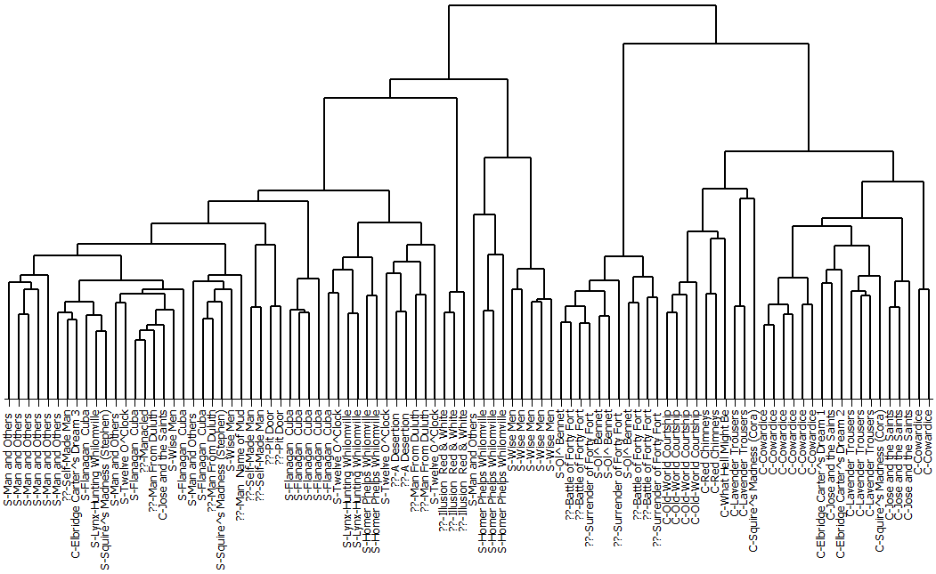

Figure 5. Cora vs Stephen and nine questionable texts: 400mfw, 600-word sections.

**References**

**Berryman, J.** (1962). *Stephen Crane*. World Publishing Company, Cleveland, OH.

**Bowers, F.,** ed. (1969). *The Works of Stephen Crane*. University of Virginia Press, Charlottesville.

**Eder, M. and Rybicki, J.** (2013). Do Birds of a Feather Really Flock Together, or How to Choose Training Samples for Authorship Attribution. *Literary and Linguistic Computing,* **28**(2): 229–36.

**Gilkes, L.** (1960). *Cora Crane: A Biography of Mrs. Stephen Crane.* Indiana University Press, Bloomington.

**Hoover, D. L.** (2004). Testing Burrows’s Delta. *Literary and Linguistic Computing,* **19**(4): 453–75.

**Hoover, D. L.** (2010). Authorial Style. In McIntyre, D. and Busse, B. (eds), *Language and Style: Essays in Honour of Mick Short*. New York: Palgrave, pp. 250–71.

**Linder, L. D.** (1978). ‘The Ideal and the Real’ and ‘Brer Washington’s Consolation’: Two Little-Known Stories by Stephen Crane? *American Literary Realism, 1870–1910,* **11**(1): 1–33.

**‘The Lounger’.** (1901). *The Critic,* **38**(1). Good Literature Publishing Company.

**Wertheim, S.** (1986). Cora Crane’s Thwarted Romance. *Columbia Library Columns,* **36**(1): 26–37.

**Wertheim, S.** (1997). *A Stephen Crane Encyclopedia*. Greenwood Press, Westport, CT.