**WANG — Animation**

<3 numbered figures embedded in tables; 2 unnumbered images; captions intentionally smaller to fit>

**Animation of Chinese Characters: The Evolution of the Shapes and Styles**

Wang, N. and Hu, J.

Hanzi (Chinese writing) is well known as a representative of an ideographic system. That means each Chinese character was formed according to a word’s meaning, which is called the character’s *original meaning*. Hanzi is also known as the oldest writing system still in daily use. The earliest confirmed evidence of the Chinese script yet discovered is inscriptions on oracle bones from the Shang dynasty (1600–1100 BC). During the long course of development, the shapes and styles of Chinese characters have undergone great changes, which can be divided into five main stages: oracle bone inscription, bronze inscription, small seal script, clerical script, and regular script. Among them, the variation between small seal script and clerical script was the greatest, which is called the *clerical change*. Those scripts before the clerical change classified as ancient scripts, while scripts after the clerical change are classified as modern scripts. The clerical change is so great that people today, without teaching, cannot recognize ancient scripts or understand why a Chinese character was formed in that fashion.

Figure 1 shows the evolution process of the Chinese character ‘’. The ‘****’ is the oracle bone inscription of ‘’. It is composed of two ‘****’ which looks like as well as means ‘right hand’. So ‘’ means ‘friendship’ clearly by ‘hand in hand’. However, it is difficult today for people to explain why ‘’ means ‘friendship’ just through its shape in regular script.

|  |
| --- |
| you |
| **Regular**  **script**  **Clerical**  **script**  **Small Seal**  **Script**  **Bronze**  **inscription**  **Oracle bone inscription**  Figure 1. The evolution of Chinese character ‘’. |

The traditional method of teaching a Chinese character’s original meaning and its evolution is to list all the shapes of this character in different stages, as Figure 1 shows. It is today, thanks to modern multimedia and virtual technology, possible to show the process vividly, as a video of Chinese character ‘’ shows.

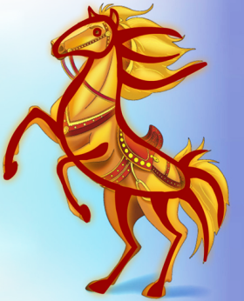

The evolution of Chinese character ‘’; see http://pan.baidu.com/s/1c0dCHBM.

As mentioned before, the clerical change, the variation between seal script and clerical script, is complicated. So a teaching system is proposed to illustrate the process of clerical change by using computer morphing technology. Based on ‘Structure Study of Chinese Characters’, Chinese characters are made up of components, and a component comprises strokes (see Figure 2). As a result, the change between the different styles of a Chinese character can be analyzed by the change of strokes. Based on the correspondence between strokes of a character in different styles (see Figure 3), a morphing process can be generated automatically by computer algorithms, like a video for the Chinese character ‘’ shows.

|  |
| --- |
| you_structure_1    Stroke  Components  The character |
| Figure 2. The structure of the Chinese character ‘’. |

|  |
| --- |
|  |
| Figure 3. The correspondence between strokes of ‘’ in different styles.  Same color means correspondence. |

[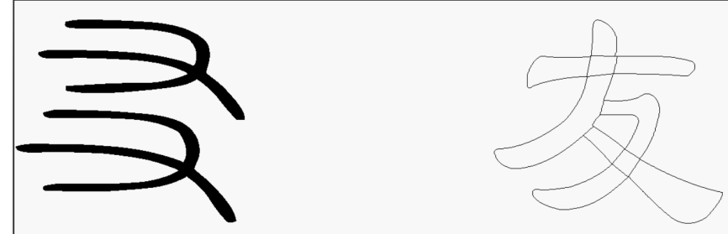](http://pan.baidu.com/s/1kTonL)

The clerical change of Chinese character ‘’; see http://pan.baidu.com/s/1kTonLbD.

Hanzi has a long history and rich content. Learning Chinese characters may be very difficult for native students as well as foreign students. What we want to do is to make the learning process more interesting and understandable by using modern multimedia and virtual technology. This multidisciplinary project required the use of various computer technologies and abundant knowledge of Chinese characters and culture. The initial goal of this project is the animation of top 500 most commonly used Chinese characters, to show their original meanings and evolution.

This paper is supported by National Key Technology Research & Development Program of China No.2014BAK18B01).

**References**

**Sun, L., Liu, M., Hu, J. and Liang, X.** (2014). A Chinese Character Teaching System Using Structure Theory and Morphing Technology. *PLoS ONE,* **9**(6): e100987.

**Wang, X., Liang, X., Hu, J. and Sun, L.** (2012). Stroke-Based Chinese Character Completion. *8th International Conference on Signal Image Technology and Internet-Based Systems 2012.* SITIS 2012r: 281–88.

**Yu, B., Liang, X., Hu, J. and Sun, L.** (2012).Statistical Structure Modeling and Optimal Combined Strategy-Based Chinese Components Recognition. *8th International Conference on Signal Image Technology and Internet-Based Systems 2012.* SITIS 2012r: 238–45.

**Yue, P., Liang, X., Hu, J. and Guo, Ch.** (2012). Knowledge-Based 2D Morphing System for Chinese Characters of Different Styles. *25th Annual Conference on Computer Animation and Social Agents*.