# HUANG — Old

<3 figures>

**Old Traces, New Links: Representation of Taiwan Baotu in OpenStreetMap**

Huang, J.-P., Liu, H.-S., Liao, H.-M. and Chuang, T.-R.

# What Is Old Is New Again

There are various approaches to digital reproductions of old artifacts. One typical approach, for example, is to make a careful scan of a rare book to preserve the book’s look and feel in high-resolution images. Other approaches, however, aim to extract as much as information from the artifacts in order to be processed by machines. Such an approach will instead convert (manually, automatically, or by a mix of manual and semi-automatic procedures) the content of a book into pure text so that it can be indexed and text-mined by computers. The digital representation of an old book is its computer text. Such a representation opens up opportunities for further reuse (e.g., audio books, hyperlinked pages, machine-translated scripts, etc.).

When working on old maps, researchers can take the latter approach: One can strike to retrace the contours and elements depicted in the maps and convert them into interlinked digital objects. Old routes in ancient atlases become road networks in online maps supported by GIS (Geographic Information Systems). We can then make travel plans as if we were living in the past by using information extracted from the old maps. The routes, however, can be calculated with the help of computer algorithms. A well-known autography can be taken apart and its essentials re-created by repurposing modern-day social network services. Researchers and students can now indulge in an interactive chronology of the people, social circles, and events described in the book.

This short paper is a preliminary report of our experience in using OpenStreetMap to digitize and put online a small portion of Taiwan Baotu. OpenStreetMap is both a grassroots, collaborative effort in global map-making, and a reliable web map service that is free for all to use (Ramm et al., 2011; Haklay and Weber, 2008). We modify and reuse the software behind the OpenStreetMap’s web map service and apply it to geospatial data digitized from old maps. We hope that what we do will come to exemplify a new approach to represent and repurpose old maps; we aim to create online resources from ancient maps where old traces become new links. Further, the links can be collaboratively added and forged when such online resources are shared and reused.

Note that OpenStreetMap has also been adapted for other purposes. In many of these cases, datasets from elsewhere are overlaid over OpenStreetMap, and it becomes convenient to browse them as themed annotations attached to a certain geographic area of interest. Often the online OpenStreetMap service is used as the source of the background map; this necessarily generates a modern map of the area (Amat et al., 2014). Such an overlaying method is frequently applied to other web mapping services as well, so that online maps enriched with collections of cultural objects (in the forms of digital images, web links, etc.) can be viewed and shared by many (Presner et al., 2014). In this work, instead, we give new lives to old maps so that they can be the background maps, be interacted with, and be enriched with other datasets. However, as OpenStreetMap depends on the use of precise geospatial coordinates, our approach is accordingly limited in its applicability to ancient maps that cannot be recoded using modern coordinate systems.

# Why Taiwan Baotu?

The Taiwan Baotu is a set of 457 topographic maps covering a major part of Taiwan. Each map is 1:20000 scaled. It was produced in 1904 when Taiwan was under Japanese rule. The collection was first published in 1906; another edition with redacted place names was released in 1920. Taiwan Baotu was derived from the output of an island-wide land survey, but had also incorporated other types of geographic information. The maps illustrate administration areas with their detailed boundaries. They contain place names, as well as land-use, transportation, landmark, and other information about Taiwan in the early 1900s.

At Academia Sinica, Taiwan Baotu was previously scanned as high-quality images. These images are available as online services from which they can be used together with other map images. Like most web-based map collections, they are delivered as map tiles to user browsers to be examined. Intrinsic details in Taiwan Baotu, such as administrative boundaries and place names, are not available as machine-processable datasets. Parts of the Taiwan Baotu had also been digitized using GIS software package. The traced contours of the maps are stored as layers of vector data (in the Shapefile format, to be exact). As such, they can be visualized and analyzed by various GIS software, but such activities cannot be easily performed and coordinated over the Web.

As we have been participating in a multidisciplinary project relating to the Taijiang Inner Sea Area (Tainan, Taiwan), we aim to represent Taiwan Baotu as a web of interlinked resources upon which researchers can further enrich and collaborate with one another.

# OpenStreetMap as Infrastructure

OpenStreetMap is a mass collaboration on mapping the world as it is now. We aim to learn from its success and use its technical infrastructure to represent the Taijiang Inner Sea Area as it was in the past. OpenStreetMap probably is best known for its practices and tools for collaborative map-making. In our work, we have not used much of the collaborative part of OpenStreetMap but rely on its underlying sub-system for map rendering, tile serving, and overlapping. To represent Taiwan Baotu in OpenStreetMap, we first took as input an existing collection of Shapefile layers. We renewed, merged, and converted these layers into new datasets following the OpenStreetMap data format.

An OpenStreetMap system is built upon a collection of open-source software packages: a database for storing map data, a rendering system for converting data into map tiles, and a tile server. The tile server responds dynamically to a user’s request for the map of a certain area and of a particular scale. OpenStreetMap software is released under free/open-source software (FOSS) licenses; everyone can freely use and modify the software to serve one’s needs (as long as the software license is respected). This means that the experiments we have done with Taiwan Baotu with OpenStreetMap can be reproduced and validated by others; the experience can be shared in the research community (which is not true if proprietary software or a proprietary service is used).

# Taiwan Baotu in OpenStreetMap

Our current work focuses on Redrawing Taiwan Baotu, converting map data for use in OpenStreetMap, and providing an interactive layer on top of Taiwan Baotu in OpenStreetMap. These can be applied to any historical maps with definite geospatial coordinates.

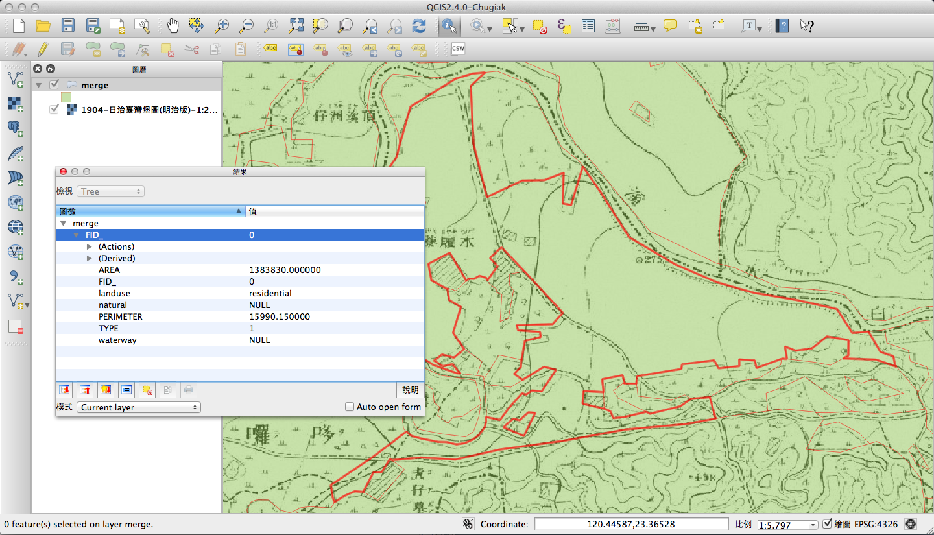

Figure 1. Redrawing maps in QGIS.

First, QGIS is chosen as the tool to redraw the historical maps (see figure 1). The redrawing is actually an iterative process: Feedback from the OpenStreetMap end will trigger editing at the QGIS end, and the data modified with QGIS is again fed to OpenStreetMap for visualization and verification. The result is saved in the ESRI Shapefile format.

Second, we convert datasets from the Shapefile format to the OpenStreetMap format. We developed a program to do the conversion automatically; we also provided a web form for people to upload and convert Shapefile datasets so as to try to bridge the various gaps between the researchers and the programmers. There are several existing conversion programs, which are unable to perform this job because our datasets contain Chinese characters. Our program supports Unicode and is able to import the result directly into the OpenStreetMap database after a map dataset is converted. Once the dataset is converted, it becomes readable and editable by simple text editors. Then the OpenStreetMap service will convert map datasets into map tiles that are then sent to display in user browsers.

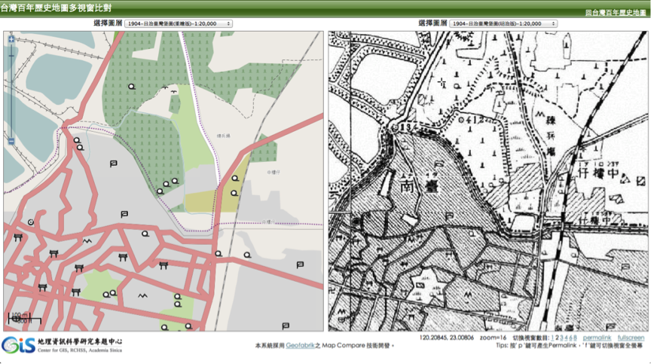

Figure 2. A comparison of a paper map and its digital representation in OpenStreetMap.

Finally, we built an interactive map of Taiwan Baotu on which users can contribute data on top of the visualized map. Figure 2 shows paper and digital maps of Taiwan Baotu in the same screen. We use this platform to review the quality of the redrawn map: one can compare the difference between the paper map and the digital map. We also provide a platform for users to connect external data to the historical map on display.

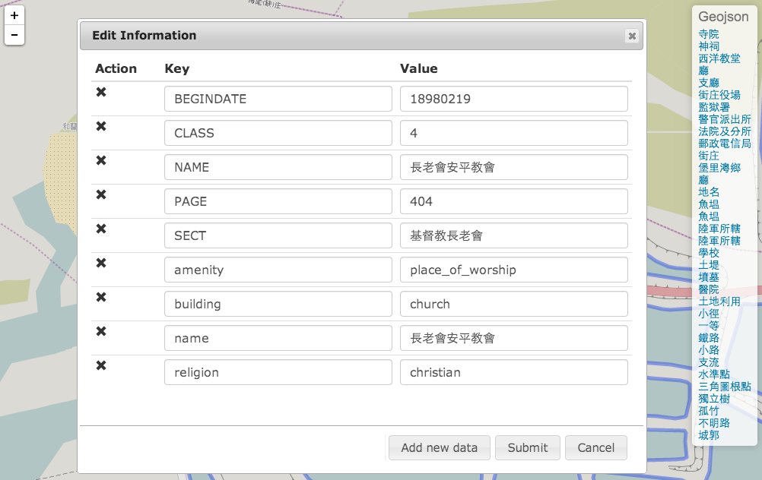

Figure 3. Attaching external information to a historical map.

The external data is usually a URL to an article, an image, or a video accessible over the Internet. We provide a form for users to fill in the URL of an external resource that is related to a location on map (see Figure 3).

# Openness in Research and Scholarship

Our method represents a workable and reproducible approach for the digital representation of historical maps where intrinsic map details are kept and opened up for reuse. As we keep much information in the maps in digital and interactive forms, these historical maps become more helpful for the historians, researchers, teachers, students, and others who are interested in the maps and wish to contribute to the development of digital humanities. Recent research and observation about research data sharing and reuse (of which maps are but one category) shows that open scholarship is the norm. Formal and informal scholarly communication (sharing and reusing map data offer one example) is converging, and open access to data is a paradigm shift (Amat et al., 2014). Our methods are small but concrete steps to open up historical maps for better sharing and reuse.

# References

**Amat, G., Fernandez, J., Arranz, Á. and Ramos, A.** (2014). Using OpenStreetMaps Data and Tools for Indoor Mapping in a Smart City Scenario. In *17th AGILE International Conference on Geographic Information Science*, Castellón, June.

**Borgman, C. L.** (2013). *Scholarship in the Networked World: Big Data, Little Data, No Data*. Oliver Smithies Lecture, Balliol College, Oxford, June.

**Haklay, M. and Weber, P.** (2008). OpenStreetMap: User-Generated Street Maps. *IEEE Pervasive Computing,* **7**(4) (October–December): 12–18.

**Presner, T. S., Shepard, D. and Kawano, Y.** (2014). *HyperCities: Thick Mapping in the Digital Humanities*. Harvard University Press, Cambridge, MA.

**Ramm, F., Topf, J. and Chilton, S.** (2011). *OpenStreetMap: Using and Enhancing the Free Map of the World*. UIT Cambridge.