**O’SULLIVAN — Electronic**

<2 images>

**Electronic Literature and the Politics of Process**

O’Sullivan, J. C.

Critics have long examined the ‘multimodal capacity of electronic literature’ (Page and Thomas, 2011, 2). The material semantics of electronic literature are not inherently new, but rather a rejuvenation of established literary practices exemplified by the material modernists and other such movements to have sought control over the paratextuality of a literary work. Yet new media does deliver rejuvenation through enhanced paratextual potential. Materiality, and in turn paratextuality, is concerned with experience: it governs the reception of a work and the ways in which its audience might interact with it. In this paper I will engage with works of electronic literature in an attempt to delineate how some of the field’s most prominent authors and practitioners have used the manipulability of digital paratext for artistic purposes.

# Electronic Literature as Avant-Garde

When an author selects a digital medium, there are ideological considerations that cannot be ignored—they are making a statement about the aesthetic they desire and what that aesthetic represents. In this respect, we see how it is that electronic literature is very much connected to concepts of the avant-garde, so much so that its works are often criticised as being overtly experimental. Responding to Andrew Gallix’s challenge that electronic literature sacrifices literary quality, Grigar accepts that ‘the hybridity of the forms and technological innovation that artists bring to their work result in a high level of experimentation that may at first obfuscate literary content’ (n.d.), but she is quick to point out that obfuscation should not deny the digital’s claim to the mantle of literary. If electronic literature serves as little more than a jolt in literature’s long history, then surely it has achieved the very thing that literature sets out to achieve? Perhaps electronic literature is more valuable ideologically than it is semantically or aesthetically, but having such political value is in itself a very literary trait. Grigar raises another interesting point in that same article, referring to electronic literature’s brief moment within the spotlight of the press, back when it still held its ‘shock of the new’. She offers this as a rebuttal to the claim that electronic literature, once popularised within the media, has since been relegated to a tertiary note on specialised blogs. On the contrary, electronic literature may no longer be a media darling, but it has found itself a place within the academy, and within the focus of respected authors and critics from across the digital humanities.

In this sense, electronic literature’s ability to disrupt the status quo has faded, but it has traded the ease by which it can shock for an ability to achieve problematisation through defamiliarisation—so much so, that electronic literature has become self-reflective to the point where it is now querying its most essential of properties: being born digital.

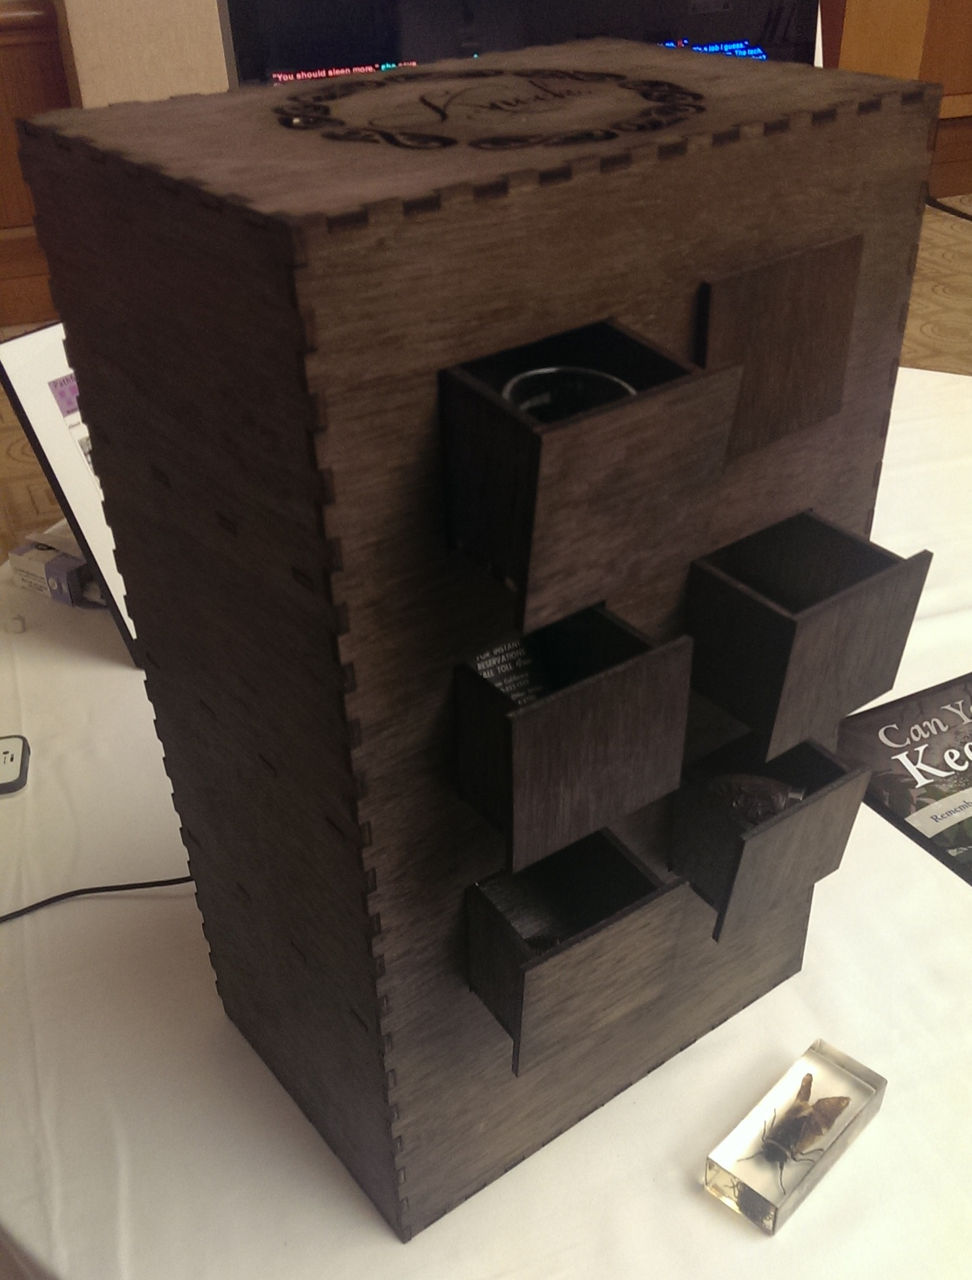

Figure 1. *Closed Room, Soft Whispers*, by Jacob Garbe. From Pathfinders Exhibit, MLA 2014 convention, Chicago, January 2014.

The Pathfinders Exhibit at the 2014 MLA convention presented a selection of early electronic literature, alongside some more recent pieces. Many of the works on show displayed a new iteration in the juxtaposition between literature and technology, in that digital and physical materiality had been fused beyond hardware and software. What Strickland achieves with her hybrid *V: WaveSon.nets/Losing L’una*, for example, has been taken to its conclusion: electronic literature is moving, diachronically, at an immense pace, its authors beginning to deconstruct the very boundaries that they themselves put up.

When code is open access, the reader can pierce the veil in a manner rarely seen before. Readers, and indeed authors, have insights into the worlds of their precursors and contemporaries. Authors in this field began by swerving away from the page, but now they are, while perhaps not swerving away from the digital, certainly seeking its convergence with other, seemingly disparate, materialities. It is re-creation of the re-created, a tension that has been consciously instigated in an effort to achieve further defamiliarisation of that which is already defamiliar. This is precisely what Pressman labels as ‘digital modernism’, a movement that, she argues, interrogates ‘cultural infrastructures, technological networks, and critical practices’ (2014, 10), and in doing so, ‘offers a surprising counterstance to this privileging of newness’ (1).

# The Politics of the Screen

Within the electronic literature community, there is a marked reaction against the intentions of software’s function. Authors in this realm practice perverse engineering, where a tool is not modified for literary purposes but rather adapted, at a surface level, so that it satisfies some authorial desire. Flash, for example, was never intended for literary purposes, but it is at the very heart of the first two volumes within the *ELO Collection*. The exploitation of computer systems is fundamental to contemporary electronic literature in that the majority of works are produced using technologies that were designed for some other purpose. This act, the manipulation of hardware and software for literary purposes, is a fundamental aspect of the movements that promote and produce much of this work. Reducing the process of writing electronic literature to a purpose-built intuitive graphical user interface would be akin to creating a program that structured the metre for nondigital poetry. In this sense, electronic literature is the product of exploited technologies; it is expression through manipulation. This presents an interesting reversal of Adorno and Horkheimer’s view, with technology becoming an instrument in the problematisation of those structures that they argue it enforces. Ideological arguments cannot always account for an author’s technological selections, but there are many instances where both the form and tools adopted for a work of electronic literature are inherently ideological, if not overtly political.

In exploring the influence of digital materiality and the politics of e-lit processes and practices, I will look at *Flight Paths* (see Figure 2),by Kate Pullinger and Chris Joseph, as well as Mark Marino’s ‘a show of hands’, a piece inspired by the 2006 immigration reform in Los Angeles.

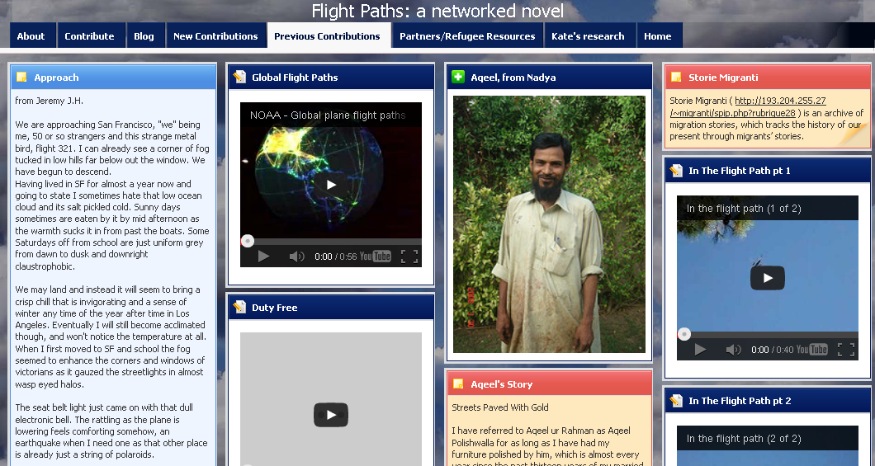

Figure 2. ‘Previous Contributions’, from *Flight Paths*, by Kate Pullinger and Chris Joseph. *Electronic Literature Collection*, Vol. 2.Electronic Literature Organization, February 2011, collection.elitarture.org.

# Conclusions

While we cannot separate ideology from any literature, we can see that electronic forms are married to the politics of process. Each of these works has meaning in its materiality, considerably more than would typically be the case, even amongst the foremost of the material modernists. While Yeats was able to embed the esoteric in his bindings, the screen permits semantic permeations throughout a work as a whole. Even concrete poets, with typographic arrangements, are restricted by the surface of the page. I do not want to represent the page as a media with particularly negative limitations: all forms have limitations that can at times be just as readily considered strengths. Concrete poetry, like the cover of a Yeatsian edition, is manifested as a permanent entity. There is no such permanence in the electronic environment, where works of art, when reduced to substance, are merely the graphically rendered representations of bits and bytes. This impermanence offers something authors that is not found in other forms, and as has been seen, it allows them a freedom of ideological expression that is very much bound to materiality. Process is also essential. Traditionally, authors collaborate with publishers to see their literature produced in book form. I think it fair to assume that the majority of writers do not actually possess a working knowledge of how it is that manuscripts are transformed into physical books. That is not to say that nondigital writing practices are without process, but that process plays a more significant role in the digital arena, where authors must be familiar with processes of production if they are to write. Even where collaboration exists, an understanding of how technology can—and cannot—manipulate the linguistic content of a piece must be possessed. It is not simply about words on the surface but rather about the surface and the underlying code that dictates part of the reader experience. Garbe did not just write *Closed Room, Soft Whispers*, he *made* it: he composed the surface-level text, he wrote the underlying code, and he built the wooden box. Marino captured his own images; he worked directly with the platform that presents his narrative. In this respect, the politics of the screen are, unlike the page, materially layered, with authors being as much makers as they are writers.

Throughout this paper, I will use these works of electronic literature to delineate how contemporary juxtapositions of traditional and modern literary practices have presented authors with hyper-paratextuality, and their engagement with such is significant. It is easier for an author to put down words on a page than it is, for example, to learn Python and produce a generative poem. Thus, it is always significant when an author chooses digital encapsulation for expression. This act, the selection of an electronic rather than nondigital medium, is an authorial statement from which immediate conclusions can be drawn. The significance of the influence exerted by digital paratextuality may be questioned on the basis that much of that which makes it digital sits behind the interface, but the recognition of digitality is in itself influential. Authors do not complicate the process of writing with additional technical requirements on a whim.

**References**

**Grigar, D.** (n.d.). Electronic Literature: Where Is It? *Electronic Book Review.*

**Page, R. and Thomas, B.** (2011). *New Narratives: Stories and Storytelling in the Digital Age.* University of Nebraska Press, Lincoln.

**Pressman, J.** (2014). *Digital Modernism: Making It New in New Media.* Oxford University Press, New York.

**Pullinger, K. and Joseph, C.** (n.d.). Flight Paths. *Electronic Literature Collection,* **2**.