**O’SULLIVAN — Computational**

<2 figures, 2 tables>

**Computational Approaches to Ireland’s Contemporary Literary Journals**

O’Sullivan, J.

Ireland’s literary communities are thriving. In the face of mounting economic pressures, the island continues to host a relatively substantial volume of prestigious publications dedicated to contemporary literature, all of which are seemingly committed to a high standard of literary quality. Some of Ireland’s most acclaimed contemporary authors are engaged with these journals as editors, with an increasingly wide spectrum of genres and modes being catered to. Ireland is a nation rich in literary tradition, but this is a varied tradition, comprising something of a riot of aesthetics, forms, and ideologies. However, unlike larger countries, it is feasible to identify Ireland’s most prestigious journals, and having done so, produce a whole range of literary extrapolations through the use of computational methodologies. This paper takes a number of Ireland’s longest-running and most prestigious literary journals, and using a variety of computational methods, conducts a series of macro-analytical explorations designed to identify the key trends across its dynamic literary community. In choosing literary journals, I am focusing on a sector that continues to thrive, both nationally and indeed globally (Harmanci, 2011). More importantly, journals and periodicals are reflective of a region’s literary grass roots, in that they largely comprise authors who are an active part of the artistic community. Thus, they arguably provide a more accurate indicator of local and national trends than one would find in an analysis of novels or standalone collections.

# Methodology and Results

This study brings together a unique dataset, containing digitised editions of some of Ireland’s longest-running and most respected literary periodicals. Specifically, this dataset includes complete or nearly complete collections of each of the canonical journals for contemporary Irish writing. While a major analysis has been conducted and is still under way, for the sake of brevity only a sample of my findings are presented here. The journals have been analysed using a variety of approaches to textual analysis, as well as topic modeling. In this particular instance, I have elected to outline the results of a subset of my stylometric and textual analyses, as well as my initial topic models. For the purposes of this abstract, I am focusing on the online issues of two of Ireland’s leading contemporary journals, Poetry Ireland’s *Poetry Ireland Review*, and *Southword*, published by the Munster Literature Centre. The final study will incorporate the results of several other analyses relevant to this exploration of contemporary Irish writing and use a wider dataset.

## *Cluster Analysis of* Poetry Ireland Review *and* Southword

Editorial influences on style are explored using multivariate stylometric methods packaged in Stylo (Eder et al., 2013). In this instance, what is of interest is whether there is a clear stylistic separation between the submissions being accepted to *Southword* and the *Poetry Ireland Review*. A cluster analysis, using Delta (Burrows, 2002; Hoover, 2004) and 100 features, demonstrates a clear separation between the styles found in each journal (see Figure 1).

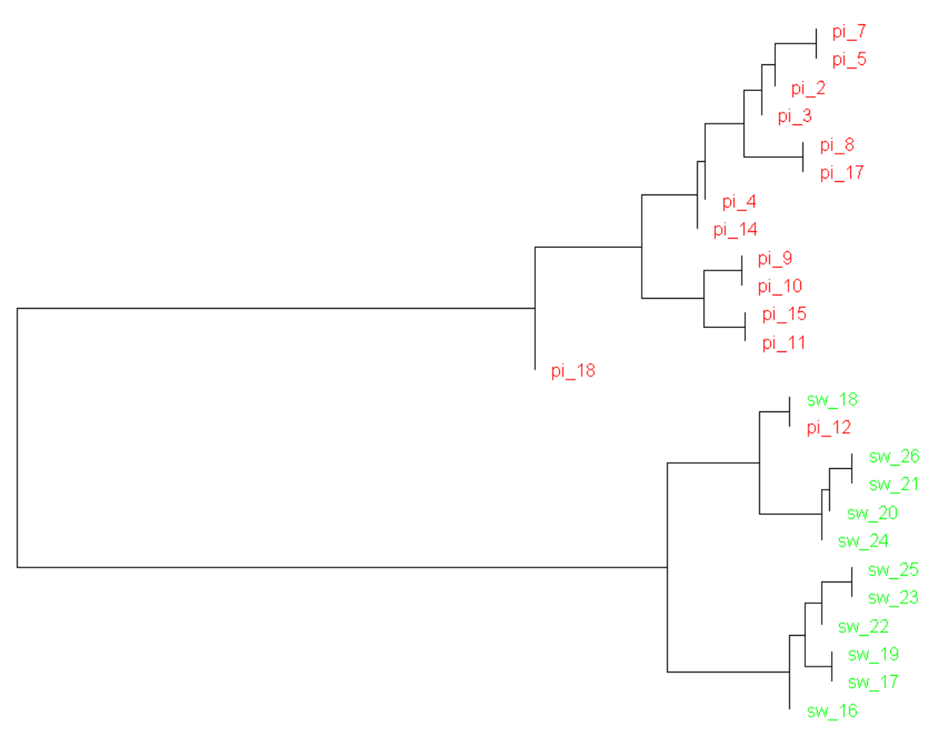

Figure 1. Cluster analysis of Poetry Ireland Review and Southword.

## *Principal Component Analysis*

Principal component analyses of the journals suggests that content is temporally comparable (see Figure 2), but also editorially separable, an issue that will be delineated in greater detail in the presentation.

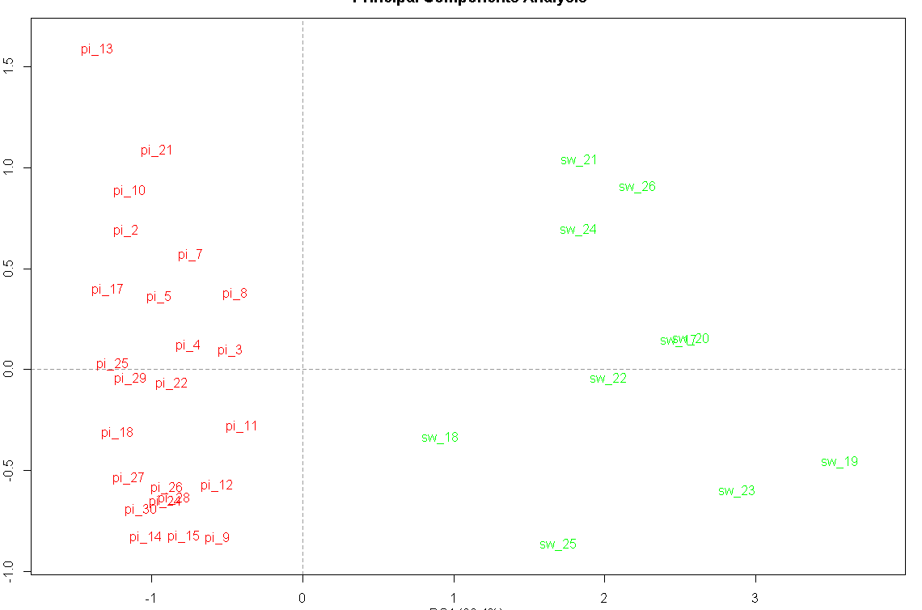

Figure 2. PCA of Poetry Ireland Review and Southword.

## *Distinctive Markers in* Poetry Ireland Review *and* Southword

A list of the most distinctive words from each journal is generated using Craig’s Zeta (Hoover, 2008; Burrows, 2007), with a text slice length of 5,000, text slice overlap of 1,000, and an occurrence and filter threshold of 2 and 0.1. Unlike Delta, Zeta is a mode of classification, the results of which demonstrate a sample of the ‘unique’ words from each journal (see Table 1).

|  |  |
| --- | --- |
| ***Poetry Ireland Review*** | ***Southword*** |
| humour  criticism  oxford  dolmen  revolution  role  perception  mythology  extent  stated  speak  shall  original  desire  pain  myth  development  described  fact  critical  awareness  celtic  passion  importance  hearing  given  matter  sight  culture  historical | father  sitting  walked  minutes  revival  across  distance  passed  drove  completing  prisons  sandwiches  seated  shouts  angled  knocks  sideways  clock  camera  cigarette  beer  pipes  pressing  shit  splash  corners  trousers  muddy  crowded  meal |

Table 1. Most distinctive words from Poetry Ireland Review and Southword.

## *Topic Modeling in* Poetry Ireland Review *and* Southword

Topic modeling is a form of probabilistic modeling designed to ‘uncover the hidden thematic structure in document collections’ (Blei, n.d.; 2012). Non-negative Matrix Factorisation was used to conduct the analysis, a fragment of which has been provided (see Table 2).

|  |  |  |  |
| --- | --- | --- | --- |
| love time home mr high deep remember war lost died | | |  |
| poetry poems poem work irish poet book poets language verse | | | |
| life great things made find part power don sense human | | |  |
| black day heart half world trees hair silence dream garden | | |  |
| night light dark sea water sun green room air sky | |  |  |
| white man dead time back red blood head leaves bed | | |  |
| na ar de ag la mo agus tuairisc se el |  |  |  |
| god long face eyes words death hands place earth hand | | |  |
| clarke house years young back church found small ll great | | |  |
| good people man women world Heaney poet political woman life | | | |

Table 2. Topic models in Poetry Ireland Review.

# Interpretations

A number of interesting peculiarities have emerged from this study. The fact that there is a consistent stylometric separation of the journals suggests that there is a clear style associated with each journal, which I suggest can be attributed to editorial contexts. To my knowledge, this is the first study that offers quantitative evidence of editorial influences. The topic models are also significant, in that they present some fascinating thematic axes. In *Poetry Ireland Review*, we see the alignment of Heaney with gender and politics, and dreams with nature.

In my presentation, I will present the complete set of results from this macro-analysis, as well as the most significant findings from this study, which in an Irish context is the very first of its kind. Key findings and interpretations in relation to literary trends—editorially, temporally, and otherwise—will be presented and discussed. I believe this study of interest to the international literary community, not only because of the global interest in Irish writing, but also because many of these findings may well be generisable, or comparable, across differing literary and cultural contexts.

# References

**Blei, D. M.** (2012). Probabilistic Topic Models. *Communications of the ACM,* **55**(40): 77–84.

**Blei, D. M.** (n.d.). Topic Modeling. http://www.cs.princeton.edu/~blei/topicmodeling.html.

**Burrows, J.** (2002). ‘Delta’: A Measure of Stylistic Difference and a Guide to Likely Authorship. *Literary and Linguistic Computing,* **17**(3): 267–87.

**Burrows, J.** (2007). All the Way Through: Testing for Authorship in Different Frequency Strata. *Literary and Linguistic Computing,* **22**(1): 27–47.

**Eder, M., Kestemont, M. and Rybicki, J.** (2013). Sylometry with R: A Suite of Tools. *Digital Humanities 2013: Conference Abstracts*. University of Nebraska, Lincoln, pp. 487–89.

**Harmanci. R.** (2011). Literary Journals Thrive, on Paper and Otherwise. *New York Times*, 7 April, http://www.nytimes.com/2011/04/08/us/08bcculture.html?_r=0.

**Hoover, D. L.** (2004). Testing Burrows’s Delta. *Literary and Linguistic Computing,* **19**(4): 453–75.

**Hoover, D. L.** (2008). Quantitative Analysis and Literary Studies. In Schreibman, S. and Siemens, R. (eds), *A Companion to Digital Literary Studies*. Oxford: Blackwell Publishing, pp. 517–33.