**MELANIE-BECQUET — Archaeology**

<2 images>

**Archaeology in the Digital Age: From Paper to Databases**

Mélanie-Becquet, F., Ferguth, J., Gruel, K. and Poibeau, T.

Research units in archaeology often manage large and precious archives containing various documents, including reports on fieldwork, scholarly studies, and reference books. These archives are of course invaluable, recording decades of work, but are generally hard to consult and access. In this context, digitizing full text documents is not enough: information must be formalized, structured, and easy to access, thanks to friendly user interfaces.

The situation at AOROC, a research unit of Ecole normale supérieure specializing in archaeology, is precisely the one described in the previous paragraph: several decades of research are contained in documents that are hardly accessible, even for people working in the lab. The situation is such that researchers may produce studies largely overlapping with previous work, which remained unknown because of poor accessibility.

A partnership has thus been established between AOROC and LATTICE—another research unit specializing in digital humanities and natural language processing—to digitize and structure a part of these documents. A pilot study concerned a collection of texts covering excavations related to the Gaul period (*Cartes Archéologiques de la Gaule* [Provost, 1988–]), resuming excavations made in an area encompassing a large part of modern France from the Iron Age to the medieval period, 800 BC to AD 800. One hundred twenty-eight volumes have been published so far, each volume corresponding to one French department; some departments are covered by several volumes. The pilot study concerned three of these volumes, along with other types of documents so as to ensure the genericity of the developed solution. The idea is, of course, not just to digitize and transfer documents online but also to extract key information so as to feed structured databases (Poibeau et al., 2013). The result should be accessible using a standard but powerful query language.

A first step consists in recognizing the structure of the documents, which mainly consist of notices, each notice corresponding to a specific ‘municipality’ (the structure is not formally encoded in the source documents and may vary from one document to the other). Specific zones inside the notices have to be recognized (see Figure 1). This step can be done by specific programs but also needs some manual cleaning. In our opinion, the most interesting part concerns advanced natural language processing techniques used for information extraction. These include

• Named entity recognition (i.e., the recognition of proper names, location, dates, etc.).

• Technical term extraction (i.e., all archaeological terms).

 • Entity linking (i.e., the recognition of the different variants of a same term or entity and its connection to the same type of object in the database).

Figure 1.A typical notice with key information to be recognized.

Different tools have been used, like TreeTagger (http://www.cis.uni- muenchen.de/~schmid/tools/TreeTagger/) for part-of-speech tagging, Yatea (https://metacpan.org/release/Lingua-YaTeA) for technical term extraction, and TyDI for terminology structuration (http://ciam.inra.fr/logiciels/node/195). In-house solutions have been developed for document structure, namely entity recognition, and entity linking. All the modules are parameterized so that they can be easily adapted to new sources of data. These tools are based on up-to-date natural language processing techniques and have obtained excellent results in recent benchmarks like Semeval (Ruiz and Poibeau, 2015).

The result of the project made it possible to automatically feed a structured database based on the textual content analysis. Documents are now accessible online with full text facilities, structured indexes, and ontologies (see Figure 2). It is thus possible to interrogate the database with queries dealing with a specific location, a specific series of objects, or a given period of time.

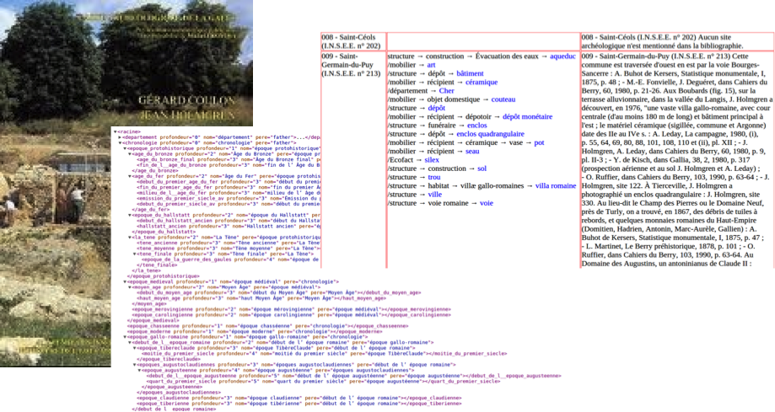

Figure 2.The original published text, along with some structured outputs after analysis.

This work can be compared to other initiatives with a similar goal. In archaeology, one can cite archaeological archiving bodies such as the ADS (http://archaeologydataservice.ac.uk/), tDAR (http://www.tdar.org/about/), or OpenContext (http://opencontext.org/), among others. Research on interoperability between archaeological databases includes, among many others, Binding et al. (2008), Doerr (2003), Jordal et al. (2004), and Vlachidis and Tudhope (2012). Our project is different since it is designed from the outset to deal with texts in different languages, especially French, Germanm and English, with a cross-linguistic perspective. One of the major research issues is the maintenance of an international terminology referring to complex notions that can vary from one country to the other. The system should be flexible enough to be able to match related concepts (even if they vary slightly from one source to the other), but relevant enough so as to provide only relevant information. This goal involves a permanent dialogue between experts of the domain and the maintenance of an up-to-date terminology. The tools and interfaces developed within the project should help to keep this goal a reality as much as possible.

**Acknowledgements**

This work has received support of Paris Sciences et Lettres (program ‘Investissements d’avenir’ ANR-10-IDEX-0001-02 PSL*) and of the laboratoire d’excellence TransferS (ANR-10-LABX‑0099). The project has been realised during the PEPS CNRS-PSL EITAB 2013–2014.

**References**

**Binding, C., May, K. and Tudhope D.** (2008). Semantic Interoperability in Archaeological Datasets: Data Mapping and Extraction Via the CIDOC CRM. In *Research and Advanced Technology for Digital Libraries*. LNCS 5173. Berlin: Springer, pp. 280–90.

**Doerr, M.** (2003). The CIDOC Conceptual Reference Module: An Ontological Approach to Semantic Interoperability of Metadata. *AI,* **24**(3): 75–92.

**Jordal, E., Holmen, J. and Olsen, S. A.** (2004). From XML-Tagged Acquisition Catalogues to an Event-Based Relational Database. In Niccolucci, F. (ed.), *Beyond the Artefact—Proceedings of CAA2004*. Archaeolingua, pp. 81–85.

**Poibeau, T., Saggion, H., Piskorski, J. and Yangarber, R.** (eds). (2013). *Multi-Source, Multilingual Information Extraction and Summarization.* Theory and Applications of Natural Language Processing. Springer, Berlin.

**Provost, M.** (ed.). (1988–). *Cartes archéologiques de la Gaule.* FMSH editions, 128 vols. published to date. Académie des Inscriptions et Belles Lettres, Paris.

**Ruiz, P. and Poibeau, T.** (2015). Entity Linking Combining Open Source Annotators via Weighted Voting. *Proceedings of Semeval 2015.* Boulder.

**Vlachidis, A. and Tudhope, D.** (2012). A Pilot Investigation of Information Extraction in the Semantic Annotation of Archaeological Reports. *International Journal of Metadata, Semantics and Ontologies Archive,* **7**(3): 222–35.