**QUAMEN — Clock**

<3 figures>

**‘On the Clock’: Grading the NFL Draft Pundits**

Quamen, H., Bouchard, M. and Keenan, A.

Every spring, fans of the National Football League gather around televisions and websites to watch their favourite teams draft the most promising young players from the college and university ranks. A few decades ago, the NFL Draft was a closed-door affair held in a nondescript hotel conference room, but today the annual draft fills New York City’s Radio City Music Hall to capacity and the spectacle attracts as many television viewers as baseball’s World Series (Kaboly, 2013). It has even prompted a recent Hollywood movie: *Draft Day*, starring Kevin Costner. What sabermetrics and the movie *Moneyball* did for baseball is now clearly happening to football as well (Lewis, 2004). The NFL draft is a pop culture extravaganza that gives DH specialists the ability to take their data analytics and data visualizations outside academia.

The weeks and months leading up to the draft are filled with a flurry of mock drafts and finely-tiered player rankings from professionals and amateurs alike. Regardless of the format, however, fans hang on every new post as pundits like Mel Kiper, Mike Mayock, Gil Brandt, Rob Rang, and Nolan Nawrocki update their respective lists on a weekly—and sometimes even daily—basis. But how do the pundits fare? How accurately do these experts predict the top-ranked players whom teams will covet most highly?

**Methodology**

This project uses correlation analysis and data visualization to measure the accuracy of NFL draft pundits. Given that NFL teams’ individual ‘draft boards’ are top-secret affairs, the only accessible data are from the pundits themselves. But because the draft itself functions like a marketplace—the more highly valued players will be selected first—we can use a simple tool like Pearson’s correlation coefficient (colloquially known as ‘Pearson’s *r*’) to calculate how accurately a pundit’s ranking of top players matches the draft’s actual progression. Calculating and graphing Pearson’s *r* at every draft pick yields not only a clear visualization of the best and worst pundits, but also how their accuracy increases or decreases as the draft progresses.

This poster evaluates the performances of 32 different pundits in last year’s 2014 NFL draft. Although the draft itself consists of 256 selections distributed across seven rounds, not all pundits rank enough players to cover all seven rounds. A few pundits predict only the top 32 players—the elite players to be chosen in the first round—while a few sources grade 500 or even 1,000 players. As our visualizations progress from round to round, then, many pundits drop off the charts, but the results are telling.

**Results**

Although our goal was merely to measure pundits’ accuracy, these visualizations allow us to learn much more about the culture surrounding the NFL draft and about how top-secret data move through invisible channels. Visualizing multiple rounds of the draft clearly shows which pundits work independently and which have some access to one of the two official NFL scouting consortia, called BLESTO and National (Business Arena Sports, 2013; *Finding Giants*, 2014). Because official scouting information from those two consortia is private and secret, we can only infer the circuits of communication through which these lists move, but the fact that information is ‘leaked’ every year is irrefutable because we can see exactly where it surfaces. By Round 7, our visualizations even allow us to deduce which specific pundits have allegiances to which consortium.

In short, the results are these:

• The most high-profile television pundits—ESPN’s Mel Kiper and NFL Network’s Mike Mayock—are independents who, despite their enormous popularity, have only middle-of-the-pack accuracy. Like most independent pundits, their accuracy severely plummets about 80 or 85 picks into the draft. Still, they are the most accurate of the independents.

• It’s in Round 3 (about pick 100) that the independents are clearly separated from the pundits who have closer access to organizations of professional NFL scouts. Lists generated by those organizations surface in otherwise relatively quiet and low-profile venues such as news organizations like CBS Sports and data aggregators like Drafttek.

• By Round 7, few independent or amateur scouts remain. The remaining pundits’ scores converge here into two very distinct groups, and our conclusion is that these pundits have access to either of the two private lists used by the NFL teams themselves. Given that pundit Rob Rang was sued in 2011 by National Scouting for violating copyright on their draft data (Business Insider, 2013), we can deduce that the pundits that cluster near Rang have access to the player rankings provided by National Scouting whereas the other group most likely represent BLESTO.

**References**

**Brandt, G.** (2014). Hot 100 + 25: Johnny Manziel, Jadeveon Clowney Lead Draft Class. Nfl.com, 24 April, http://www.nfl.com/news/story/0ap2000000343420/article/hot-100-25-johnny-manziel-jadeveon-clowney-lead-draft-class.

**Business Arena Sports.** (2012). NFL Scouting Foundation—Blesto & National, 2 November, http:// www.businessarenasports.com/ba-blog/nfl-scouting-foundation-blesto-national.

**Business Insider.** (2013). Football Blogger Might Get Away with Publishing ‘Secret’ Player Grades, 16 January, http://www.businessinsider.com/copyright-claim-against-rob-rang-dropped-2013-1.

***Draft Day*.** (2014). Dir. Ivan Reitman. Starring Kevin Costner. Summit Entertainment.

***Finding Giants.*** (2014). Television series. NFL Network. 30 September, http:// nflcommunications.com/2014/09/22/nfl-networks-original-series-finding-giants-provides-insidelook- into-scouting-building-the-new-york-giants/.

**Kaboly, M.** (2013). NFL Draft Has Become Must-See Television, 7 April, http://triblive.com/­sports/steelers/3763292-74/draft-nfl-espnfiaxzz3H91nu3zA.

**Kiper, M.** (2014). Big Board: Top 100 Prospects. http://insider.espn.go.com/nfl/draft2014/story/_/id/ 10890085/2014-nfl-draft-jadeveon-clowney-tops-mel-kiper-final-big-board-top-100- prospects.

**Lewis, M.** (2004). *Moneyball*. W.W. Norton, New York.

**Mayock, M.** 2014 NFL Draft: Mike Mayock’s Top 100 Prospects. http://www.nfl.com/news/ story/0ap2000000346744/article/2014-nfl-draft-mike-mayocks-top-100-prospects.

***Moneyball***. (2011). Dir. Bennett Miller. Starring Brad Pitt. Columbia Pictures.

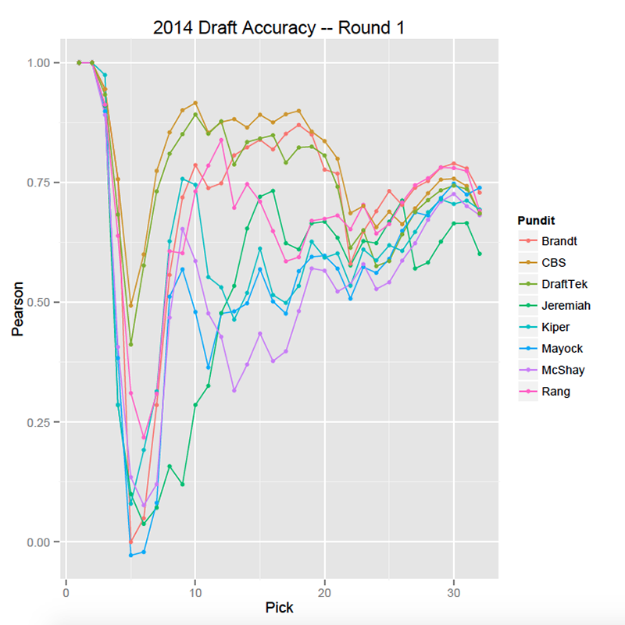

Figure 1.

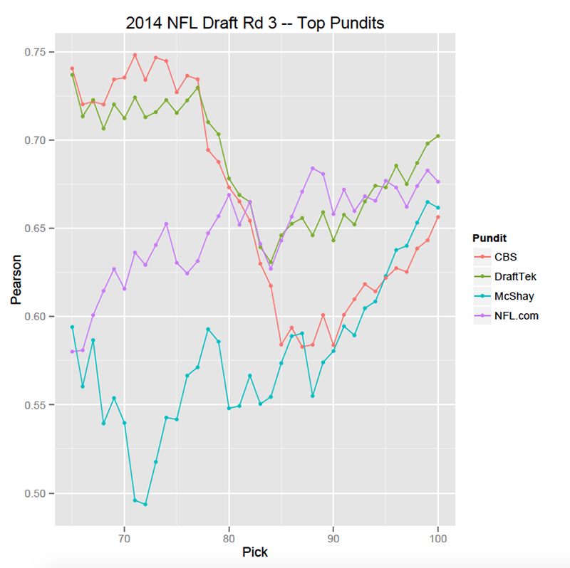

Figure 2.

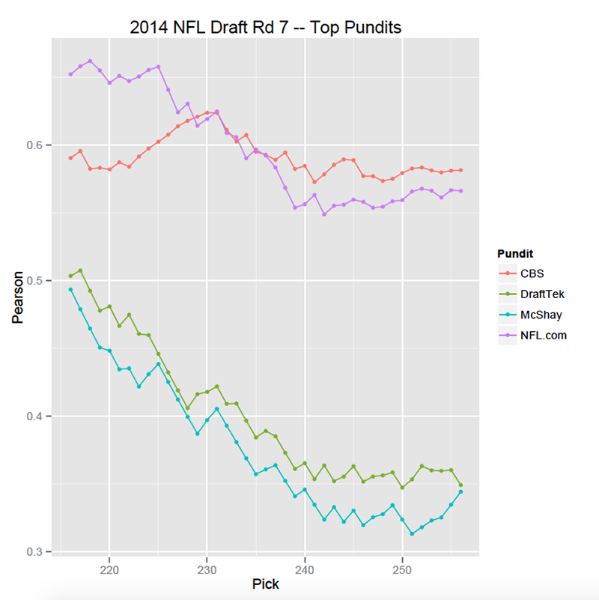

Figure 3.