**SCHOFIELD — Research**

<2 images>

**Research Through Design and Digital Humanities in Practice: What, How, and Who in an Archive Research Project**

Schofield, T. W., Kirk, D. and Whitelaw, M.

This paper highlights shared methods, questions, and challenges between research through design (RTD) and digital humanities (DH) through the discussion of an archival research project. In DH, debates continue (Gold, 2012) regarding the impact of digital technologies on epistemology, methodology, and our professional identities as researchers, scholars, academics, and teachers. Our reading of this debate is that there is a tripartite relationship at work between the kind of work we should call DH (and aspire to produce); the nature of knowledge, research, and scholarship (particularly with reference to the role of artefacts produced); and issues of disciplinary orientation or professional identity. We could phrase these as the what, how, and who of DH and, of course, RTD. The discussion of our project is in no sense intended to provide an exclusive answer to those questions, but to give one snapshot of what DH and RTD look like when they come together.

RTD emphasises artefact-led, practice-based research with an emphasis on developing design methods, conceptual frameworks and theories, as well as products (Gaver, 2012). Its speculative orientation and emphasis on making with digital materials aligns it well with some currents of thought in DH (see, e.g., Drucker, 2009). Indeed, Joanna Drucker has pointed to a shared ground with design, generally noting that ‘all forms of design share a propositional orientation that is well-suited to the challenges that come with designing new structures, for design asks, “What if?”’ (Burdick et al., 2012). At the same time she warns that ‘the cultural authority of digital technology is still claimed by the fields that design the platforms and protocols on which we work. These are largely fields in which quantitative, engineering, and computational sensibilities prevail’. We wish to qualify Drucker’s claim by noting a series of more detailed concordances with RTD of a particular propositional, speculative, and explorative orientation. We note that despite Drucker’s valid concerns for the positivist outlook of some design research contexts, within the field of human-computer interaction (despite its background and reputation for some as computing engineering’s heartland), and interaction design, a vibrant dialogue is being sustained concerning the role of designed artefacts in knowledge production (Bowers, 2012), their responsiveness to the values of users (see, e.g., Vines et al., 2013), and the state of critique and criticality (Bardzell and Bardzel, 2013), all of which are directly relevant to DH. In the following paragraphs we will describe aspects of an ongoing project, positioned as DH with roots in RTD methodology. Through it we will position our work in relation to the tripartite relationship we identified between what digital humanities research looks like, what role its artefacts play, and what kind of people do it.

Our project is, typically for digital humanities research, based around an archive. Bloodaxe Books is a small but internationally significant publisher of contemporary poetry, whose archive, consisting mostly of edited manuscripts, was purchased by Newcastle University, UK, in 2013. Our role within a research project as artists and Interaction Designers was to create exploratory and provocative interactions with the archive both online and in physical space. This is the ‘what’ of our project.

The interfaces we designed for the archive respond to its formal and textual specificities, and this flexible and responsive mode of engagement is typical of RTD processes. We think that this kind of approach is well aligned with a view of the role of DH as one that expands the ground of research processes as well as simply augmenting their methods with new tools and techniques. In our project we began with loose research questions (as described above) that were refined alongside the project. Our treatment of the archival material was to be informed by the experience of 30 project participants, each of whom was conducting personal, creative research in the archive. Inspired by previous research through design work, we conceived of a ‘cultural probes’ (Gaver et al., 2004) activity to gain insight into the way the archive was being used by our project participants and to uncover some of the things they found interesting about the materials themselves, the better to inform our ‘what’. Our activity used a bookmark-like insert completed and left by participants in the archive boxes themselves to act as a conversation ‘backchannel’ for participants. A trial of this activity revealed a number of interesting features of the archive that focused our interests and informed future designs. Particularly our later work with archival Marginalia and our related interest in the temporality of the archive was significantly informed by this process. When Drucker asks, ‘Have the humanities had any impact on the digital environment?’, one answer is in exactly this kind of enquiry, which has at least a 10-year history in design research. The probing activity described above was user-focused, not in the sense of a formal ‘requirements’ analysis but as a kind of critically sensitizing activity. For instance, in the final interface three particular areas of our design responded to questions and issues raised by the participants and our literary research colleagues: ‘Shapes’1 allows users of our interface to sketch—with the mouse—the shape of a poem and receive matches from the archive. ‘Data’ mashes our own metadata with British Library and Wikipedia data to explore wider the context of the archive.2 ‘Words’3 uses text mining techniques and word distancing to produce network graphs of correspondences between documents and relationships to themes (e.g., flowers, death).

In practice-based research processes, an inevitable question arises concerning the status of the artefact as a bearer or disseminator of knowledge, and researchers in (Ramsay and Rockwell, 2012) and out (Ingold, 2013) of DH have noted the problems this causes for the place of such work within academia. In other words, our ‘how’ is about how we treat the things we make, how we evaluate their contribution and ensure that they are productive. Our perspective, as writers of both code and research papers, is that there is knowledge in both objects and commentary but that the relationship between them should be negotiated honestly and delicately. In our project we adopted a fast prototyping cycle in which we made a series of early visualisations and web interfaces to the digitized material publically available and invited criticism and feedback. We also made a feature of both our ongoing design work and the cataloguing and digitization taking place in the library by producing a Twitter feed of computationally extracted archival marginalia connected live to the work of the archivist and digital assistant and a drawing robot, the Marginalia Machine, which publically re-draws these same editorial notes.



Figure 1. Screen grab from the @BloodaxeArchive Twitter bot.

These artefacts acted as kinds of a ‘boundary object’ (Star and Griesemer, 1989), around which we and our colleagues in the library and the English Department could discuss future iterations of design work. Their production afforded what we might call the ‘unimagined interactions’ characteristic of this kind of speculative prototyping. In our project, as is common in RTD, the artefacts were a part of a methodology for integrating facets of our research, working with our colleagues and participants and of course improving future designs. Despite this pivotal function for the ‘things’ (Brown, 2001) of our research, we recognise the value of reflection, in written or other forms, for future work. John Bowers proposes the ‘annotated portfolio’ (Bowers, 2012) as one approach to communicating the value of our work to ourselves and others. We note that however much artefacts articulate a position, their situatedness in a world of stuff means that they will always be poly-vocal. This is both their strength (when we wish to explore) and their weakness (when we want to be specific).

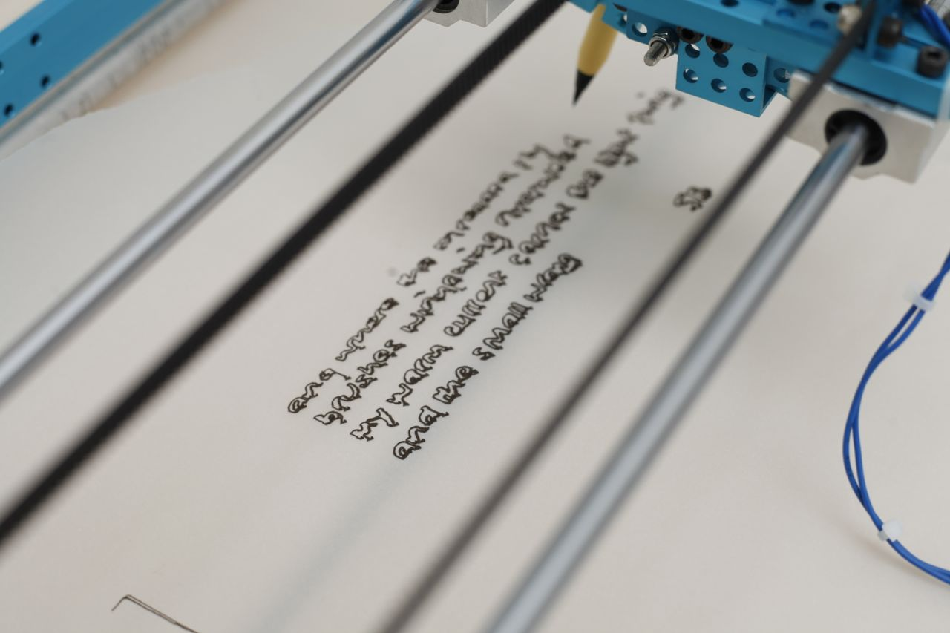

Figure 2. Detail of the Marginalia Machine.

Finally we observe that in the picture of the digital humanities researcher as one who can ‘research, write, shoot, edit, code, model, design, net-work, and dialogue with users’ (Burdick et al., 2012), RTD shares a problem educating, finding, and hiring such people. We further note that the role of a designer, even one with such competencies, in a DH project remains problematic for a number of reasons. If we wish to pursue successful interdisciplinary research, then we must decide to what degree our research questions will be common with our collaborators or distinct. One model for the latter sees a humanities researcher provide a problem for a computer scientist to work with—for instance, the development of a corpus analysis tool. The computer scientist produces technical innovation while the humanist integrates the tool into the research. In our project, however, the designer, coming from a humanities background himself, brought his own questions to bear on the material, which were informed by art history, philosophy, and the cultural history of design. A challenge for such designers is how to meaningfully collaborate with other humanities researchers without, first, denigrating their own research questions and competencies to a second-tier status, and second, ignoring the nuance and depth of good humanities research. Strategies for the successful avoidance of these two pitfalls, we feel, should be the focus of future discussion of this relationship.

**Notes**

1.http://bloodaxe.ncl.ac.uk/explore/#/shapes.

2. http://bloodaxe.ncl.ac.uk/explore/#/data.

3. http://bloodaxe.ncl.ac.uk/explore/#/words.

**References**

**Bardzell, J. and Bardzel, S.** (2013). What Is Critical about Critical Design? In *Proceedings of CHI 2013*, Paris, 27 April–2 May 2013, ACM Press, pp. 3297–306.

**Bowers, J.** (2012). The Logic of Annotated Portfolios: Communicating the Value of ‘Research Through Design’. In *Designing Interactive Systems*. ACM Press, pp .68–77.

**Brown, B.** (2001). Thing Theory. *Critical Inquiry,* **28**(1): 1–22.

**Burdick, A., Drucker, J., Lunenfeld, P., Presner, T. and Schnapp, J.** (2012). *Digital_Humanities*. MIT Press, Cambridge, MA.

**Drucker, J.** (2009). *SpecLab*. University of Chicago Press, Chicago, doi:10.7208/chicago/9780226165097.001.0001.

**Gaver, W.** (2012). What Should We Expect from Research through Design? In *Proceedings of CHI 2012*, Austin, TX, 5–10 May 2012. ACM Press, pp. 937–46.

**Gaver, W., Boucher, A., Pennington, S. and Walker, B.** (2004). Cultural Probes and the Value of Uncertainty. *Interactions*, **11**(5): 53–56.

**Gold, K.** (2012). *Debates in the Digital Humanities*. University of Minnesota Press, http://dhdebates.gc.cuny.edu/debates.

**Ingold, T.** (2013). *Making: Anthropology, Archaeology, Art and Architecture*. Routledge: London.

**Ramsay, S. and Rockwell, G.** (2012). *Developing Things: Notes toward an Epistemology of Building in the Digital Humanities*. *Debates in the Digital Humanities*. http://dhdebates.gc.cuny.edu/debates/text/11.

**Star, S. L. and Griesemer, J. R.** (1989). Institutional Ecology, ‘Translations’ and Boundary Objects: Amateurs and Professionals in Berkeley’s Museum of Vertebrate Zoology, 1907–39. *Social Studies of Science,* **19**(3): 387–420, doi:10.1177/030631289019003001.

**Vines, J., Clarke, R., Wright, P., McCarthy, J. and Olivier, P.** (2013). Configuring Participation: On How We Involve Users in Design. Proceedings of the 2013 ACM SIGCHI Conference on Human Factors in Computing Systems, Paris, 27 April–2 May 2013, pp. 429–38.