**TOGIYA — Proposal for Creation**

<1 figure>

**Proposal for Creation of ‘Research Profile’ of Photo Archives Using Digital Book Format**

Togiya, N.

In recent years, digital/analog archives for photographs have been created in various places, and photos from different time periods and regions have been exhibited.1 However, one faces several challenges when trying to use the original photo materials as data.

The first challenge is that it is very difficult to precisely determine the specifics of the subject of the photographs, such as people, buildings, time period, etc., due to there not being enough descriptions in writing, as the photographs are iconographic materials.

The second challenge is that it is rare for the inherited photographs to remain intact, and they are often damaged after natural disasters, wars, disagreements, etc. Therefore, it is necessary to grasp the information about their history and state of preservation. In addition, as a third point, in the analysis of photo materials it is rare that the frequency with which a particular subject is expressed has been quantified before the analysis, so in many cases the target analysis is performed from a subjective impression. However, in an objective analysis, it is desirable that the analysis is based on main quantitative data, such as frequency of the subject (Togiya and Kawashima, 2013). For this reason, in photo materials, it is necessary to provide basic data, such as frequency with which the particular subject is expressed.

**Outline of the Research Project**

In this study, we propose basic elements and an implementation plan for a ‘Research Profile’ of the photo documentation in order to objectively use photographic materials as academic materials. First, the ‘Research Profile’ of the photo archive proposed in this study includes the following three elements:

1. Documentation on provenance and original condition (related documents, footage of interviews with old warehouse owners, visual material of the old warehouse space, distribution of the material, and a graph showing inheritance status).

2. Materials that became a rationale for the content of the material for cataloging purposes, such as video interviews, official records and discussions by experts (video and online discussion data), personal information of the subjects, genealogical data, information on the buildings, etc.

3. Frequency with which names that can be recognized are expressed in the subject, frequency with which multiple subjects are expressed together in the photo documentation group.

Figure 1 is a diagram showing the actual configuration of the screen shown in the previous section ‘Research Profile’. Video and audio materials that contain detailed information about the corresponding material are stored in the profile after publishing the photo material of interest. These are stored in EPUB format, and text, voice, and images are integrated and stored in one set of files, enabling access with various e-book viewers.

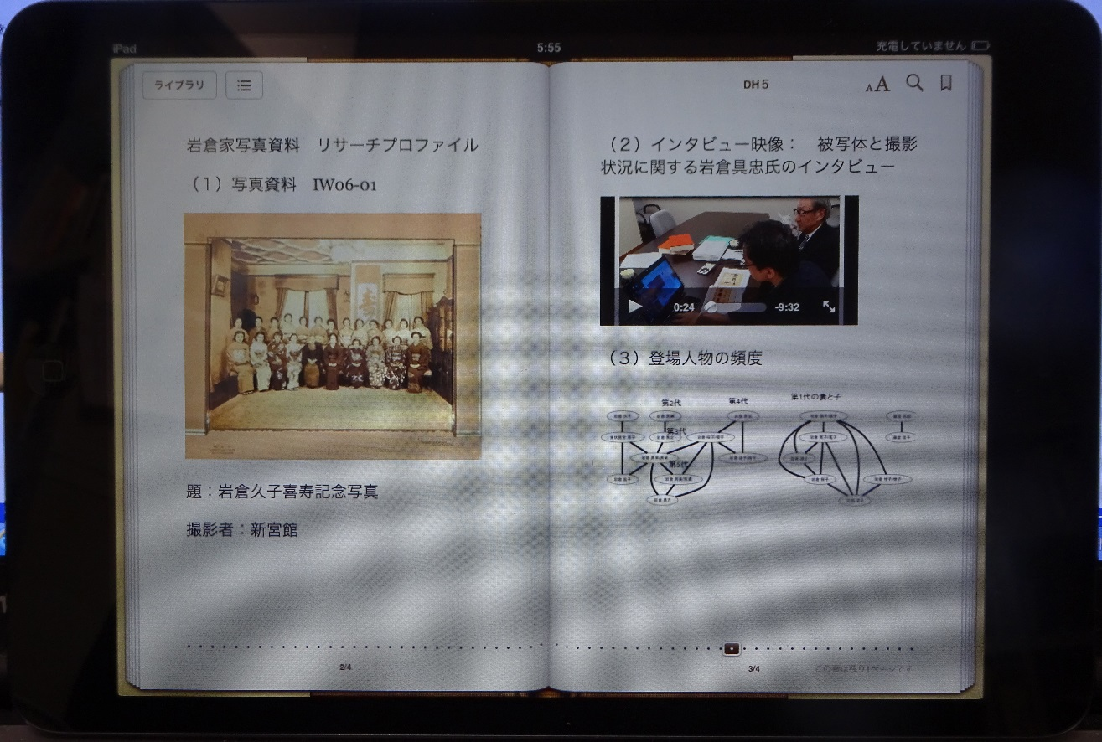

Figure 1. The sample of research profile consisted of photo, movie, and graph.

**Summary**

The main point in this presentation is that since the number of photo archives is expected to increase in the future, it is important to collect data that can be browsed and analyzed from a more objective viewpoint and open it to the public as a ‘Research Profile’. In addition, another feature is that data, such as provenance information, interviews with witnesses, and discussions with experts—which became a reference at time of cataloging and until now was out of focus—can be systematically collected as objective data on quantitative analysis of the subject, and can be aggregated and published as material for scientific use. Additionally, these texts, pictures, audio, still images, and other media are aggregated in e-book format, and by using tablets, etc., they can be viewed in one set of files, browsed, and viewed in parallel in PC photo archive format or paper book format. Furthermore, persistent management is possible by storing them in an e-book format into e-book deposit systems, which are becoming popular these days.

By making public ‘Research Profiles’ of photo archives, like the one in this study, it will be possible to use photo materials more objectively as scientific materials. An awareness that the testimony of the people involved in the photo is ‘documentation’ will develop, which will provide a base for developing the budding ‘Photograph Material Science’ in the future.

**Note**

1. Library of Congress: Prints & Photographs Online Catalog, http://www.loc.gov/pictures/;

Smithsonian American Art Museum Photograph Archive, http://americanart.si.edu/research/programs/archive/.

**Reference**

**Togiya, N. and Kawashima, T.** (2013). Research to Clarify the Interrelationships between Family Members through the Analysis of Family Photograph. *Digital Humanities Monthly,* no. 27 (October), http://www.dhii.jp/DHM/dhm27-1.