**TURNER-JENSEN — Cusp**

<1 figure>

**The Cusp of Change: A Culturally Safe E-Learning Platform on Ancient Australia**

Turner-Jensen, N. and Latcham, J.

## What Is a Culturally Safe E-Learning Platform?

A conceptual framework based on Aboriginal and Torres Strait Islander peoples’ unique sense of identity has been developed as a structural tool for the embedding of Aboriginal and Torres Strait Islander histories and cultures within the schools and workplace settings of Australia. This sense of identity is approached through the interconnected aspects of country/place, people, culture, and learnt generational knowledge. Embracing these elements enhances all areas of a young person’s spirituality, thus ensuring pride and a sense of connection with their culture, local history, and traditions.

Aboriginal and Torres Strait Islander communities can again become strong, rich, and diverse. Aboriginal and Torres Strait Islander and Australian peoples’ identity is central to this priority and is intrinsically linked to living, learning about their local Aboriginal and Torres Strait Islander communities’ history, deep knowledge traditions, and general expertise with regards to the flora, fauna, and landscapes where we live.

**Why Learn Only about Ancient Australia?**

After four years of focus group and market research, our team have determined that some astounding outcomes can occur if all education settings simply include ancient Australia systematically within their subject areas:

• Create economic opportunity for Aboriginal and Torres Strait Islander peoples across many sectors and encourage them to attend school.

• Produce an opportunity to achieve a strong sense of identity and deep connection to this continent of Australia for every person today and for all future generations (something we believe has never been achieved by most non-Aboriginal or Torres Strait Islander Australians and is impossible without connecting with ancient Australia).

• Forge a new era of positivity and acceptance in this country of people from all cultures.

The acceptance and implementation of ancient Australia in education settings will establish more sustainable and harmonious communities—for Indigenous as well as non-Indigenous people.

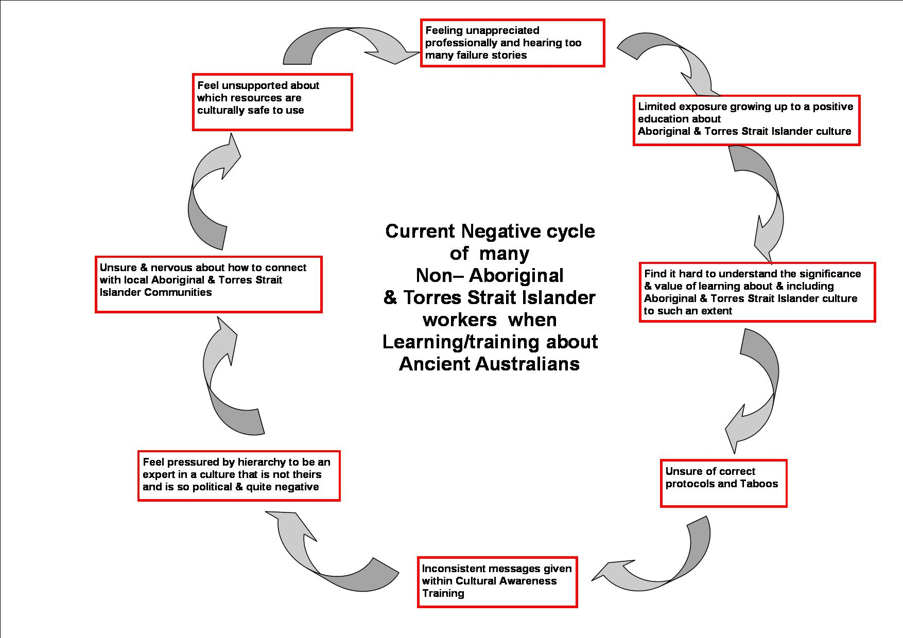

Figure 1. The negative cycle of many non-Aboriginal and Torres Strait Islander service providers and educators.

**Understanding the Historical Education of Most Australians in Regards to Aboriginal and Torres Strait Islander Culture and People**

According to the Melbourne Declaration on Educational Goals for Young Australians (MCEECDYA),1 educators and workers from all sectors are important partners in engaging young Australians with Aboriginal and Torres Strait Islander knowledge and traditions. However, these are generations of Australians who, through no fault of their own, have had very limited access to an informed and positive education about Aboriginal and Torres Strait Islander people and their culture. Most Australian education up to now excluded Aboriginal and Torres Strait Islander information (except at the most tokenistic level), and certainly the media has portrayed Australia’s Indigenous peoples in a very negative light.

Ma Rhea and Russell (2012) state that it is therefore important that today’s educators and trainers are supported and provided with a culturally safe framework to expand their knowledge and understanding of Aboriginal and Torres Strait Islander people and their knowledge and traditions. We believe that if all Australians are initiated in ancient Australia, we will finally break the negative cycle that modern and ancient Australians are trapped within today.

**Note**

1. The core aspects from the Melbourne Declaration on Educational Goals for Young Australians related to teaching Indigenous knowledge and perspectives retrieved from http://www.mceetya.edu.au/mceecdya/melbourne_declaration,25979.html.

**Reference**

**Ma Rhea, Z. and Russell, L.** (2012). The Invisible Hand of Pedagogy in Australian Indigenous Studies and Indigenous Education. *Australian Journal of Indigenous Education,* **41**(1): 18–25.