**WHITELAW — Succession**

<1 figure>

***Succession*: Generative Techniques, Speculative Interpretation, and Digital Heritage**

Whitelaw, M.

*Succession* (http://mtchl.net/succession) is a web-based work that uses combinatorial techniques to provide an engine for investigating the complex fields of meaning latent in digital cultural collections. This paper introduces this practice-led research project and investigates the potential of combinatoric generative techniques for imaginative, interpretive meaning-making with digital cultural collections.

**Context, Aims, and Approach**

Digitisation is turning out corpora that rapidly exceed human interpretive scope: the Internet Archive recently published some 2.6 million machine-extracted images to the Flickr Commons (Miller, 2014). Techniques for dealing with non-text collections at scale are developing, such as Manovich’s work on macroscopic analyses (2012). Another emerging strand of practice takes a more poetic and playful approach, offering serendipitous samples and chinks of algorithmic insight. Tim Sherratt’s Trove News Bot tweets archival news articles based on daily headlines (Sherratt, 2013); the British Library’s Mechanical Curator posts random images from the library’s digitised books (Baker, 2013). Sherratt’s Eyes on the Past (2014) harvests faces from digitised newspapers and has their eyes peer out through the interface, inviting investigation. These approaches reflect an emerging interest in collections as active sites of meaning-making and experimentation with how we might encounter such collections in an everyday digital environment.

*Succession* addresses the industrial and pre-industrial heritage of Newcastle-Upon-Tyne and surrounds, reflecting my encounters with the city during an extended visit, and the thoughts (and affects) on energy, history, industrialisation, and capital that the place provoked. Newcastle was a key Roman settlement, later one of the crucibles of the Industrial Revolution, now finding its way in a ‘de-industrial’ Britain (Chakrabortty, 2011). While the work is highly localised, it reads this place as a cypher with far wider implications. The work’s title draws a term from ecology, alluding to continuous and ongoing change and adaptation. *Succession* aims to mine the city’s industrial past in order to fuel consideration of our possible futures.

In practice the work is a web application that draws on a corpus of some 2,000 image records harvested from the Flickr Commons and combines these elements into new composites (or ‘fossils’). Each fossil comprises five randomly selected source images arranged, composited, and potentially repeated. Sources are cited; thus, while composites often radically obscure, transform, or juxtapose their elements, the sources and their attendant contexts remain navigable and intact. Composites may be saved, acquiring a permalink to become a new citable online object. The generative process of composition is performed live, in the browser; each viewer will encounter a series of unique composites. The system allows for around 2.5x1015 combinations of elements (ignoring spatial and blending variations). At a rate of one per second, it would take around 8 million years to show all permutations.

**Generative Digital Humanities**

Schnapp and Presner called for a ‘generative digital humanities’ in their 2009 manifesto; here ‘generative’ means hands-on, makerly, productive, and integrative. This project fits their proposal for a DH that is ‘qualitative, interpretive, experiential, emotive [and] generative in character’. I use ‘generative’ more specifically to describe formal and computational techniques; as such, my approach also reflects Berry’s call (2011) for DH to focus on the attributes of computation and their implications for knowledge. The work described here aims to be generative in both senses: a computational system that provokes experiential, interpretive modes of encounter with digitised history and culture. This is what Drucker and Nowviskie (2004) term *speculative computing*: ‘speculative approaches to digital humanities engage subjective and intuitive tools’ while enlisting computation for augmentation, rather than simply automation. A speculative DH pursues computation that is ‘dynamic and constitutive’, ‘creating programs that have emergent properties’.

As Drucker and Nowviskie show (2004), generative procedures have long been used in the arts to augment and extend thought, creating aesthetic and conceptual provocations. *Succession* uses combinatorics, the procedural combination of specific formal elements. Permutation gives combinatorics a form of quantitative leverage: small sets of elements proliferate into vast numbers of possible outcomes. When the permuted elements are symbolic or textual, combinatorics becomes a machine for knowledge or meaning. Ramon Lull’s *Ars Magna* (1305) permuted divine principles into sets of theological assertions; these conceptual machines marked out domains of knowledge for investigation (see Gardner, 1958). In the 1960s, poets Brion Gysin and Raymond Queneau used combinatorics to pursue unforeseen or inconceivable meaning using fixed and finite textual means. Bill Seaman’s ‘recombinant poetics’ seeks ‘emergent meaning’ within digital arrays of textual and audiovisual elements (2001). Ross Gibson and Kate Richards’ *Life after Wartime* applies combinatorics to an archive of 1940s crime-scene photographs, showing how a generative ‘story engine’ can prompt speculative interpretations of digital heritage (Richards, 2006).

**Authored Spaces and Generative Artefacts**

*Succession* consists of two related domains common to any computational generative process. The first is the generative system: the set of source elements, rules, and procedures that make up the work; the second is the field of actual and potential digital artefacts produced by that system. These two domains have distinct characteristics and specific discursive modes, as outlined below.

Bill Seaman describes his combinatoric generative system as an ‘authored electronic space’, emphasising that it is expansive, but not arbitrary (2001, 426). Similarly, *Succession*’s space is authored, in part through its corpus: sources were selected for content relevance, as well as visual potential. The content base grew and was pruned around the conceptual focus in a slow process of subjective evaluation, exploratory search, and tangential investigation. In Seaman’s words, this authorship seeks out a ‘resonant unfixity’ (Seaman, 2002).

In *Succession* the rules for compositing elements are also authored, tailored around the idiosyncrasies of the sources and the poetic aims of the work. Layered composition is both formal machine and metaphor: to address a city built on coal it seemed necessary to combine and compress, to obscure while at the same time hopefully intensifying the energy latent in those sources. Thus the image blending modes are biased to overlay dark elements; this treatment resonates with the engraved illustrations in the Internet Archive and British Library collections. Process and corpus (algorithm and data) are interdependent. Where (default) Cartesian space is inert, extensive, and homogeneous, here authored space is co-constituted by an active assemblage of media, concepts, and computational processes.

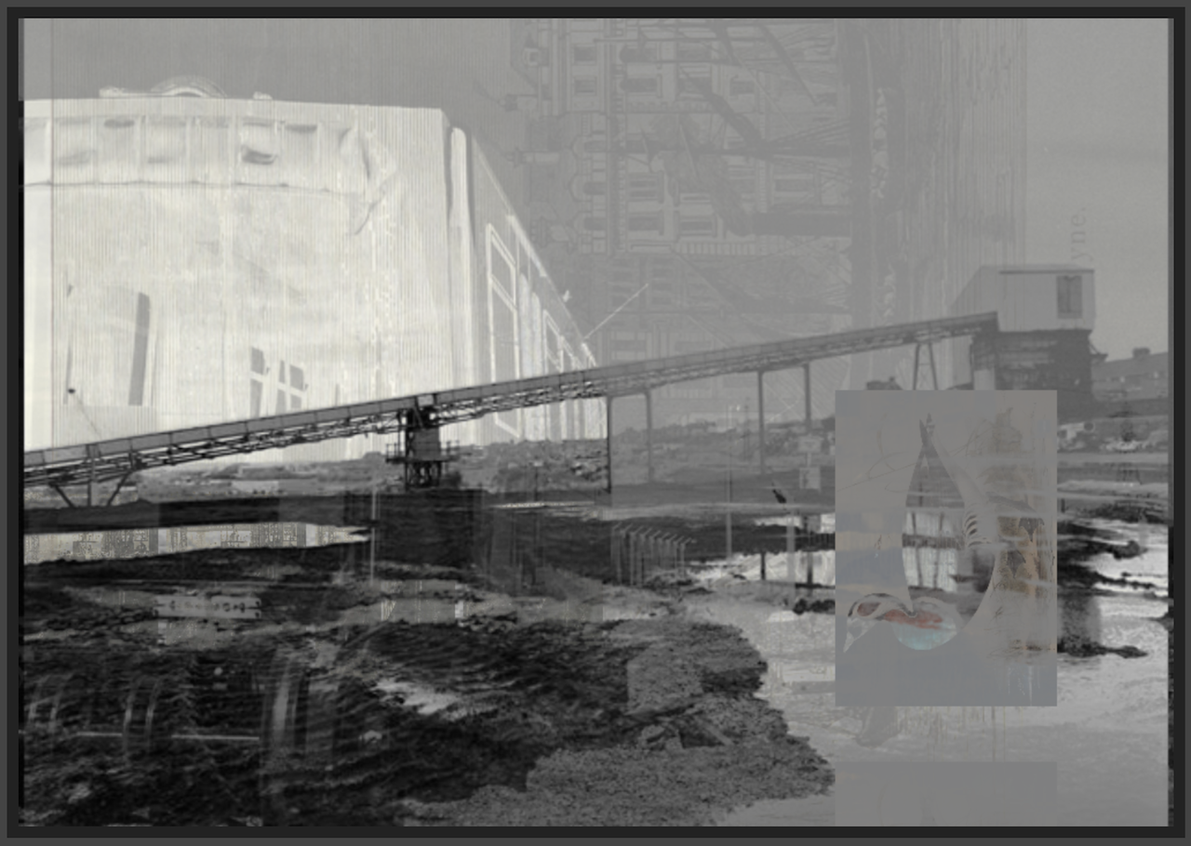Figure 1. *Succession* composite 1413513552860 (see http://mtchl.net/succession/#/saved/1413513552860).

This saved composite in Figure 1 shows how the generated artefacts can also operate as what Drucker and Nowviskie (2004) call ‘aesthetic provocations’ while enlisting the contexts and referents of their source elements in speculative juxtapositions. This composite is dominated by a 1993 photograph of Wearmouth Colliery in its final week of operation—a poignant image of the last days of Newcastle coal. But a spectral water-bird (from Gould’s 1837 *Birds of Europe*) seems about to splash down in those desolate puddles. Faintly in the background is the bustling River Tyne itself, circa 1880, and on the left of frame appears a carriage destined for Newcastle’s Metro system, under development in the mid-1970s. Almost imperceptible at bottom left is the HMS *Opal*, a torpedo destroyer, under construction at the Sunderland shipyards in 1915. So this composite encompasses not only 150 years of urban history but a latent portrait of 20th-century capital, the rise and (UK) fall of extractive industry, war, urbanism, and pre-Industrial naturalism and the non-human lives it records.

This example shows how formal and visual transformations inflect narrative or historical interpretations, and thus that these generative artefacts are not simply bundles of citations but speculative visual propositions. Layering emphasises simultaneity and atemporal juxtaposition rather than chronology: Gould’s duck, about to dive into the colliery puddles, or perhaps swimming on the 1880s Tyne? Faded traces evoke the presence of the lost; visual collisions prompt an interpretive search for coherence, patterns of connection in the authored space of the system.

Thus generative systems like *Succession* can be both prompts for interpretation and humanistic ways of speaking in themselves. In addressing complex topics (or ‘wicked problems’) such as extractive industry, capital, and urban change, it seems necessary to respond in kind. Generative techniques provide a way to speak complex multitudes, as well as an engine for unforeseeable combinations, the seeds of something new. Seaman terms this ‘unfixity’; Gibson calls it a ‘restlessness’ that prompts imagination through ‘artful imbalances and implied possibilities for completion or patterning’ (Gibson, 2006). This active imagination is essential, Gibson argues, in understanding and potentially altering ‘the continuous tendencies that are making us as they persist out of the past into the present’.

Generative systems have a long history as formal tools for generating (and navigating) large fields of potential meaning in the arts. This paper argues that such systems are also relevant in the digital humanities. *Succession* draws on networked digital heritage to create a ‘restless’ generative system that produces speculative propositions anchored in specific historical contexts, shaped by specific authorial themes and metaphors. It shows how generative techniques can support the creation of new composite cultural objects, and how these composites can use historical fragments to speak richly to the complexity of our present moment.

**References**

**Baker, J.** (2013). The Mechanical Curator. Digital Scholarship Blog, http://britishlibrary.typepad.co.uk/digital-scholarship/2013/09/the-mechanical-curator.html.

**Berry, D.** (2011). Digital Humanities: First, Second and Third Wave. stunlaw, http://stunlaw.blogspot.com.au/2011/01/digital-humanities-first-second-and.html.

**Chakrabortty, A.** (2011). Why Doesn’t Britain Make Things Any More? *The Guardian*, 17 November, http://www.theguardian.com/business/2011/nov/16/why-britain-doesnt-make-things-manufacturing?CMP=twt_gu.

**Drucker, J. and Nowviskie, B.** (2004). Speculative Computing: Aesthetic Provocations in Humanities Computing. In Schreibman, S., Siemens, R. and Unsworth, J. (eds), *A Companion to Digital Humanities*. Oxford: Blackwell, pp. 431–47, http://digitalhumanities.org:3030/companion/view?docId=blackwell/9781405103213/9781405103213.xml&chunk.id=ss1-4-10&toc.depth=1&toc.id=ss1-4-10&brand=9781405103213_brand.

**Gardner, M.** (1958). *Logic Machines and Diagrams*. McGraw-Hill, New York, http://archive.org/details/logicmachinesdia227gard.

**Gibson, R.** (2006). Places Past Disappearance. *Transformations,* **13**, http://www.transformationsjournal.org/journal/issue_13/article_01.shtml.

**Manovich, L.** (2012). How to Compare One Million Images? In D. M. Berry (ed.), *Understanding Digital Humanities*. Palgrave Macmillan, pp. 249–78.

**Miller, R.** (2014). Millions of Historic Images Posted to Flickr. Internet Archive Blogs, http://blog.archive.org/2014/08/29/millions-of-historic-images-posted-to-flickr/.

**Richards, K.** (2006). Life after Wartime. *Canadian Journal of Communication,* **31**(2), http://cjc-online.ca/index.php/journal/article/view/1729.

**Schnapp, J. and Presner, T.** (2009). The Digital Humanities Manifesto 2.0, http://jeffreyschnapp.com/wp-content/uploads/2011/10/Manifesto_V2.pdf.

**Seaman, B.** (2001). Oulipo | vs | Recombinant Poetics. *Leonardo,* **34**(5): pp. 423–30.

**Seaman, B.** (2002). Interview with Yvonne Spielmann, http://www.fondation-langlois.org/html/e/page.php?NumPage=386.

**Sherratt, T.** (2013). Conversations with Collections. *Discontents*. http://discontents.com.au/conversations-with-collections/.

**Sherratt, T.** (2014). Eyes on the Past. http://eyespast.herokuapp.com/.