**WILSON — Building**

<6 figures>

**Building the Early Modern Digital University: Using Social Network Analysis and Digital Visualization Tools to Bring the Early Modern Network Of Networks (EMNON) to Life**

Wilson, E. A.

This paper will present the prototype of EMNON, the Early Modern Network Of Networks, an open-access research resource using social network analysis in tandem with digital visualization techniques to enable modern scholars to access, explore, and participate in the reconstruction of the social network of scholars working in Europe and America between 1500 and 1750 whose intellectual discoveries fuelled literary and historical developments throughout this period. I will discuss how EMNON expands on the work of Findlen et al. (2008–), Elson, Dames, and McKeown (2010), and Piper (2014) by pioneering the combination of NodeXL and VisualEyes to create digital visualizations of different facets of the Early Modern Network Of Networks. In using digital techniques to re-discover early modern social networks, EMNON aims to enable our modern global knowledge network to re-engage with our early modern counterparts in an interactive digital environment, so that we reach new understandings of how social relationships drove intellectual change in this period on a global scale.

**Critical Background for the Project**

Findlen et al. (2008–) are using network analysis to reconstruct correspondence networks, whilst Elson, Dames, and McKeown (2010) used these techniques to investigate social networks of fictional characters. Turkel’s (2011) use of network analysis examining the NiCHE community is a representative example visualizing a modern knowledge network, whilst Klein’s (2012) engagement with Protovis to explore familial interactions documented in *The Papers of Thomas Jefferson* provides insight into the utility of network analysis in animating historical social dynamics. One of the most exciting recent applications of network analysis in literary studies has been Piper’s (2014) research creating network graphs visualizing a variety of connections between the literary works of J. W. Goethe. In treating the texts themselves and their lexis as network nodes, Piper’s work is closely aligned to the approach used by EMNON in which not only people but also specific intellectual terms act as nodes within network diagrams.

Work conducted by the Centre for Early Modern Mapping, News, and Networks and the Centre for Early Modern Exchanges provides crucial early-modern-specific critical contexts. Ahnert’s 6 Degrees of Francis Bacon is a reference point, though EMNON differs from this in reconstructing a very specific early modern network of logicians and their readers. Aranda’s prosopographical study of scientific networks in Spain is also a useful comparison, as, like EMNON, he uses archival research to trace early modern intellectual relationships linking people with one another via the ideas that they promulgated. Likewise, Suzanne Sutherland’s research (2000–) exploring and visualizing the correspondence network of Athanasius Kircher via Palladio offers crucial blueprints for effective data collection and analysis from early modern manuscript materials in particular. These projects are allies with my work in transforming textual data into network visualizations, and by the time of DH 2015 it is my hope to have live dynamic network mapping capabilities on the EMNON website to provide a new approach for this kind of work. I concur that James Secord’s (2004) concept of ‘knowledge in transit’ is key to my project, and I will engage with his.

**EMNON’s Approach: Aims and Method**

Logic was the fundamental ‘*ars artium, scientia scientiarum*’ (art of arts, science of sciences) in the early modern period, providing the tools for creating all forms of written expression and textual analysis, and governing the selection of subject matter and the structuring of discourse. A plethora of logic textbooks were produced across Europe and America from 1500 to 1750, and these texts were used ubiquitously in schools and universities in this period to teach students to read, analyze texts, and write new works. Howell (1956), Kneale and Kneale (1962), and recently Mack (2011) have employed traditional approaches to establish a bibliographic printing history of this field. EMNON expands on this work to contend that intellectual developments in this fundamental ‘art of arts’ were propelled by an extensive global knowledge network of scholars working throughout Europe and America. These scholars operated in diverse confessional, geographic, chronological, and linguistic contexts, and yet it is through their intellectual exchanges and friendships that the early modern ‘art of arts’ evolved.

Whilst much work is being done using tools specifically designed for historical network analysis, there is a notable lacuna of engagement with software designed to tackle the social elements of social network analysis. EMNON is innovative in highlighting the importance of the sociability of early modern knowledge networks by using software explicitly created for the analysis of social networks via social media, NodeXL. This open-source graphing software enables complex multi-faceted analysis of relationships in a large dataset. NodeXL’s flexible, extendible format allows EMNON to visualize relationships between people and ideas in the early modern network in numerous different ways. In conjunction with the use of NodeXL to reconstruct social relationships within the early modern network of networks, EMNON also engages with the open-source tool VisualEyes developed at the University of Virginia, and used experimentally by Bill Ferster et al. to visualize Jefferson’s travels to England. EMNON is among the first projects to adopt VisualEyes as a tool for the visualization and animation of historical social networks, and in this paper I propose to discuss the benefits of doing so, furnishing examples from the prototype EMNON website, which will be live at DH2015.

**Data Collection**

Working in rare book libraries for five years, I transcribed 1.5 million words from logic textbooks and literary works from 1550 to 1700.1

Sources include publications by writers and thinkers involved, their manuscript discussions of early modern logic with one another, correspondence, marginalia, pedagogical exercises, university class lists, and records of book loans from private libraries, which combine to illuminate distinctive edges connecting people and ideas in the network.

**EMNON at Work: Examples**

In this paper I wish to show several examples of the utility of using NodeXL and VisualEyes in creating dynamic visualizations that capture the intricate layers of connectivity in a social network. In this proposal I wish to furnish some brief examples to illustrate the early results of the efficacy of these dual approaches, creating graph-based visualizations of the Early Modern Network Of Networks, and animated visualizations of this data bringing digitized primary source materials about this subject to life.

The following example documents the birth, genealogy, and migration of the logical term ‘procatarctic’. This term refers to an ‘external’ logical cause, and was coined and adopted by a very specific but diffuse network of scholars whose links had not been appreciated prior to their documentation and discovery within EMNON’s NodeXL graphs. Bartholomaeus Keckermann first uses the term ‘procatarctic’ in 1600. He identifies Galen as the intellectual progenitor of this word, and this engenders two of the first critical connections in the ‘procatarctic’ network: almost half a century earlier, also writing on ‘external cause’, Petrus Ramus references the same part of Galen in his 1543 *Dialecticae Libri Duo*, although without adopting this terminology. This small triadic relationship between two of the titans of early modern logic had been

unappreciated until discovered via NodeXL’s graph visualizations as follows:

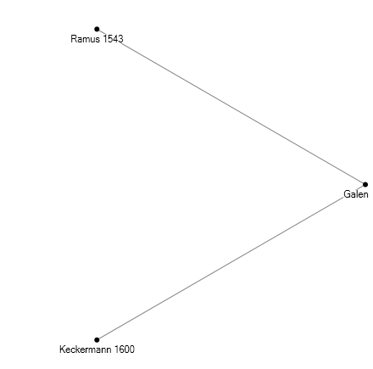Figure 1. NodeXL visualizes a triadic relationship in EMNON.

Yet the network of intrigue does not end with these three nodes. The term was promulgated through a subset of scholars working in Europe in the 17th century, from English Puritans Zachary Coke and John Milton to Dutch scholars Burgersdijck and Heereboord, who passed the torch to English Presbyterian dissenting academies via Samuel Jones and Charles Morton. Morton in turn used this term and its corresponding logical precepts to teach pupils including Daniel Defoe at the dissenting academy at Newington Green in the 1670s and 1680s, before immigrating to the Massachusetts Bay Colony where he introduced it to students at Harvard and later Yale. NodeXL enables users of EMNON to visualize this network in many different ways, including chronologically (Figure 2) and as a web of influence (Figure 3).

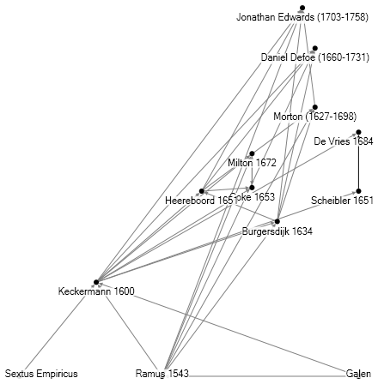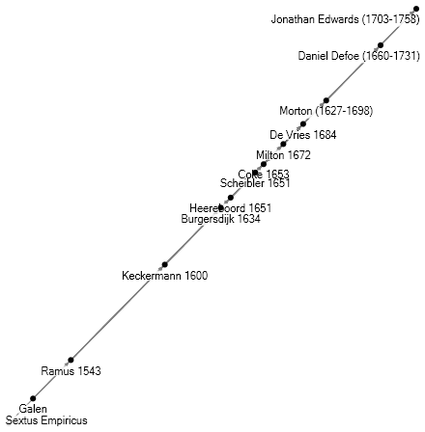

Figure 2: A chronological graph of usage. Figure 3: A graph showing the web of influence and connections between users of this term.

Alongside these graph representations, EMNON is pioneering the application of the VisualEyes software to bring this early modern social network to life.

VisualEyes enables me to animate the spread of ideas through the early modern network, displaying its results in video format with multiple different available views. For example, Figure 4 is a still from EMNON’s moving map, which has traced the geographic spread of the same term ‘procatarctic’ as it moved through Europe and eventually to America:

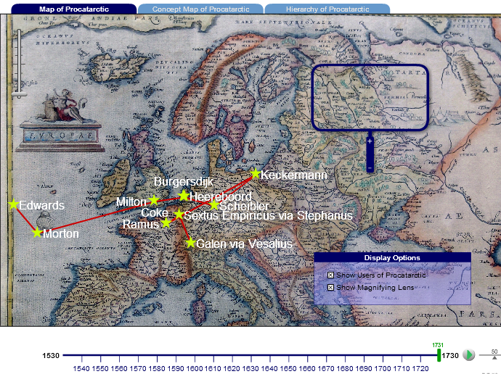

Figure 4. EMNON uses VisualEyes to create a moving map tracing the geographic spread of the term ‘procatarctic’.

In this paper I will also showcase the ways in which EMNON uses the interactive capabilities of VisualEyes to allow users an enriched engagement with this early modern social network. For instance, Figure 5 illustrates what happens if a user clicks on one of the ‘clickable’ waypoints on EMNON’s moving map tracking ‘procatarctic’:

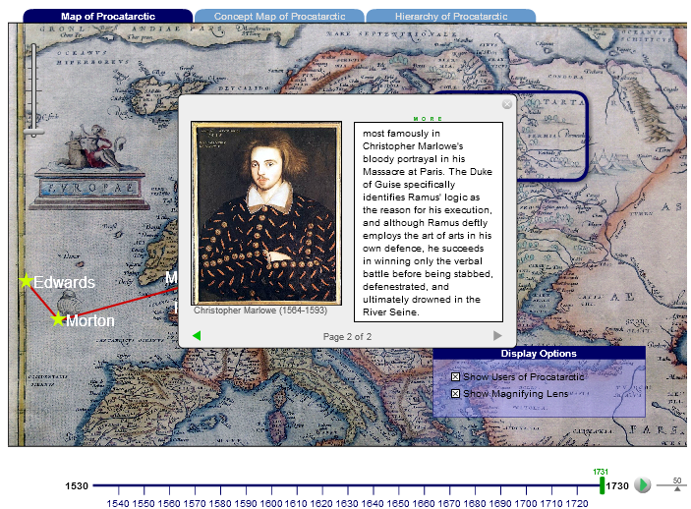

Figure 5. Interactive map whose ‘clickable’ labels display pictures and text about that particular user of the term ‘procatarctic’.

VisualEyes enables users to discover multiple pages of additional information about any of the waypoints on EMNON’s moving map, including digitized primary materials and research resources. VisualEyes also has its own graphing capabilities that EMNON can draw upon to enable users to visualize specific subsets of the extensive early modern social network that it documents (Figure 6):

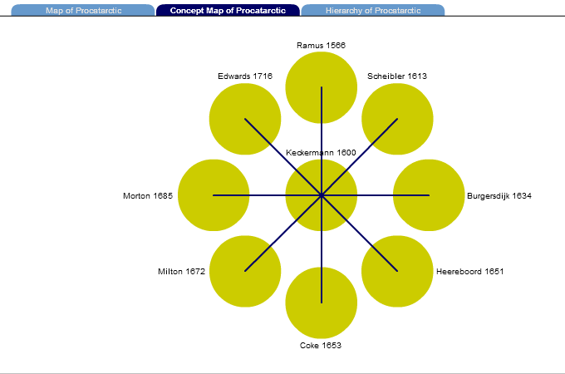

Figure 6. Concept map showing the nexus of users of the term ‘procatarctic’.

In pioneering the use of NodeXL and VisualEyes in the context of historical network analysis, EMNON aims to bring the early modern global knowledge network to life so that, in turn, a network of modern scholars can make new discoveries about the accomplishments, trials, and tribulations of the Early Modern Network Of Networks on a pan-European and transatlantic scale.

**Note**

1. Thanks to the following institutions for fellowships that enabled this research: the Rare Book and Manuscript Library at the University of Illinois at Urbana-Champaign for the John ‘Bud’ Velde Fellowship, the International Society for the History of Rhetoric for their fellowship award, and the University of St. Andrews for their Russell Trust Award.

**References**

**Ahnert, R.** (2012–). Six Degrees of Francis Bacon. http://sixdegreesoffrancisbacon.com/page/2.

**Elson, D. K., Dames, N. and McKeown, K. R.** (2010). Extracting Social Networks from Literary Fiction. In *Proceedings of the 48th Annual Meeting of the Association for Computational Linguistics (ACL 2010)*, Uppsala, Sweden.

**Findlen, P., et al.** (2008–). Mapping the Republic of Letters. https://republicofletters.stanford.edu.

**Howell, W. S.** (1956). *Logic and Rhetoric in England, 1500–1700*. Princeton University Press, Princeton, NJ.

**Klein, L. F.** (2012). Social Network Analysis and Visualization in ‘The Papers of Thomas Jefferson’. *DH2012*, http://www.dh2012.uni-hamburg.de/conference/programme/abstracts/social-network-analysis-and-visualization-in-the-papers-of-thomas-jefferson.1.html.

**Kneale, W. C. and Kneale, M.** (1962). *The Development of Logic*. Oxford University Press, Oxford.

**Mack, P.** (2011). *A History of Renaissance Rhetoric, 1380–1620*. Oxford University Press, Oxford.

**NodeXL.** (n.d.). http://nodexl.codeplex.com/.

**Piper, A.** (2014). *Blue Periods: On Aging and Writing*. http://txtlab.org/?p=278.

**Secord, J.** (2004). Knowledge in Transit. *Isis,* **95**(4) (December): 654–72.

**Sutherland Duchacek, S. and Gorman, M. J.** (2000–). Athanasius Kircher at Stanford. http://web.stanford.edu/group/kircher/cgi-bin/site/.

**Turkel, W. J.** (2011). Social Network Analysis and Visualization. http://williamjturkel.net/2011/08/02/social-network-analysis-and-visualization/.

**VisualEyes.** (n.d.). http://viseyes.org/.