STRATFORD — LinkedIn
<1 figure>

LinkedIn circa 2000 BCE: Towards a Network Model of Pušu-ken’s Commercial Relationships in Old Assyria
Stratford, E. and Browne, J.

Long before the Silk Road arose from Han Dynasty China, a ‘tin road’ supported an eastern flow of this rare metal from Central Asia to the Aegean basin. Like the Silk Road, the ancient tin road operated as a relay trade where goods were transferred between groups along segments of the route. The basics of the Old Assyrian trade are well understood (Veenhof and Eidem, 2008). From their home city Aššur, on the Tigris in northern Iraq, the Assyrian traders trucked the tin and textiles to the central plateau of modern Turkey, where they sold the goods through dozens of cities across the plateau. But aspects of the commercial organization are still debated (Larsen, 2007; Stratford, 2014). This paper describes a nascent project that applies network analysis to an Old Assyrian corpus to characterize commercial organization.
Approximately 23,000 Old Assyrian documents exist (written in cuneiform on clay tablets), most written between 1900 and 1850 BCE. These documents, excavated from the site of Kültepe at intervals since 1884, are stored at more than a dozen European, North American, and Turkish museums. Researchers have transcribed, photographed, and/or catalogued roughly half of them, though fewer have been translated into modern languages.
Working from these transcriptions and catalogues, Dr. Edward Stratford selected 538 documents that concerned a merchant named Pušu-ken and his associate, Salim-ahum. Dr. Stratford translated the documents from transcriptions, photographs, and tablets, using the University of Chicago’s Online Cultural and Historical Research Environment (OCHRE) to record the text and its associated metadata.
Recent attempts to model Old Assyrian commercial networks (Bamman et al., 2014) have shown promise, but several non-trivial barriers limit the accuracy of these models. First, previous analyses have analyzed co-occurrence on a document-by-document basis. Each document, in fact, describes many ‘occurrences’, such as financial transactions, commercial orders, payment disputes, etc. A more accurate analysis would define associations in terms of interactions between individuals rather than co-occurrence within documents.
The second barrier to an accurate analysis of Old Assyrian trade records is the confusion caused by individuals who share informal appellations (see also Bodard et al., 2014). For example, more than 100 individuals in Old Assyrian texts named Aššur-malik can be distinguished by their patronymic designations (e.g., Aššur-malik, son of Al-ahum). However, patronymics were not normally used in Old Assyrian correspondence. Experts familiar with the corpus must rely on context clues—geography, known associates, and specific roles—to deduce the identity in question.
Despite its tremendous utility, OCHRE’s ability to link names to individual persons—and thereby distinguish between two individuals with the same name—is still in development. Jeremy Browne worked with Stratford to develop a prototype database and interface to extract names from the corpus and help Stratford quickly map instances of names to specific individuals.

Building the Database and Preliminary Analysis
This prototype relational database began with a single table to store the translated text segmented into over 2,000 occurrences. Browne wrote routines that extracted from the occurrences almost 1,000 unique non-English words, which Stratford classified as names, places, or technical terms (e.g., minas). The names—which are pertinent to this project—were stored in a new data table, while places and technical terms were set aside for future use. The routines that recorded names also recorded the association between names and occurrences.
At this point Browne and Stratford could perform a preliminary analysis of the corpus. (Remember, this analysis only considers names, not individuals, within occurrences. The ongoing labor to disambiguate individuals from common names is described below.) Nearly half (287 out of 606, or 47%; see Figure 1) of the names found in the corpus only occur once. While these names represent ‘dead-end’ nodes in the commercial network, they can reveal the importance of the one or more names with which they co-occur.

Figure 1. A histogram of name-frequency in the corpus.

Visualizing the entire network via Gephi and Elijah Meeks’ GexfD3 library proved problematic because of Pušu-Ken’s and Salim-ahu’s super-degree-centrality. Because the entire corpus was selected based on the documents’ association with those individuals, they are connected to virtually every name in the database by one or two links. Removing Pušu-Ken and Salim-ahu from the dataset revealed a much clearer preliminary picture of the network (see Figure 2). The ring of dots around the periphery represents names and occurrences who only co-occur with Pušu-ken and/or Salim-ahu, but the dots appearing in the intra-space may be very informative.
This analysis may provide hints as to which names represent multiple individuals. For example, Figure 3 highlights the subnetwork of Buzuliya, a name whose two occurrences are otherwise geodesically isolated. It is unlikely that one lightly connected person took part in such disparate events, so Buzuliya likely represents two individuals.
Figure 4 displays the constellation of occurrences in which the name Lamassi occurs. It is tempting to apply the above criteria here and conclude that this name cannot represent a single individual. However, Lamassi was the name of Pušu-Ken’s wife, who one would expect to occur in a diverse set of interactions. Despite the variety of occurrences in which this name appears, we must be cautious in blindly applying such heuristics.

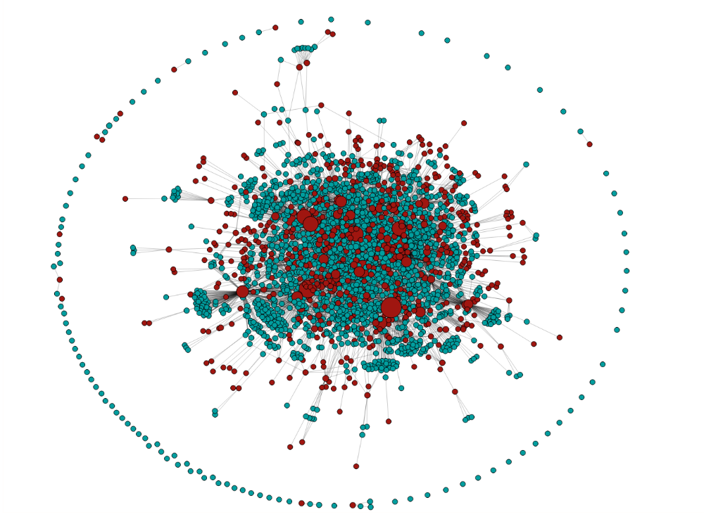

Figure 2. The commercial network sans Pušu-Ken.

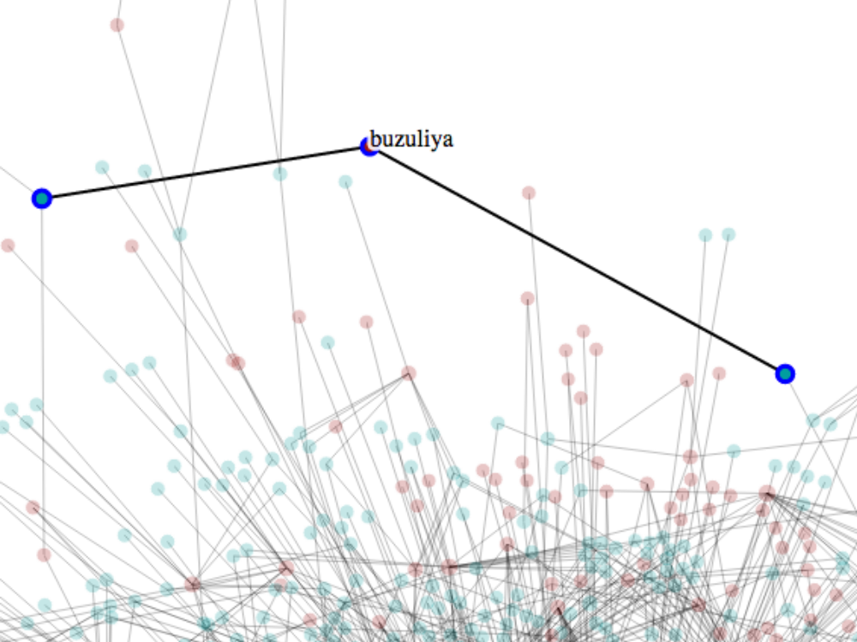

Figure 3. Indication that the name Buzuliya refers to two people.

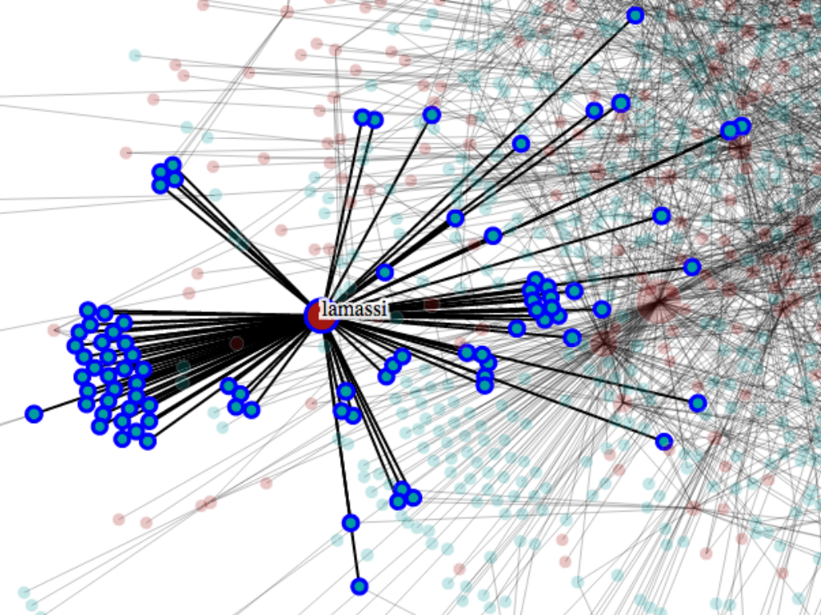

Figure 4. Lamassi’s subnetwork.

Name Disambiguation Interface
The database was expanded with the addition of a persons table that contained patronymic designations compiled by Stratford. Browne wrote routines that attempted to match these patronymics to names extracted from the corpus. If a given name in a patronymic was not found in any other patronymic, the system would link that name and all of its associated occurrences with that patronymic. Also, if a name only occurred once in the corpus, and no patronymic contained that name, then the name was added as its own patronymic, and its occurrence was linked to that new patronymic.
These procedures accounted for almost 300 of the 606 names found in the corpus. As the Old Assyrian expert, Stratford must comb through the remaining names. To assist Stratford, Browne created an AJAX-based web form. The interface presents two select boxes: a box above displaying the names in the corpus, and a box below displaying the known patronymics. There is also a small form at the bottom to add new patronymics to the data table (see Figure 5).
When the user clicks on either a name or a patronymic, the text from its associated occurrences appears on the right. For names, the occurrences appear with the name highlighted in blue. The user may click on any of the occurrences displayed for the selected name, and link them to the selected patronymic.

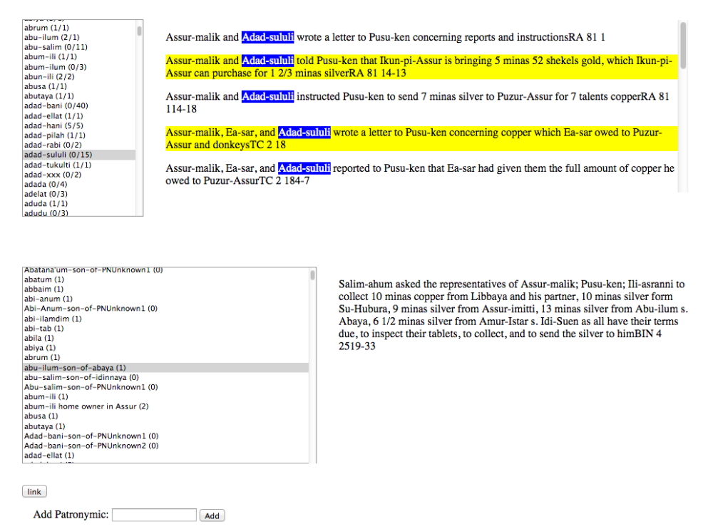

Figure 5. The name disambiguation interface.

Stratford will disambiguate homonymous individuals, and, by the end of 2014, he and Browne should have more detailed and accurate analyses of this 4,000-year-old commercial network to share. It is possible that, as happened with Jackson’s (2014) analysis of medieval Scottish charters, previously unknown connections and communities will be revealed.

Moving On
Besides the individual-disambiguated network analysis, Browne and Stratford plan to map specific business transactions and assets to further characterize Old Assyrian commerce and society. Methods that Suen, Luenzel, and Gil (2013) used to analyze an array of media may be adapted to uncover nuances between various types of transactions. The OCHRE metadata for the original clay tablets describe features of handwriting style, so there is an opportunity for ‘transcriptionship’ attribution. Ongoing spectral analyses of the clay tablets may reveal the place of transcription as well. Finally, Stratford and Browne are investigating various metadata standards such as SNAP:DRGN (Bodard et al., 2014) to allow OCHRE and the prototype database to interoperate with other such corpus systems.

References
Bamman, D., Anderson, A. and Smith, N. (2013). Inferring Social Rank in an Old Assyrian Trade Network. Paper presented at DH 2013, Lincoln, NE.
Bodard, G., Depauw, M. and Rahtz, S. (2014). SNAP:DRGN—Standard for Networking Ancient Prosopographies: Data and Relations in Greco-Roman Names. Poster presented at DH 2014, Lausanne.
Jackson, C. (2014). Using Social Network Analysis to Reveal Unseen Relationships in Medieval Scotland. Paper presented at DH 2014, Lausanne.
Larsen, M. T. (2007). Individual and Family in Old Assyrian Society. Journal of Cuneiform Studies, 59 (January): 93–106.
Stratford, E. (2014). ‘Make Them Pay’: Charting the Social Topography of an Old Assyrian Caravan Cycle. Journal of Cuneiform Studies, 66 (January): 11–38.
Suen, C., Luenzel, L. and Gil, S. (2013). Extraction and Analysis of Character Interaction Networks From Plays and Movies. Paper presented at DH 2013, Lincoln, NE.
Veenhof, K. R. and Eidem, J. (2008). Mesopotamia: The Old Assyrian Period. Academic Press, Fribourg.

