CHAKI — Remote
<2 figures>

Remote Health Support System for Pregnant Women in Rural Areas
Chaki, R.

The primary objective of this proposal is to present a pervasive and wearable logic that will act as a doctor (or watchdog) for the pregnant women of remote areas. This logic is aimed to monitor the pregnant women’s health condition. It is well known that in countries such as India and Australia, large parts of the country are not easily reachable by road. In remote places, pregnant women face several risk factors besides the normal ones associated with pregnancy, such as,

• A woman may feel sick while she is busy in her housework at her village and no one is there to assist her.
• In rural areas, teenage motherhood is a serious problem. Babies born to teenage mothers have an increased risk of pre-term birth, low birth weight, and associated complications.
• Pregnant mothers living in remote areas usually do not have the same access to prenatal care as women living in rural areas.
• Women in remote areas also involve themselves in risky hard work, such as farming, carrying heavy loads, etc.

Due to the locational disadvantage, social beliefs, and lack of money, women are reluctant to visit the health centres, which might be situated quite a distance away. In such situations, monitoring of sudden changes in physiological and physical factors like accelerated pulse rate, blood pressure, glucose rate, sudden body movement, and body temperature would be helpful in assisting the pregnant women.
Our logic aims to sense the above-mentioned physiological and physical parameters of the woman. If it senses something out of ordinary from the sensor data it sends an alarm to the server of nearest health sub-centre. In case the people at the sub-centre are unable to manage the sensed information, they send a suggestion to the woman’s phone to provide temporary relief. Otherwise, they send an alarm message to a PSH (Public Service Health) centre. PSH takes the necessary action to monitor that woman.
Our logic helps in monitoring the health condition of pregnant women, who have the knowledge that their doctors are always with them through this device.

Proposed Logic
In describing the detailed methodology, the whole system is explained as relates to the overall system architecture and a description of each module.
WEARABLE SENSOR BAND

Heart rate of fetal

SMART
PHONE

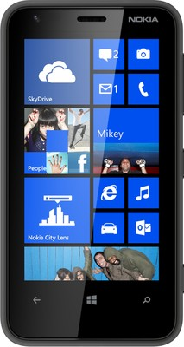
Controller
Fall Detector
Optical blood flow sensor

Server at Health sub-centre station

Glucometer

Public Service Health Centre

Figure 1. Overall system architecture.
The wearable sensor band is attached to the wrist of the pregnant woman. The sensor band is built around five sensors that act in concert simultaneously and in real time to provide a holistic, precise, and accurate view of the woman’s health immediately and over extended periods of time and even in dangerous situations.
The 3D accelerometer detects even the smallest movement. It measures the rate of change of velocity of the device, both in terms of magnitude (g-force) and direction (3 axes). This can range from whole-body movement, like walking or running or a sudden fall to smaller movements also.
By measuring the user’s skin surface temperature, the temperature sensor provides a more accurate reading of exertion in an activity state. By measuring how the body is regulating skin temperature, the sensor band gets a much better picture of how a person’s body is responding to one’s physical activity or mental state. The body regulates itself to keep running at just the right temperature.
The wearable glucometer measures women’s glucose levels.
The heart rate sensor employs reflectance mode photoplethysmography to extract the pulse signal from the wrist, which is equivalent to the heartbeat of a pregnant woman.
Fetal heart rate is also measured by a fetal heart rate monitoring sensor.
The controller on the sensor band acquires data from the sensors and sends it to the smart phone of the user through low-power Bluetooth technology.
Different and fusion sensor data are clustered among several groups according to their source, pregnant women’s behaviour, and locational context. This work implements classification algorithms to classify the new data to which group it belongs. Multi-classifiers are developed for each different cluster group. All classifiers are trained with sensor data using a supervised learning algorithm.
The smart phone has a machine learning algorithm such as a decision tree to decide whether the acquired sensor data have crossed the threshold value. The threshold is precalculated and stored in the smart phone based on laboratory and field testing results. When the accumulated data cross the threshold value, the smart phone sends an alert message with its location through the GSM network (with short message service) to the server, which resides with a sub-health center and the PSH. The server is equipped with a GSM modem. The server’s database will contain the user’s name and home address. The location where the event has occurred and time of the event are received by the server through the alert SMS. After receiving the alert message, the server will flash an alarm on its dashboard.

Modular Description

Software Functionalities of the Sensor Band
• Establishing and maintaining Bluetooth connectivity with the smart phone of the user.
• Acquisition of heart rate of mother and fetus, body movement of pregnant mother (such as a sudden fall downstairs, a sudden accident) during household work, and blood sugar and body temperature of mother signals at a predefined sampling rate.
• Transmission of the acquired signals to the smart phone device through Bluetooth (Figure 2).

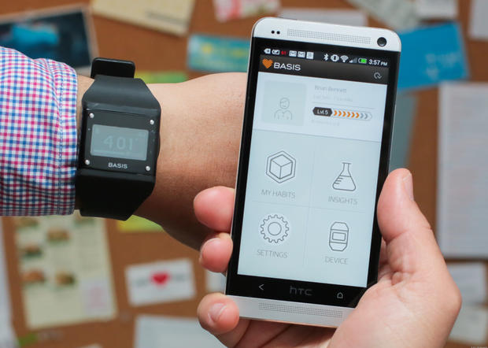

Figure 2. Sensor band transfers acquired signal to the smart phone through Bluetooth.

Software Functionalities of the Smart Phone
• Acquisition of data from the sensor band via Bluetooth at regular time intervals.
• Different and fusion sensors data are clustered into different groups using a clustering algorithm.
• The clustering algorithm is designed based on the data value received from sensor band and locational content.
• Multi-classifiers are developed for each different cluster group.
• All classifiers are trained with sensor data using supervised learning algorithm.
• Application of decision tree algorithm on the acquired sensor data to determine whether the threshold value has been exceeded.
• Determination of GPS location and event time and sending of an alert message to the server, which resides at the public sub-health center.

Functionalities of Public Sub-Health Centre
• Logging of alarm events.
• Annunciation of alarm messages on the dashboard with user location, time, identification, and data value of sensor band.
• Server database contains patient ID, name, address, normal heart rate of mother and fetus, blood sugar level of mother during previous checkup, and previous checkup date.
• If datavalue > m*threshold
* Sending an alarm message to PSH.
• Else
* Send suggestion to the patient’s mobile.

