VERBERT — Visualization
<3 figures>

On the Use of Visualization for the Digital Humanities
Verbert, K.

Recent computing developments have created several visualization techniques and tools for building interactive visualizations that can be used to explore data in new ways. These techniques and tools play a central role in many novel digital humanities applications, ranging from social network visualizations to 3D models of historic buildings.
In this paper, a wide range of visualizations that have been presented at the digital humanities conference 2014 (DH2014) is analyzed. The research contribution of this paper is twofold. First, an analysis of prominent research in this domain is presented, focusing on the following research questions:

• RQ1: Which visualization techniques are used by current prototypes and systems?
• RQ2: Which interaction techniques are supported by current prototypes and systems?
• RQ3: How are visual approaches to digital humanities research evaluated?

Second, based on an analysis of existing applications that were presented at DH2014, opportunities for future research in this area are outlined.

Analysis of Visual Approaches in the Digital Humanities
RQ1: Which visualization techniques are used by current prototypes and systems? Out of all DH14 contributions, 58 presentations report on significant work on the use of visualizations. Fifteen techniques for different data types are deployed 74 times (see Figure 1):

• 1-dimensional: Word clouds (four occurrences) and histograms (three occurrences) are used to represent 1-dimensional data. Word clouds and histograms are, for instance, used to understand the main themes.
• 2-dimensional: Scatterplots (one occurrence) and timelines (four occurrences) are typical examples of data that are represented on two dimensions.
• Multi-dimensional: 3D models are used by 12 out of 58 applications. In most cases, these 3D models render historic buildings to support virtual exploration. Geographic maps are also commonly used (13 occurrences). In all cases, a third variable is represented in addition to longitude and latitude data to support data analysis. The size of a dot on a map and different colors are, for instance, used to represent the number of occurrences of entity types in their geographic context. Parallel coordinates and infographics have the potential to represent more than three dimensions—but are not used often. An example of the use of parallel coordinates is represented in Figure 3 and enables exploration of correlations or trade-offs between more than two variables.
• Relations: Most common are uni- or bi-directional relations represented by graphs. Graphs are present in 23 out of 58 prototypes. Other relations are less common and include hierarchical relations represented by trees, relations between sets represented by a cluster map, Sankey diagrams, matrices, and heatmaps.
• Animations: Three out of 58 applications employ animation techniques to enhance understanding of complex data.

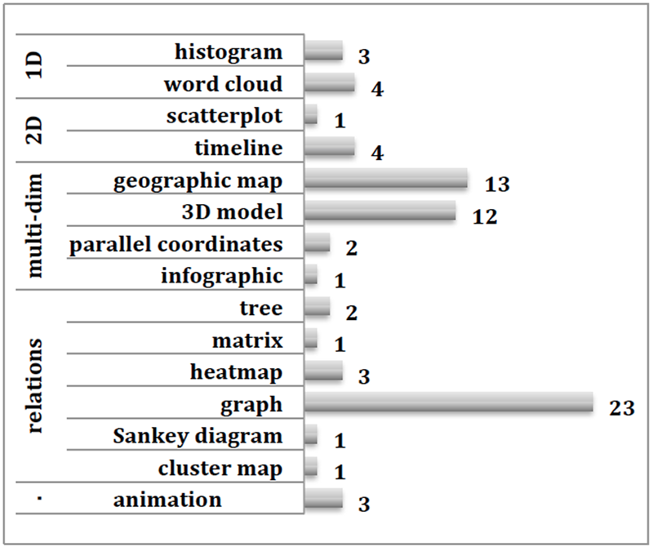
Figure 1. Visualization techniques used by work presented at DH14.

RQ2: Which interaction types are supported by current prototypes and systems?
For analyzing the level of interactivity, Yi et al.’s classification (2007) of interaction types was used. Out of the 58 presentations, 35 visualizations are interactive. Twenty-three presentations represent a static visualization, or a visualization at a conceptual level without specifying the level of interactivity. Of interest for this analysis are the 35 visualization prototypes that implement interaction. Figure 2 presents the interaction types that are supported:

• The most common interaction type is abstract/elaborate that enables users to show more or less detail in a visualization. An example is a drill-down operation in a tree representation that allows the user to examine a particular sub-tree. A zooming operation to see part of a geographic map in more detail is another interaction technique that is supported by many prototypes. Another common example is a tool-tip interaction technique that provides detailed information when a mouse cursor hovers over a data item. These interactions have been defined as details-on-demand operations. Abstract/elaborate interactions are supported by 35 out of 58 prototypes that implement visualizations.
• A second common interaction type is an explore operation. Such operations enable the user to see a different subset of the data in the visual representation. A typical explore operation is a panning action that enables the users to see a different part of a graph representation or a different part of a geographic map. Thirty-four out of the 35 interactive prototypes support this type of interaction.
• Filter interaction techniques enable the user to change the set of data items that is presented based on specific conditions. Data items not satisfying the condition are hidden or shown differently. Sliders to specify a range of dates and check boxes to filter categorical data are typical examples. Some visualizations use input boxes to filter data elements such as names through keyboard interaction. Fifteen out of 35 interactive prototypes provide filter operations. Such interactions are key when working with large datasets and enable users to refine research questions on the fly.
• One prototype uses an encode interaction technique to enable users to show a different representation. Figure 3 presents an example of a visualization that enables users to select a different representation technique (table, graph, etc.) to analyze data.
• To the best of our knowledge, reconfigure interactions that enable users to see a different arrangement, such as different variables on the X- and Y-axis of a scatterplot, connect interactions, and select/focus interactions to mark information are not supported.

Figure 2. Interactions supported by DH14 applications.

RQ3: How are visual approaches to digital humanities research evaluated?
Most contributions presented at DH14 present proof-of-concept prototypes that implement research ideas in prototypes or full systems. These prototypes or systems are then used by the authors to answer specific research questions. Only four out of 58 applications have been evaluated in case studies to assess their value for other researchers. In these case studies, applications have been made available to target users who have used the applications to conduct a research task. Such case studies provide valuable insight into the usefulness and usability of different visualization and interaction techniques.

Figure 3. Visualization to interpret biographies (Booth and Martin, 2014)

Conclusion
In this paper, visualization and interaction techniques in visual applications presented at DH14 have been analyzed. From this analysis, a few take-away messages and opportunities for future research can be highlighted:

1. Visualization techniques (RQ1). DH applications employ a wide variety of visualization techniques. An earlier study by Montague et al. (2014) identified trees, histograms, graphs, word clouds, and scatter plots as key visualization techniques to support text mining analysis. Results of our study identify a broader range of visualization techniques that have been applied successfully in digital humanities prototypes, beyond the scope of text analysis. Our analysis indicates that graphs, geographic maps, and 3D models are the most prominent techniques. Trees, histograms, word clouds, and scatter plots are also employed, although less often. In general, our analysis identifies a wide variety of techniques that have been used successfully, including advanced multidimensional techniques such as parallel coordinates.
2. Interaction techniques (RQ2). A subset of 35 out of 58 applications employs interaction techniques to enable users to drive the analysis. Most common are abstract/elaborate techniques that enable users to retrieve details on demand. Explore interactions are also common in interactive prototypes. Filter operations are key when dealing with large data collections and enable retrieval of a subset of the data that is relevant. Such interactions are supported by 15 prototypes. Other interactions that enable users to choose different data types (reconfigure) or different representation methods (encode) are not used often: such techniques are more advanced, and can play a role in interactive interfaces that support data analysis from different perspectives. The use of such techniques to steer visual data analysis processes constitutes a further line of research.
3 Evaluation (RQ3). Our analysis indicates that case studies that evaluate the usefulness and usability of visualization techniques to support digital humanities are still rare. Four out of 58 prototypes have been evaluated in significant case studies. Whereas such case studies have been identified as key to gain insight into actual use of visualization techniques, only a limited number of research contributions report on insights derived from such studies. Results of our own work indicate that case studies are key to identifying suitable visualization and interaction techniques: a cluster map technique to represent relations turned out to be complex for novice users, whereas a traditional Venn diagram was more successful in a case study that we conducted with researchers. Similar experiments are needed to gain insight into the merits and drawbacks of representation and interaction techniques, and how they can be successfully deployed in useful applications.

References
Booth, A. and Martin, W. (2014). An XML Schema to Interpret Networked Biographies: Reading Mid-Range. In Proceedings of Digital Humanities 2014, http://dharchive.org/paper/DH2014/Paper-823.xml.
DH2014. (2014). Digital Humanities 2014 Conference. http://dh2014.org/.
Montague, J. J., Rockwell, G., Ruecker, S., Sinclair, S., Brown, S., Chartier, R., Frizzera, L. and Simpson, J. (2014). Seeing the Trees and Understanding the Forest. In Proceedings of Digital Humanities 2014.
Yi, J. S., ah Kang, Y., Stasko, J. T. and Jacko, J. A. (2007). Toward a Deeper Understanding of the Role of Interaction in Information Visualization. IEEE Transactions on Visualization and Computer Graphics, 13(6): 1224–31.

