***Uncle Sam and His Deadly Addiction***

***The U.S. Government has funded itself by borrowing at an astonishing scale for four decades***

The U.S. is 31 trillion dollars in debt. Read it again, *trillion*. And then multiplied 31 times over. Here is a visualization.

If this square represented 1 billion dollars, and an additional 999 squares were added side-by-side like this…



…then the 1,000 squares would represent 1 trillion dollars. Now take the 1,000 squares and multiply them by 31. That’s a lot of little squares: 31,000 to be exact. That’s the scale of the amount of debt the U.S. has on its books. Before we can judge that number to be small or large, prudent or irresponsible, let’s set the table and make sure we understand what federal debt *is* and what function it serves.

***The Debt Limit In Less Than 60 Seconds***

The debt limit (aka the debt ceiling) is exactly what the name implies. It’s the upward boundary that the U.S. Government (USG) *cannot* borrow beyond (e.g. the amount of total debt that can be outstanding on the books at any one specific time). If *more* money is needed than the current debt limit is set at, then one of two scenarios can play out:

1. The Government stops paying money out: aid to other countries, interest payments on bonds, federal employee salaries, etc,. Hard stop on everything. While arguably being the responsible decision, alloying this to happen would be political suicide for whoever made the decision.

**OR…**

1. Capitol Hill can propose an *increase* on the debt limit and can then kick the debt problem down the road a bit. The valuable end-game of this scenario is that neither side of the political aisle needs to bravely fall on their sword by raising taxes or cutting spending.

Using your knowledge of how U.S. politics work, which decision do you think the fearless starched shirts in D.C. will agree to for the previously mentioned meeting? Hint, it won’t be #1.

***Repetitive Behavior is not Redundant - it’s Compounding***

If you seem to recollect other headlines from past years addressing the debt limit, you are not crazy. This soundbite, and the financial fundamentals behind it, have been occurring for many decades. The D.C. elect would have you believe that each time the debt limit is reached it is an anomaly caused by the other side of the aisle. But the truth is that the actual phenomena is so predictable it has become laughable. Here is the *not-so-very-dramatized* process that supports our country’s capital budgeting needs:

1. U.S. politicians spend too much money and get dangerously near the debt limit
2. Politicians scramble to look busy by passionately arguing about the debt limit
3. Politicians cut shady deals to increase the debt limit
4. Politicians recuperate at Marthas Vineyard

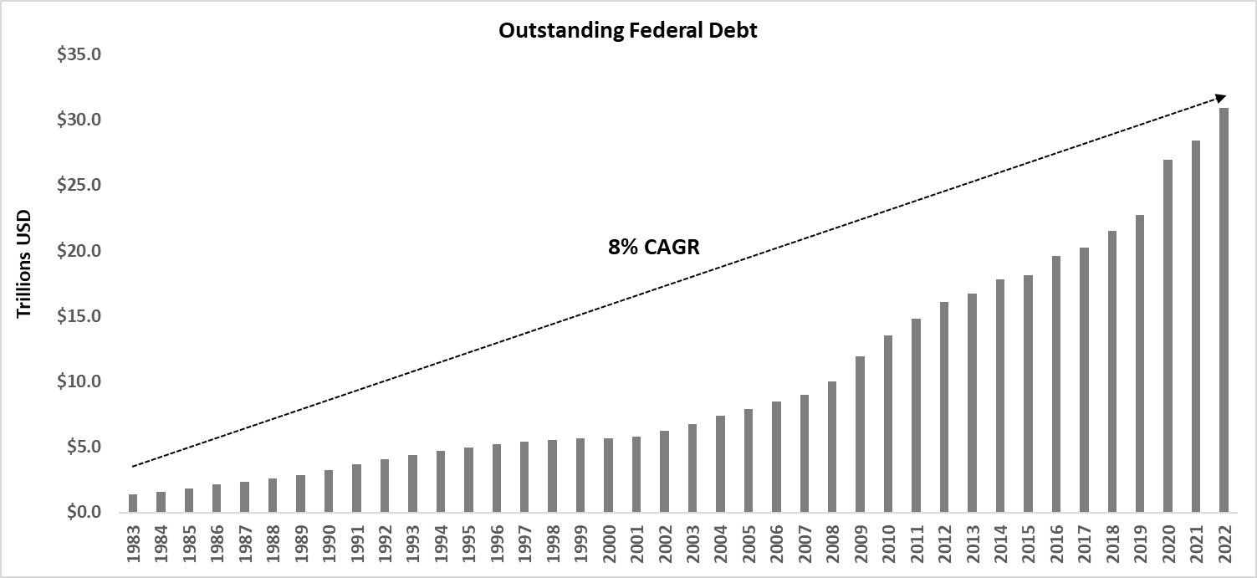Seriously, this is not a joke – this exact punchline is written every few years. The U.S. has raised or extended its debt limit 78 times since 1960: 8 of those times in just the *past decade*. Though common and frequent, the continuous raising of the debt limit is anything but unimportant. Sure, the headlines seem to be repeating themselves but the impact of bad financial decisions are compounding at more costly levels every year. While some years increase more than others, outstanding debt has grown at 8% over the past 40 years. Here is how that has accumulated.

***The Debt Problem is a Spending Problem***

In reference to economic outcomes, Ray Dalio recently said “*each stage is the logical consequence of the stage that preceded it” .* Ironically, he was referring to the exact subject of this article: the troth of debt that the United States is drinking from. And he is right. The tidal wave of debt is just the *outcome*, not the original *problem*. The problem is that Washington D.C. is flagrantly irresponsible with spending. End of story.

You might be wondering why the world’s largest financial entity would even need to borrow money in the first place - shouldn’t the current piggy bank be adequate? The answer is that without fail, the USG spends ***more*** than it takes inevery single year*.* This is called a “deficit”. In fact, the last 3 years (2020-2022) have resulted in such large deficits that they equaled the entire prior decade’s deficits summed together. The cost of running the USA has become so expensive that Governmental revenue (aka taxes) has been at least 10% short of annual outlays for the past 15 years! That annual shortcoming has helped to accumulate $17 Trillion of the current $31 trillion in debt. Here is what the relationship of budget deficit and outstanding debt look like when plotted together. The debt incurred since 2009 has had a massive impact on the debt level. See the correlation?

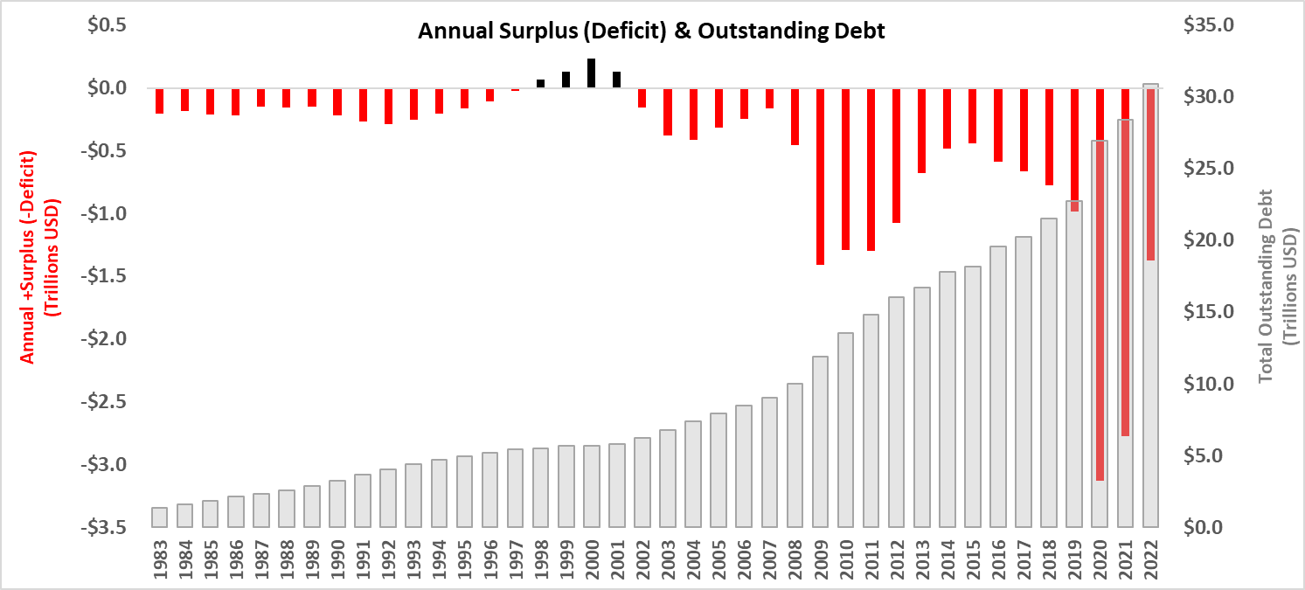

***Absolutely screwed vs. relatively screwed***

Humans like *absolutes*. Absolutes help to make an otherwise complicated world more understandable. But can global economics be understood simply as good or bad or is the truth a bit more relative? To build a relative understanding of the situation at hand (that is, to truly understand the gravity of 31 trillion dollars), we need additional comparison points. We can complete this exercise by introducing a new metric and assessing that metric against our global peer set. Enter the Gross Domestic Product (GDP). GDP is the *value* that a country produces. It’s a barometer of productivity and profitability rolled into one metric. The entire U.S. workforce makes up the GDP: from the largest corporations to tiny bodegas. The U.S. leads the world in this metric with $25 trillion in 2022 – no other country is even close to second place.

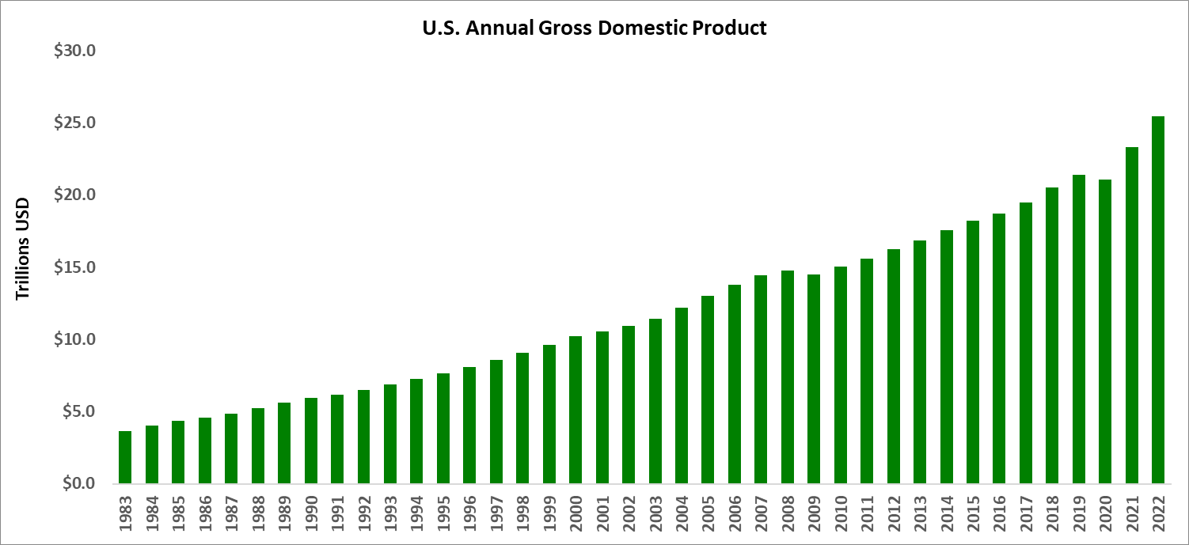

So far, our story arc has featured two numbers: **$31 Trillion** of debt and **$25 Trillion** of GDP. Now let’s bring them together to create the *relative* story. We can compare the two numbers in a ratio: a higher ratio means more leverage (more risk) and a lower ratio would mean less leverage (less risk). This ratio makes sense for this reason: if a country takes on more *more* debt than the value it produces, there *has* be a plan to increase tax (take more money in) and/or cut spending. Otherwise, the country will be stuck in a perpetual loop of being more in debt than it is worth. This principle is no different than if you personally took out $75,000 in debt each year but only made $50,000 at your job - that would be considered highly improdudent.

Returning to the conversation on economic relativity…the U.S. has a debt-to-GDP ratio of **1.22** ($31 Trillion ÷ $25 Trillion). Of the 150+ countries shown here – where do you think *Old Glory* sits?

Do you see that thin red-white-blue bar? It’s darn near the top. Even in *relative* terms our financials look problematic. But perhaps even this view is unfair throwing shade on the U.S.? Shouldn’t we be compared only to our close peer set (E.g. the most advanced countries)? Perhaps advanced countries (like rich people) take on a ton of debt because they just can? It’s a hopeful view and worth exploring. Zooming in on the graph will show which countries are economic *nearest neighbors* – the ones that are most similar to the United States in this particular metric. If those nearest neighbors are also our closest competitors, then our current debt management strategy would make a lot more sense, right? Let’s hit the zoom-in button.

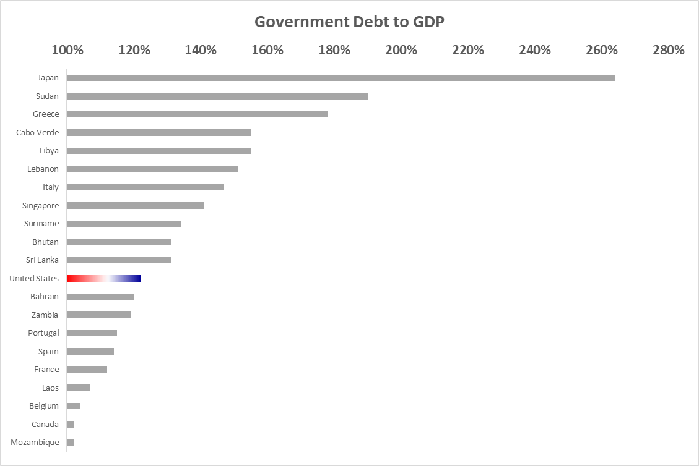

Yikes, this is not a good look. I can’t even locate Zambia, Bahrain, Sri Lanka, or Bhutan on a map without cheating. So why the heck is the world’s foremost economic power mentioned in the same economic strata as them? And while we are on the subject, where do our main competitors stack up?

* Brazil: 88%
* India: 83%
* China: 77%
* Russia: 16%

Welp, our competitors have managed to grow with half the leverage we have. They are using debt prudently with a focus on the *long-game*. And let’s not forget that Russia has been planning an assault on the Ukraine for many years; if ever there would have been a time for them to borrow extravagantly, the last few years would have been that time. Instead, Russia has bankrolled this war (though cruel and wrong) primarily out of their own cash account: no credit cards needed. The only comparably advanced economy to the U.S. that has a *higher* debt-to-GDP ratio is *Japan*: which, ironically, has one of the most problematic economies of modern times. Certainly not a comparison that helps our case for spending.

***Blame game***

You might be tempted to try to correlate the state of economic affairs to the political party in the presidential office. It’s certainly worth exploring but unfortunately does *not* provide a definitive conclusion. Here is Year-over-Year debt growth going back 40 years colored by the political party of the sitting president (**red** = republican | **blue** = democrat).

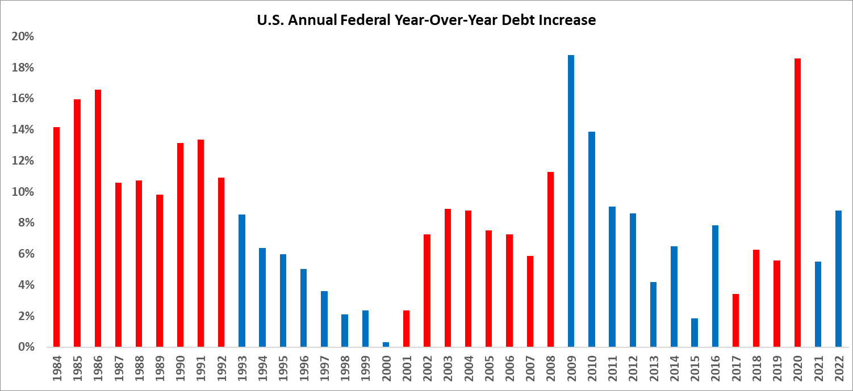

A few interesting callouts:

* *Reagan* & *Bush #1* clocked in annual double digit debt growth in the 80s/early 90’s
* There was a definite slowdown in debt growth under Clinton in the early 90’s until 2000
* The DotCom crash + Bush #2 erased the conservative trend preceding it
* Obama and Trump both saw the largest year-over-year-gains in debt but that was for emergency measures

It’s tempting to draw conclusions from these data points, but there are so many reasons why economics is difficult to tie to a single president, a single political party, or even a single decision. Too many reasons to cite in this short synopsis.

***There is no static, just upward or downward***

Most sports enthusiasts would agree that the most precarious position for a competitor to be in is the #1 ranking. The scenario of “champion-turned-bust” has played out so many times that the body-of-proof is irrefutable: boxing champions lose hunger, super-bowl winners lose cohesiveness, F1 legends lose decisiveness, etc. Why does this scenario play out so frequently? It boils down to this: *direction*. When you are less than 1st place, there is only one place you *want* to be: 1st place. When you are in 1st place, there is only one ranking direction you can *move*: downward.

World powers frequently mimic this same progression (albeit over a longer timeframe): Ancient Rome, colonial France, and the dominant British empire didn’t lose the top spot in one cataclysmic event: their declines looked like slow atrophy over time and were frequently tied to bad economic policies. Successful outcomes were expected based on past history – not rigorous decision-making. Does this sound familiar? America pays the bills for a large amount of the world for the past half-century, has a bloated government office for *any* service you can think of, and enters into military conflicts without a thought of the cost. We are used to being at the top of the heap: being the #1 economic super power is considered to be a right, not a luxury. We are used to low costs of bad decisions. Our competitors don’t have this luxury.

***Shared Responsibility***

The U.S. is addicted to debt, plain and simple. Whether or not that addiction is stronger in a certain political party is inconsequential. While the *rate* of debt increase does seem to differ between the parties, the actual debt amount still has never *gone down* in a given year, regardless of political party. Read that last sentence again: the debt has *never* gone down in the last 40 years. It’s pointless to debate which party is more to blame: addiction is addiction. The D.C. elect is either serially inept or unmistakably corrupt. However, there is another group of constituents that needs to own up as well.

It’s us. Me and you.

We the populous are to blame as well. We secretly *like* government programs that require someone *else* to understand their function and their nuance. Let’s be honest, most of us fall into a category of wanting: our military to have the most advanced weapons, constantly improving highways, government-sponsored loan forgiveness, or (for Pete’s sake) we even think that our current internet is slow enough that the government should upgrade it. Do any of these points resonate with you? These services cost money, more money than our country is currently producing. Why do we think the economic fundamentals of *spend less than you make* don’t apply to large countries as well? We have quietly pawned the financial future of our country off to individuals sitting thousands of miles away in a Georgetown brownstone apartment that *we* paid for. We have grown eerily comfortable with a tiny minority of unqualified people making economic decisions that will compound with difficulty for future generations. When it comes to voting time, very few of us look at the financial history of the candidates. Too often, we are far more concerned with their party-driven speeches and their empty rhetoric.

So where does this leave us? I wish I had a neat and clean call-to-action that could be summed up in a acronym, but I don’t. I wish I could I could give out financial advice – but I am not qualified for that. The only thing I can do is to act prudently and encourage my tribe to do the same. Ships collide with icebergs if they don’t veer; this is my small and humble attempt to raise the alarm in hopes that someone more talented than I can actually turn the wheel. And soon.

Thank you for reading.

Sources

1. https://home.treasury.gov/policy-issues/financial-markets-financial-institutions-and-fiscal-service/debt-limit
2. <https://bipartisanpolicy.org/debt-limit-history/>
3. <https://www.youtube.com/watch?v=GDuXvOs0d_k>
4. www.cbo.gov/publication/58848
5. <https://www.worldeconomics.com/Indicator-Data/Economic-Size/Dept-to-GDP-Ratio.aspx>
6. https://www.commerce.gov/news/fact-sheets/2023/03/investing-america-biden-harris-administration-boosts-manufacturing-ahead