Assignment 8 – Visual Odometry
Jeffrey Millard

Task 1

I used Good Features to Track to initialize features at each new frame. I used LK pyramidal optical flow to track features between frames. I didn’t skip any frames. The fundamental matrix was generated using findFundamentalMat and the FM_RANSAC algorithm to omit outliers. Points were undistorted before finding the Essential matrix. RecoverPose helped with generating the rotation and translation. RecoverPose does a great job of the cheirality check, but occasionally produced untrustworthy values. This could be remedied by monitoring the translation vector each iteration and making sure that there is always forward motion. There was a more rare phenomenon in which the cheirality check would produce a 180deg flip, which was manifest in a negative value on the diagonal of R. This was very rare, but it could be remedied by monitoring R each iteration to ensure positive diagonal values. If ill conditioned R matrices were detected, identity was used just for that iteration and T adopted the values from the previous iteration. This had the effect of propagating the estimate forward without rotation.

The concatenated translation and rotation transformations, C_k are included in the rt_practice.txt file. Below is the estimated VO trajectory for the practice dataset. It isn’t perfect, but the overall transformation wasn’t far off and the curvature matches pretty well.

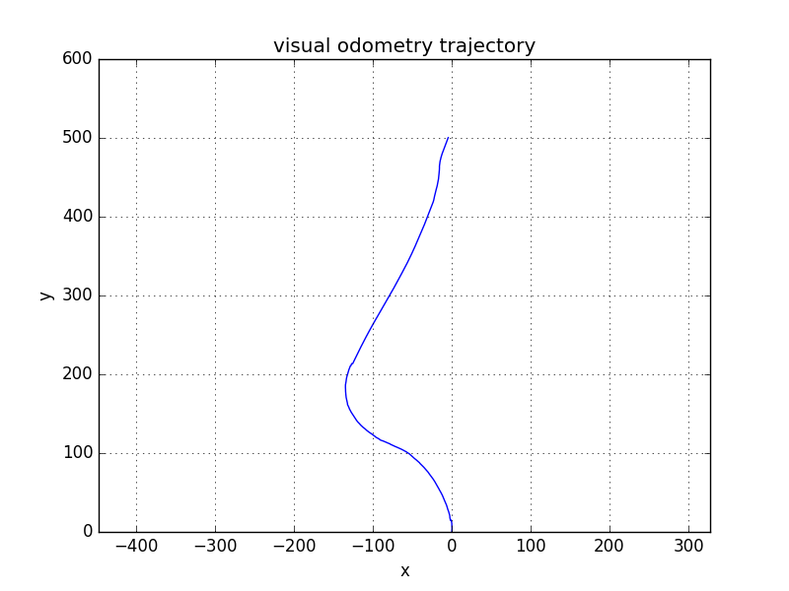

Task 2

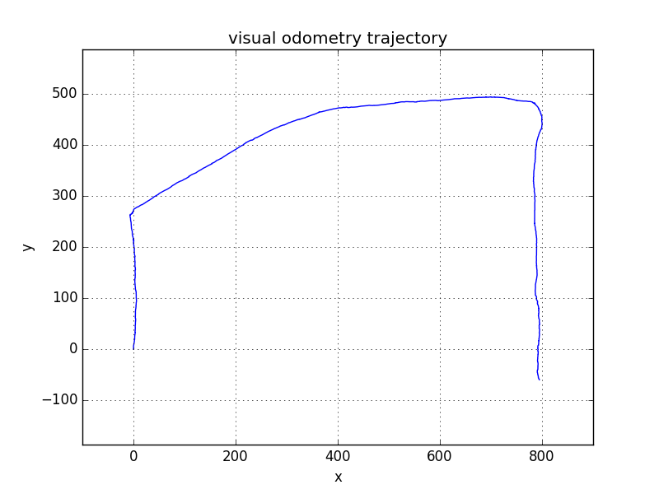
The code was run on the hallway dataset. The results here are pretty good considering that the thresholds and weights for various parts of the algorithm were not needed to change between the practice set and the hallway set. This suggests robustness in the face of unique lighting conditions. This run, however, used a scale factor of 0.8.

The rotation at the first corner isn’t quite 90deg, but the overall proportions remain pretty accurate. It is seen that the last hallway is twice as long as the first, as expected. The dimensions aren’t perfect which suggests that the scale factor ought to be refined, but I used the one provided, 0.8.

