­­Concept Document

JDMN Music Hall

This webapp is a mobile application meant to promote a music venue. It is a 6-page web application that runs with a tab style navigation similar to applications like Facebook, YouTube, and Instagram. The webapp consists of a home page, an artists page, a shorts page, a buy page, a contact hero page, and a final page accessible from the contact page.

The targeted market is concert goers on mobile devices. Usually, teenagers and young adults prefer to access websites from there mobile devices and this application fits their needs. Although highly coded for mobile use, it is responsive for all devices.

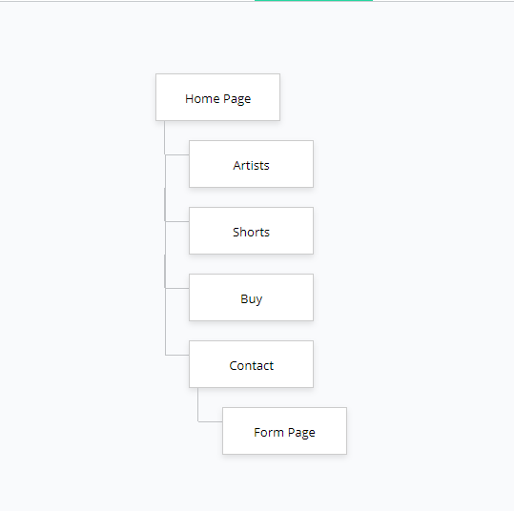

The necessity of a tab style application was not a question. This style of navigation caters to the users who prefer a navigation bar within the reach of a thumb. It also allows for less obstruction of content. The feeling of a full viewport height is achieved by moving the navigation to the bottom of the mobile device.

Apps such as Instagram, Facebook, TikTok are pretty similar design wise. They are mobile social media apps that are extremely successful. I would like to argue that the success is derived from the simplicity of the designs and how easy they are to pick up and learn to navigate them. Ideally what I wanted to achieve to differentiate against other apps was to provide content is a presentation that strayed away from hamburger menus, deep rooted pages, and also was content focused.