User Manual
Performance and Complexity Analyzer: empirical complexity of holographic reconstruction algorithms

1 Introduction
Computational complexity describes how the resources an algorithm needs (execution time, processor instructions, memory) grow with the size of its input. It can be derived theoretically from the structure of the algorithm, or measured empirically. For algorithms with many nested operations, FFTs, iterative searches and non-trivial memory-access patterns, such as holographic phase-compensation methods, the theoretical derivation is cumbersome, and an empirical measurement is a direct and reproducible alternative.
This repository contains an automated framework for that empirical evaluation. It works in two independent stages:
- Measurement (Analysis tab, Main.py). the program takes a dataset made of one folder per image size, runs the algorithm under test on every image under the Linux perf utility, and records CPU instructions, cycles, cache counters and elapsed time into a plain-text results file.
- Interpretation (Visualization tab, visualizer_v2.py + complexity_fit.py). the program reads one or more results files, fits a family of complexity models (O(1), O(√N), O(N), O(N log N), O(N^1.5), O(N²), O(N³) and a free exponent O(N^p)), selects the best one statistically, and draws two plots: instructions vs. N and time vs. N, where N is the number of pixels. If the data cannot support a conclusion, the classifier says so (it abstains) instead of guessing.
Because the two stages only share a text file, results measured earlier, or on another machine, can be classified without running anything again.
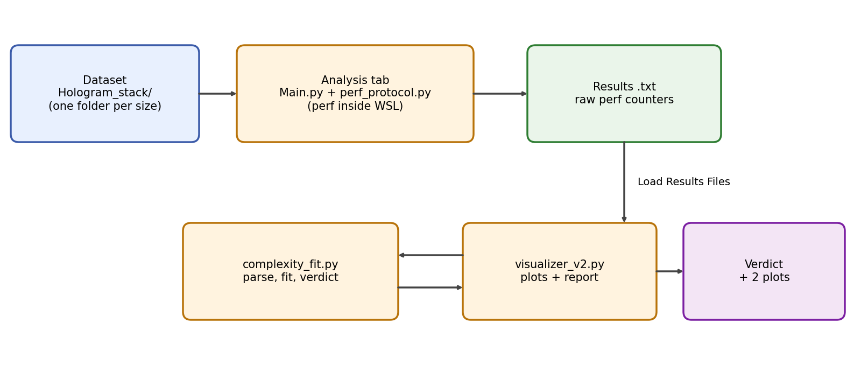
Figure 1. General workflow of the framework.
This manual explains how to install and use everything in the repository (sections 2 to 6 and 10 to 13) and how Main.py and the modules it uses (perf_protocol.py, visualizer_v2.py, complexity_fit.py) work internally (sections 7 to 9).

2 Installation
The framework quantifies hardware-level behavior using perf, a native Linux tool that reads the processor performance counters. perf only runs on Linux. On Windows, the graphical program runs natively, and every measurement is executed inside WSL2 (Windows Subsystem for Linux), which provides a real Linux kernel. Main.py calls into WSL (wsl python3 …, wsl bash -c …) for each measurement.

2.1 Windows: automated setup (recommended)
Open PowerShell or Command Prompt, as Administrator the first time, in the repository folder and run:
python setup_windows.py

The script performs these steps and prints each one with a [+] prefix:
1. Checks that wsl.exe exists (Windows 10 version 2004 or newer, or Windows 11).
2. If no distribution is installed, it runs wsl --install -d Ubuntu --no-launch. Windows may require a restart; after rebooting, run the same command again and it continues where it stopped.
3. Initializes the distribution as root (ubuntu.exe install --root), so no Linux user or password is needed.
4. Converts the path of setup.py with wslpath and runs it inside WSL as root. This compiles perf and takes roughly 10 to 30 minutes.
5. Verifies the installation by printing perf --version.
Options: --distro <name> (default Ubuntu) and --skip-update (skips the apt update/upgrade).

2.2 Windows (manual) or Linux
If you prefer to run the Linux part yourself, open WSL, make setup.py reachable (Windows drives are mounted under /mnt/, for example /mnt/c/Users/<username>/Desktop/…) and run:
python3 setup.py # clones the WSL2 kernel sources and builds only tools/perf
python3 setup.py --skip-update # skip apt update/upgrade
python3 setup.py --only-build-perf # build perf only, assume packages are installed

setup.py installs the build dependencies with apt, clones https://github.com/microsoft/WSL2-Linux-Kernel (shallow clone), and builds only tools/perf with make NO_LIBTRACEEVENT=1 NO_LIBTRACEFS=1. Its log is written to ~/perf_setup.log. On a regular Linux machine perf is normally available from the linux-tools-* packages and setup.py is not needed.

2.3 Python dependencies
Install the dependencies on Windows, where the GUI runs:
pip install -r requirements.txt

requirements.txt lists wxPython, numpy, scipy, matplotlib, Pillow, opencv-python, scikit-image and pytest.
The algorithms under analysis are executed inside WSL, so the libraries that they import must also exist there:
wsl pip3 install numpy scipy matplotlib Pillow opencv-python scikit-image

Note: Before the first run, the program checks WSL for numpy, PIL, matplotlib, scipy and skimage (see section 7.6). If one is missing, it shows "Missing dependencies in WSL. Check the console." Note that this check uses a fixed list of libraries, not the imports of the file you selected. opencv-python (cv2), needed by SHPC.py, is not part of that check; if it is missing in WSL the run will report a Traceback inside the results file instead.

2.4 Launching the program
python Main.py

The window "Performance and Complexity Analyzer" opens with two tabs: Analysis and Visualization.

3 Repository Layout
Path | Purpose
Main.py | Main GUI: Analysis tab (produce measurements) and Visualization tab (interpret them).
perf_protocol.py | Measurement protocol v2: builds the scripts that are run under perf and decides K.
complexity_fit.py | Parser of results files, model fitting, statistical selection and verdict. No GUI code.
visualizer_v2.py | Plot builder and verdict text report used by the Visualization tab.
test_complexity_fit.py | Unit tests (pytest) of complexity_fit.py.
setup_windows.py | One-command WSL2 + perf installation from Windows.
setup.py | Builds perf inside WSL / Linux.
requirements.txt | Python dependencies of the Windows side.
Hologram_stack/ | Simulated off-axis holograms: 11 square sizes × 10 images (128 to 4096 pixels per side).
Test_algorithm/ | Algorithms that were measured: SHPC.py, phaseCompensation.py (FRS, ERS, CFS, CNT), karina_methods.py (PCA, PVM).
Test_files/ | Functions of known complexity (test_functions.py), their results (Lineal, fftl, quadratic, cubic .txt) and an image generator, plus test_data/ with the real measurements used by the tests.
Algorythm_results_windows/ | Measurements of SHPC, FRS, ERS and PCA taken on Windows + WSL2.

4 Quick Start
Reproduce a classification without measuring anything (about one minute):
1. Run python Main.py and open the Visualization tab.
2. Press Load Results Files and select Test_files/Lineal.txt (several files may be selected at once).
3. Press Generate Plots. Two plots appear and the Log reports the verdict, the equation and the ranking of all models.
Measure an algorithm yourself:
1. Run python Main.py. On the Analysis tab, press Browse and select Test_algorithm/SHPC.py.
2. Choose the function shpc_reconstruction. Select the folder Hologram_stack/ with the folder button of the first parameter.
3. Fill in the other parameters (for example dx=3.75, dy=3.75, lamb=0.633, G=3, radio_mascara=200, paso=0.2), set Repetitions and an Output file.
4. Press Run Analysis. When it finishes, a "Success" message appears; load the output file in the Visualization tab.

5 GUI Overview
The window has a menu bar and two tabs. The menu offers File ▸ Open Python File… (Ctrl+O), File ▸ Load Results Files… (Ctrl+L), File ▸ Exit, Analysis ▸ Run Analysis (Ctrl+R, enabled once a function is selected) and Analysis ▸ Generate Plots (Ctrl+G). A status bar at the bottom echoes the last log line.

5.1 Analysis Tab: Producing Measurements
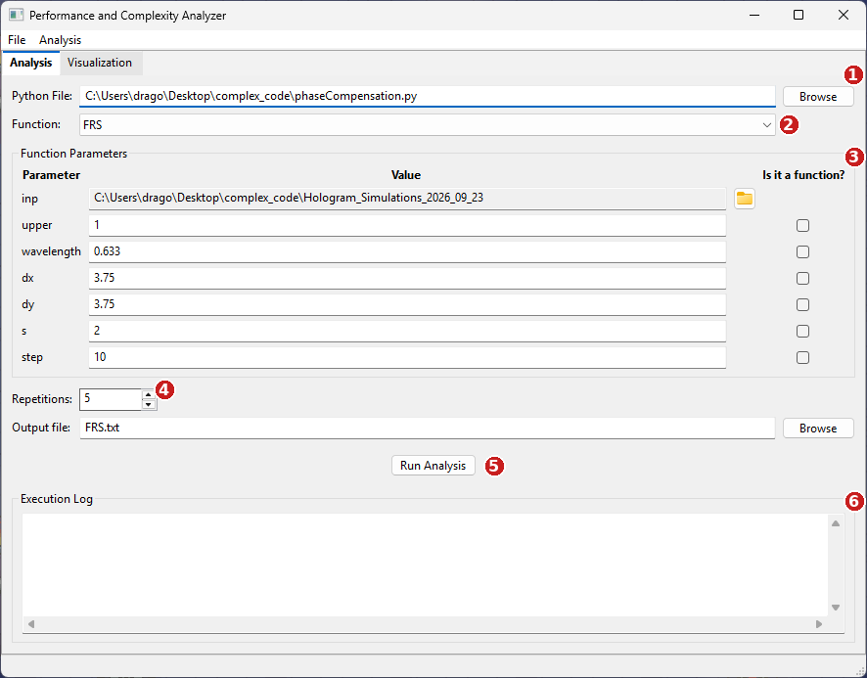
Figure 2. Analysis tab with a function selected. The numbered regions match the text below.

5.1.1 Python File and Function (regions 1 and 2)
Press Browse (or Ctrl+O) and select the .py file that contains the algorithm. The file is imported, and every function defined in that file (functions it merely imports are excluded) is listed in the Function drop-down. The first one is selected automatically. Select the entry point you want to measure.
Note: Importing the file runs its top-level code once inside the GUI process. Keep heavy computations inside functions or under if __name__ == "__main__".

5.1.2 Function Parameters (region 3)
Once a function is selected, the program reads its signature and builds one row per parameter, with default values pre-filled.
Default parameter (the dataset).
- The first parameter of the function is always the image parameter. Its field is read-only and has a folder icon; click it and select the dataset folder (for example Hologram_stack/).
- That folder must contain subfolders, one per image size (128x128, 256x256, …), each with images. A folder with no subfolders is rejected with an error message.
- You never type a value here. During the run, the program replaces this parameter with each image of each subfolder, loaded as a 2-D grayscale float32 array. Your function therefore receives a numpy array (height × width), not a path.
- Accepted image formats: .png, .jpg, .jpeg, .tif, .tiff, .bmp (images are opened with Pillow and converted to 8-bit grayscale, mode "L").
User-defined parameters.
- Type the value in the text field. Values are converted automatically: the word None (any case) becomes None; text containing a dot becomes a float (3.75); text without a dot that is a valid integer becomes an int (200); anything else stays a string.
- Use a decimal point, not a comma. A value such as 0,633 is kept as the string "0,633" and your function will receive a string.
- Scientific notation without a dot (for example 1e-3) is also treated as a string. Write 0.001 instead.
- Lists, tuples and other expressions are passed as strings. Use "Is it a function?" for a name that has to be evaluated as code.
- The checkbox "Is it a function?" at the right of each parameter must be ticked when the parameter expects a function (for example a spatial filter, def f(img, filter_fn)) or any value that must be written into the call without quotes. The text is then inserted verbatim into the call; it must be a name that exists in the selected file.
Example. If the selected function is def test(a, b, function), then function must have "Is it a function?" ticked. Otherwise its value is quoted as a string and the function will fail.

5.1.3 Execution Settings (region 4)
- Repetitions: Number of repetitions (1 to 20, default 5): how many times each measurement block is repeated per image (section 8). More repetitions give a more reliable median and error bars at the cost of time.
- Output file: name or full path of the .txt file that receives the results (default performance.txt, saved in the working directory unless a path is given). Browse opens a save dialog. The file is written progressively and flushed to disk after every image, so a long run can be inspected, or recovered, while it is running. Use descriptive names, for example shpc_G3.txt.

5.1.4 Run Analysis (region 5)
Press Run Analysis (or Ctrl+R). The program verifies WSL dependencies, validates that the first parameter is a folder with subfolders, sorts the subfolders from the smallest to the largest image size, and measures every image. The GUI remains responsive because the log is refreshed between steps, but a run over large images with many repetitions can take hours; the console also prints [folder i/n] and [image j/m] progress.

5.1.5 Execution Log (region 6)
Shows, in real time: the constructed function call, the function and base directory, the number of repetitions and of subfolders found, the baseline progress (Baseline libs i/15), each folder (Processing folder i/n: 256x256), each image, the estimated duration of one call with the chosen K ("1 call ~ 84.1 ms -> K=12"), errors and the final location of the results file.
At the end of the output file a summary is appended: Total runs, Errors found and Success rate. A run counts as an error when its output contains "Error:" or "Traceback".

5.2 Visualization Tab: Interpreting Measurements
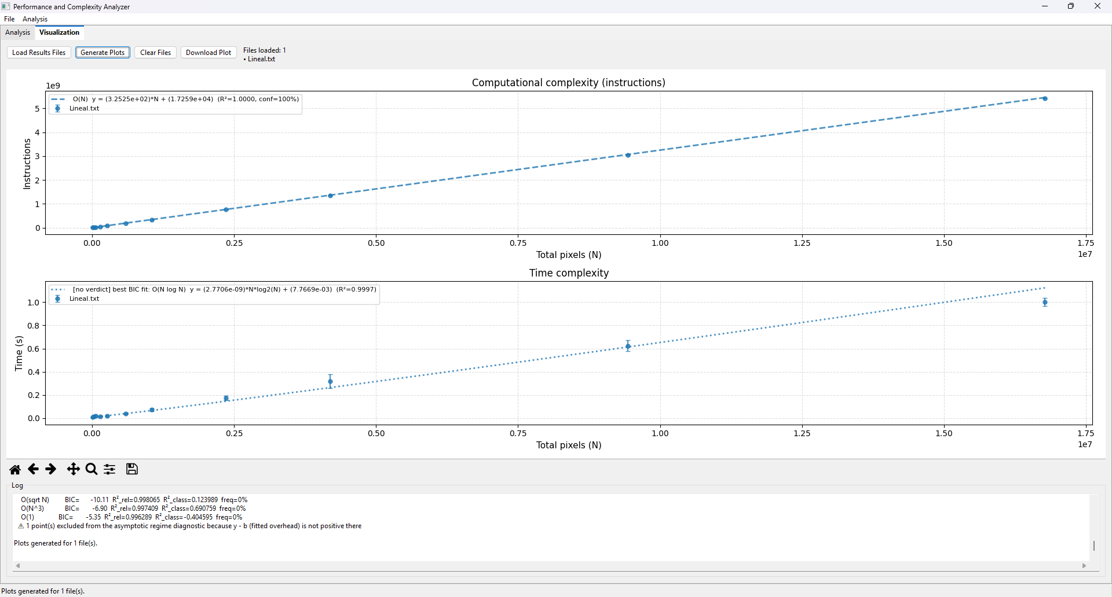
Figure 3. Visualization tab after loading Test_files/Lineal.txt and pressing Generate Plots.
Control | What it does
Load Results Files | Opens a file dialog (multiple selection). Each file is added to the list; selecting several files overlays them with a different color each (up to six colors, then they repeat). Duplicates are ignored.
Generate Plots | Parses and classifies every loaded file and draws two stacked plots: Instructions vs. N (top) and Time vs. N (bottom), N being the total number of pixels. Points are medians with MAD error bars; a dashed curve is the winning model.
Clear Files | Empties the list of loaded files and the plot area.
Download Plot | Saves the current figure. The format is chosen by the extension: .png, .pdf, .svg, .jpg (300 dpi, white background).
Log (lower panel) | Per-file report: verdict, equation, local slopes, number of points, ranking of all models, and warnings.
Plot toolbar | Standard matplotlib navigation toolbar (zoom, pan, save, reset view).

Files that cannot be used are reported, never silently ignored. A file with no "=== FOLDER:" markers is "not a recognized results file", and a file with the right structure but without counters (for example because perf was not installed on the machine that generated it) is reported with the first WARNING line found in the file as the probable cause.
Note: In the Visualization tab of Main.py the shape filter is fixed to "none": all measured sizes are used. The other filters (section 9.3) can be used from Python.

6 Reading the Results
Each plot point is the median of the repetitions of one image size; the error bar is the MAD (median absolute deviation). The bars are absolute, so on a wide scale they are invisible for the small sizes, where the variation is a tiny fraction of the value.
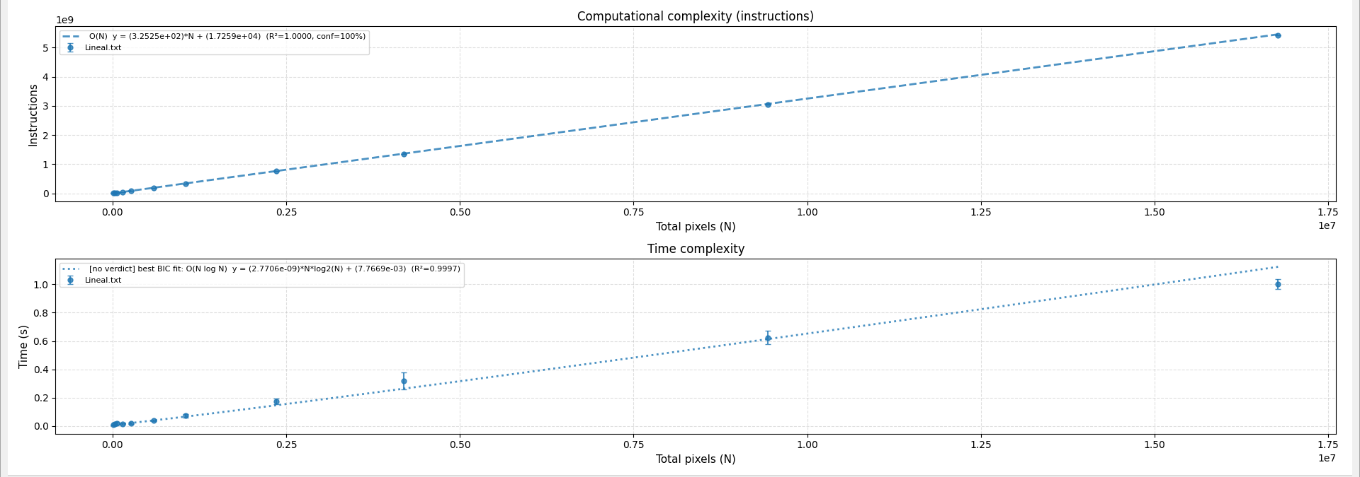
Figure 4. Plots generated for Test_files/Lineal.txt (a linear function). Instructions: verdict O(N), dashed curve. Time: the classifier abstained, so a dotted curve labeled [no verdict] shows the best BIC fit for reference only.

6.1 The verdict report
For each file and metric the Log prints a report. Real output for Test_files/Lineal.txt (instructions):
--- Lineal.txt | Instructions ---
Verdict: O(N) (bootstrap confidence=100%, R²_relative=1.000000, R²_classical=0.999938)
Equation: y = (3.2525e+02)*N + (1.7259e+04)
Raw local slopes: ['1.12', '0.88', '1.01', '0.97', '1.00', '1.00', ...]
Corrected local slopes: ['1.13', '0.88', '1.01', '0.97', '1.00', '1.00', ...]
Asymptotic regime reached: True
Points used: 11 (discarded by shape filter: 0)
Useful points (signal >= overhead): 11/11 ratios (y-b)/b: [...]
Ranking (BIC, relative R² [used to choose], classical R², bootstrap frequency):
O(N) BIC= -77.27 R²_rel=1.000000 R²_class=0.999938 freq=100% << WINNER
O(N^p) free BIC= -75.91 ...
O(N log N) BIC= -43.71 ...

Field | Meaning
Verdict | Winning model, or ABSTAIN together with the reason (Reason).
bootstrap confidence | Fraction of 500 resamplings in which the winner was also the best model. Must be at least 60% for a verdict.
R²_relative | R² computed on relative residuals. It is what the fit optimizes; it can read very close to 1 even for poor models, so do not use it alone.
R²_classical | Textbook R², reported for the reader only.
Equation | Fitted curve in physical units: y = a·f(N) + b. The offset b is the fixed overhead (process start-up, imports) and is constrained to be ≥ 0.
Local slopes | Slope of log y versus log N between consecutive sizes. For O(N) it tends to 1, for O(N²) to 2. "Corrected" first subtracts the fitted overhead b.
Asymptotic regime | True when the last three corrected slopes have settled (section 9.6).
Useful points | How many points have algorithmic signal at least equal to the overhead, (y−b)/b ≥ 1.
Ranking | All candidate models ordered by BIC (lower is better) with their bootstrap frequency. The winner is marked << WINNER.

6.2 Reasons for abstaining
Abstaining is a valid and informative result. It means that the data do not allow a trustworthy conclusion.
Reason | What it means and what to do
Fewer than 5 points after the filter | Not enough image sizes to discriminate models. Measure more sizes.
Winner is O(1), or does not beat O(1) by BIC ≥ 6 | No measurable scaling with image size. The function may be dominated by fixed costs, or the sizes are too small.
Tie between two models (ΔBIC < 6) | The data fit two laws equally well, typically O(N) and O(N log N). Use more or larger sizes, more repetitions, or non-power-of-two sizes.
Fewer than 4 usable points (y−b > 0) | Too few points above the fitted overhead.
Start-up overhead dominates | Fewer than 3 points have signal ≥ overhead. Use larger images or a function that runs longer.
Asymptotic regime not reached | The last corrected local slopes still drift or scatter. Larger sizes are needed.
Bootstrap confidence < 60% | The BIC winner is not stable under resampling, or the bootstrap favors another model.

6.3 Warnings
- More than 70% of the used points have a power-of-two side. Power-of-two strides cause cache aliasing; the estimated exponent is an upper bound, not the algorithmic exponent. This is why Hologram_stack also includes non-power-of-two sizes (192, 384, 768, 1536, 3072).
- Fewer than half of the points have signal ≥ overhead: the fit rests on few informative points, and the bootstrap confidence does not reflect this.
- Points excluded from the asymptotic diagnostic because y − b ≤ 0.

7 Technical Description of Main.py
Main.py is a wxPython application (class PerformanceAnalyzerApp, a wx.Frame holding a wx.aui.AuiNotebook) plus the machinery that runs a Python function under perf. It does not parse or fit anything itself: it delegates the protocol to perf_protocol.py and the analysis to visualizer_v2.py / complexity_fit.py.

7.1 Architecture
Component | Role
PerformanceAnalyzerApp | Frame, menus, the two tabs, event handlers. State: function_module, function_args (one wx.TextCtrl per parameter), function_flags (the "Is it a function?" checkboxes), loaded_txt_files, current_figure.
load_functions / on_function_selected | Import the chosen file with importlib.util.spec_from_file_location, list its functions with inspect.getmembers (keeping those whose __module__ matches), and build the parameter form from inspect.signature.
run_analysis | Orchestrates a complete run (section 7.2).
execute_perf_code | Writes a script into WSL, runs it under perf stat, deletes it, and returns the text output.
perf_protocol (module) | measure_libs_baseline and measure_image build and run the L, LI, L1 and LK blocks.
generate_plots / show_figure / download_plot | Visualization tab: call analyze_file and create_plots from visualizer_v2 and embed the matplotlib figure with FigureCanvasWxAgg plus a navigation toolbar.

7.2 Execution flow of a run
1. Check WSL dependencies (verify_dependencies_once).
2. Build the call string from the form: each parameter becomes name=repr(value), or name=value when marked as a function. Example: shpc_reconstruction(archivo='C:/…/Hologram_stack', dx=3.75, …). It is shown in the log as "Constructed call".
3. Validate that the first parameter is an existing directory with subfolders.
4. Build a plan: for every subfolder, list its images, read the size of the first one (image_dims) and sort the folders by number of pixels, ascending; folders with unreadable size go last. This ordering makes the results file ready for the parser and lets you stop a long run after the small sizes.
5. Read the source of the selected .py file once (module_code).
6. Measure the library baseline L (perf_protocol.measure_libs_baseline, 15 runs) and write the file header: function name, analyzed directory, original parameters and the L blocks.
7. For every folder write "=== FOLDER: name ===". For every image: replace the first parameter of the call by the variable _img, run perf_protocol.measure_image (blocks LI, L1 and LK, R repetitions) and append "--- IMAGE: name ---" with its blocks, flushing to disk.
8. Append the summary and show a message box.

7.3 How the measured script is built
Each measurement is an independent Python process launched in WSL. The source of your file is copied verbatim into a temporary script, followed by a small driver. For a block with a call, the generated script is:
# -*- coding: utf-8 -*-
import sys, os
import numpy as np
from PIL import Image
sys.path.insert(0, r'/mnt/c/.../Hologram_stack/128x128')

<full source of the selected .py file>

if __name__ == '__main__':
_img = np.array(Image.open(r'/mnt/c/.../hologram_01.png').convert('L'), dtype=np.float32)
try:
w, h = Image.open(r'/mnt/c/.../hologram_01.png').size
print(f'IMAGE_DIMENSIONS: {w}x{h}')
except Exception as e:
print(f'IMAGE_DIMENSIONS_ERROR: {e}')
for _ in range(K):
result = shpc_reconstruction(archivo=_img, dx=3.75, ...)

- The image is loaded inside the measured process, so the cost of reading it is included in the block (and removed later by subtraction, section 8).
- The line IMAGE_DIMENSIONS: WxH is printed so that the parser can know the exact size of each image, independent of the folder name.
- Windows paths are converted to WSL paths: C:\Users\x → /mnt/c/Users/x (convert_windows_path_to_wsl).
- The script is written to /tmp/temp_perf_<pid>.py inside WSL through wsl bash -c "cat > …", executed, and removed with rm -f.
Note: Your file is pasted whole. If it has an if __name__ == "__main__": block, that block runs in every measured process as well (the helper remove_main_block exists in Main.py but is not used in the current flow). Keep demo code out of the file, or move it into a separate script.

7.4 The perf command
perf stat -e cycles,instructions,cache-references,cache-misses python3 /tmp/temp_perf_<pid>.py

On Windows the command is wrapped in wsl bash -c "cd /tmp && … 2>&1 | grep -v 'WARNING: perf not found for kernel'". perf stat prints its report on the error stream, so both streams are captured and concatenated. The counters are user-space only (the :u suffix, for example 1,234,567 instructions:u), which excludes the kernel and makes results less sensitive to system activity. Elapsed time comes from the "seconds time elapsed" line.

7.5 Output file format
Performance analysis - shpc_reconstruction
==================================================
Analyzed directory: C:/.../Hologram_stack
Original parameters: {'archivo': '...', 'dx': 3.75, ...}

--- BASELINE L (libs without image or call) ---
[BLOCK L K=0] Repetition 1:
Performance counter stats for 'python3 /tmp/temp_perf_15920.py':
1655199187 cycles:u
...
=== FOLDER: 128x128 ===
--- IMAGE: hologram_01.png ---
Repetition 1:
[PROTOCOL v2] K=12 reps=5
[BLOCK LI K=0] Repetition 1:
...
[BLOCK L1 K=1] Repetition 1:
...
[BLOCK LK K=12] Repetition 1:
...
=== SUMMARY ===
Total runs: 110
Errors found: 0
Success rate: 100.00%

The raw perf output of every block is preserved. Nothing is averaged at measurement time, so the analysis can be redone later with a different estimator.

7.6 Dependency check
verify_dependencies_once runs only on Windows. It takes a fixed example list of imports (numpy, PIL, math, matplotlib, scipy, scipy.ndimage, scipy.optimize, skimage.restoration, scipy.sparse.linalg, scipy.interpolate, tkinter), discards the standard-library ones with detect_dependencies, and for each remaining package runs wsl python3 -c "import <alias>". Missing packages abort the run with an error message.

7.7 Known limitations of Main.py
- One function per run; the first parameter must be the image. The image is always grayscale float32.
- Only the first image parameter is substituted. Functions that need two images or a path need a wrapper function in the file.
- Parameter values are not validated against the signature. A typo is only visible as a Traceback in the results file (counted in "Errors found").
- The run cannot be cancelled from the GUI; close the window or the console. Because the file is flushed after every image, the partial results are usable.

8 Technical Description of the Measurement Protocol (perf_protocol.py)
Measuring a function inside a fresh python3 process includes a large fixed cost: starting the interpreter, importing numpy, scipy, OpenCV…, loading the image and the first (cold) execution of the function. For fast algorithms this overhead can be larger than the algorithm itself, hiding the scaling law. Protocol v2 isolates the cost of the function by differences between blocks. Each block is a separate process, so memory and caches do not leak from one to the next.
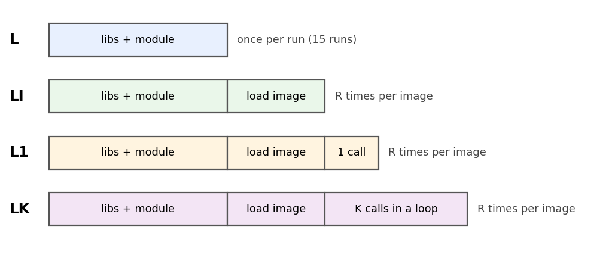
Figure 5. The four measurement blocks of protocol v2.
Block | Contents | Repetitions
L | Libraries and module only: no image, no call | LIBS_REPS = 15, once per run
LI | L + loading the image | R per image
L1 | LI + 1 call to the function | R per image
LK | LI + K calls in a loop (K ≥ 2) | R per image

8.1 Cost of a call
- Cold cost of one call: L1 − LI. This is the first call, including the first-call initialization (FFT plans, caches, lazy imports). It is the default estimator of the analyzer.
- Warm (steady-state) cost: (LK − L1) / (K − 1). Removes start-up, imports, image loading and the cold first call. It is only valid when every iteration of the loop costs the same, which is false for functions that cache or mutate their input.
Note: The parser defaults to the cold estimator (parse_performance_file(..., estimator="cold")). The warm estimator is available in the code but neither Main.py nor visualizer_v2.py selects it; it can be used from Python: parse_performance_file("file.txt", estimator="warm"). LK blocks are still recorded in every file so that either estimator can be applied later.

8.2 Choosing K (adaptive)
After measuring the first LI and L1 pair of an image, the time of one call is estimated as t_call = time(L1) − time(LI). K is chosen so that the loop lasts about one second:
K = max(K_MIN, min(K_MAX, ceil(K_TARGET_SECONDS / t_call))) with K_MIN = 2, K_MAX = 20, K_TARGET_SECONDS = 1.0

If t_call cannot be estimated or is not positive (the function is too fast to measure), K_MAX is used. The chosen K is stored in the file in the header line "[PROTOCOL v2] K=… reps=…" and in each LK block label.

8.3 Order of execution per image
For repetition 1 the program runs LI, L1, computes K, runs LK; for repetitions 2 to R it runs LI, L1 and LK in turn. In the file, however, the blocks are grouped (all LI, then all L1, then all LK) and repetitions are paired by index. Non-positive differences are noise and are discarded, not clamped to zero, because they would break the relative-error fit.

8.4 Counters and files
Collected per block: cycles, instructions, cache-references and cache-misses (all user-space) and elapsed seconds. The analyzer fits instructions and time. Cycles and cache counters are parsed and kept in the data model (Measurement) but are not plotted.

9 Technical Description of the Visualizer and the Classifier
The analysis is split into two files. complexity_fit.py is a pure module (no wxPython, no matplotlib): it parses, fits and decides. visualizer_v2.py glues the module to the plots and the report, and is used by Main.py. This separation lets the classifier be tested without a GUI (test_complexity_fit.py) and be used from scripts.

9.1 Data flow
analyze_file(txt, shape_filter)
parse_performance_file(txt) -> list[Measurement] (one per image size)
filter_measurements(measurements, f) -> kept, n_discarded
for metric in (instructions, time):
classify(measurements, metric, f) -> Verdict
aggregate_measurements(kept, metric)-> points (median, MAD)
returns {filename, metrics{...}}
create_plots(list_of_results) -> matplotlib Figure (2 subplots)

9.2 Parser
- Detects "=== FOLDER:", "--- IMAGE:", "[BLOCK LI|L1|LK K=n]", "Performance counter stats for", the counter lines (regular expressions for cycles:u, instructions:u, cache-references:u, cache-misses:u and "seconds time elapsed") and IMAGE_DIMENSIONS.
- If "[PROTOCOL v2]" appears in the file, it applies the estimator per (folder, image) and stores one value per valid repetition. Files without it are read with the legacy layout (one perf output per repetition).
- The image size of each folder is the median of the IMAGE_DIMENSIONS values found; if absent, the folder name (for example 256x256) is used. N = width × height.
- Repetitions are kept raw so that the bootstrap can resample them.
- Errors: PerfFileFormatError (no folder markers) and PerfMeasurementsMissingError (structure present but zero measurements).

9.3 Shape filters
Filter | Keeps | Used by
none | All sizes | Main.py Visualization tab
square | width = height | Python use only
square_no_pow2 | Square and the side is not a power of two | Python use only
aspect_matched | The largest group of sizes sharing an aspect ratio (default of classify()) | Python use only

Mixing different aspect ratios (for example 640×480 and 1024×1024) mixes shapes that may scale differently; aspect_matched avoids it. All the sizes in Hologram_stack are square, so every filter except square_no_pow2 gives the same result there.

9.4 Aggregation
For each size, the repetitions are reduced to the median (robust against outliers), the MAD (median of |x − median|, drawn as error bar) and the coefficient of variation.

9.5 Candidate models and fitting
Every model has the form y = a·f(N) + b, with a > 0 and an overhead b ≥ 0:
Model | f(N) | Parameters
O(1) | constant | 1
O(√N) | √N | 2
O(N) | N | 2
O(N log N) | N·log2 N | 2
O(N^1.5) | N^1.5 | 2
O(N²) | N² | 2
O(N³) | N³ | 2
O(N^p) free | N^p, p free | 3

- Weighted least squares with scipy.optimize.curve_fit and sigma = y: this minimizes relative residuals, which is equivalent to a fit in log-log space. Without it, the largest sizes would dominate the error.
- Normalization: the shape is normalized on its output, g(N) = f(N) / f(N_max), and y by y_max. Normalizing the input instead broke O(N log N): N/N_max falls in (0, 1], and the safety clamp max(N, 1) turned every point into log2(1) = 0, collapsing the model into a constant. The coefficients are then converted back to physical units exactly.
- Models whose fitted a is not positive are discarded ("not a growing model"); non-convergent fits are discarded too.
- Selection criterion: BIC = n·ln(RSS_rel / n) + k·ln(n), computed on relative residuals. It penalizes extra parameters.
- The free-exponent model is nested over all the others, so it could win by fitting noise. It is only allowed to win if it beats the best canonical model by ΔBIC ≥ 6 (Kass-Raftery "strong evidence") and its exponent p is farther than 0.15 from every canonical order (0, 0.5, 1, 1.5, 2, 3); otherwise the canonical model wins ("snap back"). A genuine O(N^2.5) is still reported as such.

9.6 Overhead and asymptotic regime
- Local slopes: s_i = Δ ln y / Δ ln N between neighboring sizes. Corrected slopes use y − b instead of y.
- Signal-to-overhead ratio per point: |(y − b) / b|. A ratio below 1 means that the point measures mostly interpreter start-up.
- Asymptotic regime reached (last three corrected slopes): not reached if there is a significant monotonic trend (Spearman p < 0.10) and the range exceeds 15% of the mean, or if the range exceeds 50% of the mean regardless of trend. A legitimate convergence such as [0.95, 0.99, 1.00] is not penalized for being monotonic.

9.7 Bootstrap
Hierarchical bootstrap with 500 iterations (fixed seed 0 by default): in every iteration the repetitions of each size are resampled with replacement, the medians recomputed, all models refitted, and the winner by BIC counted. The confidence is the winning frequency of the model chosen on the real data, not of the plurality of the bootstrap. When the two disagree the reason says so explicitly.

9.8 Decision gates
The verdict is produced by a sequence of gates, evaluated in order; failing any gate yields an abstention with the reason of that gate (section 6.2). The order matters: asking "has the regime converged?" before "is there any signal at all?" would give a misleading message on pure noise.
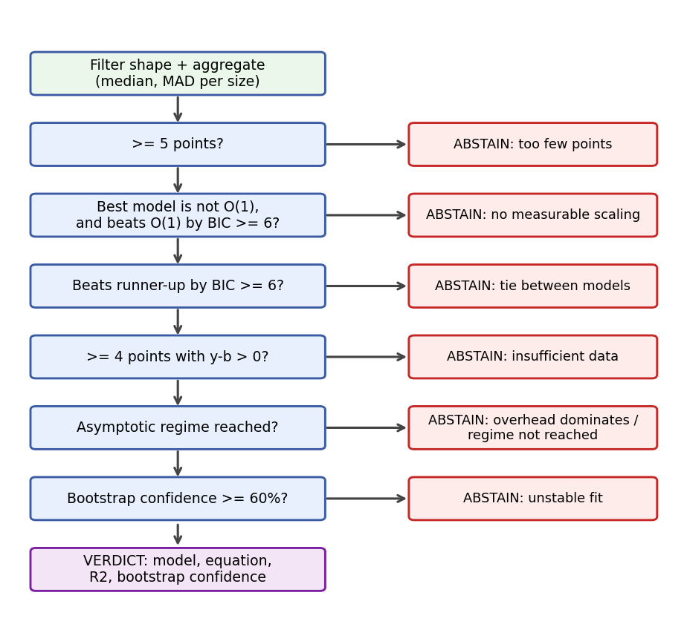
Figure 6. Decision gates of complexity_fit.classify().
Constant | Value | Meaning
MIN_POINTS | 5 | Minimum sizes after filtering
MIN_DIAGNOSTIC_POINTS | 4 | Minimum points for the slope diagnostic
BIC_MARGIN | 6.0 | ΔBIC required to prefer a model (all comparisons)
CONFIDENCE_THRESHOLD | 0.60 | Minimum bootstrap confidence
POW2_WARNING_FRACTION | 0.70 | Share of power-of-two sides that triggers the warning
USEFUL_RATIO_THRESHOLD | 1.0 | (y−b)/b needed for a "useful" point
MIN_USEFUL_POINTS_FOR_ASYMPTOTIC | 3 | Useful points needed to blame sizes rather than overhead
ASYMPTOTIC_WINDOW | 3 | Slopes inspected
DRIFT_P_THRESHOLD / DRIFT_RANGE_FRACTION / NOISE_RANGE_FRACTION | 0.10 / 0.15 / 0.50 | Thresholds of the regime test
EXPONENT_SNAP_TOL | 0.15 | Distance to a canonical exponent that snaps the free model back

9.9 Plots (create_plots)
- A figure of two stacked subplots (6×5 in): instructions and time against total pixels N, with grid and legend.
- One color per file; points with error bars of MAD; if there is a verdict, a dashed curve of the winning model drawn with model_value and a legend entry with model, equation, R² and confidence.
- If the classifier abstained, no verdict curve is drawn; the best BIC fit appears dotted and labeled "[no verdict] best BIC fit" to show what scipy found, explicitly marked as not validated.

9.10 Programmatic use
from complexity_fit import parse_performance_file, classify, ShapeFilter
m = parse_performance_file("Test_files/fftl.txt") # estimator="cold" by default
v = classify(m, field_name="instr_reps", shape_filter=ShapeFilter.NONE)
print(v.model_name, v.equation, v.confidence, v.abstain_reason)

field_name is "instr_reps" or "time_reps" (the two used by the GUI) and also "cycles_reps", "cache_refs_reps" or "cache_miss_reps".

10 Included Test Data and Results

10.1 Hologram_stack
Simulated off-axis holograms with λ = 0.633 µm, pixel pitch 3.75 µm, magnification 40×, numerical aperture 0.65 and 10 holograms per size. There are 11 square sizes in two families: powers of two (128, 256, 512, 1024, 2048, 4096) and 5-smooth non-powers of two (192, 384, 768, 1536, 3072). The files are 8-bit grayscale PNGs named hologram_01.png … hologram_10.png. simulation_summary.txt records the parameters and the MSE and SSIM of each size.

10.2 Validation functions (Test_files/test_functions.py) and expected results
Before trusting the classifier on a real algorithm, it was checked against four functions whose complexity is known by construction. They are in Test_files/test_functions.py and their measurements are the files Lineal.txt, fftl.txt, quadratic.txt and cubic.txt (the v3 series of results; Test_files/ holds exactly the same files).
Convention: All complexities in this section are expressed in P = n × n, the total number of pixels of an n × n image. This is the variable of the plots ("Total pixels (N)" axis) and of every model in the classifier, so "O(N)" in a verdict means O(P). A function whose cost depends on the side n is converted with P = n²: O(n²) = O(P), O(n³) = O(P^1.5), O(n⁴) = O(P²).

10.2.1 Expected complexity of each function
Function | What it does | Cost in n (side) | Expected in P = n² | Results file
process_nm | Element-wise operations on the n² pixels (sin, cos, sqrt, log1p, mean) | O(n²) | O(P) | Lineal.txt
process_nm_logn | 2-D FFT, autocorrelation and cepstrum | O(n² log n²) | O(P log P) | fftl.txt
process_nm2 | Gram matrix imgᵀ·img (n×n×n product) and its eigenvalues | O(n³) | O(P^1.5) | quadratic.txt
process_nm3 | n products of n×n matrices (one per row) | O(n⁴) | O(P²) | cubic.txt

The names quadratic and cubic come from the exponent in the side length of the matrix (N·M² and N·M³ operations for an N×M image); they do not mean O(P²) and O(P³). Measured over square images, the expected exponent in P is 1, 1 (with a logarithmic factor), 1.5 and 2.

10.2.2 Measurement conditions
File | Sizes measured (side, pixels) | Points | Repetitions
Lineal.txt | 128 … 4096 (all 11 sizes of Hologram_stack) | 11 | 110 runs
fftl.txt | 128 … 4096 (all 11 sizes) | 11 | 110 runs
quadratic.txt | 128 … 2048 (9 sizes) | 9 | 90 runs
cubic.txt | 128 … 1024 (7 sizes) | 7 | 70 runs

process_nm2 and process_nm3 are far more expensive, so they were measured on dedicated datasets (Hologram_Simulations_nm2 and _nm3, not included in this repository) with a smaller largest size. The results files can still be loaded and plotted; to measure them again, generate image sets with the same sizes (Test_files/crear_imagenes_de_testeo.py creates random-gray images in folders named WxH).

10.2.3 What was obtained
Loading the four files in the Visualization tab gives the following (instructions metric). "p (free fit)" is the exponent fitted by the free-exponent model O(P^p) with its standard error, which is a direct estimate of the scaling law independent of the canonical candidates.
Function | Expected | Verdict obtained (instructions) | Fitted equation | p (free fit) | Match
process_nm | O(P) | O(P), confidence 100% | 325.25·P + 1.73·10⁴ | 0.997 ± 0.006 | Yes
process_nm_logn | O(P log P) | O(P log P), confidence 100% | 31.06·P·log2 P + 2.34·10⁶ | 1.048 ± 0.006 | Yes
process_nm2 | O(P^1.5) | O(P^p) free with p = 1.334, confidence 100% | 8.75·P^1.334 + 8.9·10⁶ | 1.334 ± 0.015 | Partial: below 1.5
process_nm3 | O(P²) | O(P²), confidence 100% | 0.584·P² + 1.84·10⁸ | 1.973 ± 0.076 | Yes

For the elapsed-time metric the results are less sharp, as expected from a noisier counter:
Function | Expected | Verdict obtained (time) | p (free fit) | Comment
process_nm | O(P) | Abstains: tie between O(P log P) and O(P) (ΔBIC = 1.96) | 1.085 ± 0.074 | Both models are compatible with the data; the best BIC fit is O(P log P), shown dotted as [no verdict].
process_nm_logn | O(P log P) | Abstains: tie between O(P log P) and O(P) (ΔBIC = 1.81) | 1.216 ± 0.105 | Same situation; the last local slopes are noisy (up to 2.4).
process_nm2 | O(P^1.5) | Abstains: tie between O(P^1.5) and O(P log P) (ΔBIC = 0.87) | 1.299 ± 0.138 | The best BIC fit is O(P^1.5), the expected law, but not by a sufficient margin.
process_nm3 | O(P²) | O(P²), confidence 100% (2.29·10⁻¹¹·P² + 1.49·10⁻²) | 1.994 ± 0.156 | Match.

10.2.4 Interpretation
- Instructions are the reliable metric: they do not depend on the machine load and give three exact matches (O(P), O(P log P) and O(P²)). The linear and N log N functions are told apart even though their exponents differ by only about 5% over the measured range, thanks to the BIC margin and the 100 % bootstrap confidence.
- process_nm2 yields p = 1.334 ± 0.015, below the theoretical 1.5, and the classifier reports it as a free exponent instead of forcing O(P^1.5). The local slopes are still growing at the largest sizes (0.65, 0.85, 1.05, 1.18, 1.26, 1.32, 1.37, 1.43), so the measured law is moving toward 1.5 and the largest size (2048) has not reached the asymptotic regime. A plausible cause is that the n² terms of the function (conversion to float64, memory traffic) and the better efficiency of the optimized linear-algebra library at larger matrices dominate at small sizes; this reading is an interpretation, not something the program verifies. To confirm O(P^1.5), measure larger sizes.
- process_nm3 matches O(P²) with a wide uncertainty (p = 1.97 ± 0.08) because only seven sizes up to 1024 were used. Its local slopes oscillate between 1.5 and 2.8, which is a typical signature of the cache and BLAS blocking effects on power-of-two sizes.
- For time, the 0.1 s of interpreter start-up hides the signal at small sizes, so the points with signal comparable to the overhead are few (6 of 9 for process_nm2). The classifier prefers to abstain on ties rather than choose arbitrarily; the free exponents (1.09, 1.22, 1.30 and 1.99) remain compatible with the expected laws taking their standard errors into account.
- The set uses non-power-of-two sizes (192, 384, 768, 1536, 3072) next to powers of two, so the power-of-two warning is not raised: only 6 of the 11 sides are powers of two (55%, under the 70% limit). In the nm3 file 4 of the 7 sides are (128, 256, 512, 1024), so the pow2 share is 57%, also under the limit.
Conclusion: the method recovers the expected complexity of the known functions in P = n×n for three of the four cases and quantifies the fourth (exponent 1.33 versus 1.5 expected). When using it on a real algorithm, trust a verdict on instructions when confidence is high and the asymptotic regime is reached, and treat an abstention as "not enough evidence", not as a failure.

10.3 Algorithm results (Algorythm_results_windows)
Measurements of SHPC.txt, FRS.txt, ERS.txt and PCA.txt over Hologram_stack, taken on Windows + WSL2. Load them in the Visualization tab to reproduce the plots without running anything. The "Original parameters" line in each header records the values used. For instructions, SHPC is classified O(N) (9.65·10³·N + 1.42·10⁸, confidence 100%); the rest of the algorithm/metric combinations abstain, each with the reason shown in the Log (a tie between O(N) and O(N log N) for PCA and for the SHPC time, no measurable scaling against O(1) for FRS and ERS instructions, regime not reached for PCA time).
Note: The results depend on hardware and system configuration. Compare algorithms only from measurements taken on the same machine under the same conditions.

11 Algorithms Under Study
All of them are measured the same way: Browse to the file, select the function, point the first parameter to Hologram_stack/, fill in the rest.
Algorithm | File → function | Parameters
SHPC (Semi-Heuristic Phase Compensation) | Test_algorithm/SHPC.py → shpc_reconstruction | archivo (image), dx=3.75, dy=3.75, lamb=0.633, G=3, radio_mascara=200, paso=0.2
FRS | Test_algorithm/phaseCompensation.py → FRS | inp (image), upper, wavelength, dx, dy, s=2, step=10
ERS | Test_algorithm/phaseCompensation.py → ERS | inp (image), upper, wavelength, dx, dy, s, step
PCA | Test_algorithm/karina_methods.py → PCA | inp (image), wavelength=0.632, dx=3.75, dy=3.75, limit=16
Also available | phaseCompensation.py: CFS, CNT; karina_methods.py: PVM | Same convention: first parameter is the image

Typical values used in the stored runs are in the header of each results file: for example FRS with upper=1, wavelength=0.633, dx=dy=3.75, s=2, step=10.
Note: phaseCompensation.py defines many helper functions (FT, intensity, spatialFiltering, …); they all appear in the Function drop-down. Choose the entry points listed above.

11.1 Measuring your own algorithm
1. Write a function whose first parameter receives a 2-D numpy array (grayscale image).
2. Keep every import at the top of the file (libraries must exist in WSL) and avoid code that runs at import time.
3. Put the images in a folder with one subfolder per size.
4. Select the file and the function in the Analysis tab and run.

12 Tests
pip install pytest
pytest test_complexity_fit.py

The suite (38 tests) covers the parser (error cases, protocol v2 and the legacy format), the model fitting, the shape filters and the abstention logic of complexity_fit.py. It does not need WSL, perf or wxPython.
Current status: All 38 tests pass. The tests that read real measurements use the files in Test_files/test_data/ (quadratic.txt, performance_fft2d.txt, performance_FRS_gray.txt, Results_FRS.txt, linear.txt), so they do not depend on the working directory.

13 Troubleshooting
Symptom | Cause and solution
"Missing dependencies in WSL. Check the console." | A library is not installed in WSL. Install with wsl pip3 install <package>. See section 2.3.
"The first parameter … must be a valid directory." | The dataset field is empty or the folder does not exist. Select it with the folder icon.
"The directory … does not contain subfolders." | Images must be in subfolders by size (128x128/, 256x256/, …), not directly in the selected folder.
Results file reports "Errors found" > 0 | Open the file and search for Traceback. Usually a wrong parameter value, a missing library in WSL, or a function that does not accept a 2-D array.
Function receives a string instead of a number | Decimal comma or scientific notation without a dot. Write 0.633 or 0.001.
"unrecognized format … === FOLDER:" | The loaded .txt was not generated by this program.
"zero measurements … WARNING: perf not found" | perf was not available when the file was generated. Re-run setup_windows.py (or setup.py) and measure again.
wsl: command not found / WSL does not start | WSL is not installed or virtualization is disabled in the BIOS. Run setup_windows.py as Administrator and restart.
All Time verdicts abstain with "tie" or "overhead dominates" | Time at small sizes is dominated by interpreter start-up. Use larger images, more sizes, more repetitions, or rely on the instructions metric, which is less noisy.
Power-of-two warning | Add non-power-of-two sizes (as in Hologram_stack) or use the square_no_pow2 filter from Python (section 9.3).

14 Credits
- Test_algorithm/phaseCompensation.py is part of pyDHM (C. Trujillo, A. Doblas, R. Castañeda; https://github.com/catrujilla/pyDHM) and keeps its original header. Check its license before redistributing.
- Test_algorithm/karina_methods.py adapts the PCA/PVM phase-compensation algorithms of K. Ortega and R. Restrepo (SOPHIA, EAFIT).
- The perf build in setup.py uses the Microsoft WSL2 Linux kernel sources.

