Simulation of CPU Scheduling Algorithms
A case study for Operating Systems (OS)

Submitted by:
Jonalyn F. Dimarucut
BSCS-3B

Submitted to:
Ms. Jo Anne Cura

Date: May 7, 2026
- Introduction
CPU Scheduling is a crucial process in Operating Systems that helps determine which process will use the CPU while another process is on hold. The main goal of CPU Scheduling is to ensure that the CPU is utilized efficiently, making the
system faster and fairer. CPU scheduling is the process of deciding which process will own the CPU to use while another process is suspended. The main function of CPU scheduling is to ensure that whenever the CPU is idle, the OS has at least selected one process from the ready queue.
There are four conditions under which CPU Scheduling decisions are taken:
- If a process is switching between the running state and the waiting state.
- If a process is switching from the running state to the ready state (on the occurrence of an interrupt, for example).
- If a process is switching between waiting and ready states (e.g., when its I/O request is completed).
- If a process terminates upon completion of execution.

The main purpose of the case study is to demonstrate the practical implementation of various CPU scheduling algorithms. By simulating and analyzing their behavior, the study aims to gain insights into how different strategies affect waiting time, turnaround time, and overall system efficiency. To achieve this purpose, the program identifies several specific objectives that guide the implementation and evaluation process:
- Implement multiple CPU scheduling algorithms (e.g., FCFS, SJF, SRT, RR, Priority, Priority with RR).
- Generate Gantt charts to visualize process execution.
- Compute waiting time, turnaround time, and averages for each algorithm.

- Body
This section provides a detailed examination of several CPU scheduling algorithms, each representing a distinct approach to allocating processor time among competing processes. To illustrate their performance, sample test cases are presented along with input parameters, Gantt chart visualizations, and computed values for waiting time, turnaround time, and their averages.
  - First-Come, First-Served (FCFS)
The easiest and simplest CPU scheduling algorithm is the first-come, first-served (FCFS) scheduling technique. FCFS Scheduling is a non-preemptive algorithm, meaning once a process starts running, it cannot be stopped until it voluntarily relinquishes the CPU, typically when it terminates or performs I/O. This method schedules processes in the order they arrive, without considering priority or other factors. With this method, the process that requests the CPU first gets allocated to the CPU first. The execution of the FCFS policy is easily managed with a FIFO queue. As a process enters the ready queue, its Process Control Block is linked with the tail of the queue. When the CPU gets free, it is assigned to the process at the head or start of the queue.

The table below shows several advantages and disadvantages of the FCFS Scheduling Algorithm
Advantages | Disadvantages
It is simple to implement, making it easier for OS designers and students to understand and implement | Particularly troublesome for multiprogramming systems, where it is important that each user get a share of the CPU at regular intervals.
Provides fairness by treating all processes equally and giving them an equal opportunity to run | The process with less execution time suffers, i.e., waiting time is often quite long.
Guarantees that every process will eventually get a chance to execute, as long as the system has enough resources to handle all the processes | If a large process that has a long burst time arrives first, all the smaller processes that come after will have to wait for its completion.

Sample Test Case 1 - Input
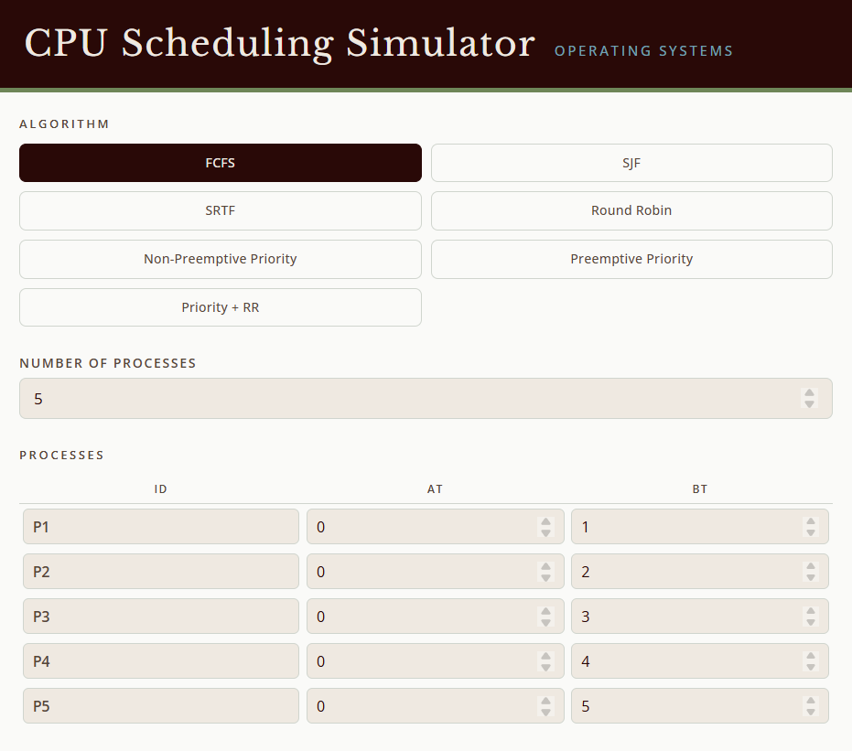
Sample Test Case 2 - Input
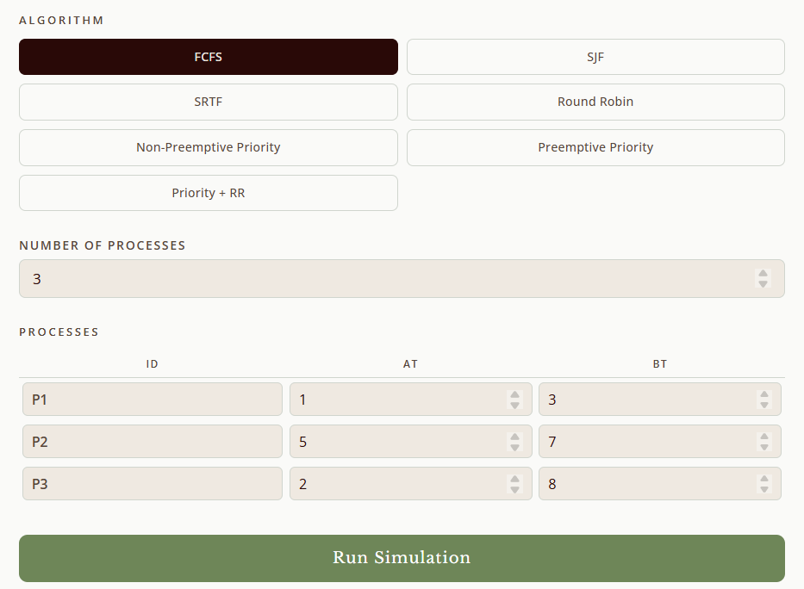
Figures 1 & 2. Input Parameters of the FCFS Algorithm
The figure illustrates the program interface for simulating CPU scheduling algorithms. At the very top, it displays the title header “CPU Scheduling Simulator”. Below is a menu with seven scheduling options, including First-Come, First-Served (FCFS), Shortest Job First (SJF), Shortest Remaining Time First (SRTF), Round Robin (RR), Non-Preemptive Priority Scheduling, Preemptive Priority Scheduling, and Priority Scheduling with Round Robin. After the user selects a scheduling method (which is FCFS), the program prompts for the number of processes, requiring a minimum of three. In these examples, five (labeled P1 through P5) and 3 processes (labeled D1 through D3), and their respective arrival times and burst times in milliseconds, serve as input for the scheduling simulation. To see the results, you need to click the “Run Simulation” button.

Sample Test Case 1 – Gantt Chart
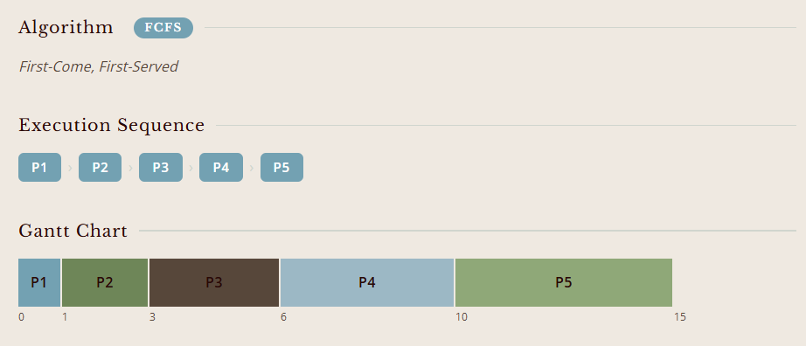
Sample Test Case 2 – Gantt Chart
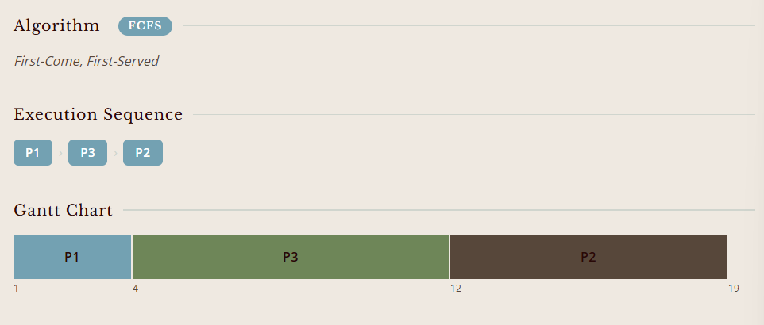
Figures 3 & 4. Gantt chart showing the execution order and completion times of processes
The figure illustrates the execution sequence along with a Gantt chart generated for five processes (P1–P5) scheduled using the FCFS algorithm. Each process is represented sequentially along the timeline, with corresponding start and finish times marked at 0, 1, 3, 6, 10, and 15 milliseconds. Meanwhile, process D1 begins at time 1 and completes at time 4, followed by D3, which runs from 4 to 12, and finally D2, which executes from 12 to 19.

Sample Test Case 1 – Computed Values
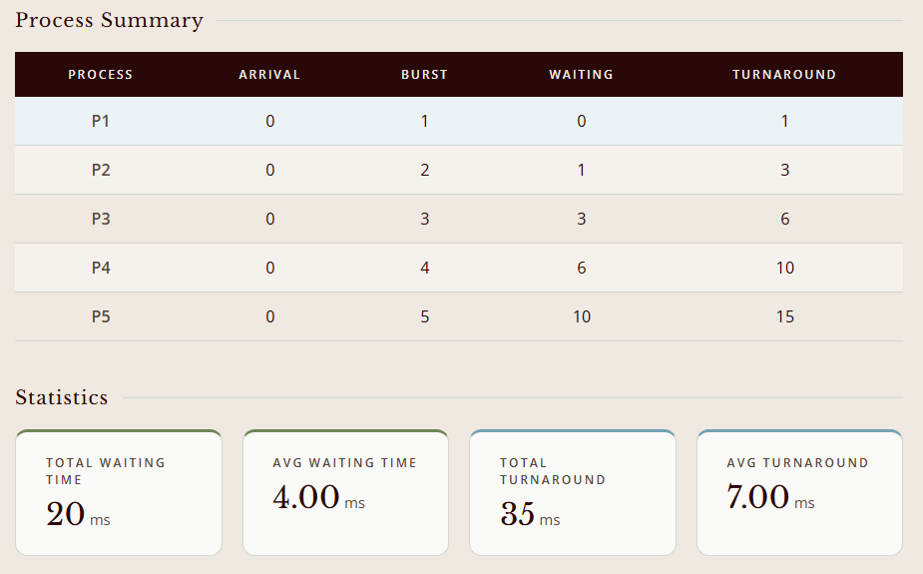
Sample Test Case 2 – Computed Values
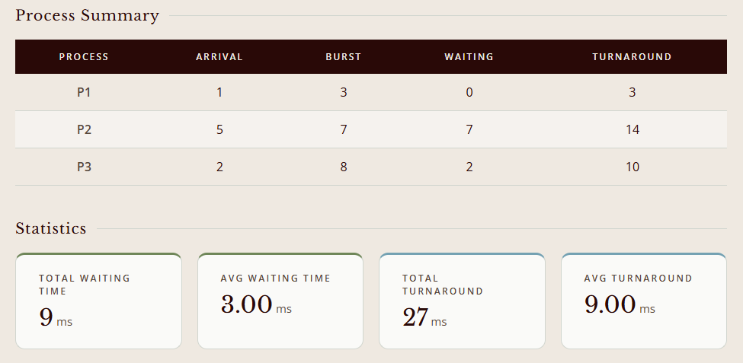
Figures 5 & 6. Process summary table showing arrival time, burst time, waiting time, and turnaround time for five processes
The figure presents the process summary generated after applying the FCFS Scheduling Algorithm to five processes (P1–P5). Each row lists the arrival time, burst time, waiting time, and turnaround time for the respective process. The summary also provides aggregate statistics, including a total waiting time of 20 with an average of 4.0, and a total turnaround time of 35 with an average of 7.0. On the other hand, the results show that D1 completes quickly with no waiting, while D2 and D3 wait longer due to execution order. The totals yield an average waiting time of 3.0 and an average turnaround time of 9.0.

  - Shortest Job First (SJF) – Non-preemptive
Like the name suggests, the shortest job first scheduling algorithm works on the principle of giving the CPU to the process that has the shortest burst time. It can be both preemptive and non-preemptive. When it is preemptive, it becomes the Shortest Remaining Time First (SRTF) Scheduling Algorithm. The CPU is assigned to the process with the minimum next CPU burst if it is available. If the subsequent CPU bursts of two processes become identical, then FCFS scheduling breaks the tie.

The table illustrates the advantages as well as the limitations of the SJF Scheduling Algorithm
Advantages | Disadvantages
Provides the lowest possible average waiting time and turnaround time for a set of processes, which leads to efficient resource utilization. | Needs to know the burst time of each process beforehand, which is impossible to predict accurately in a real system.
Shortest jobs are favored. | It cannot be implemented at the level of short-term CPU scheduling.
It is probably optimal in that it gives the minimum average waiting time for a given set of processes. | May cause starvation if shorter processes keep coming. This problem is solved by aging.

Sample Test Case 1 - Input
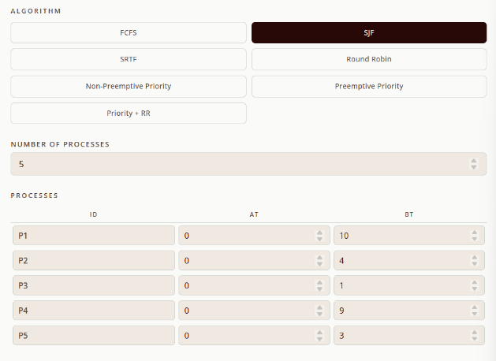

Sample Test Case 2 - Input
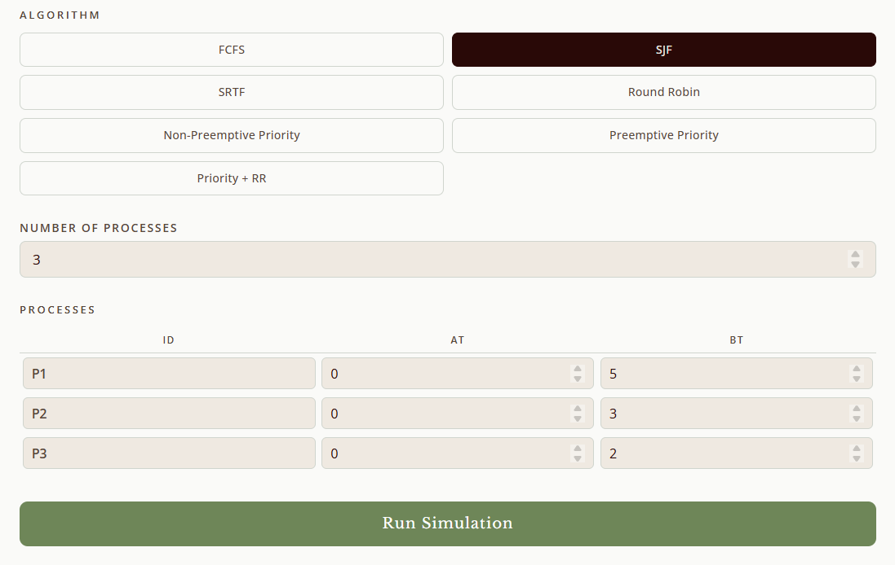
Figures 7 & 8. Input Parameters of the SJF Algorithm
The figures above show the input parameters of SJF scheduling for five processes (P1–P5) and three processes (D1–D3). In both cases, all processes arrive at time 0, and their burst times determine the execution order, with shorter tasks scheduled first. For P1–P5, burst times range from 1 to 10, while for D1–D3, burst times are 5, 3, and 2.

Sample Test Case 1 – Gantt Chart
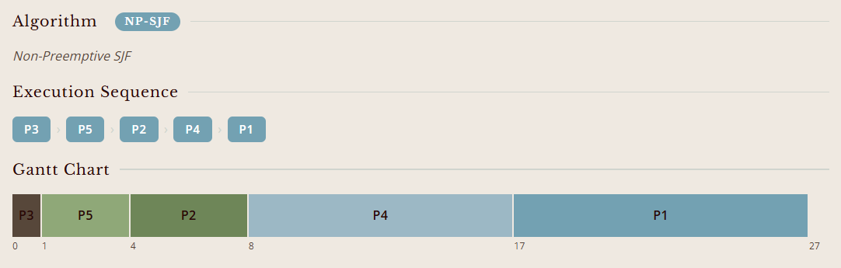

Sample Test Case 2 – Gantt Chart
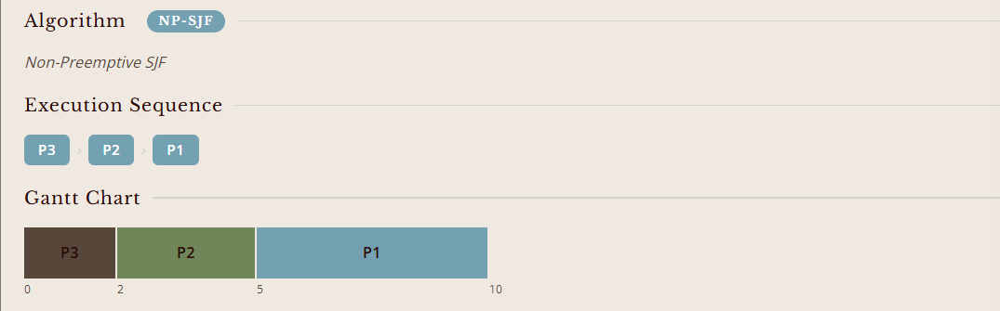
Figures 9 & 10. SJF Gantt chart showing the execution order and completion times of processes
The figures illustrate Gantt charts for two sets of processes scheduled using the SJF algorithm. In the first chart, processes P3, P5, P2, P4, and P1 are executed in ascending order of burst time, producing completion times at 1, 4, 8, 17, and 27. In the second chart, processes D3, D2, and D1 follow the same principle, finishing at 2, 5, and 10, respectively.

Sample Test Case 1 – Computed Values
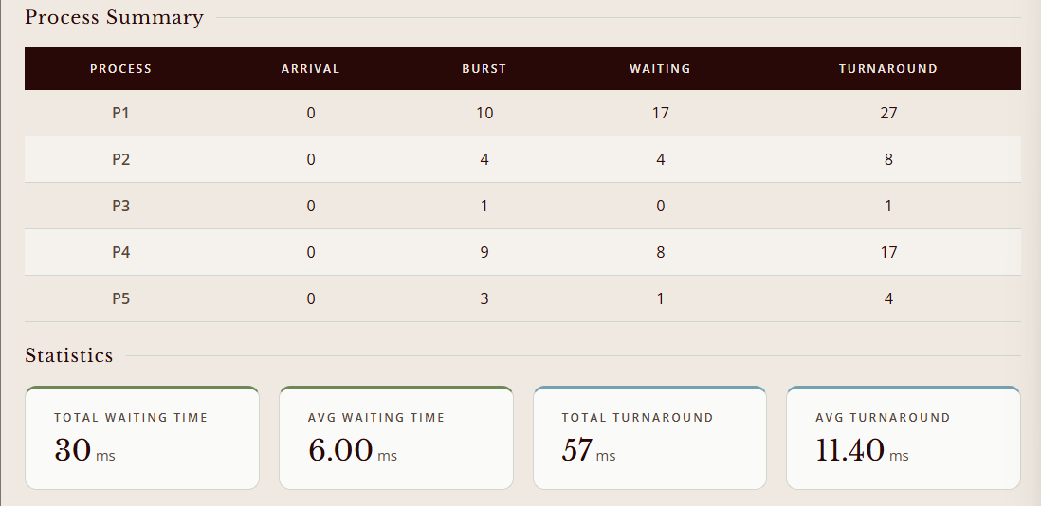

Sample Test Case 2 – Computed Values
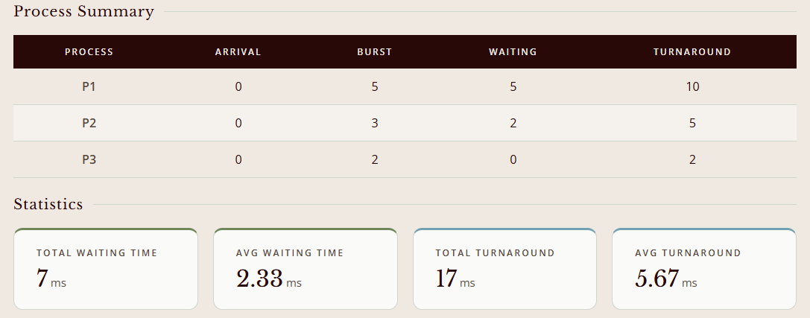
Figures 11 & 12. SJF Process summary table showing arrival time, burst time, waiting time, and turnaround time for five processes
The process summaries for P1–P5 and D1–D3 under SJF scheduling show how shorter burst times are prioritized to reduce waiting. For the five-process case, the averages are 6.0 for waiting time and 11.4 for turnaround time, while for the three-process case, the averages are lower at 2.33 and 5.67.

  - Shortest Remaining Time (SRT) – Preemptive
As mentioned above, the Shortest Remaining Time First scheduling algorithm in OS is just the preemptive version of the SJF algorithm. In contrast with SJF, which assigns the CPU to the process that has the least burst time, SRTF assigns the CPU to the process that has the shortest burst time remaining. If a new process arrives with a CPU burst time that is shorter than the remaining time of the currently executing process, the currently executing process is preempted, and the new process starts executing.

Shown below is a summary of the advantages and disadvantages inherent in the SRT Scheduling Algorithm
Advantages | Disadvantages
Gives the lowest possible average waiting time, which dynamically adjusts to any new process that arrives | Needs to know the burst time beforehand to accurately schedule the processes
Effectively minimizes the turnaround time by quickly processing shorter jobs, whether newly arrived or already existing, first, reducing their total time in the system. | Constant checking for shorter remaining times and the preemption of running processes can lead to overhead, reducing efficiency.
Can ensure that the CPU is utilized efficiently, as it can handle multiple processes at once. | If shorter processes continue to arrive, longer processes may be delayed indefinitely, leading to starvation.

Sample Test Case 1 – Input
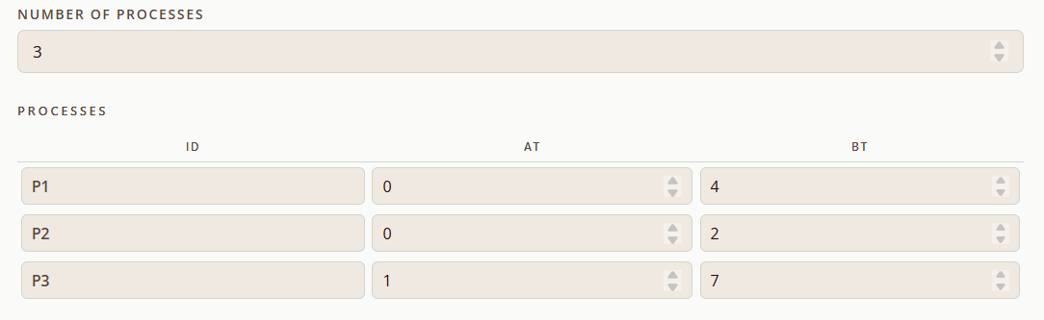

Sample Test Case 2 - Input
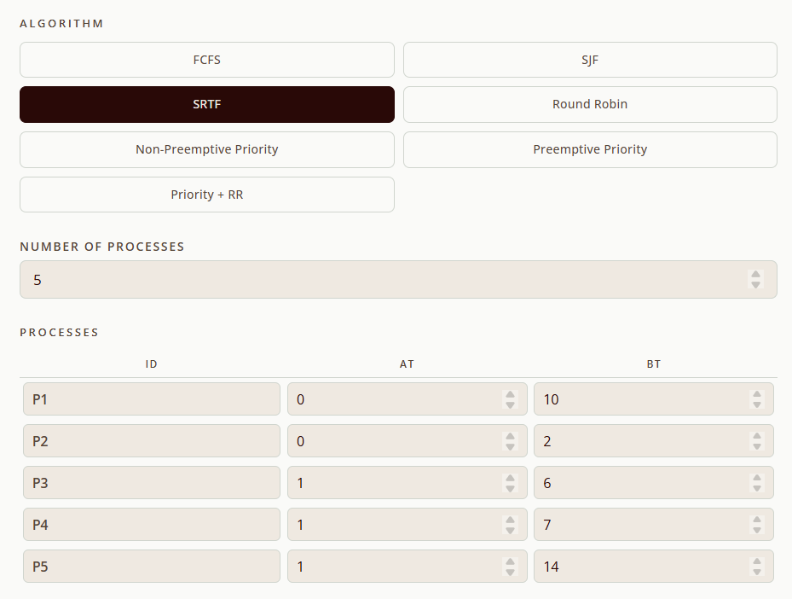
Figures 13 & 14. Input Parameters of the SRT Algorithm
The inputs for P1–P5 and D1–D3 define processes with varying arrival and burst times, which are then scheduled using the SRT algorithm. Since SRT is preemptive, processes with shorter remaining burst times interrupt longer ones, ensuring that smaller tasks finish earlier. In the five-process case, burst times range from 2 to 14, while in the three-process case, they are 4, 2, and 7.

Sample Test Case 1 – Gantt Chart
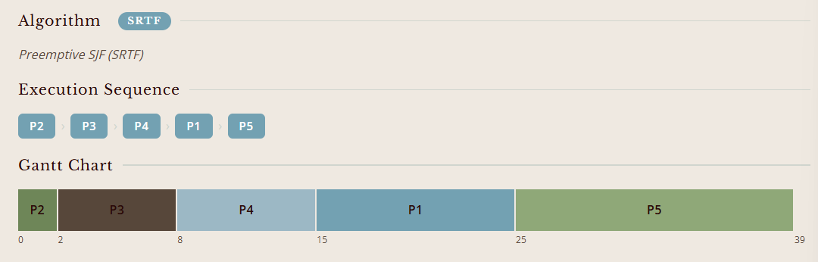

Sample Test Case 2 – Gantt Chart
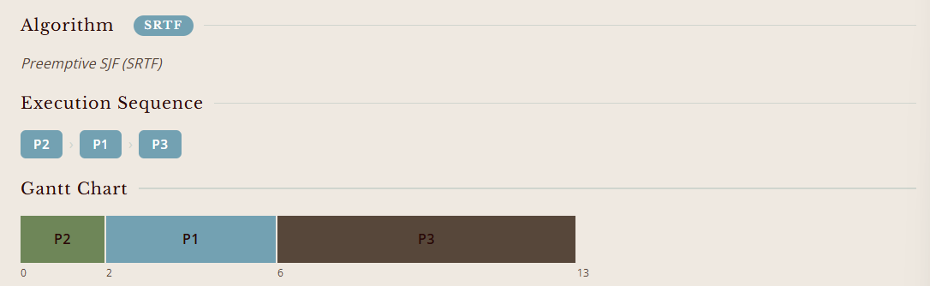
Figures 15 & 16. SRT Gantt chart showing the execution order and completion times of processes
The Gantt charts illustrate the execution order of processes under SRT scheduling. In the first chart, processes P2, P3, P4, P1, and P5 are arranged sequentially with completion times at 2, 8, 15, 25, and 39, while in the second chart, processes D2, D1, and D3 finish at 2, 6, and 13.

Sample Test Case 1 – Computed Values
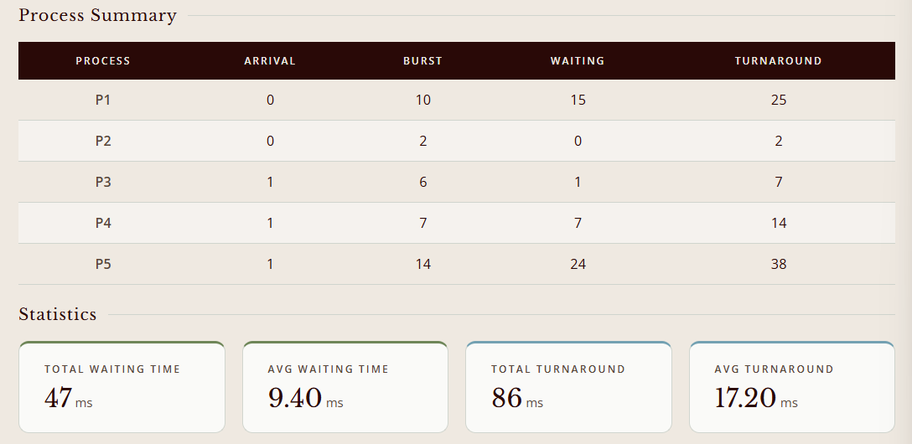

Sample Test Case 2 – Computed Values
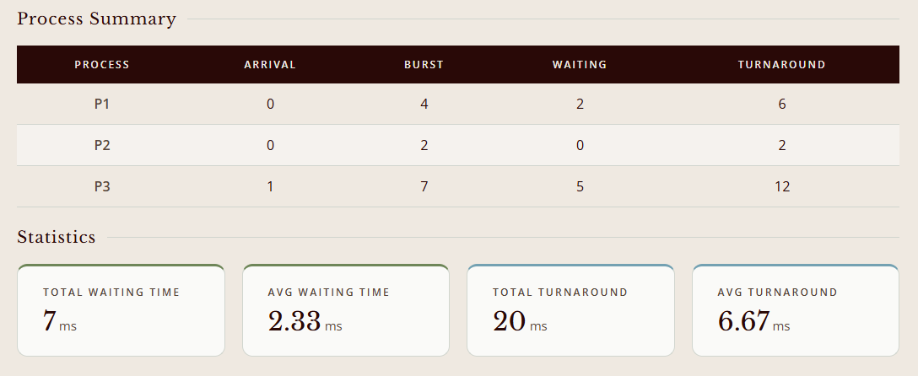
Figures 17 & 18. SRT Process summary table showing arrival time, burst time, waiting time, and turnaround time for five processes
The process summaries for P1–P5 and D1–D3 under SRT scheduling show how preemptive execution allows shorter remaining tasks to finish earlier, reducing overall delays. In the five-process case, the averages are 9.4 for waiting time and 17.2 for turnaround time, while in the three-process case, the averages are lower at 2.33 and 6.67.

  - Round Robin (RR)
In the Round-Robin Scheduling Algorithm, each process gets a small amount of CPU time called a time slice or quantum. The process executes for its time slice and is preempted. If the process completes its burst time, the process releases the CPU; otherwise, the process is added at the end of the ready queue and gets a chance to execute again. It's the preemptive version of the FCFS CPU Scheduling algorithm and generally focuses on the time-sharing technique.

The table highlights both the advantages and the disadvantages of applying the RR Scheduling Algorithm.
Advantages | Disadvantages
It prevents starvation and a single process from having the CPU for too long, making it suitable for multitasking environments. | Setting the quantum too short increases the overhead and lowers the CPU efficiency, but setting it too long may cause a poor response to short processes.
The system becomes more responsive because Round Robin gives each process time, as no process waits indefinitely. | The average waiting time under the RR policy is often long.
The system becomes more responsive because Round Robin gives each process time, as no process waits indefinitely. | If the time quantum is very high, then RR degrades to FCFS.

Sample Test Case 1 – Input
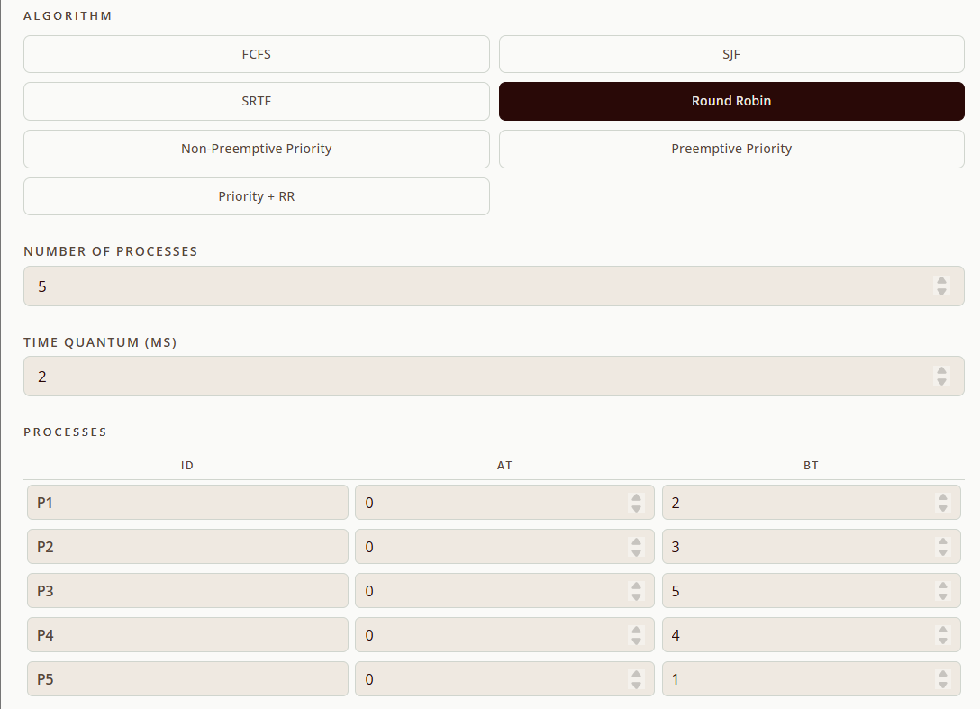

Sample Test Case 2 – Input
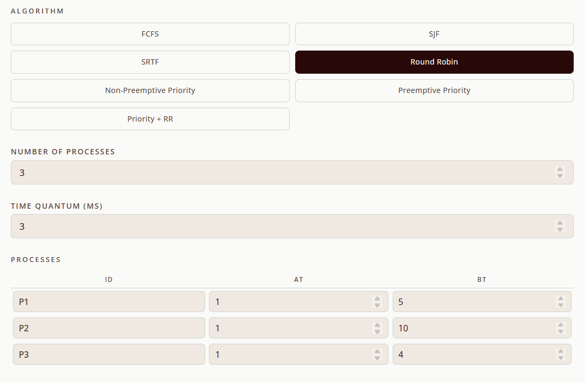
Figures 19 & 20. Input Parameters of the RR Algorithm

The inputs for P1–P5 and D1–D3 define processes with varying burst times and arrival times, along with a specified time quantum (2 ms for P1–P5 and 3 ms for D1–D3). Under Round Robin scheduling, each process receives CPU time in equal slices, ensuring fairness and responsiveness. Shorter tasks like P5 and D2 finish quickly within their allotted quantum, while longer tasks such as P2 and D3 are preempted and resumed in subsequent cycles.
Sample Test Case 1 – Gantt Chart
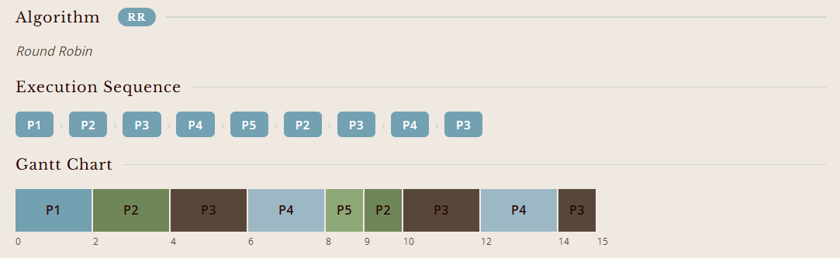

Sample Test Case 2 – Gantt Chart
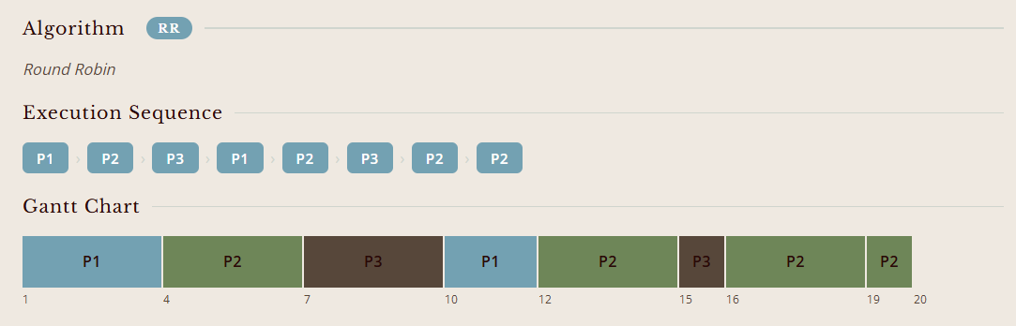
Figures 21 & 22. RR Gantt chart showing the execution order and completion times of processes

The Gantt charts illustrate Round Robin scheduling for two sets of processes, with a time quantum of 2 ms for P1–P5 and 3 ms for D1–D3. In the first chart, processes P1 through P5 are executed in repeated cycles until completion, with shorter tasks like P5 finishing quickly while longer tasks such as P3 and P4 are preempted and resumed. In the second chart, D1, D2, and D3 follow the same principle, sharing CPU time fairly across multiple rounds.

Sample Test Case 1 – Computed Values
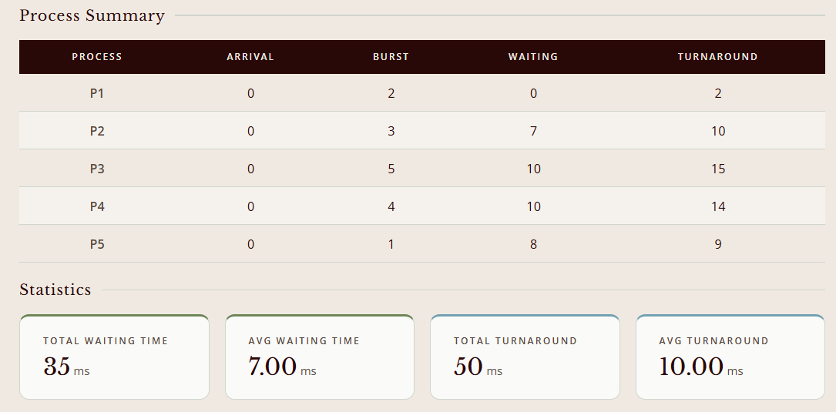

Sample Test Case 2 – Computed Values
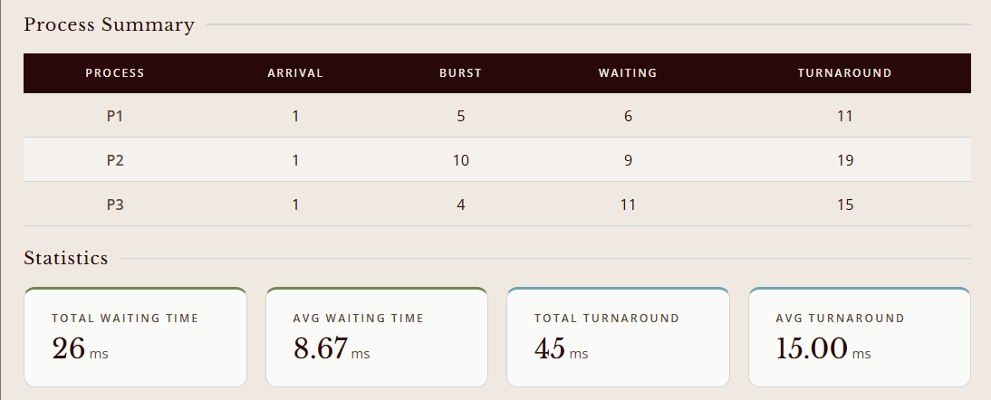
Figures 23 & 24. RR Process summary table showing arrival time, burst time, waiting time, and turnaround time for five processes

The process summaries for P1–P5 and D1–D3 under Round Robin scheduling highlight how equal time slices affect waiting and turnaround performance. In the five-process case, the averages are 7.0 for waiting time and 10.0 for turnaround time, while in the three-process case, the averages are higher at 8.67 and 15.0.

  - Priority Scheduling (Preemptive and Non-preemptive)
Priority Scheduling is a CPU scheduling algorithm that assigns a priority level to each process. The CPU is allocated to the process with the highest priority. If two processes have the same priority, they are typically scheduled using a tie-breaking rule, such as First-Come, First-Served (FCFS). Priority Scheduling can be either preemptive or non-preemptive. In preemptive priority scheduling, if a new process arrives in the ready queue with a higher priority than the currently executing process, the CPU is immediately allocated to the new process. In non-preemptive priority scheduling, the currently executing process completes its burst time before the CPU is allocated to another process.

Presented below is a table representation of the advantages and disadvantages of the Priority Scheduling Algorithm
Advantages | Disadvantages
Allows for the assignment of different priorities to processes based on their importance, urgency, or other criteria. | If high-priority processes use up a lot of CPU time, lower-priority processes may starve and be postponed indefinitely.
Provides a good mechanism where the relative importance of each process may be precisely defined. | If the system eventually crashes, all of the processes that have low priority will get lost since they are stored in the RAM
The priority of the process is selected on the basis of memory requirement, user preference, or the requirement of time. | In preemptive priority scheduling, frequent context switching may occur when new high-priority processes arrive. This can lead to increased overhead and reduced overall system efficiency, as the CPU spends more time switching between processes rather than executing the

- Non-Preemptive Priority Scheduling

Sample Test Case 1 - Input
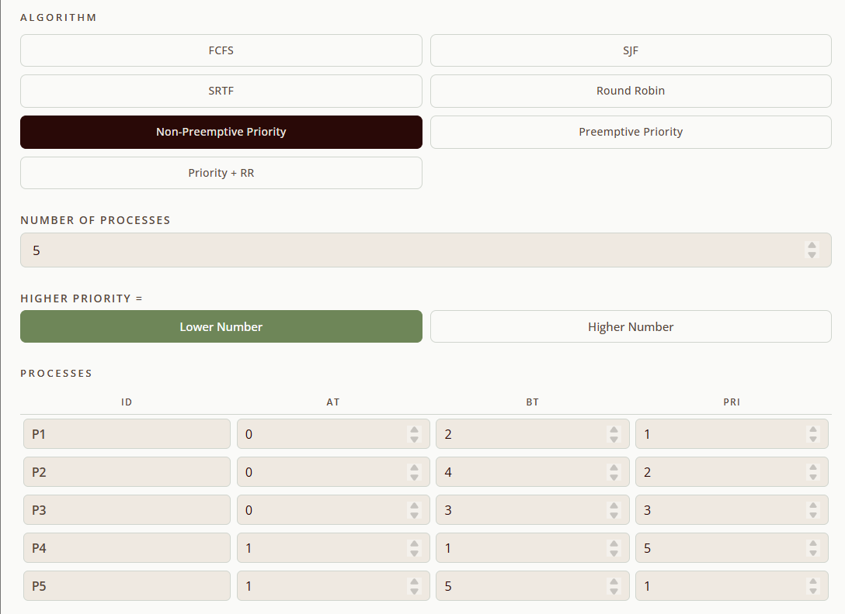

Sample Test Case 2 - Input
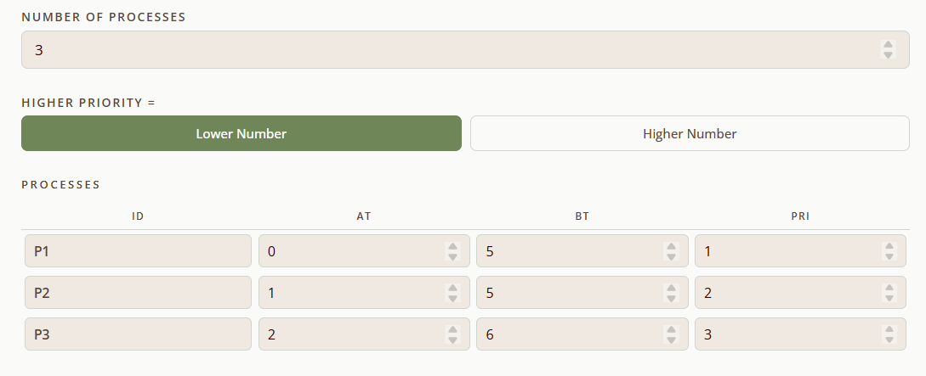
Figures 25 & 26. Input Parameters of the NPPS Algorithm
The input values define two sets of processes for non‑preemptive priority scheduling. In the five‑process case (P1–P5), arrival times range from 0 to 1, burst times vary between 1 and 5, and priorities are assigned with lower numbers representing higher importance, giving P1 and P5 the highest priority. In the three‑process case (D1–D3), arrival times are 0, 1, and 2 with burst times of 5, 5, and 6, and priorities 1, 2, and 3, respectively.

Sample Test Case 1 – Gantt Chart
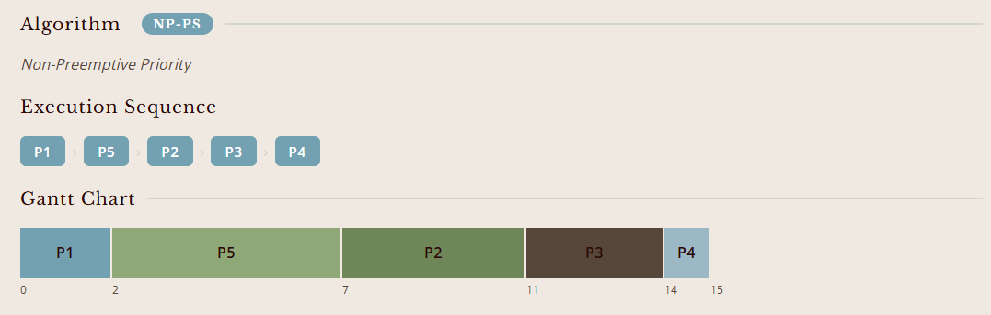

Sample Test Case 2 – Gantt Chart
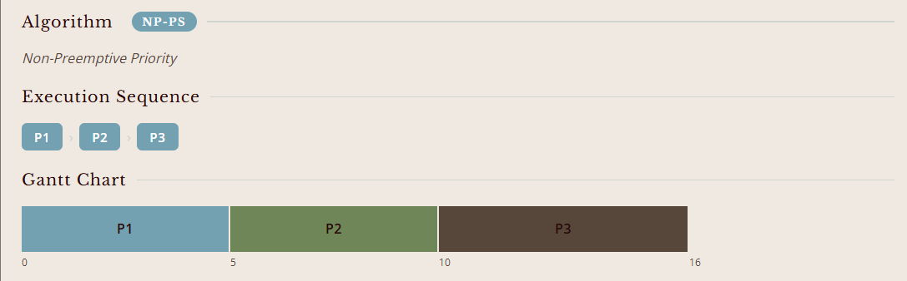
Figures 27 & 28. NPPS Gantt chart showing the execution order and completion times of processes
The Gantt charts show the execution order of processes under non-preemptive priority scheduling. In the five-process case (P1–P5), the timeline runs from 0 to 15, beginning with P1, followed by P5, P2, P3, and finally P4, reflecting the rule that once a process starts, it runs to completion before the next is scheduled. In the three-process case (D1–D3), the chart spans from 0 to 16, with D1 running first, then D2, and finally D3.

Sample Test Case 1 – Computed Values
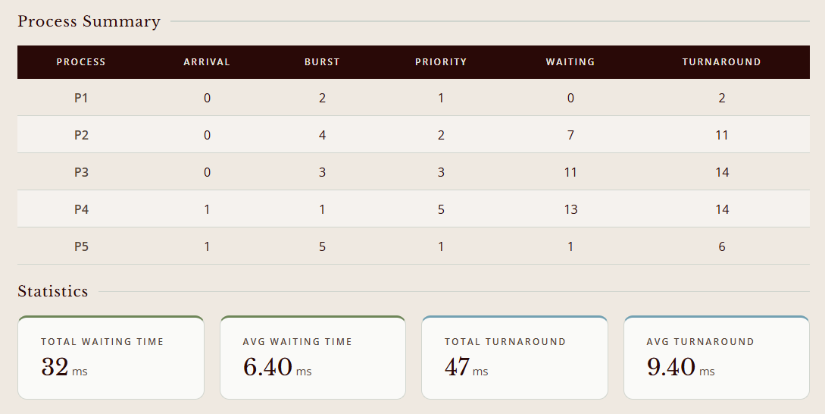

Sample Test Case 2 – Computed Values
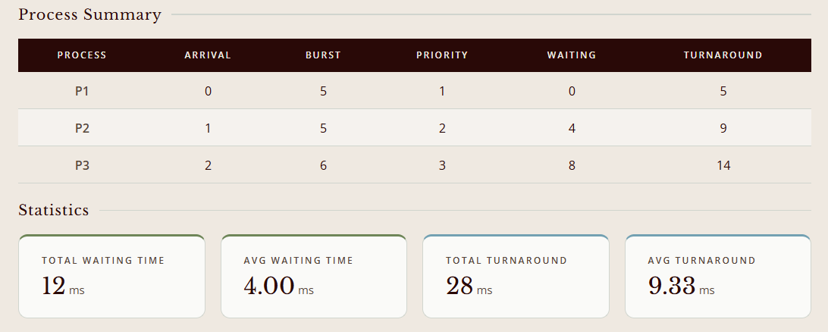
Figures 29 & 30. NPPS Process summary table showing arrival time, burst time, waiting time, and turnaround time for five processes
The process summaries present the results of non-preemptive priority scheduling for two sets of processes. In the five-process case (P1–P5), waiting times range from 0 to 13 and turnaround times from 2 to 14, with averages of 6.4 and 9.4 respectively. In the three-process case (D1–D3), waiting times are 0, 4, and 8 while turnaround times are 5, 9, and 14, yielding averages of 4.0 and 9.33.

- Preemptive Priority Scheduling
Sample Test Case 1 – Input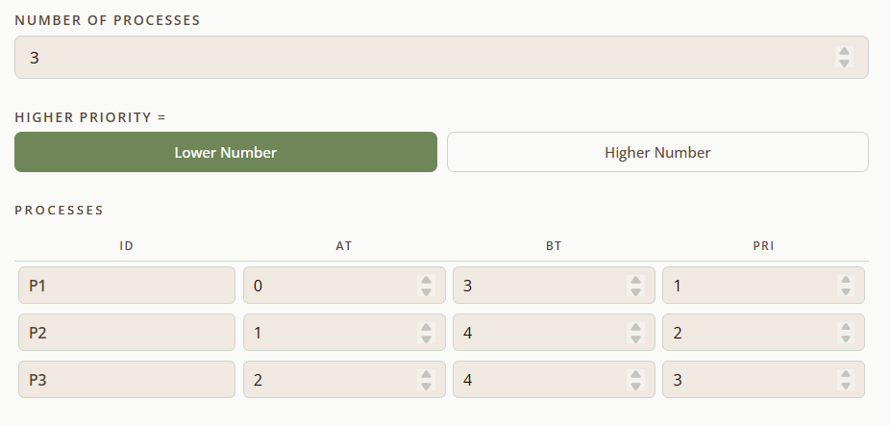

Sample Test Case 2 – Input
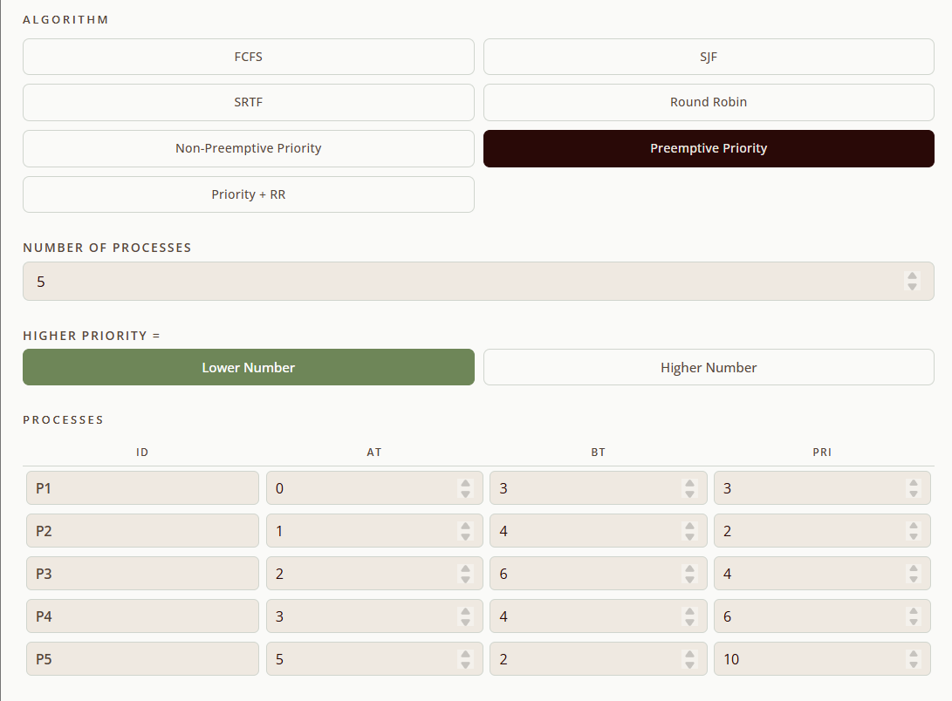
Figures 31 & 32. Input Parameters of the PRS Algorithm
The input values define two sets of processes for priority scheduling. In the five-process case (P1–P5), arrival times range from 0 to 5 with burst times between 2 and 6, and priorities assigned such that lower numbers indicate higher importance. In the three-process case (D1–D3), arrival times are 0, 1, and 2 with burst times of 3, 4, and 4, and priorities 1, 2, and 3, respectively.

Sample Test Case 1 – Gantt Chart
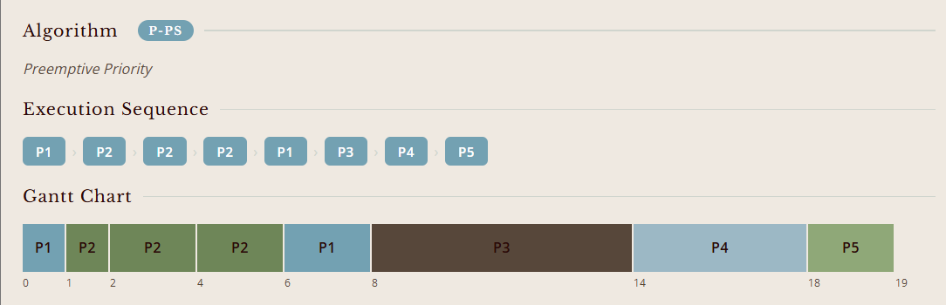

Sample Test Case 2 – Gantt Chart
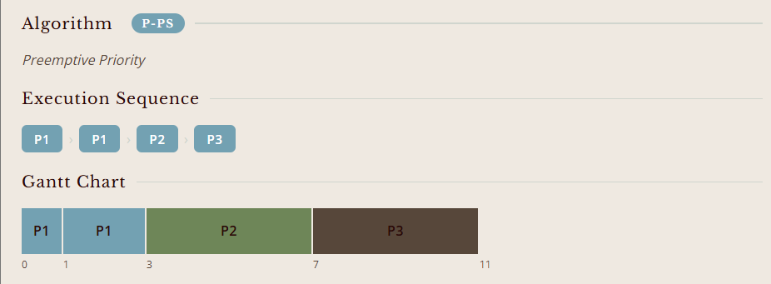
Figures 33 & 34. PRS Gantt chart showing the execution order and completion times of processes

The Gantt charts illustrate the execution order of processes under priority scheduling. In the five-process case (P1–P5), tasks are arranged from time 0 to 19, showing how higher-priority processes such as P2 preempt lower-priority ones like P1, while P3, P4, and P5 follow in sequence. In the three-process case (D1–D3), the chart spans from time 0 to 11, with D1 starting first, then yielding to D2, and finally D3.

Sample Test Case 1 – Computed Values
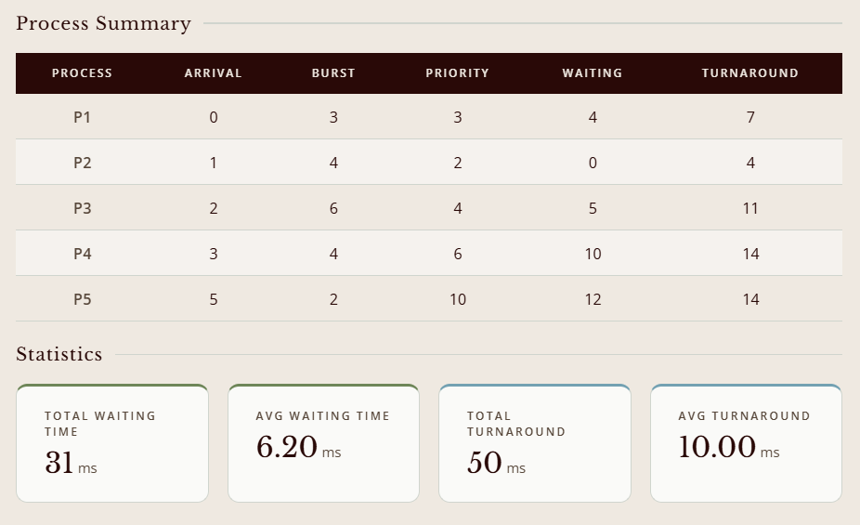

Sample Test Case 2 - Computed Values
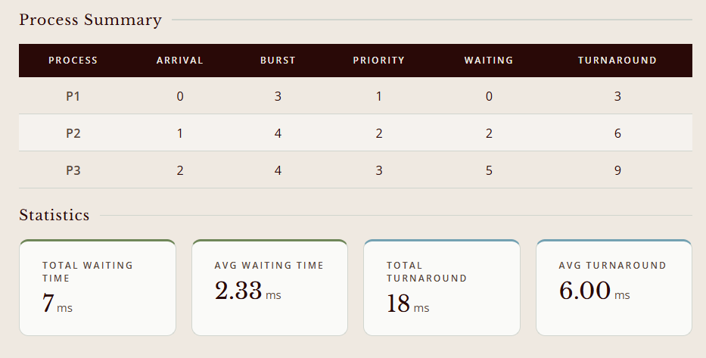
Figures 35 & 36. PRS Process summary table showing arrival time, burst time, waiting time, and turnaround time for five processes
The process summaries present the results of priority scheduling for two sets of processes. In the five-process case (P1–P5), waiting times range from 0 to 12 and turnaround times from 4 to 14, with averages of 6.2 and 10.0, respectively. In the three-process case (D1–D3), waiting times are 0, 2, and 5 while turnaround times are 3, 6, and 9, yielding averages of 2.33 and 6.0.

  - Priority Scheduling with Round Robin
Priority-Based Round Robin scheduling typically involves maintaining multiple ready queues, one for each priority level. The scheduler first serves processes in the highest-priority queue. Within each priority queue, processes are scheduled using the Round Robin algorithm with a defined time quantum. When the highest-priority queue is empty, the scheduler moves to the next lower-priority queue and applies Round Robin scheduling there. This continues until all processes are executed.
This approach allows high-priority processes to be executed quickly, similar to pure Priority Scheduling. However, because Round Robin is used within each priority level, processes of the same priority share the CPU fairly. Furthermore, by eventually moving to lower-priority queues, this method reduces the risk of starvation for less critical processes. However, it doesn't eliminate it if high-priority processes are constantly arriving.

Outlined in the table are several merits and demerits of the Priority Scheduling with RR Scheduling Algorithm
Advantages | Disadvantages
Improved responsiveness for high-priority tasks. Critical processes are handled promptly due to their higher priority. | Implementing and managing multiple priority queues adds complexity to the scheduler.
Reduced starvation (compared to pure Priority Scheduling). By using Round Robin within each priority level and eventually moving to lower levels, processes are less likely to be indefinitely delayed. | If there is a constant influx of high-priority processes, lower-priority processes may still experience significant delays. Techniques like aging (gradually increasing the priority of processes that have been waiting for a long time) can help mitigate this.
Fairness within priority levels. Processes of the same importance share the CPU fairly due to the Round Robin mechanism. | Difficulty in determining priorities. Assigning appropriate priority levels to processes can be challenging and may require system-specific knowledge.

Sample Test Case 1 – Input
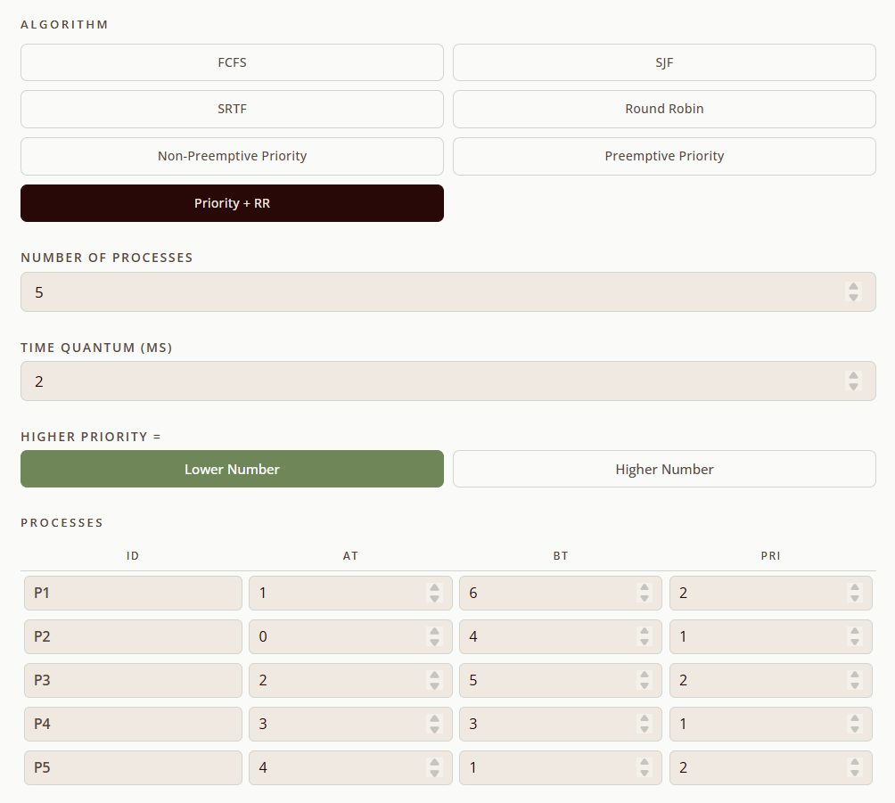

Sample Test Case 2 – Input
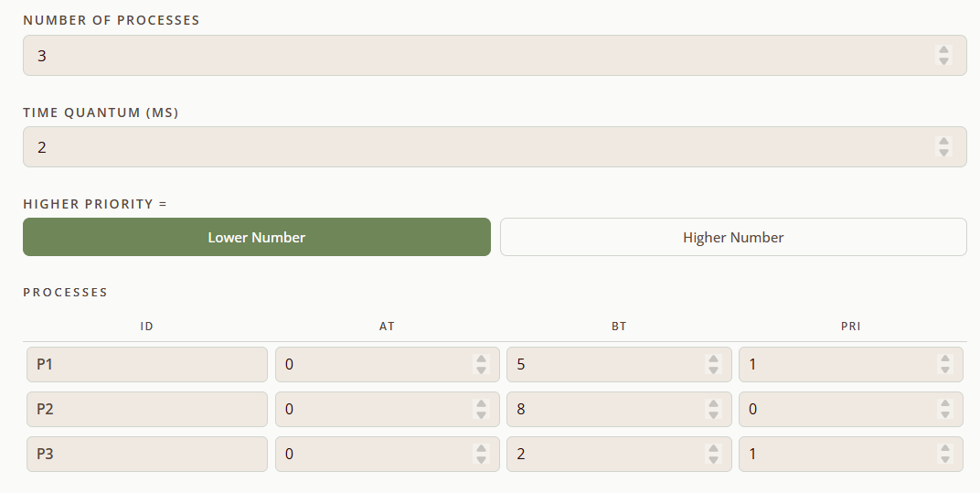
Figures 37 & 38. Input Parameters of the PS + RR Algorithm
The input values define two sets of processes for priority scheduling with round robin. In the five-process case (P1–P5), arrival times range from 0 to 4, burst times vary between 1 and 5, and priorities are assigned such that lower numbers indicate higher importance. P1 and P3 hold the highest priority with values of 1, while P2 and P5 are assigned priority 2, and P4 is given priority 3. In the three-process case (P1–P3), all processes arrive at time 0, with burst times of 5, 8, and 2, respectively. Priorities are set to 1, 0, and 1, establishing a configuration where lower values denote higher scheduling importance.

Sample Test Case 1 – Gantt Chart
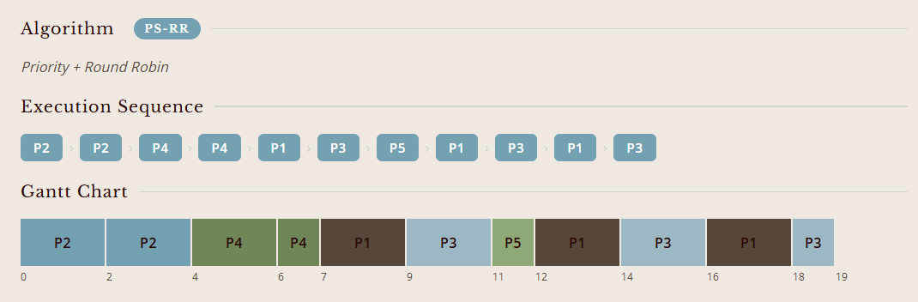

Sample Test Case 2 – Gantt Chart
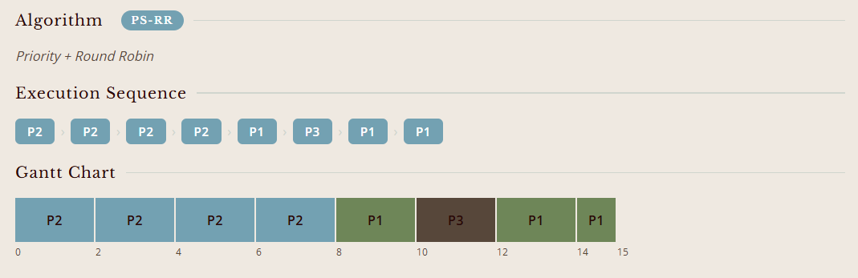
Figures 39 & 40. PS + RR Gantt chart showing the execution order and completion times of processes
The execution sequence illustrates how processes are scheduled under the combined priority and round robin method. In the five-process case (P1–P5), the order of execution proceeds as P2 → P4 → P1 → P5 → P3 → P1 → P5 → P3, reflecting both priority levels and the time quantum of 2 ms. The corresponding Gantt chart shows the timeline from 0 to 19, with P2 occupying 0–2, P4 at 2–6, P1 at 6–9, P5 at 9–11, P3 at 11–13, P1 at 13–15, P5 at 15–16, and P3 at 16–19. In the three-process case (P1–P3), the sequence is P2 → P2 → P2 → P1 → P3 → P1, with the Gantt chart spanning 0 to 15. Here, P2 executes in three consecutive slices (0–2, 2–4, 4–6), followed by P1 (6–8), P3 (10–12), and P1 again (12–15).

Sample Test Case 1 – Computed Values
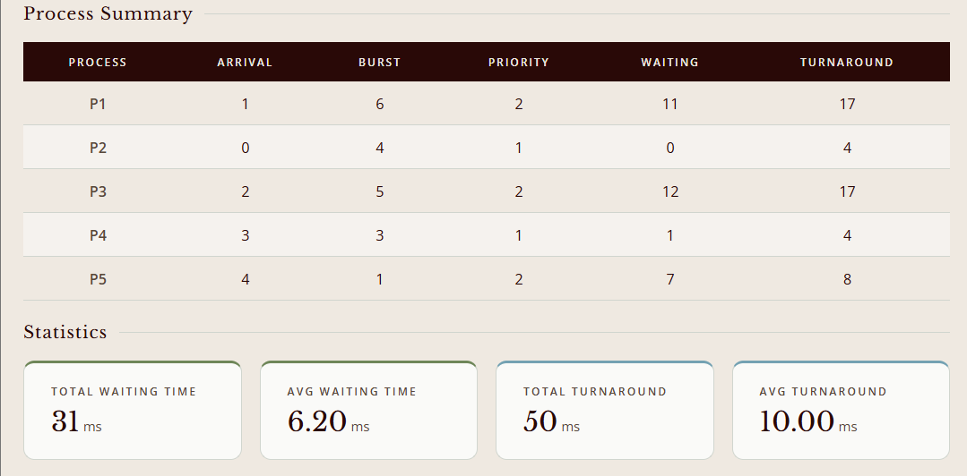

Sample Test Case 2 – Computed Values
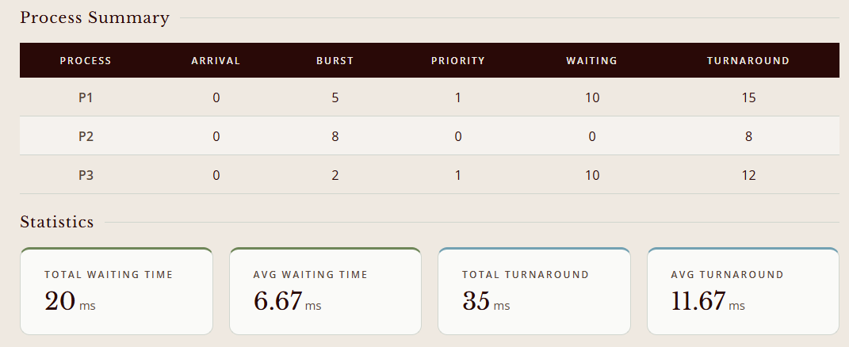
Figures 41 & 42. PS + RR Process summary table showing arrival time, burst time, waiting time, and turnaround time for five processes
The process summary shows waiting and turnaround times under priority with round robin scheduling. In the five-process case, P2 and P4 (priority 1) finish with shorter delays, while P1 and P3 (priority 2) wait longer. Turnaround ranges from 4 for P2 to 17 for P1 and P3. In the three-process case, P2 (priority 0) completes immediately, while P1 and P3 (priority 1) incur 10 ms of waiting each. The statistics report average waiting times of 6.20 and 6.67, and average turnaround times of 10.00 and 11.67, highlighting the balance between priority and round robin fairness.

- Summary/Takeaways
Completing this case study was a genuinely challenging yet rewarding experience. Developing almost all seven scheduling algorithms was difficult in one way or another, but the most demanding were the priority-based algorithms, both Non-Preemptive Priority Scheduling and Preemptive Priority Scheduling. A lot of testing and revision was needed to get the preemption logic right to make sure that a newly arrived higher-priority process correctly interrupts the one currently running and then accurately recomputes waiting and turnaround times. Even the non-preemptive one had subtle difficulties dealing with tie-breaking and edge cases when multiple processes had the same priority level. But the exercise of working through these problems increased understanding of the constant evaluation that the CPU must make between competing demands.
Key Insights Gained from Implementing the Algorithms
One of the most significant takeaways from this case study is that there is no one scheduling algorithm that is optimal in all cases. Each approach is designed with a particular trade-off in mind. The “best” algorithm depends heavily on the workload and system goals. FCFS was easy to implement but its weakness was revealed by the convoy effect. Short processes wait long because they arrive after a burst-heavy process. SJF showed that prior knowledge of burst times can greatly reduce average waiting time, but this assumption is not realistic in real systems. The implementation of SRTF proved that preemption is very powerful but adds a lot of complexity and the possibility of starvation for longer processes. Round Robin implies that fairness and responsiveness come at a cost and that the time quantum value is not a trivial setting. A quantum that is too small inflates the context switching overhead, while a quantum that is too large makes it behave like FCFS. Finally, Priority Scheduling with Round Robin showed that the disadvantages of each algorithm can be overcome by combining them; however, it had the highest implementation complexity.

Observed Differences in Performance
In the simulated test cases, we could see clear differences as far as fairness, efficiency, and response time are concerned. Efficiency-wise, SJF and SRTF always gave the minimum average waiting and turnaround time, which proves the optimality of these algorithms theoretically when the burst time is known. FCFS was predictable, but the least efficient for mixed workloads, as it exhibited the worst waiting times if a long process arrived early in the queue. Round Robin was mediocre in both metrics, but it excelled at responsiveness, not throughput. No process ever waited indefinitely, which is particularly important in interactive systems. The priority-based algorithms presented the most obvious trade-off: high-priority processes suffered very little delay, while low-priority processes could be made to wait for a long time, illustrating the starvation problem. The hybrid Priority + Round Robin algorithm provided the most balanced result overall, distributing the CPU time both according to importance and with fairness within each priority tier. However, it had the highest average waiting times among the priority group due to time-sharing overhead.

Practical Relevance in Modern Operating Systems
The algorithms discussed in this case study are not only academic exercises, but they are the conceptual basis of how real-world operating systems allocate processor time today. Modern operating systems like Linux, Windows, and Mac OS do not implement a single algorithm but implement hybrid schedulers that borrow ideas from several of those studied here. For example, Linux uses the Completely Fair Scheduler (CFS), which is based on the fairness principles of Round Robin with dynamic priority adjustments similar to Priority Scheduling using a concept called virtual runtime to approximate equal CPU distribution. Windows uses a multilevel feedback queue with 32 priority levels and preemptive time-sliced scheduling, which is very similar to the Priority + Round Robin model. Strict preemptive priority scheduling is widely used in real-time operating systems for embedded devices, medical equipment, and aerospace systems, where missing a deadline is not an option. This means that anyone who works on systems programming, embedded development, or OS design needs to understand the trade-offs between these algorithms: starvation vs fairness, throughput vs responsiveness, simplicity vs adaptability. This case study, despite the implementation challenges, gave a concrete, hands-on perspective on why these scheduling decisions matter at every level of computing.

- References
GeeksforGeeks. (2026, April 24). CPU scheduling in operating systems. GeeksforGeeks. https://www.geeksforgeeks.org/operating-systems/cpu-scheduling-in-operating-systems/
TheKnowledgeAcademy. (2026). CPU Scheduling in Operating System: An In-Depth Overview of OS. Theknowledgeacademy.com. https://www.theknowledgeacademy.com/blog/cpu-scheduling-in-os/
W3Schools. (2009). Scheduling algorithms of operating system. https://www.w3schools.in/operating-system/scheduling-algorithms
GeeksforGeeks. (2025, July 12). Advantages and Disadvantages of various CPU scheduling algorithms. GeeksforGeeks. https://www.geeksforgeeks.org/operating-systems/advantages-and-disadvantages-of-various-cpu-scheduling-algorithms/
Ithy. (2025) Exploring Priority-Based Round Robin scheduling. https://ithy.com/article/priority-based-round-robin-scheduling-waj3pwlp
Mathur, T. (2022, February 17). Scaler Topics. Www.scaler.com. https://www.scaler.com/topics/operating-system/priority-scheduling-algorithm/
Goyal, S. (2025, June 10). OS scheduling Algorithms | All types explained with examples. https://unstop.com/blog/scheduling-algorithms-in-operating-system
CodeLucky. (2025, August 27). Completely fair scheduler: Linux CFS Algorithm Deep dive. CodeLucky. https://codelucky.com/linux-cfs-scheduler/
GeeksforGeeks. (2026a, January 5). Multilevel Feedback Queue Scheduling (MLFQ) CPU scheduling. GeeksforGeeks. https://www.geeksforgeeks.org/operating-systems/multilevel-feedback-queue-scheduling-mlfq-cpu-scheduling/
CFS Scheduler — The Linux Kernel documentation. (n.d.). https://www.kernel.org/doc/html/latest/scheduler/sched-design-CFS.html

Github Repository
https://github.com/jdmrct/DIMARUCUT-JF.-BSCS-3B.git
Source Code
<!DOCTYPE html>
<html lang="en">
<head>
<meta charset="UTF-8"/>
<meta name="viewport" content="width=device-width, initial-scale=1.0"/>
<title>CPU Scheduling Simulator</title>
<link href="https://fonts.googleapis.com/css2?family=Libre+Baskerville:ital,wght@0,400;0,700;1,400&family=Open+Sans:wght@300;400;500;600&display=swap" rel="stylesheet"/>
<style>
:root {
--dark: #290907;
--earth: #57473A;
--sage: #6E8658;
--sky: #73A1B2;
--mist: #D0D5CE;
--cream: #EFE9E1;
--white: #FAFAF8;
--text: #290907;
--subtle: #57473A;
}

*, *::before, *::after { box-sizing: border-box; margin: 0; padding: 0; }

body {
font-family: 'Open Sans', sans-serif;
background: var(--cream);
color: var(--text);
min-height: 100vh;
}

/* ── Header ── */
header {
background: var(--dark);
color: var(--cream);
padding: 28px 48px;
display: flex;
align-items: baseline;
gap: 16px;
border-bottom: 4px solid var(--sage);
}
header h1 {
font-family: 'Libre Baskerville', serif;
font-size: 1.9rem;
font-weight: 400;
letter-spacing: 0.04em;
color: var(--cream);
}
header span {
font-size: 0.75rem;
letter-spacing: 0.18em;
text-transform: uppercase;
color: var(--sky);
font-weight: 500;
}

/* ── Layout ── */
.app {
display: grid;
grid-template-columns: 340px 1fr;
min-height: calc(100vh - 89px);
}

/* ── Sidebar ── */
.sidebar {
background: var(--white);
border-right: 1px solid var(--mist);
padding: 32px 28px;
display: flex;
flex-direction: column;
gap: 24px;
}

.section-label {
font-size: 0.65rem;
letter-spacing: 0.2em;
text-transform: uppercase;
color: var(--subtle);
font-weight: 600;
margin-bottom: 10px;
}

.algo-grid {
display: grid;
grid-template-columns: 1fr 1fr;
gap: 8px;
}
.algo-btn {
background: transparent;
border: 1.5px solid var(--mist);
border-radius: 6px;
padding: 9px 6px;
font-family: 'Open Sans', sans-serif;
font-size: 0.7rem;
font-weight: 500;
color: var(--subtle);
cursor: pointer;
transition: all 0.18s;
text-align: center;
line-height: 1.3;
letter-spacing: 0.02em;
}
.algo-btn:hover { border-color: var(--sky); color: var(--dark); background: #EBF3F7; }
.algo-btn.active {
background: var(--dark);
border-color: var(--dark);
color: var(--cream);
}

/* form controls */
.field { display: flex; flex-direction: column; gap: 5px; }
label {
font-size: 0.7rem;
letter-spacing: 0.12em;
text-transform: uppercase;
color: var(--subtle);
font-weight: 600;
}
input[type=number], select {
background: var(--cream);
border: 1.5px solid var(--mist);
border-radius: 6px;
padding: 8px 12px;
font-family: 'Open Sans', sans-serif;
font-size: 0.85rem;
color: var(--dark);
outline: none;
transition: border-color 0.15s;
width: 100%;
}
input[type=number]:focus, select:focus { border-color: var(--sky); }
input[type=number]::-webkit-inner-spin-button { opacity: 0.4; }

.priority-order { display: flex; gap: 8px; }
.po-btn {
flex: 1;
padding: 8px;
border: 1.5px solid var(--mist);
border-radius: 6px;
background: transparent;
font-family: 'Open Sans', sans-serif;
font-size: 0.75rem;
font-weight: 500;
color: var(--subtle);
cursor: pointer;
transition: all 0.15s;
}
.po-btn.active { background: var(--sage); border-color: var(--sage); color: white; }

/* process table */
.process-table-wrap { overflow-x: auto; }
table.input-table { width: 100%; border-collapse: collapse; font-size: 0.78rem; }
.input-table th {
font-size: 0.6rem;
letter-spacing: 0.12em;
text-transform: uppercase;
color: var(--subtle);
font-weight: 600;
padding: 6px 4px;
border-bottom: 1.5px solid var(--mist);
text-align: center;
}
.input-table td { padding: 4px 3px; }
.input-table td input {
width: 100%;
padding: 6px 8px;
font-size: 0.78rem;
border: 1.5px solid var(--mist);
border-radius: 5px;
background: var(--cream);
color: var(--dark);
font-family: 'Open Sans', sans-serif;
outline: none;
transition: border-color 0.15s;
}
.input-table td input:focus { border-color: var(--sky); }
.input-table td input.id-input { font-weight: 600; color: var(--earth); }

/* run button */
.run-btn {
background: var(--sage);
color: white;
border: none;
border-radius: 8px;
padding: 13px;
font-family: 'Libre Baskerville', serif;
font-size: 0.9rem;
letter-spacing: 0.06em;
cursor: pointer;
transition: background 0.2s, transform 0.1s;
margin-top: 4px;
}
.run-btn:hover { background: #5d7249; }
.run-btn:active { transform: scale(0.98); }

/* ── Main panel ── */
.main {
padding: 36px 44px;
display: flex;
flex-direction: column;
gap: 36px;
overflow-x: auto;
}

#resultsArea > div {
margin-bottom: 1.2rem; /* adjust as needed */
}

.panel-title {
font-family: 'Libre Baskerville', serif;
font-size: 0.95rem;
font-weight: 400;
letter-spacing: 0.05em;
color: var(--dark);
margin-bottom: 16px;
display: flex;
align-items: center;
gap: 10px;
}
.panel-title::after {
content: '';
flex: 1;
height: 1px;
background: var(--mist);
}

/* Gantt */
.gantt-scroll { overflow-x: auto; padding-bottom: 8px; }
.gantt-wrap { display: flex; flex-direction: column; gap: 0; min-width: max-content; }
.gantt-row { display: flex; height: 44px; }
.gantt-block {
display: flex;
align-items: center;
justify-content: center;
font-family: 'Open Sans', sans-serif;
font-size: 0.78rem;
font-weight: 600;
letter-spacing: 0.04em;
border-right: 2px solid var(--cream);
position: relative;
transition: opacity 0.15s;
min-width: 28px;
}
.gantt-block:hover { opacity: 0.85; }
.gantt-block.idle { background: var(--mist); color: var(--subtle); }
.gantt-ticks { display: flex; font-size: 0.62rem; color: var(--subtle); font-family: 'Open Sans'; margin-top: 3px; }
.gantt-tick { display: flex; justify-content: flex-start; }

/* Results table */
.results-table { width: 100%; border-collapse: collapse; font-size: 0.82rem; }
.results-table th {
background: var(--dark);
color: var(--cream);
font-family: 'Open Sans', sans-serif;
font-size: 0.62rem;
font-weight: 600;
letter-spacing: 0.14em;
text-transform: uppercase;
padding: 11px 16px;
text-align: center;
}
.results-table td {
padding: 10px 16px;
text-align: center;
border-bottom: 1px solid var(--mist);
color: var(--text);
font-size: 0.82rem;
}
.results-table tr:nth-child(even) td { background: #F5F2EE; }
.results-table tr:hover td { background: #EBF3F7; }
.results-table .process-id { font-weight: 700; color: var(--earth); }

/* Summary cards */
.summary-cards { display: flex; gap: 16px; flex-wrap: wrap; }
.card {
background: var(--white);
border: 1px solid var(--mist);
border-radius: 10px;
padding: 18px 24px;
min-width: 150px;
flex: 1;
border-top: 3px solid var(--sage);
}
.card-label {
font-size: 0.62rem;
letter-spacing: 0.16em;
text-transform: uppercase;
color: var(--subtle);
font-weight: 600;
margin-bottom: 6px;
}
.card-value {
font-family: 'Libre Baskerville', serif;
font-size: 1.5rem;
color: var(--dark);
}
.card-unit { font-size: 0.75rem; color: var(--subtle); font-family: 'Open Sans'; margin-left: 3px; }

/* Empty state */
.empty-state {
display: flex;
flex-direction: column;
align-items: center;
justify-content: center;
gap: 12px;
min-height: 320px;
color: var(--mist);
}
.empty-state svg { opacity: 0.35; }
.empty-state p {
font-family: 'Libre Baskerville', serif;
font-size: 1rem;
color: var(--mist);
font-style: italic;
}

/* Error */
.error-msg {
background: #fde8e8;
border: 1px solid #e8a0a0;
color: #7a2020;
border-radius: 7px;
padding: 10px 14px;
font-size: 0.8rem;
display: none;
}

/* Execution sequence */
.seq-wrap { display: flex; flex-wrap: wrap; gap: 6px; align-items: center; }
.seq-item {
background: var(--sky);
color: white;
border-radius: 5px;
padding: 5px 12px;
font-size: 0.75rem;
font-weight: 600;
letter-spacing: 0.05em;
}
.seq-item.idle { background: var(--mist); color: var(--subtle); }
.seq-arrow { color: var(--mist); font-size: 0.8rem; }

.algo-tag {
display: inline-block;
background: var(--sky);
color: white;
font-size: 0.65rem;
letter-spacing: 0.12em;
text-transform: uppercase;
font-weight: 600;
padding: 3px 10px;
border-radius: 20px;
margin-left: 8px;
vertical-align: middle;
}

@media (max-width: 900px) {
.app { grid-template-columns: 1fr; }
header { padding: 20px 24px; }
.sidebar, .main { padding: 20px; }
}
</style>
</head>
<body>

<header>
<h1>CPU Scheduling Simulator</h1>
<span>Operating Systems</span>
</header>

<div class="app">
<!-- ── Sidebar ── -->
<aside class="sidebar">
<div>
<div class="section-label">Algorithm</div>
<div class="algo-grid" id="algoGrid">
<button class="algo-btn active" data-algo="1">FCFS</button>
<button class="algo-btn" data-algo="2">SJF</button>
<button class="algo-btn" data-algo="3">SRTF</button>
<button class="algo-btn" data-algo="4">Round Robin</button>
<button class="algo-btn" data-algo="5">Non-Preemptive Priority</button>
<button class="algo-btn" data-algo="6">Preemptive Priority</button>
<button class="algo-btn" data-algo="7">Priority + RR</button>
</div>
</div>

<div class="field">
<label>Number of Processes</label>
<input type="number" id="numProc" value="3" min="3" max="10"/>
</div>

<div class="field" id="quantumField" style="display:none">
<label>Time Quantum (ms)</label>
<input type="number" id="quantum" value="2" min="1"/>
</div>

<div class="field" id="priorityOrderField" style="display:none">
<label>Higher Priority =</label>
<div class="priority-order">
<button class="po-btn active" id="poLow">Lower Number</button>
<button class="po-btn" id="poHigh">Higher Number</button>
</div>
</div>

<div>
<div class="section-label">Processes</div>
<div class="process-table-wrap">
<table class="input-table" id="processTable">
<thead id="tableHead"></thead>
<tbody id="tableBody"></tbody>
</table>
</div>
</div>

<div class="error-msg" id="errorMsg"></div>

<button type="button" class="run-btn" onclick="runSimulation()">Run Simulation</button>
</aside>

<!-- ── Main panel ── -->
<main class="main" id="mainPanel">
<div id="resultsArea">
<div class="empty-state">
<svg width="64" height="64" viewBox="0 0 64 64" fill="none">
<rect x="8" y="16" width="48" height="32" rx="4" stroke="#D0D5CE" stroke-width="2.5"/>
<rect x="20" y="28" width="8" height="8" rx="1.5" fill="#D0D5CE"/>
<rect x="36" y="28" width="8" height="8" rx="1.5" fill="#D0D5CE"/>
<line x1="32" y1="8" x2="32" y2="16" stroke="#D0D5CE" stroke-width="2.5" stroke-linecap="round"/>
<line x1="20" y1="8" x2="32" y2="8" stroke="#D0D5CE" stroke-width="2.5" stroke-linecap="round"/>
<line x1="44" y1="8" x2="32" y2="8" stroke="#D0D5CE" stroke-width="2.5" stroke-linecap="round"/>
</svg>
<p>Configure and run a simulation to see results</p>
</div>
</div>
</main>
</div>

<script>
// ════════════════════════════════════════════════════════════
// GLOBAL STATE
// These two variables drive conditional rendering throughout:
// - selectedAlgo: determines which algorithm runs and which
// input fields (quantum, priority) are shown in the sidebar.
// - higherIsBetter: controls priority normalization before
// running any priority-based algorithm (algos 5, 6, 7).
// ════════════════════════════════════════════════════════════
let selectedAlgo = 1;
let higherIsBetter = false;

// ── Algorithm name maps ──────────────────────────────────────
// Used by renderResults() to display full and abbreviated names
// in the results panel after simulation.
const ALGO_NAMES = {
1: 'First-Come, First-Served',
2: 'Non-Preemptive SJF',
3: 'Preemptive SJF (SRTF)',
4: 'Round Robin',
5: 'Non-Preemptive Priority',
6: 'Preemptive Priority',
7: 'Priority + Round Robin'
};
const ALGO_SHORT = {1:'FCFS',2:'NP-SJF',3:'SRTF',4:'RR',5:'NP-PS',6:'P-PS',7:'PS-RR'};

// ── Palette for process blocks ──────────────────────────────
const PROC_COLORS = [
'#73A1B2','#6E8658','#57473A','#9CB8C5','#8FA878',
'#A0876E','#4A7A8E','#4E6640','#3D2F25','#B8CDD6'
];

// ════════════════════════════════════════════════════════════
// UI INITIALIZATION — Event Listeners
// Wires up all sidebar controls to their handlers on page load.
// ════════════════════════════════════════════════════════════

// Algorithm selector buttons: clicking one sets selectedAlgo and
// calls updateUIForAlgo() to show/hide quantum and priority fields.
document.querySelectorAll('.algo-btn').forEach(btn => {
btn.addEventListener('click', () => {
document.querySelectorAll('.algo-btn').forEach(b => b.classList.remove('active'));
btn.classList.add('active');
selectedAlgo = parseInt(btn.dataset.algo);
updateUIForAlgo();
});
});

// Rebuilds the process input table whenever the process count changes.
document.getElementById('numProc').addEventListener('input', buildProcessTable);

// Priority convention toggle: sets higherIsBetter flag.
// "Lower Number" → priority 1 beats priority 5 (higherIsBetter = false).
// "Higher Number" → priority 5 beats priority 1 (higherIsBetter = true).
// normalizePriority() uses this flag to invert values before scheduling.
document.getElementById('poLow').addEventListener('click', () => {
higherIsBetter = false;
document.getElementById('poLow').classList.add('active');
document.getElementById('poHigh').classList.remove('active');
});
document.getElementById('poHigh').addEventListener('click', () => {
higherIsBetter = true;
document.getElementById('poHigh').classList.add('active');
document.getElementById('poLow').classList.remove('active');
});

// ── updateUIForAlgo() ────────────────────────────────────────
// Shows or hides conditional sidebar fields based on the
// selected algorithm:
// - Time Quantum field: only needed for RR (4) and Priority+RR (7).
// - Priority Order field: only needed for priority algorithms (5, 6, 7).
// Also rebuilds the process table to add/remove the Priority column.
function updateUIForAlgo() {
const needsQuantum = [4, 7].includes(selectedAlgo);
const needsPriority = [5, 6, 7].includes(selectedAlgo);
document.getElementById('quantumField').style.display = needsQuantum ? '' : 'none';
document.getElementById('priorityOrderField').style.display = needsPriority ? '' : 'none';
updatePriorityColumn(needsPriority);
}

function updatePriorityColumn(needsPriority) {
const thead = document.getElementById('tableHead');
const tbody = document.getElementById('tableBody');
const headerRow = thead.querySelector('tr');
const hasPriorityCol = headerRow.cells.length >= 4;

// Update header
if (needsPriority && !hasPriorityCol) {
const th = document.createElement('th');
th.textContent = 'Pri';
headerRow.appendChild(th);
} else if (!needsPriority && hasPriorityCol) {
headerRow.removeChild(headerRow.lastElementChild);
}

// Update each data row
tbody.querySelectorAll('tr').forEach(tr => {
const hasPriCell = tr.cells.length >= 4;
if (needsPriority && !hasPriCell) {
const td = document.createElement('td');
td.innerHTML = '<input type="number" value="1" min="1" placeholder="1"/>';
tr.appendChild(td);
} else if (!needsPriority && hasPriCell) {
tr.removeChild(tr.lastElementChild);
}
});
}

// ── buildProcessTable() ──────────────────────────────────────
// Dynamically generates the process input table in the sidebar.
//
// INPUT: Reads 'numProc' field (clamped to 3–10) and selectedAlgo.
// OUTPUT: Rebuilds <thead> and <tbody> of #processTable.
//
// Behavior:
// - Preserves existing user-entered values when the table is
// rebuilt (e.g. when switching algorithms or changing count).
// - Conditionally adds a "Priority" column for algos 5, 6, 7.
// - Default row values: ID = "P{n}", AT = 0, BT = empty, Pri = 1.
function buildProcessTable() {
const n = Math.max(3, Math.min(10, parseInt(document.getElementById('numProc').value) || 3));
const needsPriority = [5, 6, 7].includes(selectedAlgo);

const thead = document.getElementById('tableHead');
const tbody = document.getElementById('tableBody');

thead.innerHTML = `<tr>
<th>ID</th><th>AT</th><th>BT</th>${needsPriority ? '<th>Pri</th>' : ''}
</tr>`;

// Preserve existing values
const existing = [];
tbody.querySelectorAll('tr').forEach(tr => {
const inp = tr.querySelectorAll('input');
existing.push({
id: inp[0]?.value || '',
at: inp[1]?.value || '0',
bt: inp[2]?.value || '',
pr: inp[3]?.value || '1',
});
});

tbody.innerHTML = '';
for (let i = 0; i < n; i++) {
const e = existing[i] || {};
const row = document.createElement('tr');
row.innerHTML = `
<td><input class="id-input" type="text" value="${e.id || 'P'+(i+1)}" maxlength="6"/></td>
<td><input type="number" value="${e.at || 0}" min="0" placeholder="0"/></td>
<td><input type="number" value="${e.bt || ''}" min="1" placeholder="ms"/></td>
${needsPriority ? `<td><input type="number" value="${e.pr || 1}" min="1" placeholder="1"/></td>` : ''}
`;
tbody.appendChild(row);
}
}

// ── readProcesses() ──────────────────────────────────────────
// Reads and validates all process inputs from the sidebar table.
//
// INPUT: DOM — reads every <input> in #tableBody rows.
// OUTPUT: Array of process objects:
// { key: string, arrival_time: int, burst_time: int, priority: int }
// priority is -1 for non-priority algorithms.
//
// Throws a descriptive Error string if any burst time is missing,
// non-positive, or if priority is missing for priority algorithms.
// The caller (runSimulation) catches these and calls showError().
function readProcesses() {
const rows = document.getElementById('tableBody').querySelectorAll('tr');
const needsPriority = [5,6,7].includes(selectedAlgo);
const processes = [];
for (let i = 0; i < rows.length; i++) {
const inputs = rows[i].querySelectorAll('input');
const id = inputs[0].value.trim() || `P${i+1}`;
const at = parseInt(inputs[1].value);
const bt = parseInt(inputs[2].value);
const pr = needsPriority ? parseInt(inputs[3].value) : -1;
if (isNaN(at) || isNaN(bt) || bt <= 0) throw new Error(`Invalid values for process ${id}. Burst time must be a positive integer.`);
if (needsPriority && isNaN(pr)) throw new Error(`Invalid priority for process ${id}.`);
processes.push({ key: id, arrival_time: at, burst_time: bt, priority: pr });
}
return processes;
}

// ── Show error ─────────────────────────────────────────────
// Displays a validation or simulation error in the sidebar's
// error banner (#errorMsg). The banner auto-hides after 4 seconds.
function showError(msg) {
const el = document.getElementById('errorMsg');
el.textContent = msg;
el.style.display = 'block';
setTimeout(() => el.style.display = 'none', 4000);
}

// Displays a validation or simulation error in the sidebar's
// error banner (#errorMsg). The banner auto-hides after 4 seconds.
function clone(o) { return JSON.parse(JSON.stringify(o)); }

// ════════════════════════════════════════════════════════════
// SCHEDULING ALGORITHMS
//
// All algorithms share the same interface:
// INPUT: processes[] — array of { key, arrival_time, burst_time, priority }
// (plus timeSlice for RR / PS-RR)
// OUTPUT: { procs[], seq[] }
// - procs[]: enriched with waiting_time (and finish/turnaround
// added later by computeStats)
// - seq[]: execution timeline — array of
// { key, start_time, burst_time }
// where key='-' represents CPU idle time.
// ════════════════════════════════════════════════════════════

// ── fcfs(processes) — First-Come, First-Served ───────────────
// Core logic:
// Non-preemptive. Processes run in strict arrival order.
// If the CPU finishes one process before the next has arrived,
// an idle block ('-') is inserted and the clock jumps forward.
//
// waiting_time = start_time − arrival_time
// (first process always has waiting_time = 0)
function fcfs(processes) {
const procs = clone(processes);
procs.sort((a,b) => a.arrival_time - b.arrival_time);
procs[0].waiting_time = 0;
let time = procs[0].arrival_time;
procs[0].start_time = time;
const seq = [{ key: procs[0].key, start_time: time, burst_time: procs[0].burst_time }];

for (let i = 1; i < procs.length; i++) {
time += procs[i-1].burst_time;
if (procs[i].arrival_time > time) {
const idle = procs[i].arrival_time - time;
seq.push({ key: '-', start_time: time, burst_time: idle });
time += idle;
}
procs[i].waiting_time = time - procs[i].arrival_time;
seq.push({ key: procs[i].key, start_time: time, burst_time: procs[i].burst_time });
}
return { procs, seq };
}

// ── sjf(processes) — Non-Preemptive Shortest Job First ───────
// Core logic:
// Non-preemptive. At each scheduling decision, the process with
// the smallest burst_time among all arrived processes is chosen.
// Once a process starts, it runs to completion.
//
// Strategy:
// 1. Sort by arrival_time; pick the shortest-burst process from
// those that have arrived simultaneously at t=0.
// 2. After each process finishes, collect all processes that
// arrived during its execution into a readyQueue.
// 3. From the readyQueue, pick the one with the smallest burst_time.
// 4. If the readyQueue is empty but processes remain, insert an
// idle block and skip to the next arrival.
//
// waiting_time = finish_time_of_previous_process − arrival_time
function sjf(processes) {
const procs = clone(processes);
const n = procs.length;
if (n === 1) {
procs[0].waiting_time = 0;
return { procs, seq: [{ key: procs[0].key, start_time: procs[0].arrival_time, burst_time: procs[0].burst_time }] };
}
procs.sort((a,b) => a.arrival_time - b.arrival_time);
const secondArrIdx = procs.findIndex(p => p.arrival_time !== procs[0].arrival_time);
const pool = secondArrIdx === -1 ? procs : procs.slice(0, secondArrIdx);
let sj = pool.reduce((a,b) => a.burst_time <= b.burst_time ? a : b);
let sjIdx = procs.indexOf(sj);
let time = sj.arrival_time;
procs[sjIdx].waiting_time = 0;
let bt = procs[sjIdx].burst_time;
const readyQueue = [];
const seq = [{ key: sj.key, start_time: time, burst_time: sj.burst_time }];
const notArrived = procs.filter((_, i) => i !== sjIdx);
let completed = 1;

while (completed < n) {
const end = time + bt;
let arrivCtr = 0;
for (const pna of notArrived) {
if (pna.arrival_time >= time && pna.arrival_time <= end) {
readyQueue.push(pna); arrivCtr++;
} else break;
}
notArrived.splice(0, arrivCtr);
time = end;
if (readyQueue.length > 0) {
const curr = readyQueue.reduce((a,b) => a.burst_time <= b.burst_time ? a : b);
curr.waiting_time = end - curr.arrival_time;
completed++;
readyQueue.splice(readyQueue.indexOf(curr), 1);
bt = curr.burst_time;
seq.push({ key: curr.key, start_time: time, burst_time: curr.burst_time });
} else if (notArrived.length > 0) {
bt = notArrived[0].arrival_time - end;
seq.push({ key: '-', start_time: end, burst_time: bt });
}
}
return { procs, seq };
}

// ── srt(processes) — Shortest Remaining Time First (SRTF) ────
// Core logic:
// Preemptive version of SJF. The CPU always runs the process
// with the shortest *remaining* burst time. A running process
// is preempted the moment a new process arrives with a shorter
// remaining time.
//
// Tick-by-tick SRTF simulation.
// Tiebreaker: if remaining times are equal, the process that arrived first wins
// (FCFS). If arrival times are also equal, the one already running keeps the CPU
// (no unnecessary preemption).
function srt(processes) {
const procs = clone(processes);
const n = procs.length;
procs.sort((a,b) => a.arrival_time - b.arrival_time);
for (const p of procs) {
p.remaining_time = p.burst_time;
p.finish_time = 0;
p.waiting_time = 0;
}

let time = procs[0].arrival_time;
let running = null; // key of currently running process
const rawSeq = []; // [{key, start, end}] — one entry per continuous run

const totalBurst = procs.reduce((s,p) => s + p.burst_time, 0);
const endTime = time + totalBurst + procs[procs.length-1].arrival_time + 1;
let completed = 0;

while (completed < n) {
// Collect all processes that have arrived by 'time'
const ready = procs.filter(p => p.arrival_time <= time && p.remaining_time > 0);

if (ready.length === 0) {
// CPU idle — jump to next arrival
const nextAT = procs.filter(p => p.remaining_time > 0)
.reduce((mn, p) => Math.min(mn, p.arrival_time), Infinity);
if (rawSeq.length > 0 && rawSeq[rawSeq.length-1].key === '-') {
rawSeq[rawSeq.length-1].end = nextAT;
} else {
rawSeq.push({ key: '-', start: time, end: nextAT });
}
time = nextAT;
running = null;
continue;
}

// Pick the process to run:
// 1. Shortest remaining time
// 2. Tie → earliest arrival time (FCFS)
// 3. Tie → currently running process (no preemption on equal)
const minRem = ready.reduce((mn, p) => Math.min(mn, p.remaining_time), Infinity);
const candidates = ready.filter(p => p.remaining_time === minRem);
const minAT = candidates.reduce((mn, p) => Math.min(mn, p.arrival_time), Infinity);
const fcfsCandidates = candidates.filter(p => p.arrival_time === minAT);
let chosen;
if (fcfsCandidates.some(p => p.key === running)) {
chosen = fcfsCandidates.find(p => p.key === running);
} else {
chosen = fcfsCandidates[0];
}

// Find the next event time: next arrival or this process finishing
const nextArrival = procs.filter(p => p.arrival_time > time && p.remaining_time > 0)
.reduce((mn, p) => Math.min(mn, p.arrival_time), Infinity);
const runUntil = Math.min(time + chosen.remaining_time, nextArrival);

// Append to raw sequence (merge consecutive same-process blocks)
if (rawSeq.length > 0 && rawSeq[rawSeq.length-1].key === chosen.key) {
rawSeq[rawSeq.length-1].end = runUntil;
} else {
rawSeq.push({ key: chosen.key, start: time, end: runUntil });
}

const delta = runUntil - time;
chosen.remaining_time -= delta;
time = runUntil;
running = chosen.key;

if (chosen.remaining_time === 0) {
chosen.finish_time = time;
completed++;
running = null;
}
}

// Build seq array in the format the rest of the code expects
const seq = rawSeq
.filter(s => s.end > s.start)
.map(s => ({ key: s.key, start_time: s.start, burst_time: s.end - s.start }));

// Compute waiting times
for (const p of procs) {
p.turnaround_time = p.finish_time - p.arrival_time;
p.waiting_time = p.turnaround_time - p.burst_time;
if (p.waiting_time < 0) p.waiting_time = 0;
}

return { procs, seq };
}

// ── rr(processes, timeSlice) — Round Robin ────────────────────
// Core logic:
// Preemptive. Processes take turns on the CPU in FIFO order,
// each receiving at most `timeSlice` ms per turn. If a process
// doesn't finish in its slice, it re-joins the back of the queue.
//
// Strategy:
// 1. Sort processes by arrival_time; initialize a ready queue (rq)
// with the first-arriving process.
// 2. Each iteration: dequeue the front process, run it for
// min(timeSlice, remaining_time), then advance the clock.
// 3. After each slice, enqueue any processes that arrived during
// that slice (from naList, the not-yet-arrived list).
// 4. If the process still has remaining time, re-enqueue it.
// 5. If the queue is empty, insert an idle block and jump to
// the next arriving process.
//
// Key tracking fields per process:
// time_executing: cumulative CPU time already used (for WT calc)
// last_start_time: clock time when the process last started a slice
//
// waiting_time = last_start_time − time_executing − arrival_time
function rr(processes, timeSlice) {
const procs = clone(processes);
procs.sort((a,b) => a.arrival_time - b.arrival_time);
for (const p of procs) { p.remaining_time = p.burst_time; p.time_executing = 0; }
const notArrived = procs.slice(1).map(p => ({...p}));
for (let i=0;i<procs.length;i++) { notArrived[i-1] = notArrived[i-1] || null; }
const na2 = clone(procs.slice(1));
const rq = [clone(procs[0])];
let time = procs[0].arrival_time;
const seq = [];
let completed = 0;
const procMap = {};
for (const p of procs) procMap[p.key] = p;
const naList = clone(procs.slice(1));

while (completed < procs.length) {
if (rq.length === 0) {
const nxt = naList.shift();
const idle = nxt.arrival_time - time;
seq.push({ key: '-', start_time: time, burst_time: idle });
time += idle;
rq.push(nxt);
}
const cur = rq[0];
seq.push({ key: cur.key, start_time: time, burst_time: cur.remaining_time });
cur.remaining_time -= timeSlice;
const rt = cur.remaining_time;
const orig = procMap[cur.key];
if (rt <= 0) { orig.last_start_time = time; completed++; }
const advTime = rt >= 0 ? timeSlice : timeSlice + rt;
time += advTime;
rq.shift();
let arrivCtr = 0;
for (const pna of naList) {
if (pna.arrival_time <= time) { rq.push(pna); arrivCtr++; }
else break;
}
naList.splice(0, arrivCtr);
if (rt > 0) { orig.time_executing += timeSlice; rq.push(cur); }
seq[seq.length-1].burst_time = rt <= 0 ? (timeSlice + rt) : timeSlice;
}

for (const p of procs) {
p.waiting_time = (p.last_start_time || 0) - (p.time_executing || 0) - p.arrival_time;
}
return { procs, seq };
}

// ── np_ps(processes) — Non-Preemptive Priority Scheduling ─────
// Core logic:
// Non-preemptive. At each scheduling decision, the process with
// the highest priority (lowest numeric value after normalization)
// among all arrived processes is chosen. Once started, it runs
// to completion regardless of new arrivals.
//
// Strategy (mirrors sjf but ranks by priority instead of burst):
// 1. Sort by arrival_time; pick the highest-priority process from
// those that have arrived simultaneously at t=0.
// 2. After each process finishes, collect arrivals into readyQueue.
// 3. Pick the process with the lowest priority number (highest
// urgency) from readyQueue.
// 4. If the queue is empty, insert an idle block and wait for the
// next arrival.
//
// NOTE: Priority values are pre-normalized by normalizePriority()
// before this function is called, so lower number always = higher
// priority regardless of the user's chosen convention.
//
// waiting_time = finish_time_of_previous_process − arrival_time
function np_ps(processes) {
const procs = clone(processes);
const n = procs.length;
if (n === 1) {
procs[0].waiting_time = 0;
return { procs, seq: [{ key: procs[0].key, start_time: procs[0].arrival_time, burst_time: procs[0].burst_time }] };
}
procs.sort((a,b) => a.arrival_time - b.arrival_time);
const secondIdx = procs.findIndex(p => p.arrival_time !== procs[0].arrival_time);
const pool = secondIdx === -1 ? procs : procs.slice(0, secondIdx);
let sj = pool.reduce((a,b) => a.priority <= b.priority ? a : b);
let sjIdx = procs.indexOf(sj);
let time = sj.arrival_time;
procs[sjIdx].waiting_time = 0;
let bt = procs[sjIdx].burst_time;
const readyQueue = [];
const seq = [{ key: sj.key, start_time: time, burst_time: sj.burst_time }];
const notArrived = procs.filter((_, i) => i !== sjIdx);
let completed = 1;

while (completed < n) {
const end = time + bt;
let arrivCtr = 0;
for (const pna of notArrived) {
if (pna.arrival_time >= time && pna.arrival_time <= end) { readyQueue.push(pna); arrivCtr++; }
else break;
}
notArrived.splice(0, arrivCtr);
time = end;
if (readyQueue.length > 0) {
const curr = readyQueue.reduce((a,b) => a.priority <= b.priority ? a : b);
curr.waiting_time = end - curr.arrival_time;
completed++;
readyQueue.splice(readyQueue.indexOf(curr), 1);
bt = curr.burst_time;
seq.push({ key: curr.key, start_time: time, burst_time: curr.burst_time });
} else if (notArrived.length > 0) {
bt = notArrived[0].arrival_time - end;
seq.push({ key: '-', start_time: end, burst_time: bt });
}
}
return { procs, seq };
}

// ── p_ps(processes) — Preemptive Priority Scheduling ──────────
// Core logic:
// Preemptive. The CPU always runs the highest-priority process
// that has arrived. A running process is immediately preempted
// when a higher-priority process arrives.
//
// Strategy (event-driven):
// 1. At time=0, split processes into readyQueue (arrived) and
// notArrived (future arrivals).
// 2. Pick the highest-priority process from readyQueue.
// 3. Project how long it would run until its next interruption
// (next arrival in notArrived that falls before it finishes).
// 4. For each arriving process during that window:
// a. Emit a seq block for time elapsed so far.
// b. If the new arrival has higher priority (lower number),
// preempt — switch to the new process.
// 5. After all notArrived processes have been handled, the
// remaining readyQueue drains in non-preemptive priority order.
//
// Key tracking fields per process:
// remaining_time: burst_time minus CPU time consumed so far
// time_executing: total CPU time accumulated (for WT calc)
// last_start_time / last_burst: used to compute WT accurately
// across multiple preempted runs
//
// waiting_time = last_start_time − time_executing − arrival_time
// (adjusted via last_burst for the final run)
function p_ps(processes) {
const procs = clone(processes);
const n = procs.length;
if (n === 1) {
procs[0].waiting_time = 0;
return { procs, seq: [{ key: procs[0].key, start_time: procs[0].arrival_time, burst_time: procs[0].burst_time }] };
}
procs.sort((a,b) => a.arrival_time - b.arrival_time);
for (const p of procs) { p.remaining_time = p.burst_time; p.time_executing = 0; p.last_burst = 0; }
let time = procs[0].arrival_time;
const readyQueue = [];
const notArrived = [];
for (const p of procs) (p.arrival_time === time ? readyQueue : notArrived).push(p);
const hasNotArrived = notArrived.length > 0;
const seq = [];

while (notArrived.length > 0) {
let pcurr = readyQueue.reduce((a,b) => a.priority <= b.priority ? a : b);
let end = time + pcurr.remaining_time;
let newlyArrCtr = 0;
let prevAT = -1;
for (let i = 0; i < notArrived.length; i++) {
const pna = notArrived[i];
if (pna.arrival_time >= time && pna.arrival_time <= end) {
readyQueue.push(pna); newlyArrCtr++;
if (i === 0 || pna.arrival_time !== prevAT) {
const elapsed = pna.arrival_time - time;
pcurr.remaining_time -= elapsed;
const bt = pcurr.burst_time - pcurr.remaining_time;
pcurr.time_executing += bt;
if (seq.length === 0 || seq[seq.length-1].key !== pcurr.key) {
pcurr.last_start_time = time; pcurr.last_burst = bt;
} else { pcurr.last_burst += bt; }
seq.push({ key: pcurr.key, start_time: time, burst_time: bt });
time += elapsed; prevAT = pna.arrival_time;
}
if (pna.priority < pcurr.priority) {
pcurr = pna;
end = time + pcurr.remaining_time;
const bt2 = pcurr.burst_time - pcurr.remaining_time;
pcurr.time_executing += bt2;
if (seq.length === 0 || seq[seq.length-1].key !== pcurr.key) pcurr.last_start_time = time;
seq.push({ key: pcurr.key, start_time: time, burst_time: bt2 });
}
} else break;
}
notArrived.splice(0, newlyArrCtr);
if ('last_start_time' in pcurr) { pcurr.time_executing -= pcurr.last_burst; }
else {
pcurr.last_start_time = time;
seq.push({ key: pcurr.key, start_time: time, burst_time: pcurr.remaining_time });
}
readyQueue.splice(readyQueue.indexOf(pcurr), 1);
time = end;
if (readyQueue.length === 0 && notArrived.length > 0) {
const nxt = notArrived[0].arrival_time;
readyQueue.push(notArrived.splice(0,1)[0]);
seq.push({ key: '-', start_time: end, burst_time: nxt - end });
time = nxt;
}
}
readyQueue.sort((a,b) => a.priority - b.priority);
if (hasNotArrived && seq.length > 0) seq[seq.length-1].burst_time = time - seq[seq.length-1].start_time;
for (const p of readyQueue) {
p.last_start_time = time;
seq.push({ key: p.key, start_time: time, burst_time: p.remaining_time });
time += p.remaining_time;
}
for (const p of procs) {
p.waiting_time = (p.last_start_time || 0) - (p.time_executing || 0) - p.arrival_time;
}
return { procs, seq };
}

// ── ps_rr(processes, timeSlice) — Priority + Round Robin ──────
// Core logic:
// Hybrid algorithm. Processes are first grouped by priority level.
// Within each priority group, Round Robin scheduling is applied
// using the given timeSlice. Groups are processed in priority order
// (highest priority group completes entirely before the next).
//
// Strategy:
// 1. Sort all processes by priority, then arrival_time.
// 2. Extract the unique priority levels in sorted order.
// 3. For each priority level:
// a. Collect only that priority's processes.
// b. Run a standard RR loop on just that group:
// - Maintain a ready queue (rq) and a not-yet-arrived list.
// - Each process gets min(timeSlice, remaining_time) CPU time.
// - Re-enqueue unfinished processes; enqueue newly arrived ones.
// - Insert idle blocks if the queue empties mid-group.
// c. The clock (time) carries forward across priority groups, so
// lower-priority groups start after higher-priority ones finish.
//
// NOTE: This means lower-priority processes are starved until all
// higher-priority processes complete — a strict priority hierarchy.
//
// waiting_time = last_start_time − time_executing − arrival_time
function ps_rr(processes, timeSlice) {
const procs = clone(processes);
procs.sort((a,b) => a.priority - b.priority || a.arrival_time - b.arrival_time);
for (const p of procs) { p.remaining_time = p.burst_time; p.time_executing = 0; }
const priorities = [...new Set(procs.map(p=>p.priority))].sort((a,b)=>a-b);
const seq = [];
let time = procs[0].arrival_time;
const procMap = {};
for (const p of procs) procMap[p.key] = p;

// Outer loop: one full RR pass per priority level (strict priority order)
for (const pri of priorities) {
const group = procs.filter(p => p.priority === pri);
group.sort((a,b) => a.arrival_time - b.arrival_time);
const rq = [group[0]];
const naList = group.slice(1);
while (rq.length > 0 || naList.length > 0) {
if (rq.length === 0) {
const nxt = naList.shift();
if (nxt.arrival_time > time) {
seq.push({ key: '-', start_time: time, burst_time: nxt.arrival_time - time });
time = nxt.arrival_time;
}
rq.push(nxt); continue;
}
const cur = rq.shift();
const run = Math.min(timeSlice, cur.remaining_time);
seq.push({ key: cur.key, start_time: time, burst_time: run });
cur.remaining_time -= run;
time += run;
let arrivCtr = 0;
for (const pna of naList) {
if (pna.arrival_time <= time) { rq.push(pna); arrivCtr++; }
else break;
}
naList.splice(0, arrivCtr);
if (cur.remaining_time > 0) { cur.time_executing += run; rq.push(cur); }
else { cur.last_start_time = time - run; }
}
}

for (const p of procs) {
p.waiting_time = (p.last_start_time || 0) - (p.time_executing || 0) - p.arrival_time;
}
return { procs, seq };
}

// ── computeStats(procs, seq) ──────────────────────────────────
// Post-processes the raw algorithm output to compute derived metrics.
//
// INPUT:
// procs[] — process array with waiting_time already set by the algo.
// seq[] — execution timeline (key, start_time, burst_time).
//
// OUTPUT: Enriches each process object with:
// finish_time = latest end time seen for this process in seq
// turnaround_time = finish_time − arrival_time
// waiting_time = clamped to 0 if negative (rounding safety)
//
// Returns aggregate stats object: { totalWT, totalTAT, avgWT, avgTAT }
// used to populate the Statistics summary cards in the results panel.
function computeStats(procs, seq) {
const finishTimes = {};
for (const s of seq) {
if (s.key !== '-') {
finishTimes[s.key] = Math.max(finishTimes[s.key] || 0, s.start_time + s.burst_time);
}
}
for (const p of procs) {
p.finish_time = finishTimes[p.key] || 0;
p.turnaround_time = p.finish_time - p.arrival_time;
if (p.waiting_time === undefined || p.waiting_time < 0) p.waiting_time = 0;
}
const totalWT = procs.reduce((s,p) => s + p.waiting_time, 0);
const totalTAT = procs.reduce((s,p) => s + p.turnaround_time, 0);
const avgWT = totalWT / procs.length;
const avgTAT = totalTAT / procs.length;
return { totalWT, totalTAT, avgWT, avgTAT };
}

// ── normalizePriority(processes) ─────────────────────────────
// Normalizes priority values so all scheduling algorithms can
// assume: lower numeric value = higher urgency.
//
// When higherIsBetter is true (user set "Higher Number = higher
// priority"), this function inverts priorities by computing:
// p.priority = maxPriority − p.priority
// This maps, e.g., [1,2,3] → [2,1,0], so the largest original
// value becomes 0 (most urgent) after transformation.
//
// Called before running algos 5, 6, or 7. Mutates in place.
function normalizePriority(processes) {
if (higherIsBetter) {
const maxP = Math.max(...processes.map(p => p.priority));
for (const p of processes) p.priority = maxP - p.priority;
}
}

// ── runSimulation() ───────────────────────────────────────────
// Main entry point triggered by the "Run Simulation" button.
// Orchestrates the full pipeline:
//
// 1. INPUT VALIDATION
// Calls readProcesses() to parse and validate the sidebar table.
// Validates that timeSlice > 0 for RR/PS-RR algorithms.
//
// 2. PRIORITY NORMALIZATION
// Calls normalizePriority() for priority algorithms (5, 6, 7)
// to ensure internal algorithms always treat lower = more urgent.
//
// 3. ALGORITHM DISPATCH
// Routes to the correct algorithm function based on selectedAlgo:
// 1 → fcfs 2 → sjf 3 → srt
// 4 → rr 5 → np_ps 6 → p_ps 7 → ps_rr
//
// 4. POST-PROCESSING
// Filters zero-duration seq entries, then calls computeStats()
// to derive finish_time, turnaround_time, and averages.
//
// 5. RENDER
// Calls renderResults() to build and inject the full results
// HTML (execution sequence, Gantt chart, table, stats cards).
//
// Any validation or runtime error is caught and shown via showError().
function runSimulation() {
document.getElementById('errorMsg').style.display = 'none';
let processes;
try { processes = readProcesses(); }
catch(e) { showError(e.message); return; }

const timeSlice = parseInt(document.getElementById('quantum').value) || 2;
if ([4,7].includes(selectedAlgo) && timeSlice <= 0) {
showError('Time quantum must be a positive integer.'); return;
}

if ([5,6,7].includes(selectedAlgo)) normalizePriority(processes);

let result;
try {
if (selectedAlgo === 1) result = fcfs(processes);
else if (selectedAlgo === 2) result = sjf(processes);
else if (selectedAlgo === 3) result = srt(processes);
else if (selectedAlgo === 4) result = rr(processes, timeSlice);
else if (selectedAlgo === 5) result = np_ps(processes);
else if (selectedAlgo === 6) result = p_ps(processes);
else if (selectedAlgo === 7) result = ps_rr(processes, timeSlice);
} catch(e) { showError('Simulation error: ' + e.message); return; }

const { procs, seq } = result;
const cleanSeq = seq.filter(s => s.burst_time > 0);
const stats = computeStats(procs, cleanSeq);

renderResults(procs, cleanSeq, stats);
}

// ── renderResults(procs, seq, stats) ─────────────────────────
// Builds and injects the complete results UI into #resultsArea.
//
// INPUT:
// procs[] — process array enriched with waiting_time,
// finish_time, turnaround_time by computeStats().
// seq[] — execution timeline: [{ key, start_time, burst_time }]
// key='-' represents CPU idle periods.
// stats — { totalWT, totalTAT, avgWT, avgTAT }
//
// OUTPUT: Sets innerHTML of #resultsArea with four sections:
//
// 1. ALGORITHM LABEL — Shows full name and short tag of the
// selected algorithm.
//
// 2. EXECUTION SEQUENCE — Pill-shaped badges showing process
// order (e.g. P1 › P2 › - › P3), including idle slots.
//
// 3. GANTT CHART — Proportionally-scaled colored blocks.
// Width per block = burst_time × PX_PER_UNIT.
// PX_PER_UNIT is adaptive (8–40 px) based on total time span
// to keep the chart readable for both short and long schedules.
// Time ticks below the chart show start times per block.
// Colors are assigned from PROC_COLORS by process index.
//
// 4. PROCESS SUMMARY TABLE — Per-process row showing:
// Arrival, Burst, (Priority if applicable), Waiting, Turnaround.
// Rows sorted alphanumerically by process ID.
//
// 5. STATISTICS CARDS — Four metric cards:
// Total WT, Average WT, Total TAT, Average TAT (in ms).
function renderResults(procs, seq, stats) {
const needsPri = [5,6,7].includes(selectedAlgo);
const colorMap = {};
procs.forEach((p,i) => colorMap[p.key] = PROC_COLORS[i % PROC_COLORS.length]);

const totalTime = seq.reduce((s,x) => s + x.burst_time, 0) || 1;
const GANTT_W = 820;
const PX_PER_UNIT = Math.min(40, Math.max(8, GANTT_W / totalTime));

// Build Gantt
let ganttBlocks = '';
let ticksHtml = '';
let runningTime = seq[0]?.start_time || 0;

for (const s of seq) {
const w = s.burst_time * PX_PER_UNIT;
const isIdle = s.key === '-';
const bg = isIdle ? '' : colorMap[s.key] || '#73A1B2';
const style = isIdle ? '' : `background:${bg};`;
ganttBlocks += `<div class="gantt-block${isIdle?' idle':''}" style="${style}width:${w}px" title="${s.key} | t=${s.start_time}–${s.start_time+s.burst_time}">${s.key}</div>`;
}

// Ticks
let tStart = seq[0]?.start_time || 0;
let cumW = 0;
for (const s of seq) {
const w = s.burst_time * PX_PER_UNIT;
ticksHtml += `<div class="gantt-tick" style="width:${w}px">${tStart}</div>`;
tStart += s.burst_time;
cumW += w;
}
const lastT = seq.length > 0 ? (seq[seq.length-1].start_time + seq[seq.length-1].burst_time) : 0;

// Sequence pills
let seqHtml = '';
for (let i = 0; i < seq.length; i++) {
const s = seq[i];
seqHtml += `<div class="seq-item${s.key==='-'?' idle':''}">${s.key}</div>`;
if (i < seq.length-1) seqHtml += `<span class="seq-arrow">›</span>`;
}

// Results table
const priHead = needsPri ? '<th>Priority</th>' : '';
let tableRows = '';
const sortedProcs = [...procs].sort((a,b) => a.key.localeCompare(b.key, undefined, {numeric:true}));
for (const p of sortedProcs) {
const priCell = needsPri ? `<td>${p.priority}</td>` : '';
tableRows += `<tr>
<td><span class="process-id">${p.key}</span></td>
<td>${p.arrival_time}</td>
<td>${p.burst_time}</td>
${priCell}
<td>${p.waiting_time}</td>
<td>${p.turnaround_time}</td>
</tr>`;
}

document.getElementById('resultsArea').innerHTML = `
<div>
<div class="panel-title">
Algorithm
<span class="algo-tag">${ALGO_SHORT[selectedAlgo]}</span>
</div>
<p style="font-size:0.82rem;color:var(--subtle);font-style:italic">${ALGO_NAMES[selectedAlgo]}</p>
</div>

<div>
<div class="panel-title">Execution Sequence</div>
<div class="seq-wrap">${seqHtml}</div>
</div>

<div>
<div class="panel-title">Gantt Chart</div>
<div class="gantt-scroll">
<div class="gantt-wrap">
<div class="gantt-row">${ganttBlocks}</div>
<div class="gantt-ticks">${ticksHtml}<div class="gantt-tick">${lastT}</div></div>
</div>
</div>
</div>

<div>
<div class="panel-title">Process Summary</div>
<div style="overflow-x:auto">
<table class="results-table">
<thead><tr>
<th>Process</th><th>Arrival</th><th>Burst</th>
${priHead}
<th>Waiting</th><th>Turnaround</th>
</tr></thead>
<tbody>${tableRows}</tbody>
</table>
</div>
</div>

<div>
<div class="panel-title">Statistics</div>
<div class="summary-cards">
<div class="card">
<div class="card-label">Total Waiting Time</div>
<div class="card-value">${stats.totalWT}<span class="card-unit">ms</span></div>
</div>
<div class="card">
<div class="card-label">Avg Waiting Time</div>
<div class="card-value">${stats.avgWT.toFixed(2)}<span class="card-unit">ms</span></div>
</div>
<div class="card" style="border-top-color:var(--sky)">
<div class="card-label">Total Turnaround</div>
<div class="card-value">${stats.totalTAT}<span class="card-unit">ms</span></div>
</div>
<div class="card" style="border-top-color:var(--sky)">
<div class="card-label">Avg Turnaround</div>
<div class="card-value">${stats.avgTAT.toFixed(2)}<span class="card-unit">ms</span></div>
</div>
</div>
</div>
`;
}

// ── Boot ──────────────────────────────────────────────────────
document.addEventListener('DOMContentLoaded', () => {
buildProcessTable();
document.getElementById('runBtn').addEventListener('click', runSimulation);
});
</script>
</body>
</html>

