**RUZ – Summary**

**Reaction times**

Here are two final results. The first one shows RT across trials. In the very first trials, participants quickly respond "target".

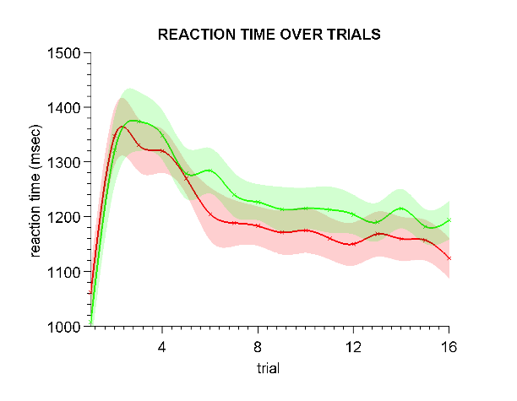

The second result shows the slowdown depending on previous choice and feedback. There are three effects:

– correct / wrong (*post-error slowing*)

– speeding up after a correct target trial

– slowing down in a wrong non-target trial, in the familiar condition respect to the novel condition*.*

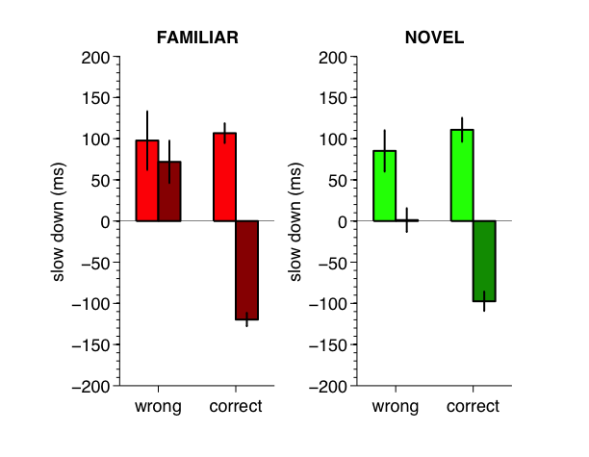

**BIC values**

Fittings and prediction (independently for each participant and Fam/Novel) are now measured using BIC values over response and performance. This allows us to compare nested models and models with different number of parameters.

BICCHOICE and BICCORRECT are calculated across trials (i.e. 16 conditions).

The resulting cost function is

C = ½ (BICCHOICE + BICCORRECT)

Additionally, we can also calculate BIC scores of the human behaviour to obtain a lower boundary:

**>> run_bic**

**BIC(human) = 30.63 = 31.27**

**Models**

The model has been simplified. Previous formula was

dH = ½ cos(½πα) ((+1) - H) if target

dH = ½ sin(½πα) ((+1) - H) if nontarget

H = H + dH

while now it is

dH = αM ( αR) ((+1) - H) if target

dH = αM (1 - αR) ((-1) - H) if nontarget

H = H + dH

Note that the new model has one additional parameter.

Additional models include

1) Nested model with 2 parameters (fixing αM)

2) Dependent on correct/incorrect rather than target/nontarget

3) Dependent both on correct/incorrect and target/nontarget.

**Philosophy behind the model**

This family of models allows us to estimate learning rates in different conditions. Hence, we can quantify both confirmation biases. Confirmation biases have been theorised as a good strategy when the information to process overcomes the capacity of the agent. However, this capacity does not need to be reflected in our model for our kind of analysis. **This needs to be clearly specified in the manuscript.**

**Model analysis – TARGET**

This is the fitting landscape for a model that has different learning rates for target and nontarget.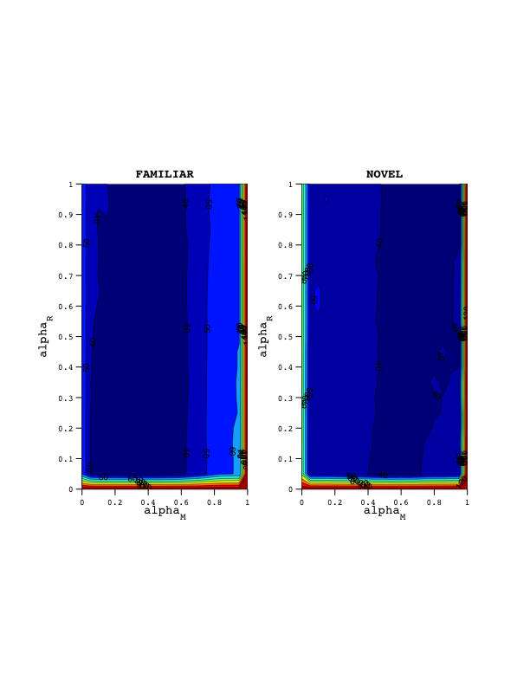

Fixing αM to 50% is not a sensible idea.

**BIC(ta3) = 50.00 = 69.73**

**BIC(ta2) = 55.71 = 83.68**

BIC scores don't validate this approach either. Plotting the parameters, we can see that for most fittings αM don't fall into this line and that it differs between familiar and novel.

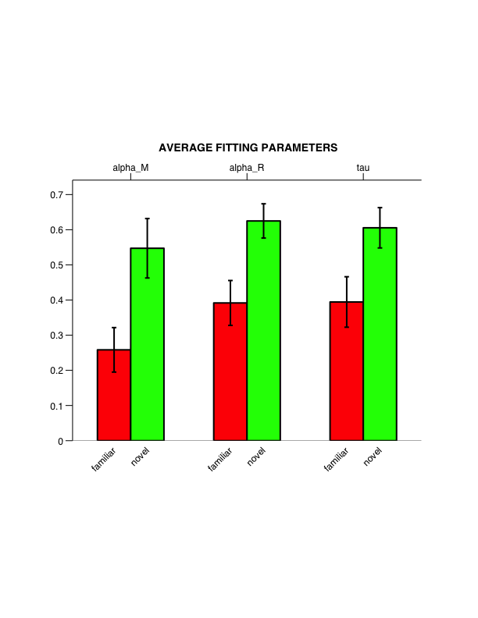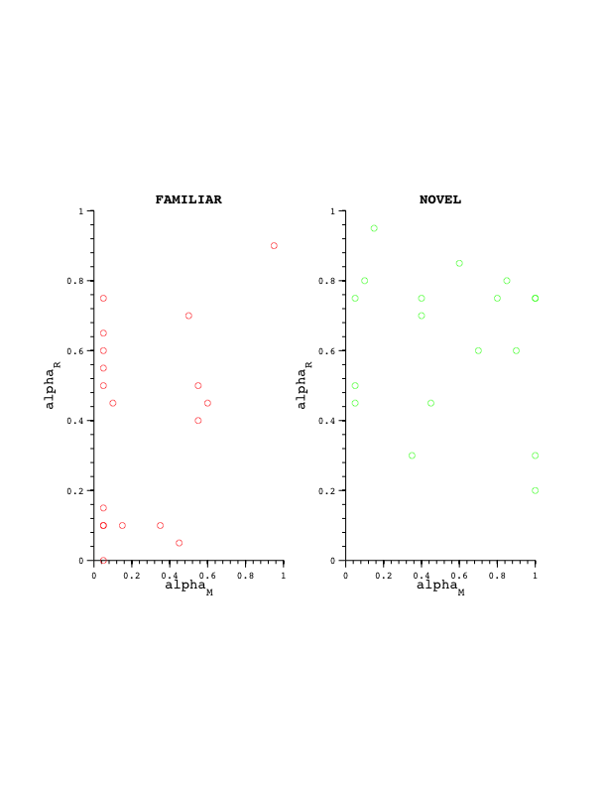

We actually find main effects of fam/novel for all parameters. In short, we learn quicker (we also forget quicker), and we learn more from target, in the novel condition.

To test significance, we can use a *Wilcoxon rank sum test:*

p(αM) = 0.01482

p(αR) = 0.00961

p(τ) = 0.05446

Then we can repeat everything again for the other model.

Note:

There's one thing left to do: αM should be between [0,2]. We could use bigger spaces, but i don't expect anything to change really.

**Model analysis – PERFORMANCE**

This is the fitting landscape for a model that has different learning rates for correct and incorrect.

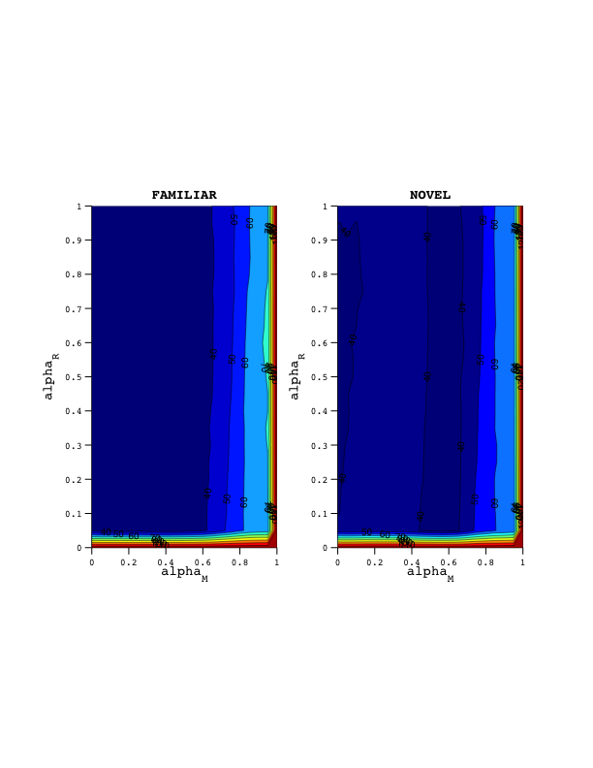

We can calculate BIC scores for the model, and the nested model of two parameters (fixing alpha_M = 1/2).

**BIC(co2) = 44.49 = 51.67**

**BIC(co3) = 43.04 = 52.29**

This fittings are better than for the TARGET model! However the main effects are much less strong here. And not significant.

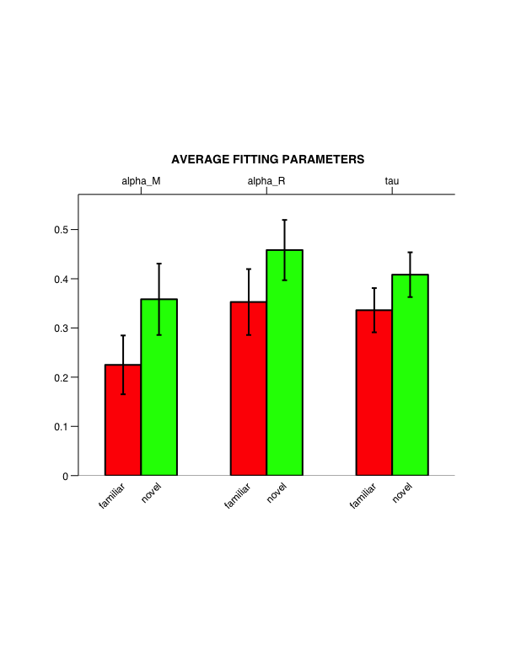

To test significance, we can use a *Wilcoxon rank sum test:*

p(αM) = 0.19422

p(αR) = 0.20410

p(τ) = 0.27705

See? Nothing significant.

Finally, we can design a model who's learning rate depend both on TARGET and PERFORMANCE.

**Model analysis – TARGET & PERFORMANCE**

This is the fitting landscape for a model that has different learning rates for everything. In this case, we have αRC and αRT ("correct" and "target" respectively), with 4 parameters in total.

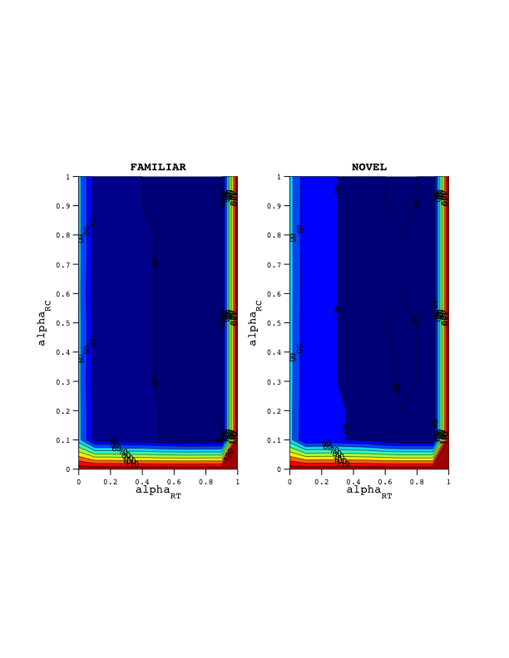

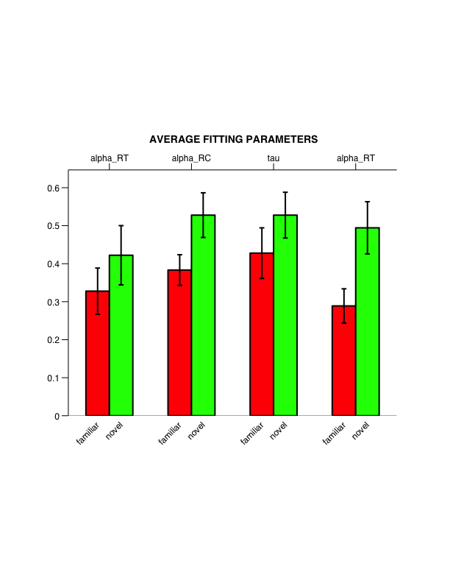

To test significance, we can use a *Wilcoxon rank sum test:*

p(αM) = 0.48922

p(αRT) = 0.05512

p(αRC) = 0.21860

p(τ) = 0.03334

In this case, the effect on αM is a lot smaller. Fixing it here would be better justified – though I would need to look at the fitting landscapes and the individual fittings first.

Maybe that would turn the main effect of αRT significant.

**BIC scores – summary**

>> run_bic

run_bic: criterion "@(ch,co)(ch+co)*0.5"

BIC(human) = 30.63 = 31.27

BIC(hbm) = Inf = Inf

BIC(ta2) = 55.71 = 83.68

BIC(ta3) = 50.00 = 69.73

BIC(co2) = 44.49 = 51.67

BIC(co3) = 43.04 = 52.29

BIC(taco4) = 43.88 = 48.11

TARGET & CORRECT (4 parameters) wins, even with a grid with worse resolution.

**Predicting RT with our model**

We then can take the decision value |mmmaVc| for our final model "taco4" (without the sign) and plot it against RT to see how well we could predict the latter one.

The higher the value, the stronger the evidence, and thus the smaller the RT should be.

Note that I have excluded the first trial, because it seems to follow a different strategy than the rest of the task.

