Correlates of hierarchical representations during goal-directed navigation
Jan Balaguer¹, Demis Hassabis², Hugo Spiers³ and Christopher Summerfield^{1*}

¹ Dept. Experimental Psychology, University of Oxford, UK
² Gatsby Computational Neuroscience Unit, University College London, UK
³ Institute of Behavioural Neuroscience, University College London, UK

* to whom correspondence should be addressed:
christopher.summerfield@psy.ox.ac.uk
Dept. Experimental Psychology
University of Oxford
South Parks Road
Oxford OX1 3UD, UK
ABSTRACT
...

KEYWORDS
Decision-making
Hierarchical planning
Navigation
fMRI
INTRODUCTION

You face new situations everyday. Whether your bike breaks on your way to work, or whether you aim to cook risotto, you easily figure out how to reach your goal (e.g. take the bus; or look for a recipe). This is usually referred to as goal-directed behaviour and requires from planning: the ability to achieve a desired goal when you have a good knowledge of how things work, but the solution to your new problem is not obvious itself. How goal-directed behaviour is achieved by humans [ref] and other animals [ref] has remained elusive to scientists despite it lies at the heart of psychology, decision-making and artificial intelligence.

One line of research proposes that a key strategy for efficient planning is divide-and-conquer [ref]. This comes from the intuition that humans can rely on intermediate states to guide themselves towards a solution. For example, if you're not familiar with the underground in Paris and you want to go from Glacière to Oberkampf with the shortest route, you will quickly figure out by looking at a map that you will cross Place d'Italie. This knowledge constrains the space of possible paths by splitting your journey into two easier sub-journeys (how to go from Glacière to Place d'Italie; and how to go from Place d'Italie to Oberkampf) and thus alleviates the complexity of the original problem.
How we infer that some "states" are part of our solution is a mystery on itself. One way by which this can be achieved is by organising the space of states hierarchically [ref]. Following the previous example, the 303 stations in Paris are grouped into 14 lines. Travelling between two stations of the same line (e.g. from Glacière to Place d'Italie in line 6) is easy because the shortest path must be composed of stations of the same line (e.g. line 6 only has 28 stations). Additionally, if we know the line(s) of our destination (Oberkampf is in line 5) we can deduce that an intermediate step towards our goal is the intersection between lines 5 and 6 (Place d'Italie).

Hierarchical representations have also proven useful in a handful of problems, including learning [ref] and transfer of knowledge [ref]. For instance, it has been shown that humans build up hierarchies spontaneously, in order to represent their experiences, even when they don't behave towards a goal [ref].
Nevertheless, the neural mechanisms underlying hierarchical planning and goal-directed behaviour are unclear.
Set a hypothesis
We used fMRI to measure BOLD signal while 20 healthy participants (10 female; age 19-34, mean 25.6 years) performed a navigation task within a previously-learned virtual environment representing a subway network. Stations were connected via "subway lines" that (during training) were represented with a salient contextual cue (colour). We reasoned that stations where the lines intersected (exchange stations) would be treated as subgoals and predicted that they would garner unique behavioural and neural effects, even though during task performance they were not associated with explicit visual cues.

MATERIALS AND METHODS

Subjects. 22 healthy participants (10 female, 12 male; age 19-34, mean 25.6 years) were recruited into the study in accordance with local ethical guidelines. No participants reported a history of psychiatric or neurological illness, and all had normal or corrected-to-normal vision. They were paid £35 for participation in both a practice and a scanner session on two separate days. A monetary incentive up to £10, and proportional to performance was added to the previous amount. Two participants were excluded due to poor performance.

Task. Participants performed a goal-directed navigation task within a virtual environment. They were required to plan their way in the minimum amount of steps towards a destination by navigating through a subway network they had been previously familiarized (See Figure 1a). The training session was performed two days before the scanning session. Details about the training are given in the supplementary materials.

Maps. Each map (i.e. each instance of the subway network) was formed by a set of 35 stations identified by unique names. In order to move from one station to the next, participants had to take one of 4 lines represented by unique colours. Thus, the space of transitions between stations at every single step was constrained by the connectivity of these lines. There was no extra cost for switching from one line to another.
All maps were similar in structure, with applied spatial rotations of 0, 90, 180 or 270 degrees. The names of the stations were shuffled for all participants at the beginning of the experiment. Each participant navigated through the same map during the training and the scanning sessions.

Journeys. During the scanning session, participants completed many trials. Each trial corresponded to a journey, with a starting point and a destination. Start and destination were always regular stations. A monetary value (either 1 or 5 virtual coins) was randomly associated to each trial. The cumulative value of all completed journeys was converted into real money (normalised to a maximum of £10) at the end of the experiment for real payment to the participant. On all steps, there was a probability on any given step that the journey might be cancelled. This probability was calculated such that optimal behaviour would complete each journey with probability 50%. This was an incentive for participants to minimise the length of their journey in number of steps, in order to maximise their income.
Journey could belong to any of two categories. In the hard journeys (around 90%), the starting point and the destination didn't share any common line. Thus, in order to get to the destination, participants had to change lines at least once. In the easy journeys (around 10%), the starting point and the destination shared the same line and thus changing line was possible but not necessary to achieve optimal performance. Additionally, easy trials were designed such that optimal trajectories included an elbow station when one single line was used for navigation.

Stimuli. Each trial began with the presentation of a "cue" screen for 3 seconds that indicated the starting point and the destination (stations and lines). After a period of 2-5s (jittered) of blank screen, a "step" screen was displayed for 3 seconds. This screen provided multiple pieces of information: the current and destination stations (by their names); as well the lines of the current station (by its colour) they were connected to; the reward at stake for the current journey; the cumulative reward so far; and the possible actions (i.e. the possible directions of navigation). Critically, no information about the current line nor about the line associated to each action were shown. At each particular step, participants had to choose whether they wanted to navigate towards any of the cardinal directions (actions north, south, east or west; pressing one out of four buttons) or to stay in the current station (null action; not pressing any button). However, a null action would be disadvantageous in general because it increased the length of the journey (in steps or number of actions) without getting closer to the destination. Every trial was composed of multiple steps where participants navigated their way to the destination. No feedback was provided during navigation. Steps were alternate with blank screens of 1-3s (jittered). The trial ended either when the participant reached the destination or when the journey was cancelled. After the journey was finished or cancelled, a "feedback" screen informed whether the destination had been reached or not and, when relevant, the reward that had been won. This screen was displayed for 2s and followed by a blank screen of 2-5s (jittered) before the next trial started. Participants completed as many trials as possible in 4 contiguous runs of around 16 minutes buttressed by lead-in and lead-out durations of 10s and 5s respectively. The total scanning time per participant was around 75 minutes.

Behavioural analyses. We analysed reaction times with ANOVAs testing the influence of action switch and whether the current station was an exchange station or not (Figure 1b). Information about additional behavioural analyses are described in the supplementary materials.

fMRI Data Acquisition and Preprocessing. Magnetic resonance images were acquired with a 3T Siemens VERIO scanner with a 32-channel head coil using a standard echo-planar imaging sequence. Whole-head T₂*-weighted echo-planar images were continuously acquired with a repetition time of 2 s, echo time of 30 ms. We acquired XXX volumes per block, plus 3 dummy scans discarded before the analyses. Each volume included 64 × 64 × 36 voxels of 3 × 3 × 3 mm. A high-resolution T₁-weighted structural image was also obtained (voxel size = 1 × 1 × 1 mm). For standard preprocessing and univariate statistical analyses, we used SPM8 (Wellcome Department of Cognitive Neurology, London, United Kingdom). All other analyses were done with custom scripts for Matlab (Mathworks, Natick, MA, United States of America). We also used xjview (http://www.alivelearn.net/xjview) to visualize the data and to construct mask and conjunction images. For each participant, we first realigned all functional images, then we co-registered (rigid body transformation) the subject's anatomical scan to the mean functional image, and then co-registered the participant's data to the Montreal Neurological Institute (MNI) template brain. We then normalized each subject's data to the template brain space, using segmented probabilistic maps for grey matter, white matter, and cerebro-spinal fluid. Functional images were resampled (4 × 4 × 4 mm voxels) and spatially smoothed (8-mm full-width half-maximum (FWHM) Gaussian kernel).

fMRI analysis. Our univariate analyses used a generalized linear model (GLM) approach. A 128-s temporal high-pass filter was applied to remove low-frequency scanner artifacts. Temporal autocorrelation in the time series data was estimated using restricted maximum-likelihood estimates of variance components using a first-order autoregressive model (AR-1), and the resulting non-sphericity was used to form maximum-likelihood estimates of the activations. Our GLM included regressors coding for onsets and durations of stimuli or events, which were then convolved with the canonical hemodynamic response function (HRF) and regressed against the observed fMRI data. Experimental blocks were modelled using unique concatenated regressors, and constant terms for each block were included. Additionally, motion parameters were included as nuisance variables.

For the standard analyses, we included a design matrix with regressors aligned cues (beginning of trial), stimulus (steps within each trial), and feedback (end of trial). Specify main effects and interactions. We report voxels that responded to these regressors at thresholds that were corrected for multiple comparisons, using a false discovery rate of p<0.05. Voxelwise statistics were rendered onto the MNI template brain using xjview (http://www.alivelearn.net/xjview8/). To avoid selection bias (‘double-dipping’), data for each participant were extracted on the basis of an ROI defined for the remaining 19 members of the cohort. Haemodynamic response data were temporally upsampled by a factor of 10 for plotting. All ANOVAs were carried out with Greenhouse-Geisser correction for sphericity (reporting adjusted d.f. rounded to the nearest integer) using an alpha of p < 0.05.
RESULTS

Behavioural results. Twenty-two healthy human participants navigated through a virtual subway network .......
Neural results. Blablabla......

DISCUSSION
Blablabla....
REFERENCES
{Bibliography}

ACKNOWLEDGEMENT
Thanks to...

FINANCIAL DISCLOSURE
This work was supported by ##### to C.S., and ##### to C.S. The funders had no role in study design, data collection and analysis, decision to publish, or preparation of the manuscript.

COMPETING INTEREST
The authors have declared that no competing interests exist.
FIGURES

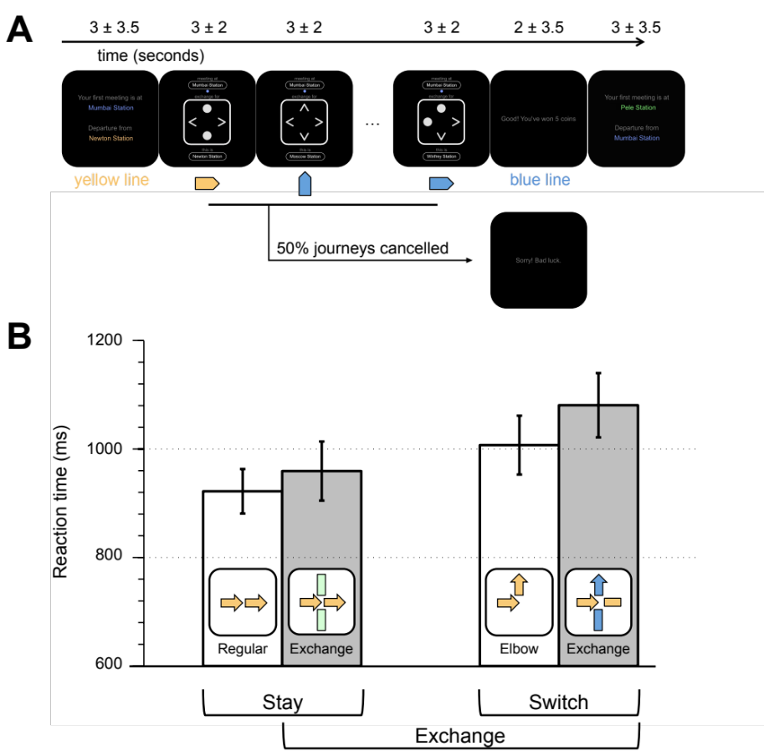

Figure 1. Task design and behavioural results
A. Task design. Participants navigated through a subway network on their way to the destination. On each trial, a cue revealed the starting and destination points, as well as the lines accessible from them. The colour of the lines were hidden during the scanning session but where previously learned in a training session. Around half of the journeys were randomly cancelled before reaching the destination point. Participants were paid a bonus (1 or 5 virtual coins randomly chosen) for each journey successfully completed. B. Behavioural results. Three kinds of stations (regular, exchange and regular) allowed us to disentangle the effects of switching action, complexity of the decision, and changing line. Reaction times revealed a double main effect where participants slowed-down their response when they had to change their pattern of response and when more actions were possible.

