**right Angular Gyrus**

The activation of the right angular gyrus is interesting.

It reflects difficulty by model complexity (main effect easy>hard), but also and model switch (interaction).

Two questions arise:

1) Is it due to plain difficulty? Do reaction times or no response reflect this activity too?

2) Do two hard journeys with different lines count as a model switch?

**Question 1.** Is it due to plain difficulty?

It's hard to see...

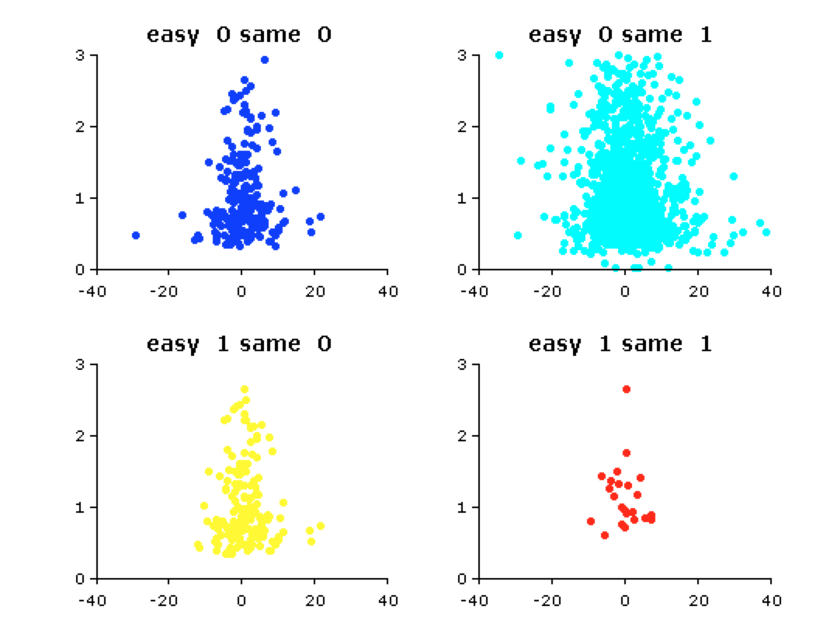

... but reaction times do correlate with activity.

With a regression (across all participants because there are not enough trials) we find this:

**constant**

beta: 2.05

p-value: 0.00

**easy**

beta: 1.78

p-value: 0.01

**same**

beta: -0.19

p-value: 0.71

**reaction time**

beta: -0.92

p-value: 0.00

..which means that participants are slower in the first trial, when the right angular gyrus is less active. It would be interesting to see if this effect is specific to easy/hard/same/different journeys.

Additionally, I run a GLM with two modulators: Easy, as before; and Bool (whether there was always response for the journey or not).

Easy modulated :

**– right angular gyrus: +6,48**

– left orbitofrontal inferior lateral: -5.65

–right precuneus (but anterior, next to central sulcus) : -4.81

–right precuneus (but posterior) : +4.78

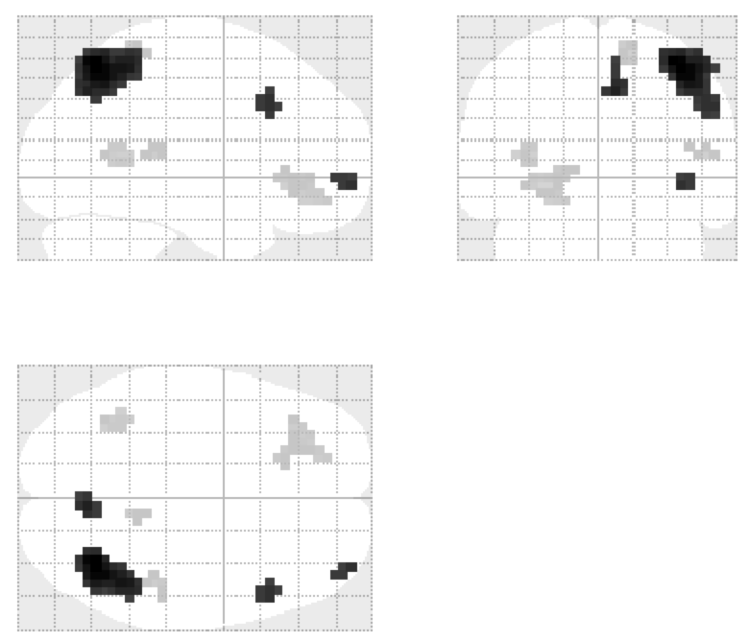

Bool modulated :

– bilateral vmPFC: -5.05

– bilateral (but mostly left) putamen: -5.25

– left frontal sueprior: -4.24

**– left angular gyrus: -5.12**

– right angular gyrus (but not quite significant, p = 0.1)

– left hippocampus: -4.21

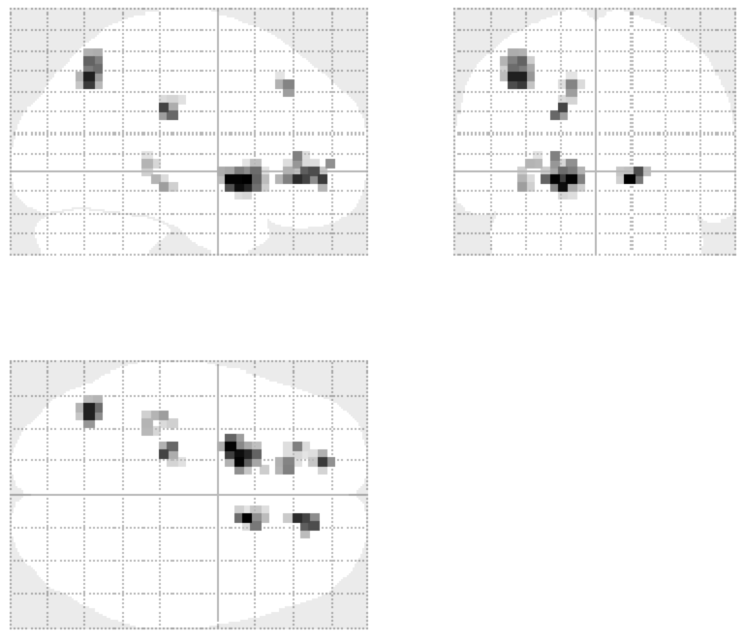

**Question 2.** Model switch between hard journeys

There are no differences between hard journeys as a function of same or different lines. However, there is a significant difference for easy journeys!

That said, we almos have no journeys with easy-easy and matching lines...

Macintosh HD:Users:jan:dmt:gitmatlab:subway_fmri:docs:documents:reports:20141204:question_2.pptx.pdf