Julia Dohner

March 16, 2018

SIOC 221B

HW #3

t_MLO = MLOyear-MLOyear(1);

cosMLO = cos(2*pi*MLOyear/(1));

sinMLO = sin(2*pi*MLOyear/(1));

G = [ones(length(MLOyear),1) t_MLO sinMLO cosMLO t_MLO.^2];

m = inv(G'*G)*G'*MLOco2;

Period is 1 year, t is in units of years

1. 1. See Figures 1 and 2 (top subplots).
   2. See Figures 1 and 2 (bottom subplots).
   3. See Figures 3 and 4.

Without noise, the skill begins to asymptote at nearly 1 after 6 data points. The growth towards a skill of 1 is not linear, however. Instead, no information is added when using three points instead of two because the third point is added at the mean, thus the skill remains unchanged as the number of data increase from 1 to 2. The skill again increases with the use of 4 data points but drops with 5. This occurs because the fifth point is added at the mean, adding no new information, and pushes (visually) the surrounding data further from the mean, increasing the distance between the points and thus decreasing the skill. After 5 points, however, the skill beings to asymptote at 1. With noise, the skill follows the same pattern with the addition of new data points, but never asymptotes or reaches 1. Instead, the skill slowly increases after 6 data points are used, but reaches a maximum of 0.8649.

* 1. See Figures 5 and 6.
  2. See Figures 7 and 8.
  3. Based on the results of the EOF analysis, I think the data for y1 were generated through the superposition of two sine waves with differing frequencies, one of which is split into two phases, each phase being applied to half the data. I think the data for y2 were generated through a random walk procedure because the first EOF shows an oscillatory pattern whereas the second EOF mostly looks to be white noise.
  4. See attached MATLAB code. The expression for the gain and the skill are the following:
 $$α= \frac{<τ^{*}u>}{<τ^{*}τ>}{ ρ}^{2}= \frac{<τ^{*}u><u^{*}τ>}{<τ^{*}τ><u^{*}u>}$$

 5. The Ekman depth is estimated to be 45.4130 m, and the latitude is estimated to be 90˚ S.

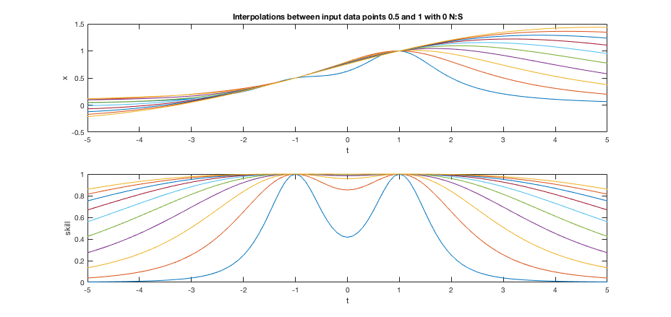

Figure 1. Estimate and skill of variable as a continuous function given data at 0.5 and 1 located at x = -1 and 1 with 0 noise-to-signal ratio.

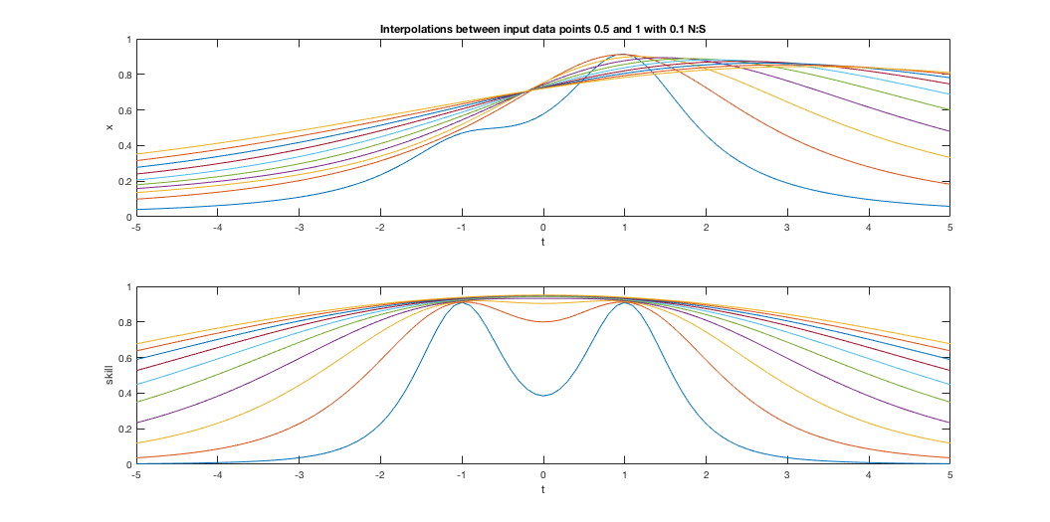

Figure 2. Estimate and skill of variable as a continuous function given data at 0.5 and 1 located at x = -1 and 1 with 0.1 noise-to-signal ratio.

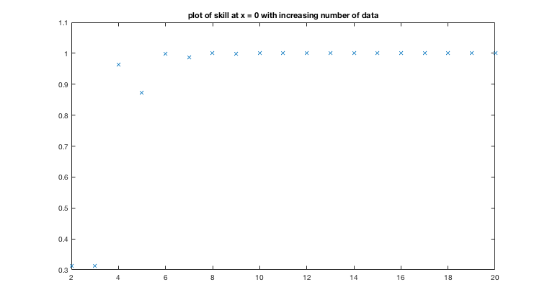

Figure 3. Plot of skill of estimates using increasing number of data points spread evenly between x = -1 and 1 with 0 noise-to-signal ratio.

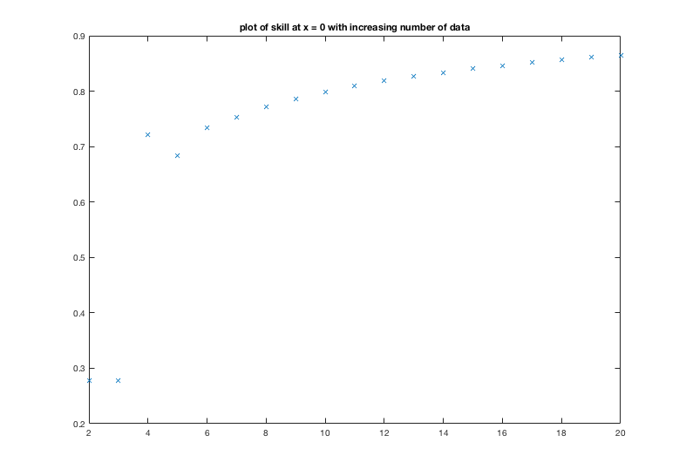

Figure 4. Plot of skill of estimates using increasing number of data points spread evenly between x = -1 and 1 with 0.1 noise-to-signal ratio.

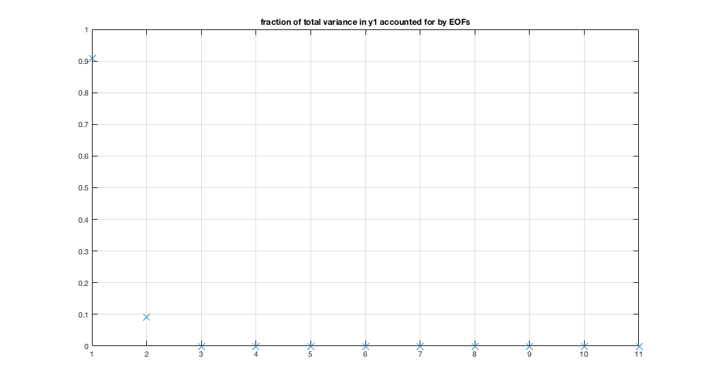

Figure 5. Fraction of total variance in y1 accounted for by each EOF.

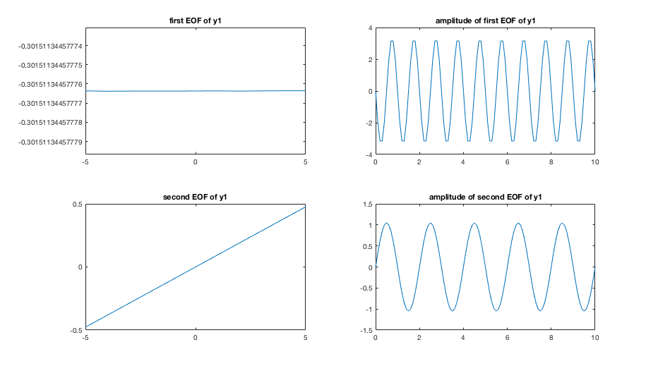

Figure 6. First two EOFs of y1 and their amplitudes.

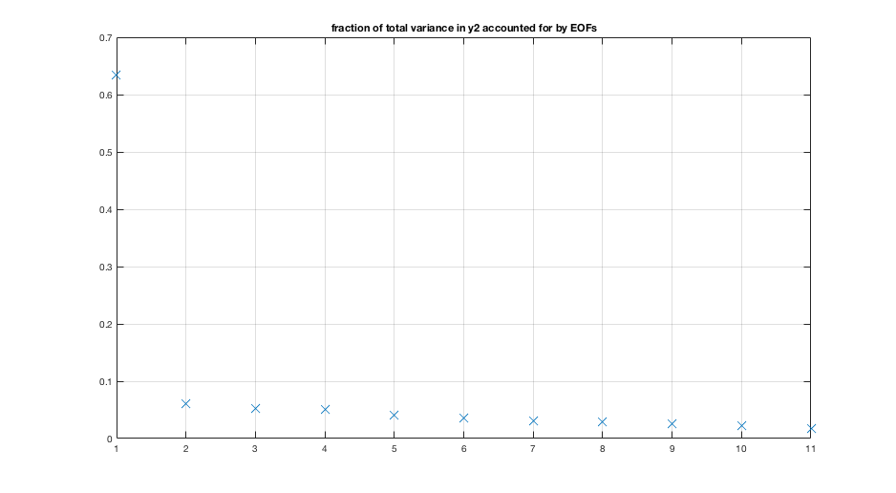

Figure 7. Fraction of total variance in y2 accounted for by each EOF.

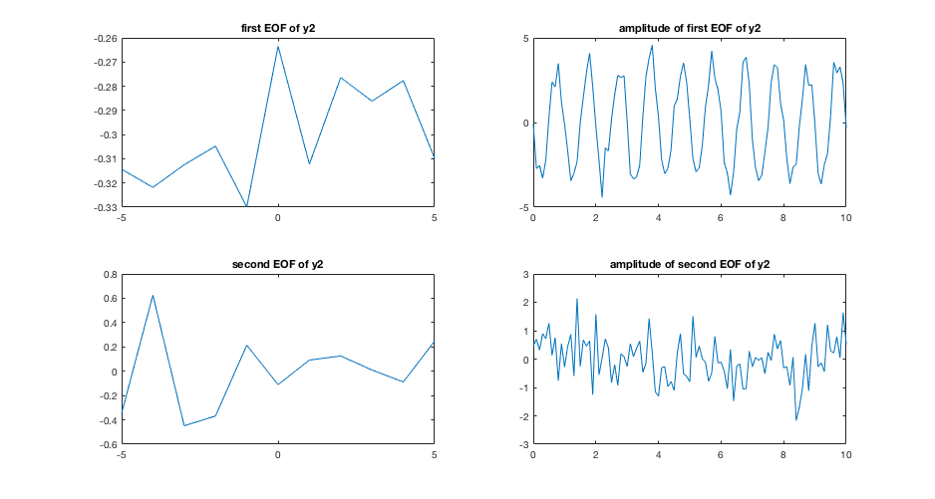

Figure 8. First two EOFs of y1 and their amplitudes.

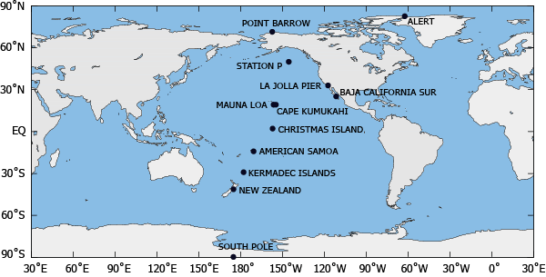

Figure 9. Map of CO2 measurement stations. Source: http://scrippsco2.ucsd.edu/

Calculations to try with your data:

1. See Figures 10 and 11. I computed EOFs for flask-collected monthly averages of atmospheric CO2 collected at five different stations: Mauna Loa, La Jolla, Christmas Island, Cape Kumukahi, and Point Barrow. I plotted the first and second EOF’s for the data. The first EOF looks to be a long-term linear growth trend with some seasonal cycle, for which all of the station time series are in phase. The second EOF is mostly the seasonal cycle, and it out of phase for some of the stations, possible for the ones that are further south or towards the poles (away from the major concentration of boreal forests at mid-latitudes that strongly influence the seasonal cycle).
2. I supposed a linear relationship between the Mauna Loa CO2 record and the Point Barrow CO­2 record. The gain of the linear estimate was 1.0041 and the mean-square error was 22.7825.
3. See Figures 14 and 15. I made an objective map of a more or less vertical line at around 155˚ W, using data from Point Barrow, Station P, Mauna Loa, Christmas Island, American Samoa, New Zealand, and South Pole Observatory, all taken in September of 1981. We’d expect CO2 to be lower in the northern hemisphere than in the southern hemisphere because September is at the tail end of the summer, meaning that CO2 levels will be lower. I can see that as I increase the scale, the skill improves between data points. I can also see that increasing the amount of noise pulls the mapped values closer to the mean and away from the data points. The analysis would benefit from more northern hemisphere points.

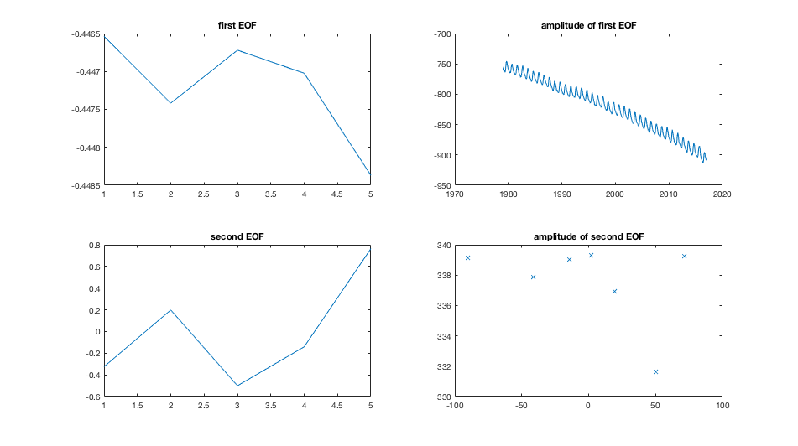

Figure 10. First two EOFs of the 5 CO2 records and their amplitudes.

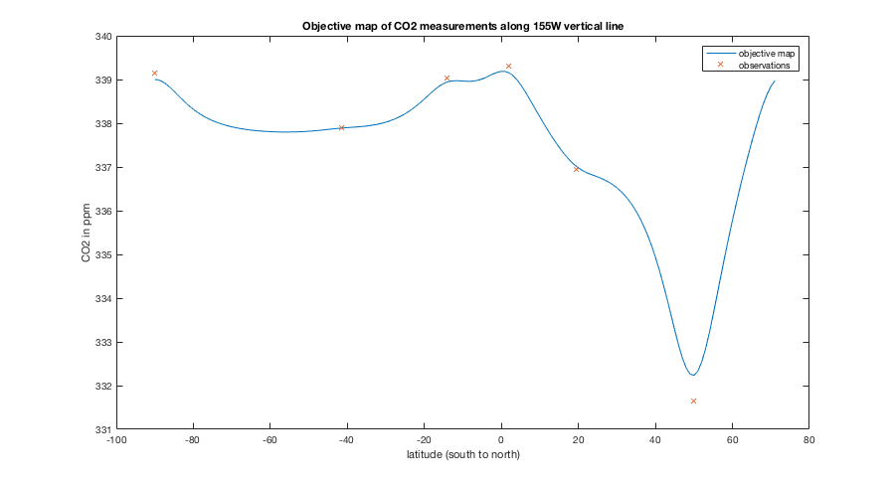

Figure 11. Objective map of CO2 on north-south line between five stations. Noise-to-signal ratio is 0.1.

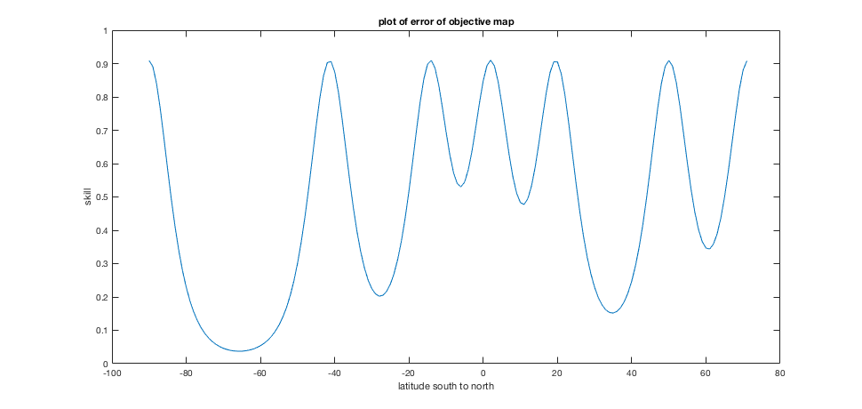

Figure 12. Error of objective map where noise-to-signal ratio is 0.1