Jerry Olds

1001533643

CSE-3330-001

2/27/2019

Assignment 4

(May have to zoom in on screenshots)

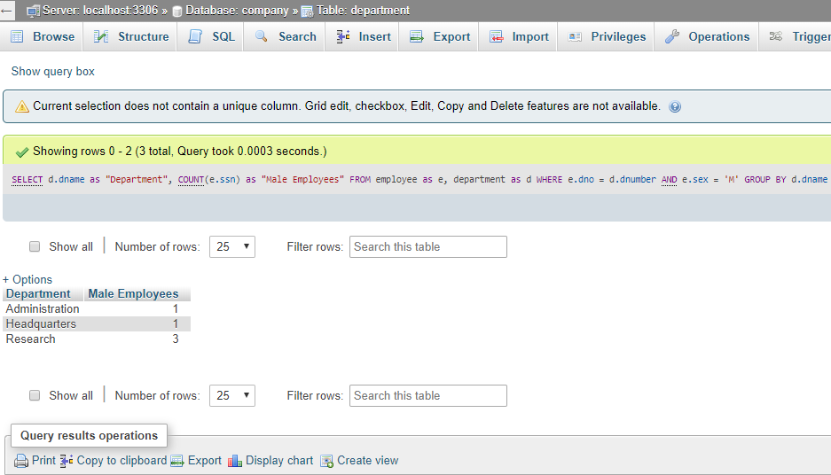1a. 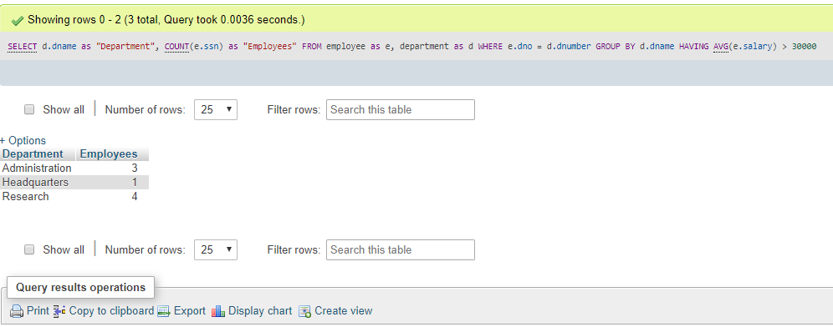1b.

1c.

SELECT e.fname as “First Name”, e.lname as “Last Name”, d.dname as “Department” FROM employee as e, department as d WHERE (e.dno, e.salary) IN (SELECT e.dno, MAX(e.salary) from employee group by e.dno)

1d.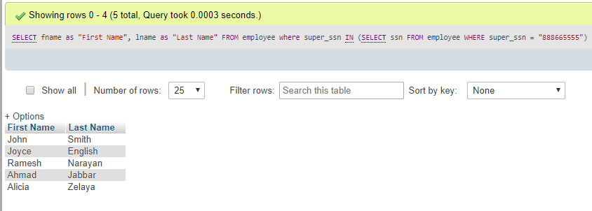

1e.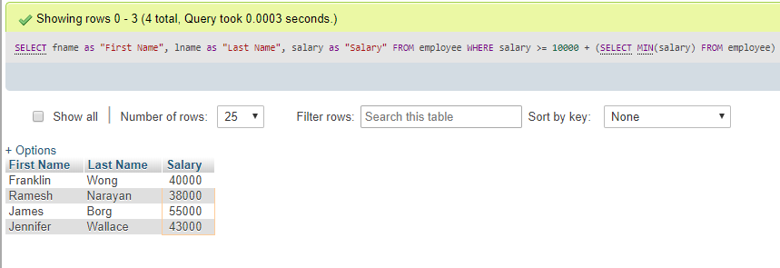

2a.

CREATE VIEW 2a AS SELECT d.dname as “Department”, e.fname as “First Name”, e.lname as “Last Name”, e.salary as “Salary” FROM employee as e, department as d WHERE e.dno = d.dnumber AND e.ssn = d.mgr_ssn

2b.

CREATE VIEW 2b (Employee_First_Name, Employee_Last_Name, Supervisor_First_Name, Supervisor_Last_Name, Salary) AS SELECT e.fname, e.lname, s.fname, s.lname e.salary FROM employee as e, employee as s, department as d WHERE d.dname = “Research” AND e.dno = d.dnumber AND e.super_ssn = s.ssn

2c.

CREATE VIEW 2c AS SELECT p.project_name as “Project”, d.dname as “Department”, COUNT(w.w_ssn) as “Number of Employees”, SUM(w.hours) as “Hours per Week” FROM project as p, department as d, works_on as w WHERE d.dnumber = p,department_id AND w.w_project_id = p.project_id GROUP BY p.project_id

2d.

CREATE VIEW 2c AS SELECT p.project_name as “Project”, d.dname as “Department”, COUNT(w.w_ssn) as “Number of Employees”, SUM(w.hours) as “Hours per Week” FROM project as p, department as d, works_on as w WHERE d.dnumber = p,department_id AND w.w_project_id = p.project_id GROUP BY p.project_id HAVING COUNT(w.w_ssn) > 1

3a.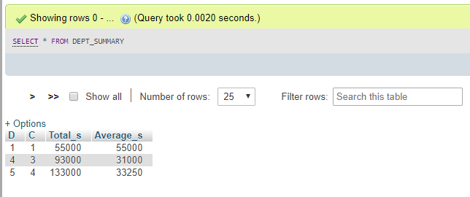

3b.

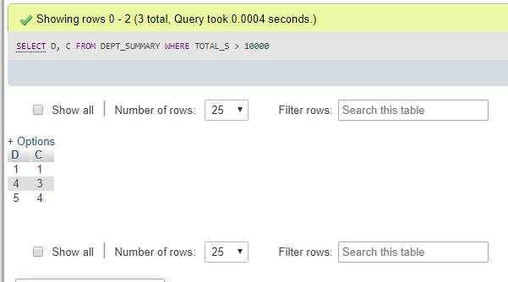

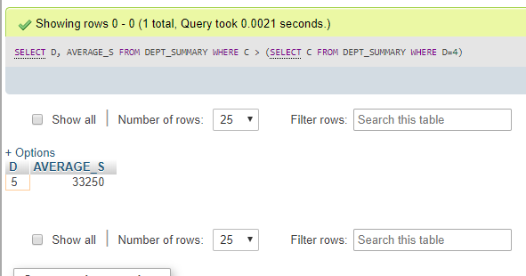3c.

3d. NOT ALLOWED

3e. NOT ALLOWED

4a. SELECT Name, Major FROM STUDENT AS s WHERE NOT EXISTS (SELECT * FROM GRADE_REPORT AS g WHERE g.StudentNumber= s.StudentNumber AND NOT(g.Grade='A'))

4b. SELECT Name, Major FROM STUDENT AS s WHERE NOT EXISTS (SELECT * FROM GRADE_REPORT AS g WHERE g.StudentNumber= s.StudentNumber AND g.Grade='A')

5. A trigger is an action that executes when data is inserted or modified in a database. An example where a trigger would be used would be to set data to desired default values when an entry is made in to a database