Jerry Olds

1001533643

CSE-3330-001

3/18/2019

Assignment 6

1. **Entity:** Any object in the system that we want to model and store information about.

**Attribute:** Instances in the row of a database.

**Attribute value:** Values that the row of the database stores.

**Relationship instance:** Tuple or row in a relation. A particular combination of attribute values.  
  
**Composite attribute:** Made of more than one simple attribute. Example would be the name of a student made of first name and last name attributes.

**Multivalued attribute:** Can have more than one value at a time for an attribute.

**Derived attribute:** Attribute whose value is calculated from other attributes.

**Complex attribute:** Comprised of composite and multivalued attributes.

**Key attribute:** Used to identify relationships between tables and to uniquely identify any record or row of data inside a table.

**Value set (domain):** All the values which a data element may contain.

1. **Entity type:** Describes the type of information that is being stored.

**Entity set:** Group of entities with same type.

Entity type is characteristic of an entity, such as number, text, or date. Entity set is a group of entities that must have the same type

1. **Recursive relationship:** A relationship between two entities of similar entity type. An example would be that a person is the child of a father and that same person may be the father of a child.
2. Rectangle – Entity

Double Rectangle – Weak Entity

Diamond – Relationship

Double Diamond – Identifying Relationships

Oval – Attribute

Oval with Underlined Name – Key Attribute

Oval with Ovals – Multivalued Attribute

Oval with Dotted Line – Composite Attribute

Double Oval – Derived Attribute

Single Line – Partial Participation

Double Line – Total Participation

1. a) BANK, LOAN, ACCOUNT, CUSTOMER

b) Yes,

**Entity Name**:BANK_BRANCH

**Partial Key**: Branch_no,

**Identifying Relationship**: BRANCHES

c) Branch_no is not unique and can be used multiple times. The relationship between BANK and BANK_BRANCH is 1 to many.

d) BANK (Total) BRANCHES (Total) BANK_BRANCH

BANK_BRANCH (Partial) ACCTS (TOTAL) ACCOUNT

BANK_BRANCH (Partial) LOANS (TOTAL) LOANS

ACCOUNT (Total) A_C (Partial) CUSTOMER

LOAN (Total) L_C (Partial) CUSTOMER

6.

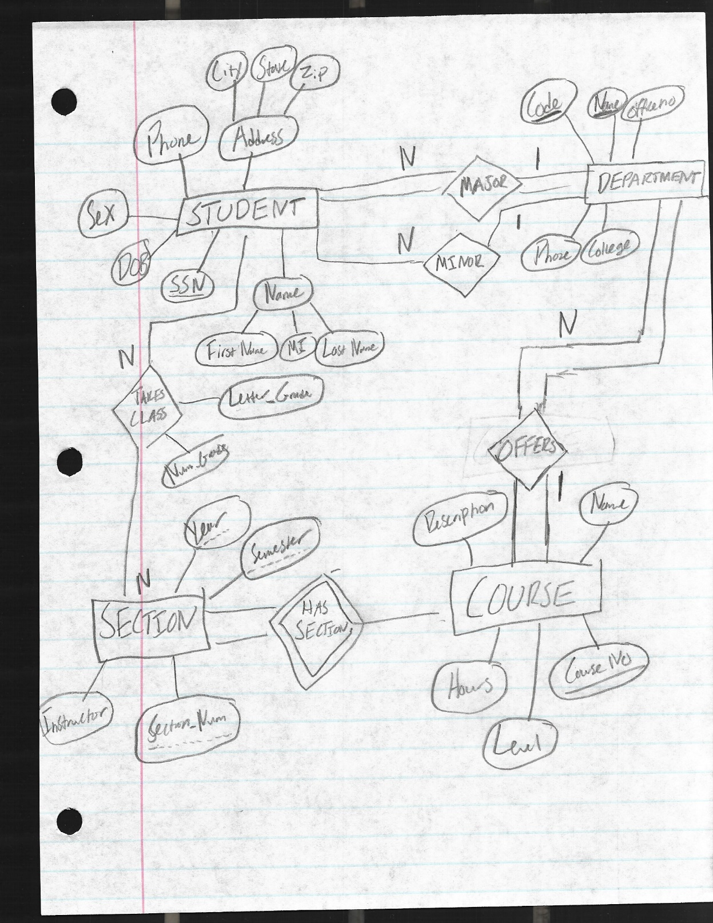

7.

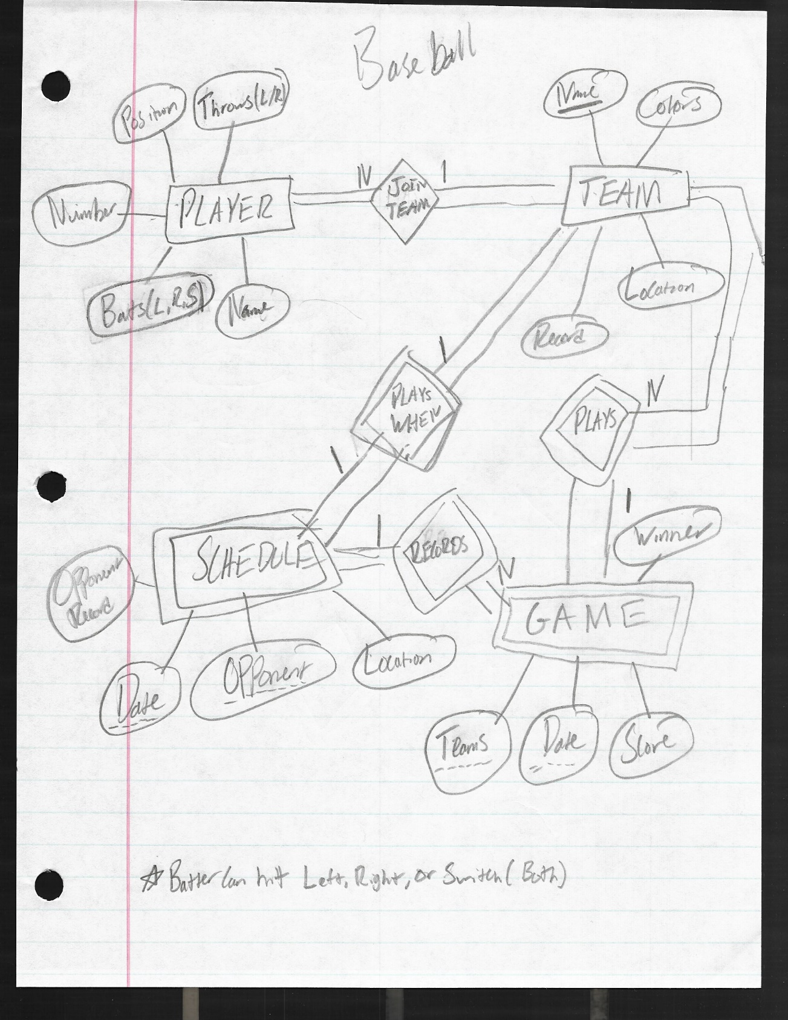

8. 1) 1 to 1 (Each student has one social security card)  
 2) 1 to Many (Student has more than one teacher)  
 3) 1 to Many (Classroom has more than one wall)  
 4) 1 to 1 (Country has one president)  
 5) 1 to 1 OR 1 to Many (could have multiple text books or just one)  
 6) 1 to Many (Student has more than one class)   
 7) 1 to 1 (Class is taught by one instructor)